Macaw User Guide
Install Process
TexGen
TexGen is used to create the weave structure. It is a 3rd party application with install instructions here: https://texgen.sourceforge.io/index.php/Download_TexGen
The default install download is Windows with Python bundled. This is the easiest route if possible. Otherwise, there are more detailed instructions for downloading and building the code from scratch using the TexGen GitHub repository and the associated applications needed to make it function.
This does not need to be in the same location where Macaw will be located, but TexGen will be used to create files that some Python code will use to create another file that Macaw will use for initial conditions. This means the TexGen output file will either need to be moved or saved to a location that the Python code can access.
MOOSE
Download and install MOOSE as instructed here, choosing the correct install environment: https://mooseframework.inl.gov/moose/getting_started/installation/index.html
Continue through until you have successfully built and tested it.
Macaw
Clone Macaw from https://github.com/tonkmr/macawupdated.git using the following commands. This will make it in a similar location to MOOSE:
cd ~/projects
git clone https://github.com/tonkmr/macawupdated.git
cd macawupdated
git checkout main
Next compile and test Macaw:
make clobberall
make -j 6
./run_tests -j 6
Python
Install Python and IDE for editing the code. Visual Studio Code is recommended.
The Python code for this process will be included in the Macaw repository in the pythonScripts folder.

Running Macaw
TexGen
There is an in-depth user guide for Texgen located here: https://texgen.sourceforge.io/index.php/User_Guide
Python
There will be 3 files created, but only the .inp file is relevant to the rest of this process. Move the .inp file exported from TexGen into the same folder as the Python code.
Change the dimensions and file name in the 3rd code box (shown below) where the options are listed. The dimensions should match the TexGen design and the name should match the .inp file that you exported from TexGen.
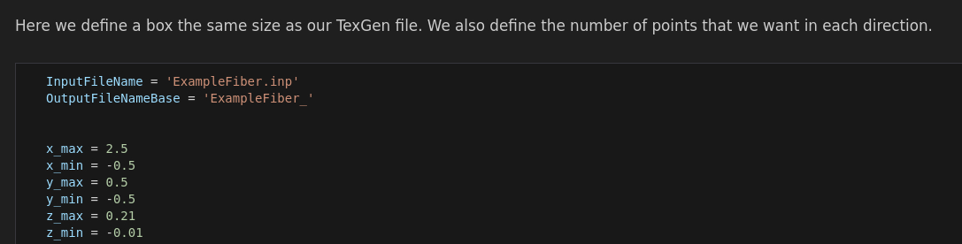
Run the code and it should handle everything else. It will create multiple different files that can be used for different examples. Currently, only some can be used in Macaw, but the others will be used for later versions of Macaw, such as the matrix oxidation model. There are comments around the majority of the code to explain more about each part.
These files will need to be imported into the correct folder in the Macaw folders so that the Macaw examples will be able to use them. The examples point towards the “Structure” folders in their respective filepath.

MOOSE
MOOSE is not directly used for this process, so there are no steps here. Macaw uses it without any steps needed from the user.
Macaw
- Go to the filepath where the desired example file to run is located in the Macaw folders.
- Activate MOOSE either through Conda or by loading the individual applications necessary to run it.
- Use the mpiexec command to run the desired input file with the macaw-opt application.
- Wait for it to complete. It will produce an exodus file and csv file in the results folder.
- Open the resulting exodus file in a program such as Paraview to view results.

Maintaining Macaw
TexGen
TexGen should not require much, if any, maintenance since it is rarely updated.
Python
Python also should not require much maintenance, but it could be updated as new versions are released. TexGen currently requires Python 3.9 to be installed to run, so that cannot be removed from the environment where TexGen is installed.
MOOSE
It is a good idea to regularly update MOOSE by fetching from the GitHub repository. You will also need to update Conda or any other applications on your HPC system used by MOOSE. Some example instructions for the Conda update method are included here under the “Staying Up To Date” section: https://mooseframework.inl.gov/moose/getting_started/new_users.html
Rebuild the Test application and run the tests to ensure things are functional.
Macaw
If there are updates on the GitHub repository, you can fetch the updates from there. If you update MOOSE or fetch updates for Macaw, you will need to recompile the application and test it with the same instructions as before:
make clobberall
make -j 6
./run_tests -j 6
2D Simple Weave Example
This will run through an example problem in detail. It assumes a Windows install of TexGen, using Visual Studio Code to run Python, and a Conda install of MOOSE/Macaw on a Linux system. There will be an example EBSD text file already in the GitHub repository created using this process to serve as a reference.

- Open TexGen
- Click the “Weave” button on the left side panel
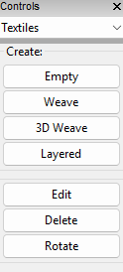
- Adjust “Warp Yarns:” to 1 and “Weft Yarns” to 3. Change the Gap Size: to 0.02, then click next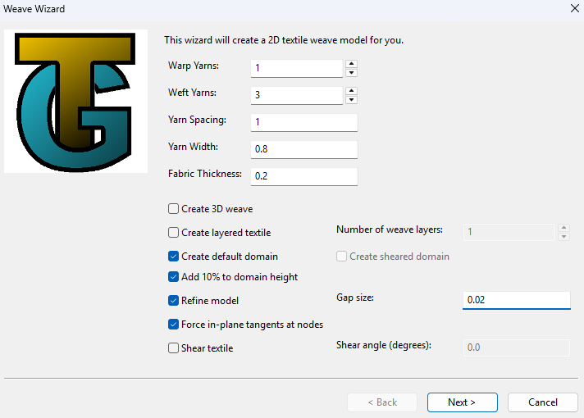
- Click on the center yarn to have it weave under the other, then click OK 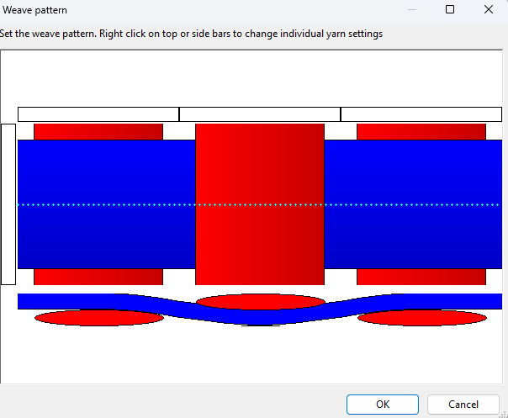

- The structure should look like this after it loads: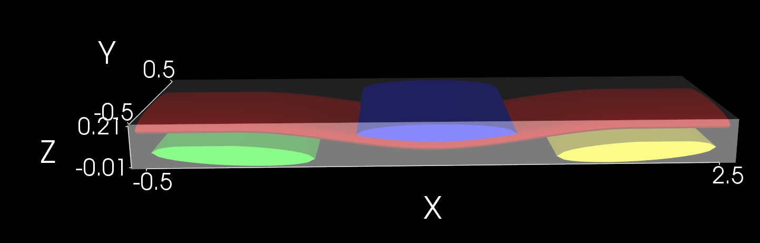

If there is any error with loading the structure, restart TexGen and try steps 1-5 again. There have been rare issues cause it not to load, but rarely twice in a row.
- In the toolbar at the top, choose: File > Export > Volume Mesh
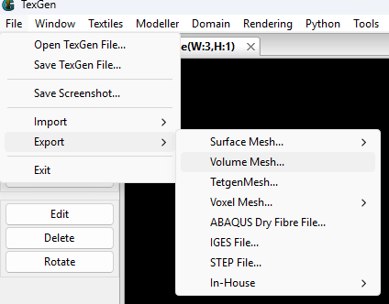
- Change the Element Order to Quadratic, uncheck “Project Mid-Side Nodes, then click OK
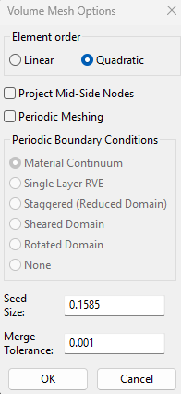
- Choose a file location and choose the file name of ExampleFiber
- TexGen will output three files with different file types. Since the only relevant file is the .inp file, move it to a location that the Python code can access. There is an example of the .inp file created by this example located in the Macaw repository. Both it and the Python script can be accessed by going to macawupdated/pythonScripts
- Since this example is for a basic 2D system, the only sections of the EBSDFileGen.ipynb script that need to be run are the “TexGen File Parsing and Processing” and “Basic 2D File Generation”. There are no updates needed for this example, so run those two sections. The first section has multiple code blocks that can take 30+ minutes and use multiple gigabytes of RAM.
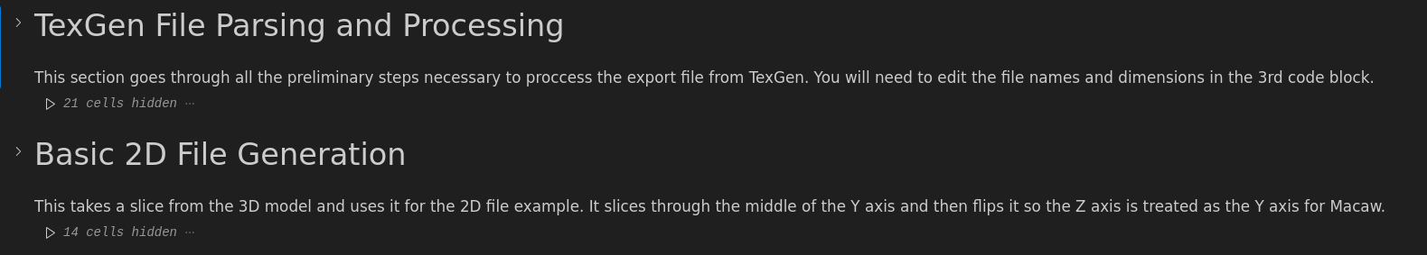
- Running those sections will create a text file called ExampleFiber_2D_ebsd.txt. Now move this to the macawupdated/examples/woven_fiber_oxidation_2D/structure folder. Once again, there will be a reference file from this example already here to compare against.
- Since we are using a conda install of MOOSE, we will use the following command to activate MOOSE:
conda activate moose
- Go to the filepath /macawupdated/examples/woven_fiber_oxidation_2D/step1
- Next, we need to run the step1_multi.i file. We will use the mpiexec command. This also requires us to set the number of CPUs that we want to use and the location of the Macaw opt executable and the input file that we want to run. For our case, this looks like the following:
mpiexec -n 30 ~/projects/macawupdated/macaw-opt -I step1_multi.i
- This should not take long and it will generate an exodus file and a csv file. The exodus file will be used by step2
- Go into the step2 folder by running the following
cd ../step2
- Run step 2 similar to how you ran step 1.
mpiexec -n 30 ~/projects/macawupdated/macaw-opt -I step1_multi.i
- This will take a bit longer and depends on how many CPUs you allocate to the process. Once it is done, it will produce another exodus file and csv file.
- Open the exodus file in an application like Paraview.
- Switch to view the eta_f variable. This variable is 1 where the fiber is and 0 where the fiber is not. It should look like this: 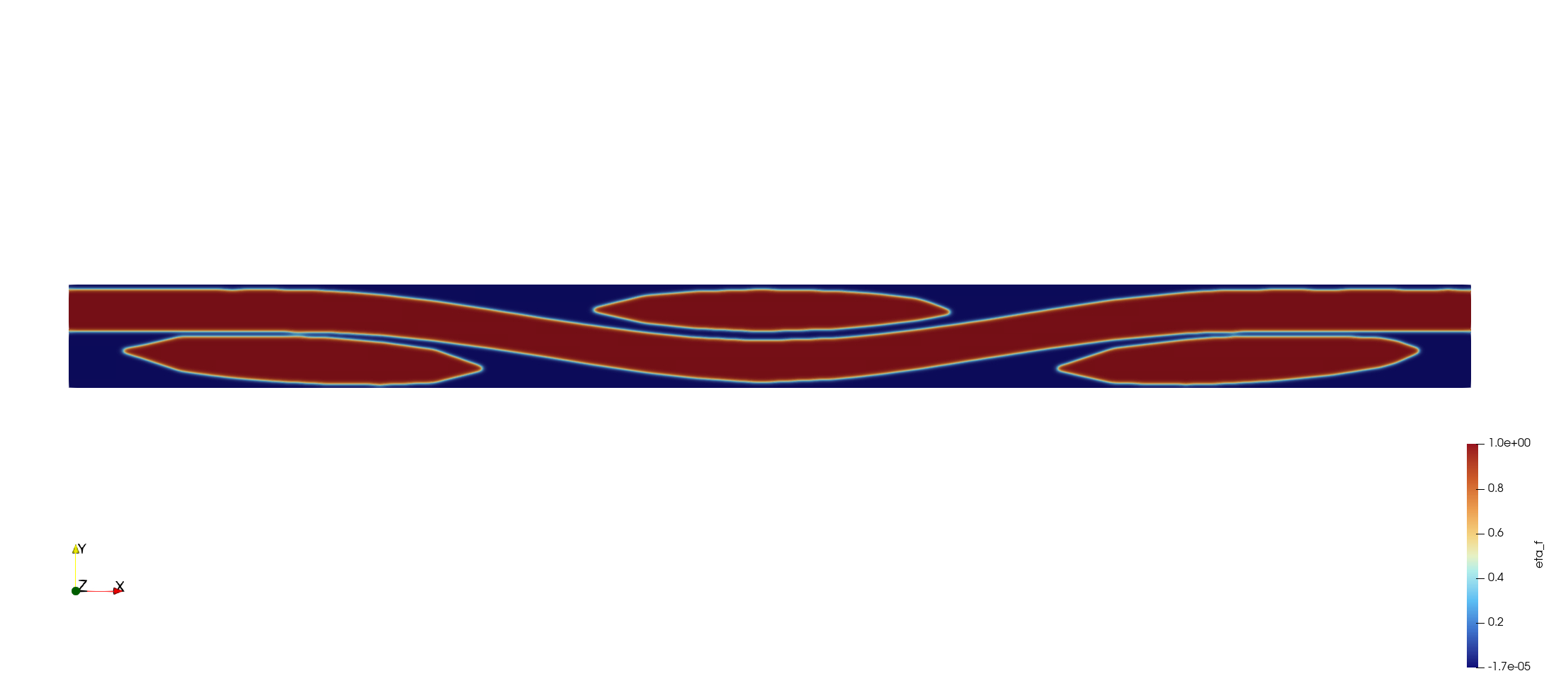
- Press play and this will show the fiber ablate.

