***CURRICULUM VITAE***

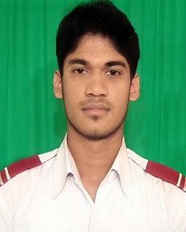

***Of* Md. Ekramul Islam**

**Mobile: +8801711091048**

**E-mail: ekramul.i@grameenphone.com**(office)

[**ekramul.ben@gmail.com**](mailto:ekramul.ben@gmail.com)(personal)

CAREER OBJECTIVES

To prove myself as a quick learner, honest and highly energetic person, I am avid to face any challenge in the field of Bachelor in Computer Science & Engineering and Telecommunication.

ACADEMIC QUALIFICATIONS

|  |  |  |  |  |
| --- | --- | --- | --- | --- |
| **Degree/**  **Certificate** | **Institution** | **Major/Group** | **Passing Year** | **GPA/ CGPA** |
| Bachelor of Science(B.Sc) | Ahsanullah University of Engineering & Technology | Computer Science & Engineering(CSE) | 2016  (Appeared) | - |
| Higher Secondary Certificate (H.S.C) | Akij Collegiate School | Science | 2011  (Jessore board) | 5.00  (Out of 5) |
| Secondary School Certificate (S.S.C) | Akij Collegiate School | Science | 2009  (Jessore board) | 5.00  (Out of 5) |

COMPUTER SKILLS

**1. Operating Systems:** Windows XP, Windows 7, Windows 8, Ubuntu

**2. Application Packages:** MS Word 2007, 2010, MS Excel, MS Power Point, Adobe Photoshop, JAVA,C#,C,SQL Server

LANGUAGE SKILLS

Excellent command over Bengali (Mother tongue) and English languages in both speaking and writing.

PERSONAL INFORMATION

**Name :** Md. Ekramul Islam

**Father’s Name :** Md. Nurul Islam

**Mother’s Name :** Mrs. Taslima Begum

**Date of Birth : 02.03.1994**

**Nationality :** Bangladeshi by Birth.

**Religion :** Islam.

**Marital Status :** Single

**Gender :** Male.

**Present address :** House No:47 , Road No: 15, Nikunja-2, Khilkhet , Dhaka-1229

**Permanent address** **:** House no: 459, Vill: Chotto Anchra, P.O: Benapole, P.S:

Benapole Port , Post Code:7431, Dist: Jessore