“Heaven’s Light is Our Guide”

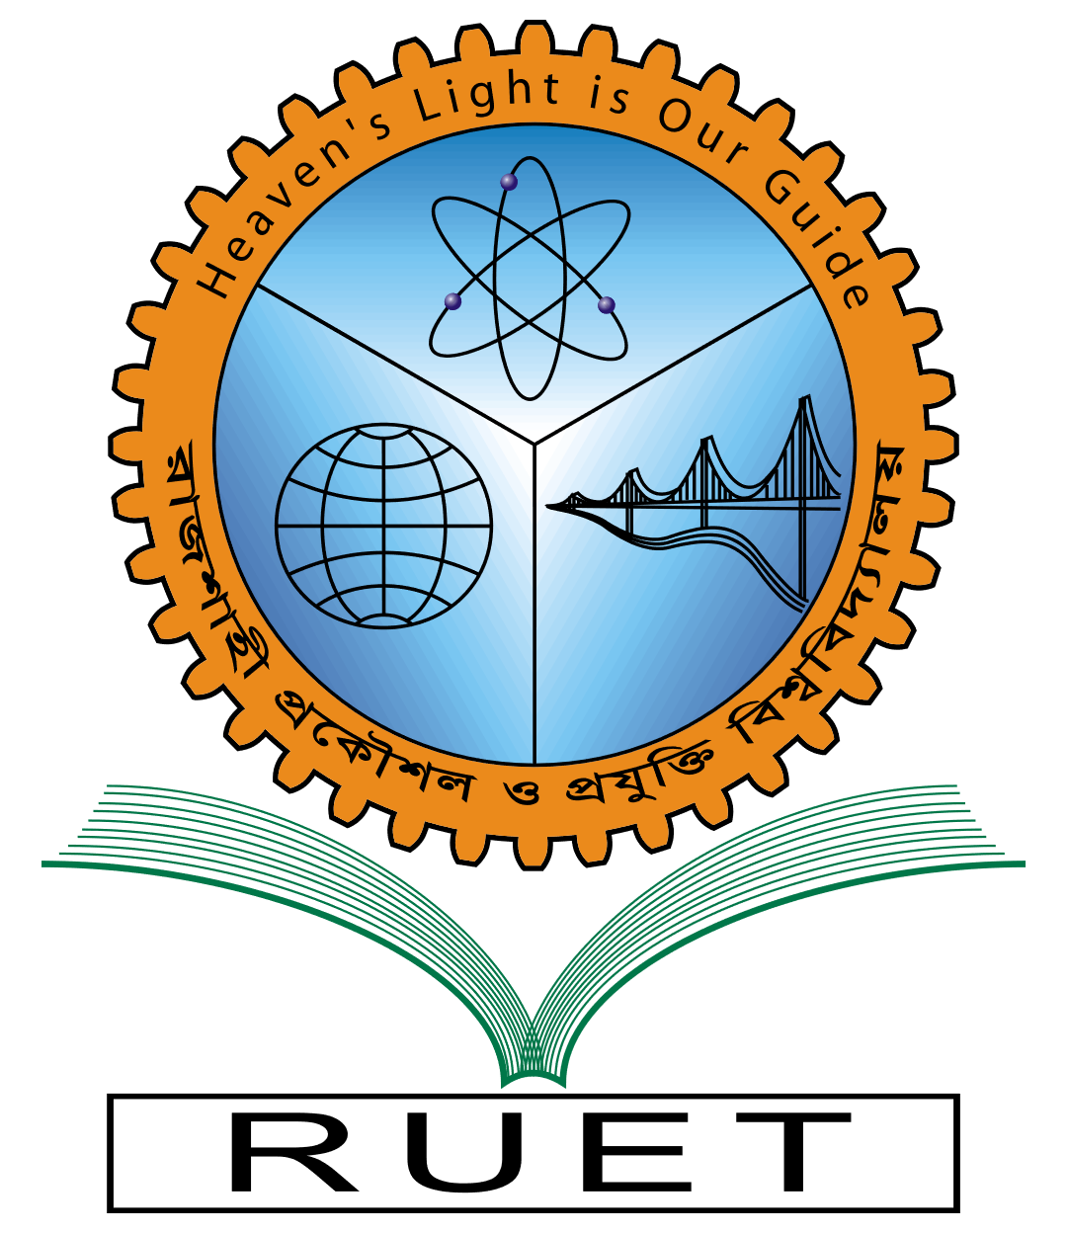

**Rajshahi University of Engineering & Technology**

Department of Computer Science & Engineering

Lab Report

|  |  |
| --- | --- |
| Course Code: | CSE 2202 |
| Course Name: | Algorithm Analysis and Design Sessional |
| Task No: | 4 |
| Task Name: |  |
| Date of Experiment: |  |
| Date of Submission: |  |

|  |  |
| --- | --- |
| Submitted By: | Submitted To: |
| Name: Tonmoy | Prof. Dr. Md. Ali Hossain |
| Section: A | Professor |
| Roll: 2003027 | CSE, RUET |
| Year: 2nd Year, Even Semester |  |