“Heaven’s Light is Our Guide”

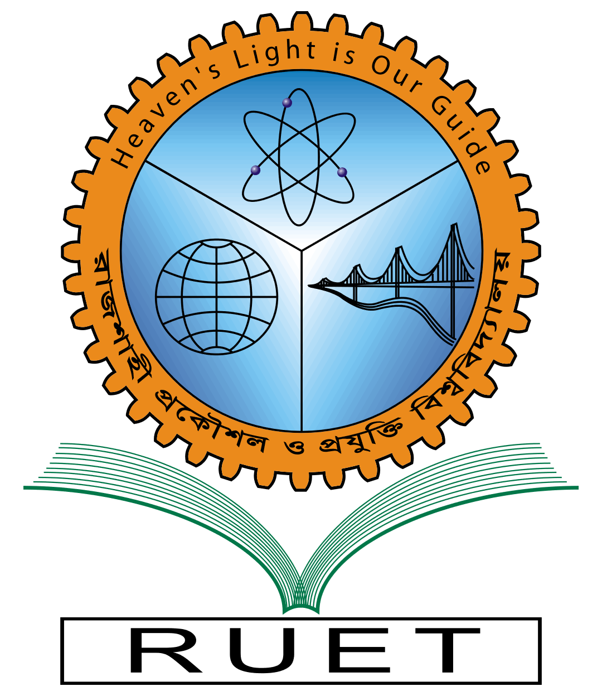

**Rajshahi University of Engineering & Technology**

Department of Computer Science & Engineering

Lab Report

|  |  |
| --- | --- |
| Course Code: | CSE 2204 |
| Course Name: | Numerical Methods Sessional |
| Experiment No: | 02 |
| Experiment Name: | Finding root of x3-2x-5 by Iteration and Newton-Raphson Method. |
| Date of Experiment: |  |
| Date of Submission: | January 7, 2024 |

|  |  |
| --- | --- |
| Submitted By: | Submitted To: |
| Name: Tonmoy | Shyla Afroge |
| Section: A | Assistant Professor |
| Roll: 2003027 | CSE, RUET |
| Year: 2nd year, Even Semester |  |