**Experiment No**: 3

**Name of The Experiment**: Write a 8086 Assembly program to display a ‘?’, read two capital letters, and display them on the next line in alphabetical order.

**Theory:** The assembly program initially prints '?' and then takes two uppercase character inputs. It compares these characters based on their ASCII codes. If the characters are not entered in ascending order, indicating the second character is smaller than the first, the program displays them in lowercase by adding 20H to their ASCII codes and printing the lowercase equivalents. The code assumes valid uppercase inputs and doesn't address error handling for non-alphabetic characters or lowercase inputs.

**Program:**

.MODEL SMALL

.STACK 100H

.CODE

MAIN PROC

                MOV AH,2

                MOV DL,'?'

                INT 21H            ;display ‘?’

                MOV AH,1

                INT 21H            ; read 1st char. & put it in BL

                MOV BL,AL

                INT 21H

                MOV CL,AL          ;read 2nd char. in AL

                CMP BL,CL

                JG  SWITCH         ;if not orderd

                JMP CONTINUE

       SWITCH:

                MOV BH,BL

                MOV BL,CL

                MOV CL,BH

       CONTINUE:

                MOV AH,2

                MOV DL, 0AH        ;enter

                INT 21H

                MOV DL,BL

                ADD DL,20H

                INT 21H

                MOV DL,CL

                ADD DL,20H

                INT 21H

                MOV AH,4CH

                INT 21H

MAIN ENDP

END MAIN

**Input and Output:**

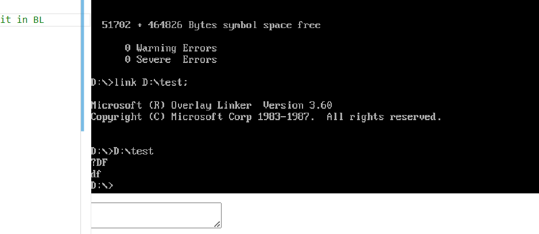

**Comments:**

I first print ‘?’ with AH,2 and then take two Capital character inputs by AH,2 one by one and compare them with CMP if they were input orderly according to ascii codes, if not They are displayed in small hand letters in order with AH,2 and ADD 20H.