**Experiment No:** 1

**Experiment Name:** Execution and Operation of Subtraction by Assembly language for 8086 microprocessors.

**Introduction:** In 8086 assembly language, subtraction is performed using the SUB (subtract) instruction. This instruction allows me to subtract one operand from another, and the result is stored in the destination operand. The basic syntax for the SUB instruction is as follows:

SUB destination, source

For example, to subtract the value in register AX from another value in register BX and store the result in BX, I can use the following assembly code.

SUB BX, AX

**Program:**

.MODEL SMALL

.STACK 100H

.DATA

     CR   EQU 0DH

     LF   EQU 0AH

     MSG1 DB  'enter 1st digit: $'

     MSG2 DB  0AH,0DH,'enter 2nd digit: $'

     MSG3 DB  0DH,0AH,'the substraction of $'

     MSG4 DB  ' and $'

     MSG5 DB  ' is: $'

     ;CHAR    DB  ?,'$'

.CODE

MAIN PROC

          MOV AX,@DATA

          MOV DS,AX

     ; show massage 1

          LEA DX,MSG1

          MOV AH,9

          INT 21H

     ; input 1st digit

          MOV AH,1

          INT 21H

          MOV BL,AL

     ;show massage 2

          LEA DX,MSG2

          MOV AH,9

          INT 21H

     ; input 2nd digit

          MOV AH,1

          INT 21H

          MOV BH,AL

     ;massage 3

          LEA DX, MSG3

          MOV AH,9

          INT 21H

     ;print 1st number

          MOV DL,BL

          MOV AH,2

          INT 21H

     ;MASSAGE 4

          LEA DX, MSG4

          MOV AH,9

          INT 21H

     ;print 2nd number

          MOV DL,BH

          MOV AH,2

          INT 21H

     ;MASSAGE 5

          LEA DX, MSG5

          MOV AH,9

          INT 21H

     ;substraction

          SUB BL,BH

     ;display result

          ADD BL,48

          MOV DL,BL

          MOV AH,2

          INT 21H

          MOV AH,4CH

          INT 21H

MAIN ENDP

    END MAIN

**Output:**

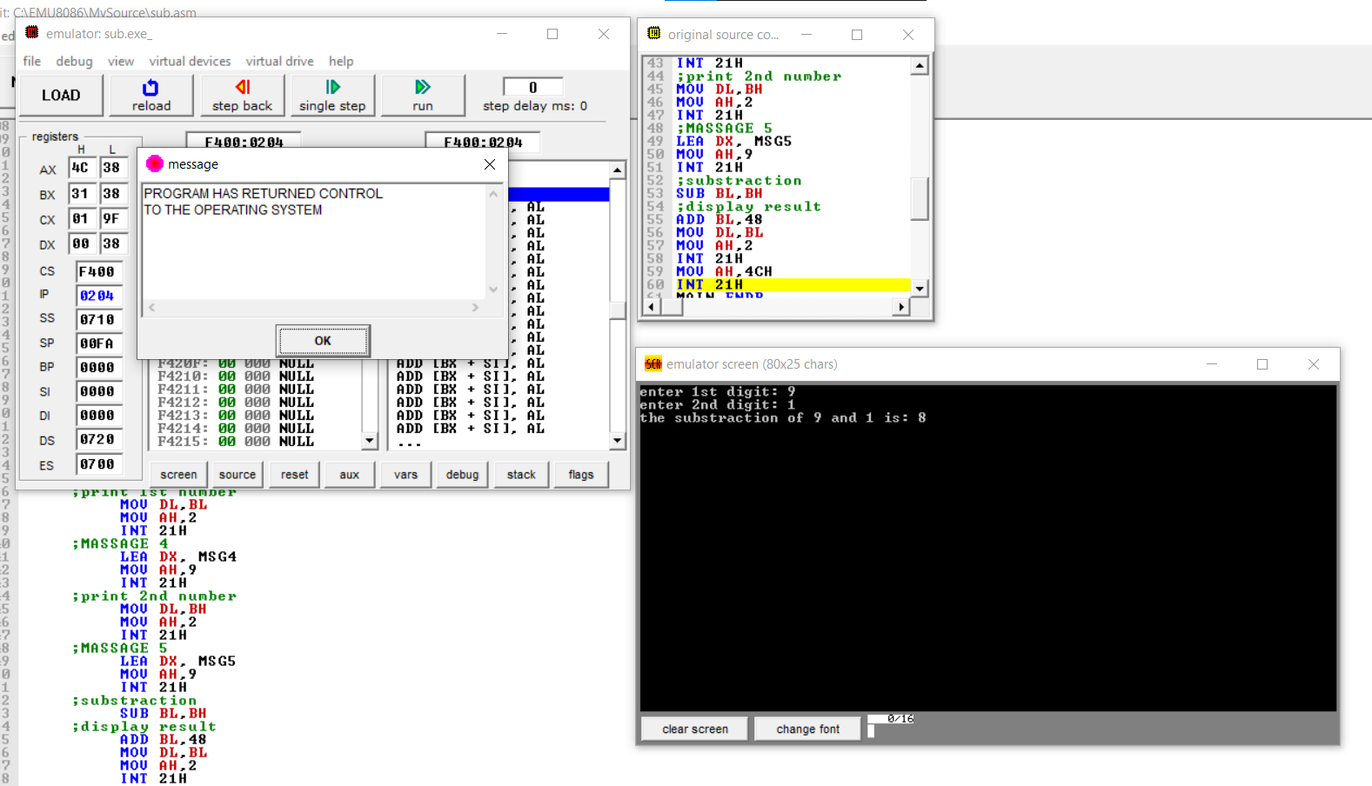

**Comments**: The tricky part about subtraction with Assembly Language is that to display it I must convert it in right ASCII characters.