Module 7 Assignment
AI-Powered Real Estate Listing System
Dubai Property Rental Automation — Apify + MCP Solution Design

1. Solution Overview
This document outlines a fully automated system that replaces manual copy-pasting with a pipeline that: (1) scrapes Dubai rental listings daily from Bayut, Dubizzle, and Property Finder using Apify actors; (2) stores structured data in Google Sheets; and (3) exposes that data to an AI assistant via a custom MCP (Model Context Protocol) server. Team members can then ask plain-language questions and receive instant, data-backed answers.

2. Architecture Diagram
The system has five layers that data flows through in sequence — from listing websites down to the AI assistant:

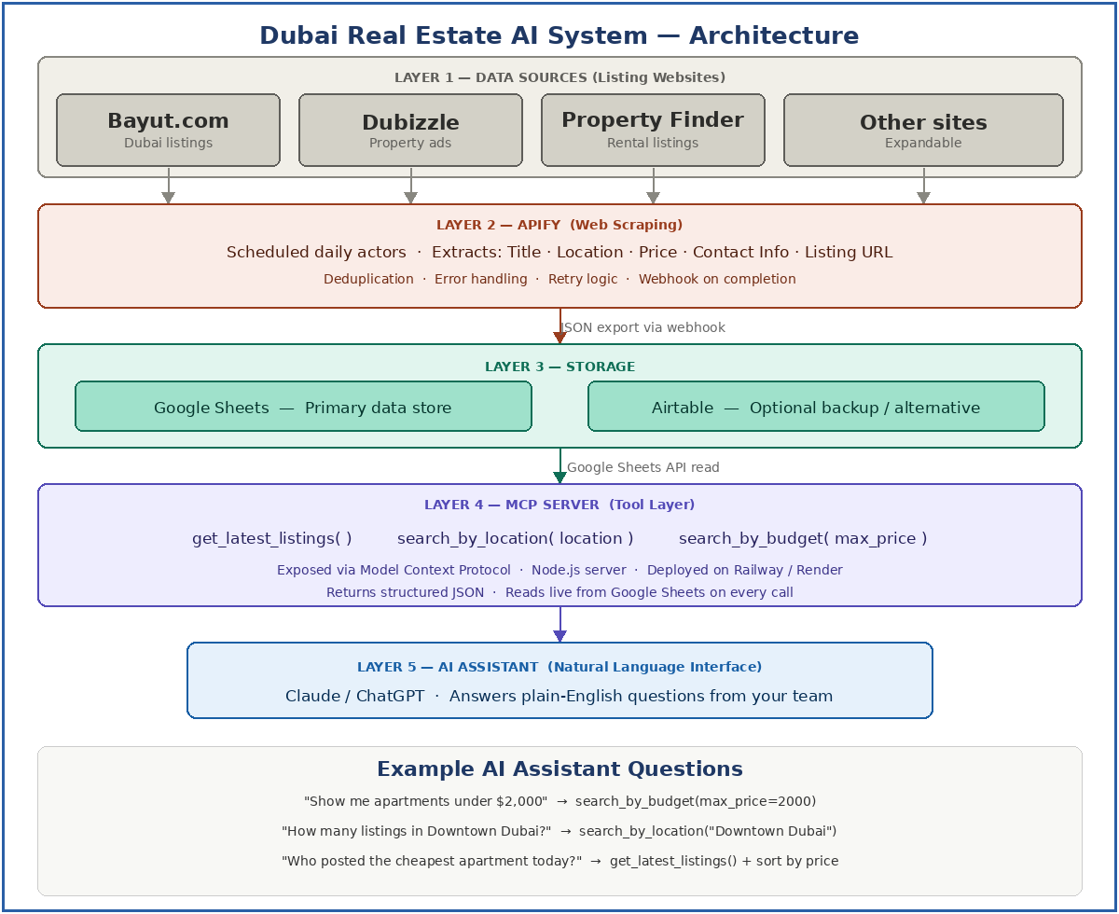

- Layer 1 — Data Sources: Bayut, Dubizzle, Property Finder, and other sites
- Layer 2 — Apify: Scheduled actors extract structured fields daily
- Layer 3 — Storage: Google Sheets (primary) and optionally Airtable
- Layer 4 — MCP Server: Exposes three tools the AI can call
- Layer 5 — AI Assistant: Natural language interface for the team

3. Apify Workflow Design

Step | Action | Details
1 | Configure Actor | Select or build a web scraper actor for Bayut, Dubizzle, Property Finder
2 | Define fields | Property Title, Location, Price (AED), Contact Name, Phone, Listing URL, Date Scraped
3 | Set schedule | Daily cron at 6:00 AM GST so data is fresh each morning
4 | Deduplication | Hash the Listing URL — skip rows already in the sheet
5 | Webhook trigger | On completion, Apify calls a webhook that pushes data to Google Sheets via Apps Script
6 | Error alerts | Email the team if an actor fails or returns 0 results

3.1 Fields Extracted Per Listing
- Property Title
- Location (area/district in Dubai)
- Price (AED per month)
- Contact Name and Phone Number
- Listing URL (used as unique key for deduplication)
- Date Scraped

3.2 Apify Actor Strategy
For each website, use one of these approaches in order of preference:
- Search the Apify Store for an existing actor (e.g. 'Bayut scraper') — reduces build time to near zero
- If none exists, build a custom actor using Apify's Crawlee framework in Node.js
- Use Apify's no-code Web Scraper actor for simpler pagination-based sites

4. MCP Tool Design

Tool name | Parameters | Returns
get_latest_listings() | limit (default 20) | Array of the most recent N listings sorted by date
search_by_location() | location: string | All listings where location contains the query string
search_by_budget() | max_price: number, currency: string | Listings with price <= max_price, sorted cheapest first

4.1 AI Assistant Q&A Examples
- "Show me apartments under $2,000" → calls search_by_budget(max_price=2000)
- "How many listings in Downtown Dubai?" → calls search_by_location('Downtown Dubai') and counts results
- "Who posted the cheapest apartment today?" → calls get_latest_listings(), sorts by price, returns contact

5. Step-by-Step Implementation Plan

Week 1 — Apify Actors
- Create a free Apify account and explore the actor store for Bayut/Dubizzle/Property Finder actors
- Configure each actor with the fields listed in Section 3.1
- Set up a daily schedule (6:00 AM GST) for each actor
- Test with 50 listings per site and verify data quality

Week 2 — Google Sheets Integration
- Create a Google Sheet with columns: Title, Location, Price, Contact, URL, Date Scraped
- Write a Google Apps Script webhook endpoint that Apify calls on completion
- Add deduplication logic: check if Listing URL already exists before inserting
- Test the full scrape-to-sheet pipeline end to end

Week 3 — MCP Server
- Scaffold a Node.js MCP server using the @modelcontextprotocol/sdk package
- Connect to Google Sheets API using a service account
- Implement the three tools: get_latest_listings, search_by_location, search_by_budget
- Deploy the server to Railway or Render (free tier) and test all tools

Week 4 — AI Assistant & Handover
- Connect Claude or ChatGPT to the MCP server using the server URL
- Test all Q&A scenarios with real data
- Document the system for the team and provide training
- Set up email alerts for scraping failures

6. Cost Estimation

Service | Plan | Est. Monthly Cost
Apify | Starter ($49/mo) — 3 actors, scheduled runs | $49
Google Sheets | Free (Google Workspace) | $0
Airtable | Free tier or Plus $10/mo | $0 – $10
MCP Server hosting | Railway / Render free tier | $0 – $7
AI API usage | Claude API (pay-per-use) | ~$5 – $20
TOTAL |  | ~$54 – $86/mo

Note: If the team only needs one or two listing sites and volumes are low, the Apify free tier may be sufficient for initial testing, reducing Month 1 cost to near zero.

7. Estimated Delivery Timeline

Week | Deliverable
Week 1 | Apify actors built and tested; scraping all three listing sites reliably
Week 2 | Google Sheets integration via webhook + Apps Script; deduplication logic
Week 3 | MCP server built and deployed with all three tools tested
Week 4 | AI assistant integrated; QA with real data; team training; handover

8. Client Reply

Subject: AI-Powered Listing Collection System — Our Proposal

Dear Team,
Thank you for reaching out. We have reviewed your requirements and are excited to propose a fully automated solution that will eliminate the manual data collection your team currently performs every day.

Here is what we will build for you:

- Automated daily scraping of Bayut, Dubizzle, and Property Finder using Apify — capturing property title, location, price, contact information, and listing URL every morning before your team starts work
- Automatic storage in Google Sheets — new listings are added daily with built-in deduplication so no listing appears twice
- An AI assistant your team can query in plain English — simply ask questions like "Show me apartments under AED 7,000 in JBR" or "Who posted the cheapest studio today?" and get instant answers

The system will be fully operational within 4 weeks. Total ongoing cost is approximately $54–$86 per month. We will handle all technical setup and provide full team training on handover.

Please let us know if you have any questions or would like to schedule a call to walk through the proposal. We are ready to begin immediately upon your approval.

Best regards,
The Development Team

