Q1:-

Q2:-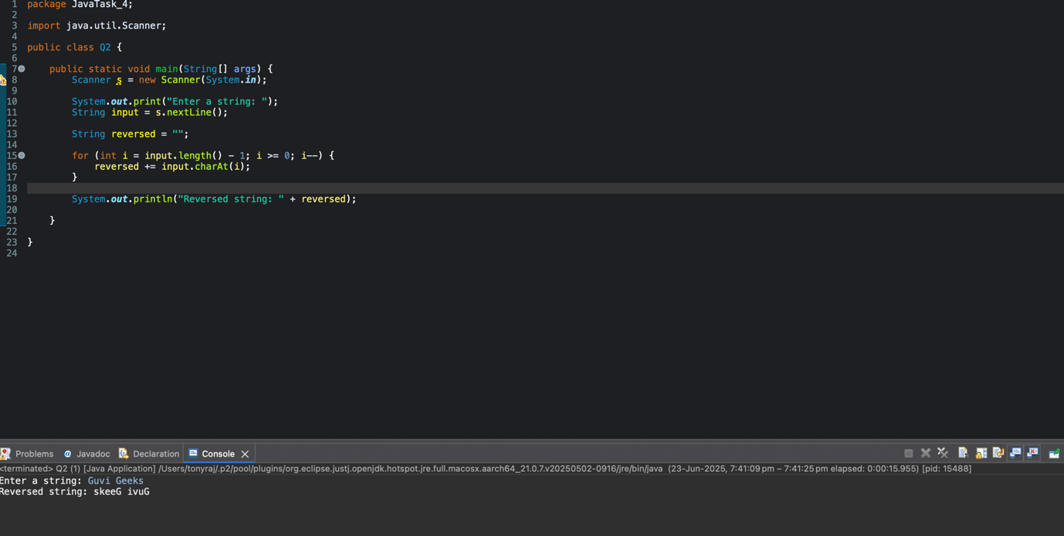

Q7:-