Homework: SQL statement Name: Pacharapol Dawmukda ID:59070503490

2. Specific Columns, All Rows

-SELECT staffNo, fName, lName, salary FROM Staff;

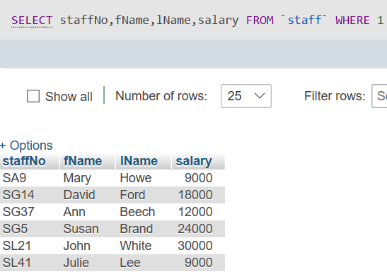Oracle MySQL

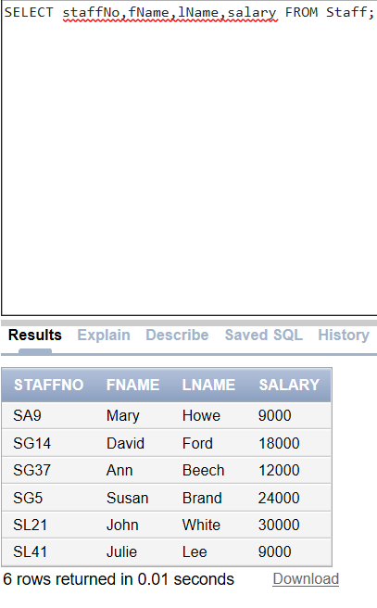   
4. To name column, use AS clause:

-SELECT staffNo, fName, lName, salary/12 AS monthlySalary FROM Staff;

Oracle MySQL

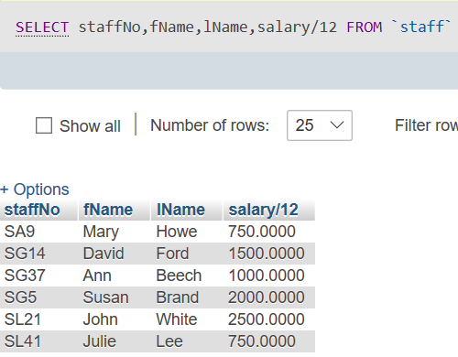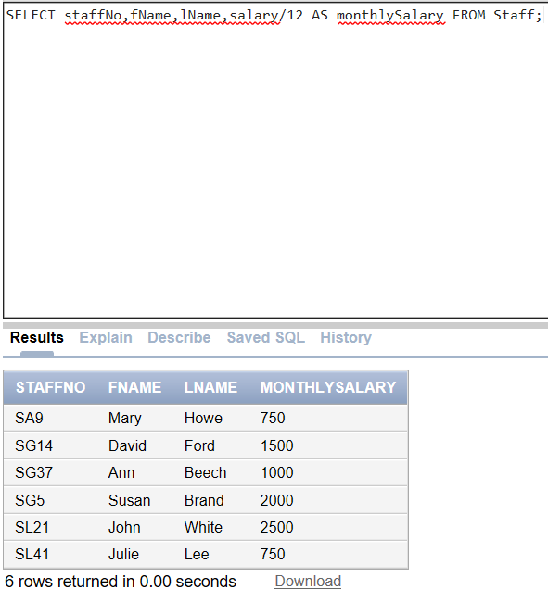

6. Compound Comparison Search Condition

-SELECT \* FROM Branch WHERE city = ‘London’ OR city = ‘Glasgow’;

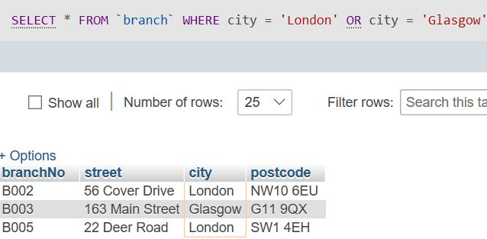 Oracle MySQL

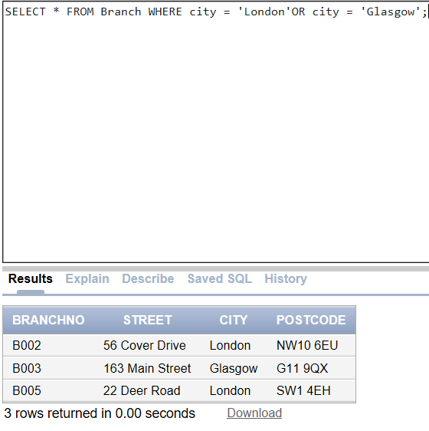

8. Set membership

-SELECT staffNo, fName, lName, position FROM Staff WHERE position=‘Manager’ OR position=‘Supervisor’;

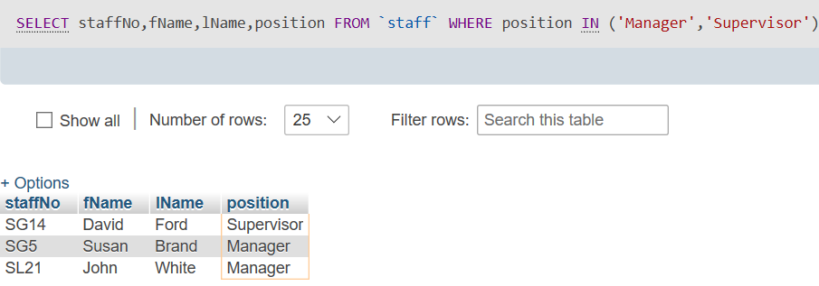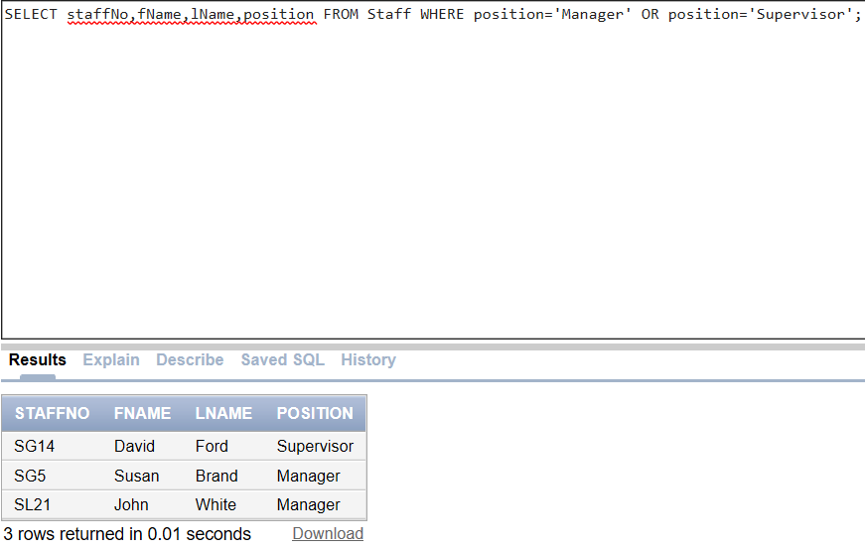 Oracle MySQL

10. NULL Search Condition

-This is true syntax. SELECT clientNo, viewDate FROM Viewing,client WHERE propertyNo = ‘PG4’ AND comments IS NULL;

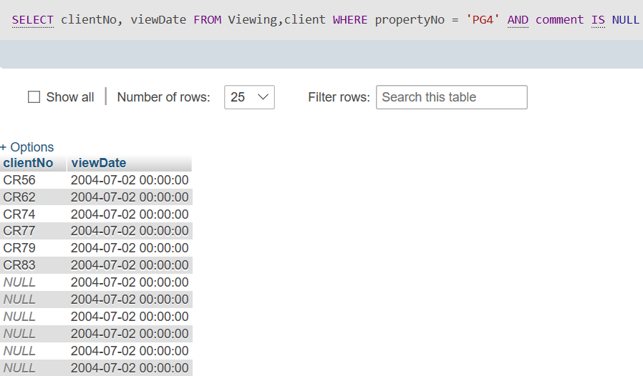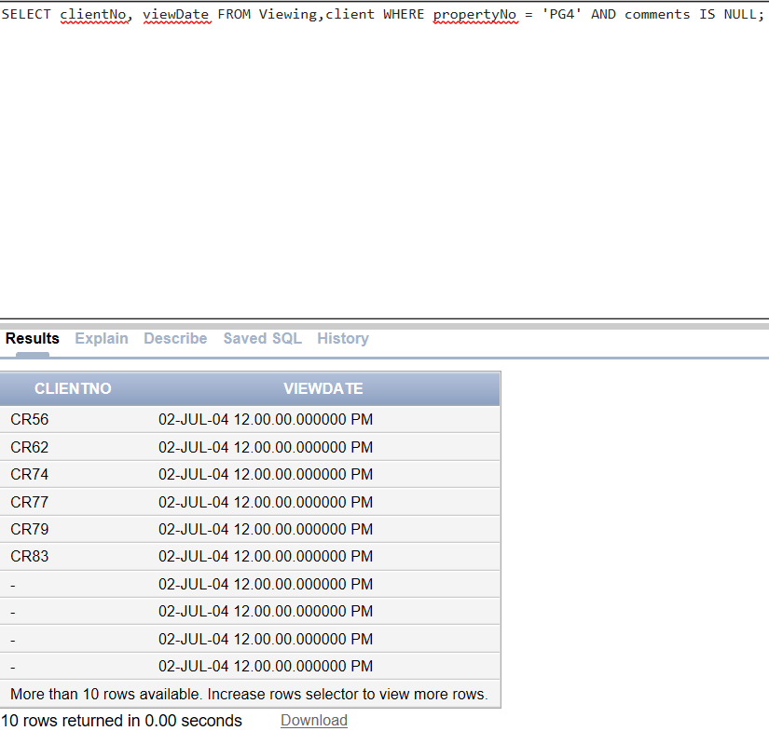 Oracle MySQL

12. Multiple Column Ordering

-SELECT propertyNo, type, rooms, rent FROM PropertyForRent ORDER BY type;

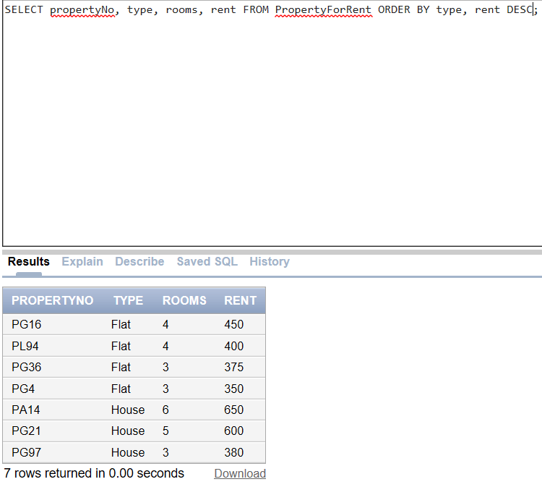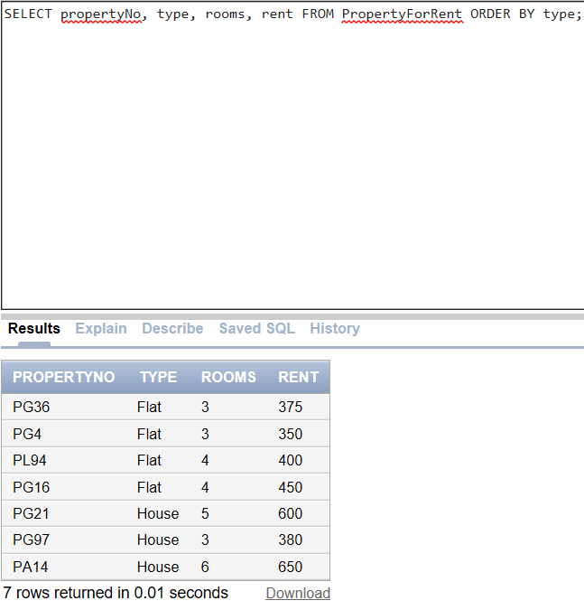 Oracle

12A. 12B.

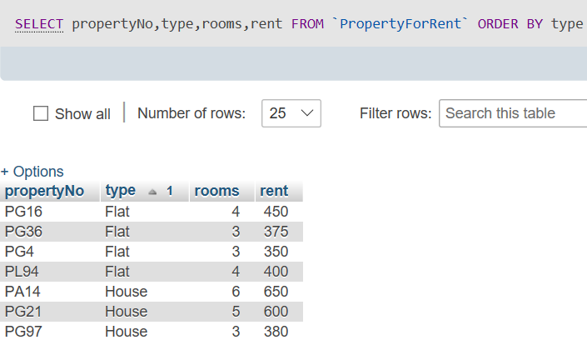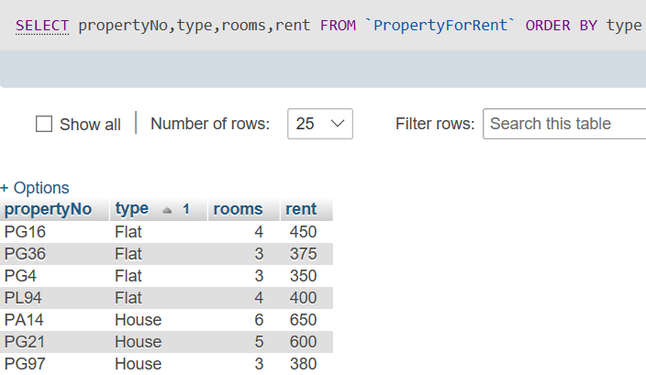MySQL

12A. 12B.

14. Use of COUNT(DISTINCT)

-SELECT COUNT(DISTINCT propertyNo) AS myCount FROM Viewing WHERE viewDate BETWEEN ‘1-May-04’ AND ‘31-May-04’;

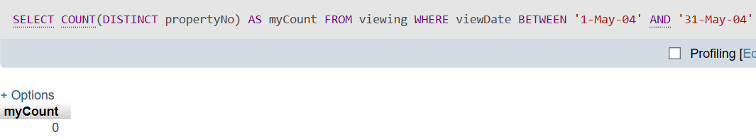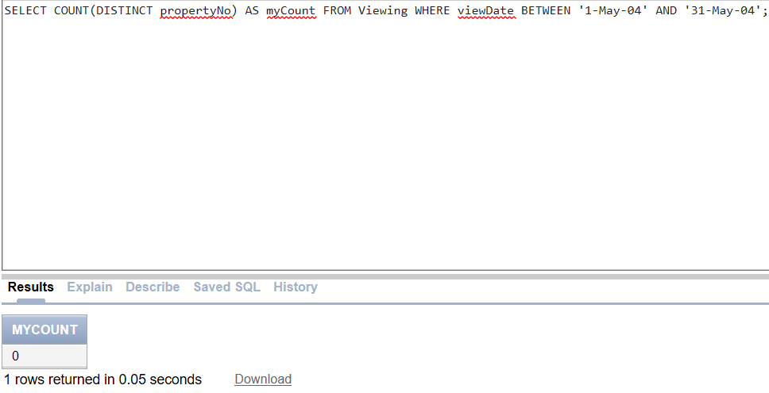 Oracle MySQL

16. Use of MIN, MAX, AVG

-SELECT MIN(salary) AS myMin, MAX(salary) AS myMax, AVG(salary) AS myAvg FROM Staff;

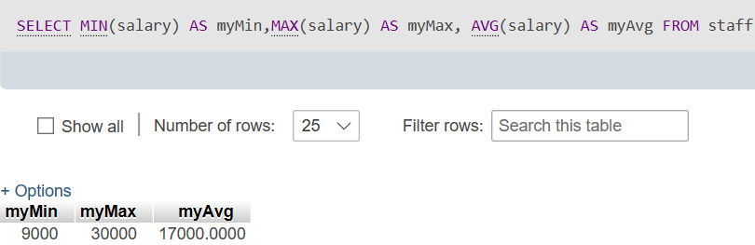 Oracle MySQL

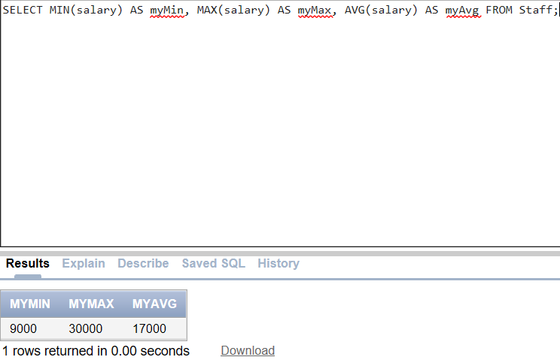

18. Use of HAVING

-SELECT branchNo, COUNT(staffNo) AS myCount, SUM(salary) AS mySum FROM Staff GROUP BY branchNo HAVING COUNT(staffNo) > 1 ORDER BY branchNo;

Oracle

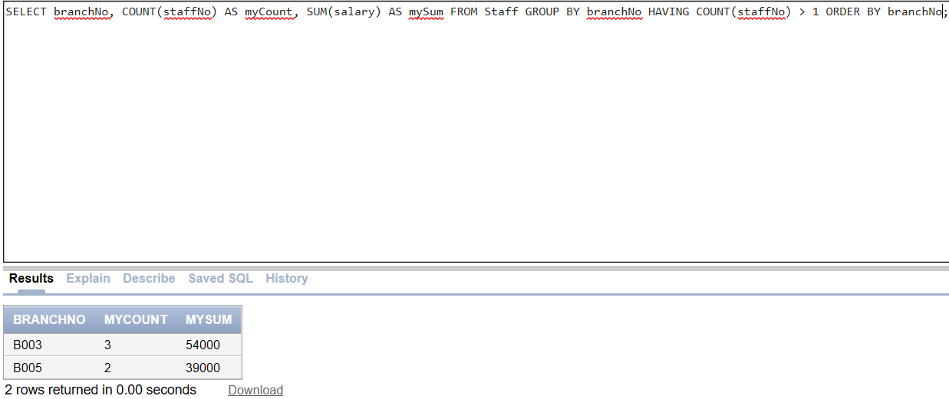

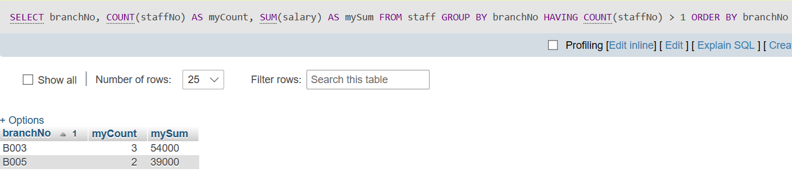MySQL

20. Subquery with Aggregate

-SELECT staffNo, fName, lName, position, salary – (SELECT AVG(salary) FROM Staff) As SalDiff FROM Staff WHERE salary >

(SELECT AVG(salary) FROM Staff);. Syntax Error in salary must have minus17000.

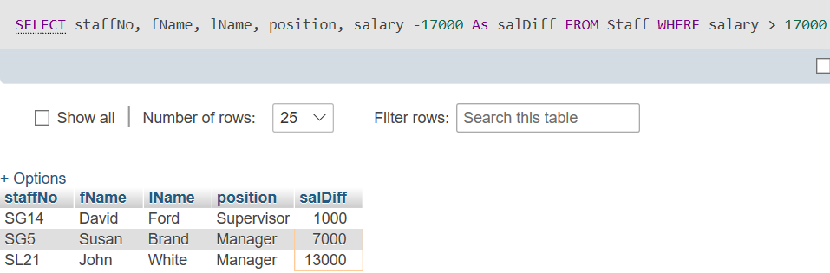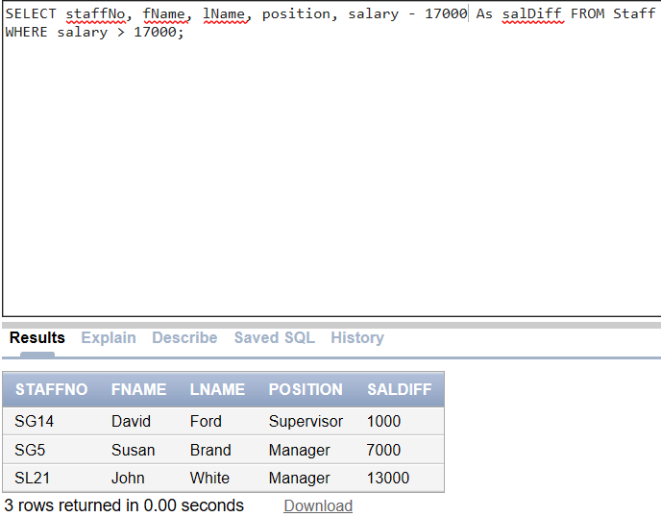 Oracle MySQL

22. Use of ANY/SOME

-SELECT staffNo, fName, lName, position, salary FROM Staff WHERE salary > SOME (SELECT salary FROM Staff WHERE branchNo = ‘B003’);. In this case change to single quote.

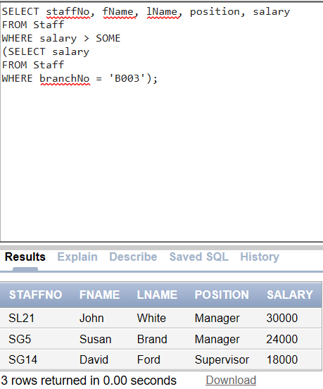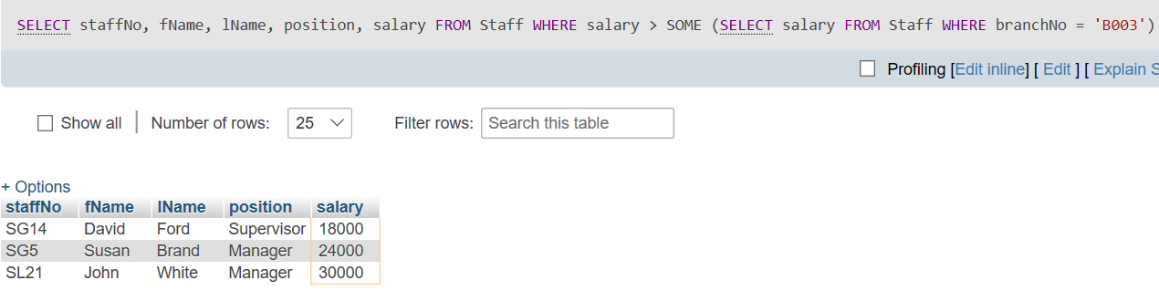 Oracle MySQL

24. Simple Join

-SELECT c.clientNo, fName, lName,propertyNo, comment

FROM Client c, Viewing v WHERE c.clientNo = v.clientNo;. In Oracle comment must have “s” and change clientNo to ID.

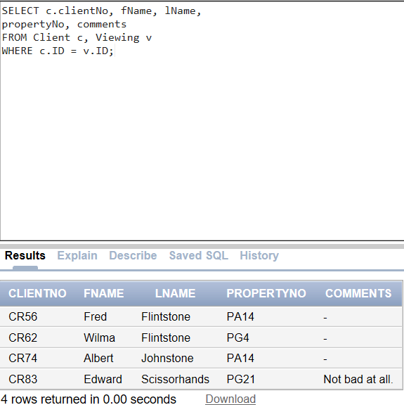 Oracle MySQL

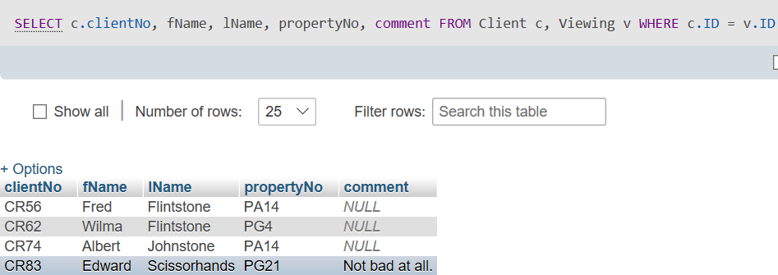

26. Three Table Join

-SELECT b.branchNo, b.city, s.staffNo, fName, lName, propertyNo FROM Branch b, Staff s, PropertyForRent p WHERE b.branchNo = s.branchNo AND s.staffNo = p.staffNo ORDER BY b.branchNo, s.staffNo, propertyNo;

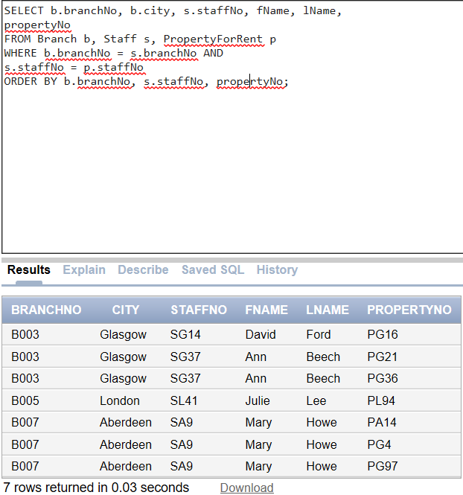 MySQL

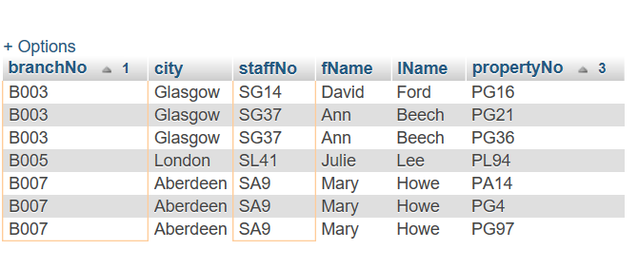 MySQL

28. Left Outer Join

-SELECT b.\*, p.\* FROM Branch1 b LEFT JOIN PropertyForRent1 p ON b.bCity = p.pCity;

Oracle MySQL

30. Full Outer Join

-SELECT b.\*, p.\* FROM Branch1 b FULL JOIN PropertyForRent1 p ON b.bCity = p.pCity;

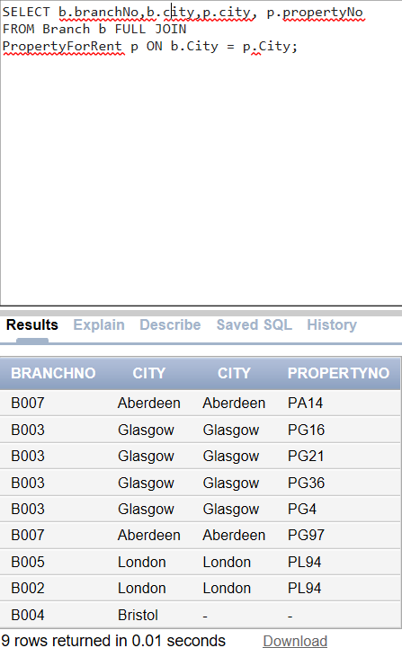 Oracle MySQL

32. Use of UNION

- (SELECT city FROM Branch WHERE city IS NOT NULL) UNION (SELECT city FROM PropertyForRent WHERE city IS NOT NULL); or

- (SELECT \* FROM Branch WHERE city IS NOT NULL) UNION CORRESPONDING BY city (SELECT \* FROM PropertyForRent WHERE city IS NOT NULL);

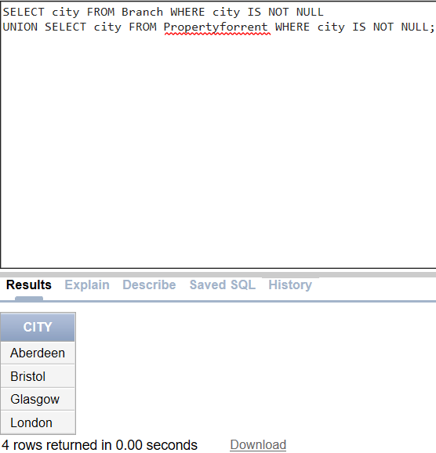Oracle

MySQL

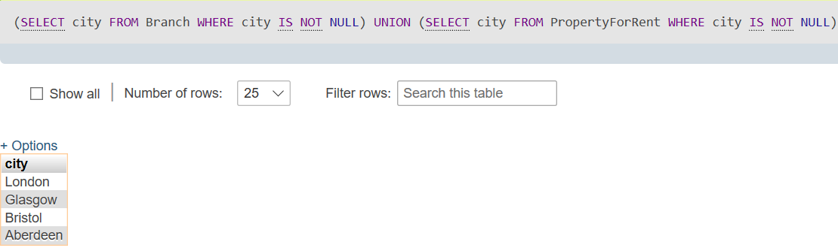

34. Use of EXCEPT - (SELECT city FROM Branch) EXCEPT (SELECT city FROM PropertyForRent); • Or

- (SELECT \* FROM Branch) EXCEPT CORRESPONDING BY city (SELECT \* FROM PropertyForRent);

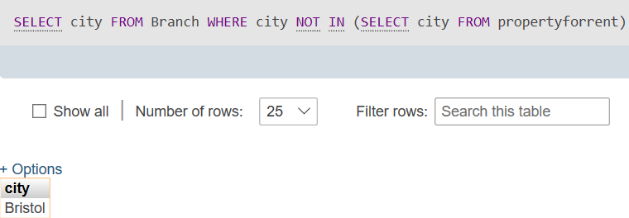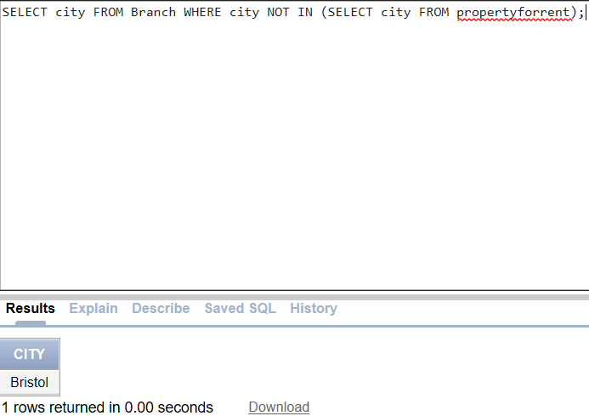 Oracle MySQL

36. INSERT using Defaults

-INSERT INTO Staff (staffNo, fName, lName, position, salary, branchNo) VALUES (‘SG44’, ‘Anne’, ‘Jones’, ‘Assistant’, 8100, ‘B003’); • Or

-INSERT INTO Staff VALUES (‘SG44’, ‘Anne’, ‘Jones’, ‘Assistant’, NULL, NULL, 8100, ‘B003’);

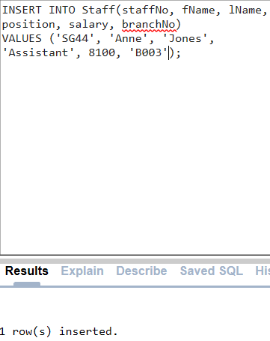 Oracle MySQL

   
38. UPDATE All Rows

Give all staff a 3% pay increase.

-UPDATE Staff SET salary = salary\*1.03;

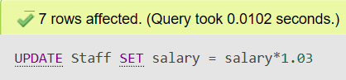 Oracle MySQL

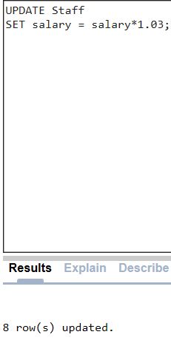

40. UPDATE Multiple Columns

- UPDATE Staff SET position = ‘Manager’, salary = 18000 WHERE staffNo = ‘SG14’;

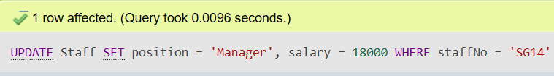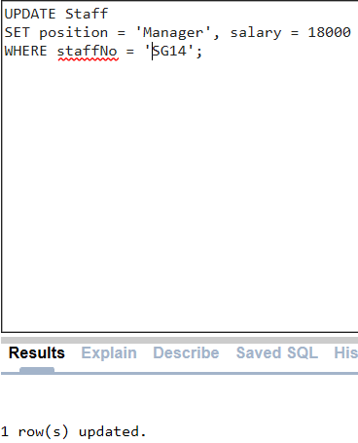 Oracle MySQL

42. DELETE Specific Rows

Delete all records from the Viewing table.

-DELETE FROM Viewing;

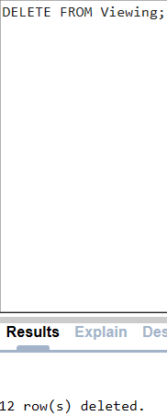 Oracle MySQL

