BUILD: means compile,test and package the application into jar or war file

Perform continuos download and build

Download: downloading the code from github to devserver
Build: convert the source code into artificat(war)

connect to aws machine with gitbash terminal
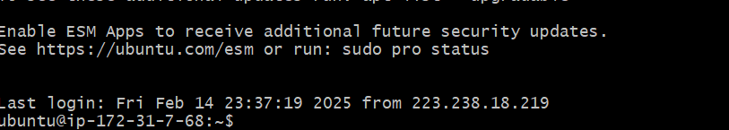

Check java is there are not if java is not exist then install java

Sudo apt-get update
Sudo apt-get install -y openjdk-21-jdk

Check jenkins is installed or not. If not install install jenkins(experiment3)

If you have java and jenkins then u are good to start

Install maven in the aws machine with gitbash

Go to the root directory in gitbash
Sudo su -

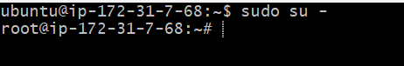

#Pwd
#cd /opt
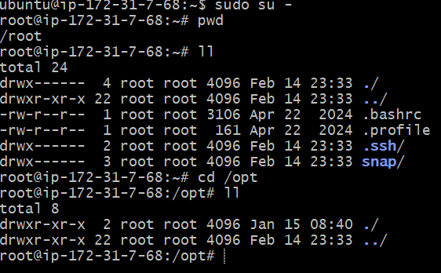

Here download maven. Go to the browser download maven

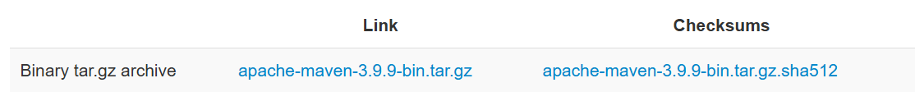

Right click on the .gz file and copy the path and paste in the gitbash beside the wget command

#wget https://dlcdn.apache.org/maven/maven-3/3.9.9/binaries/apache-maven-3.9.9-bin.tar.gz

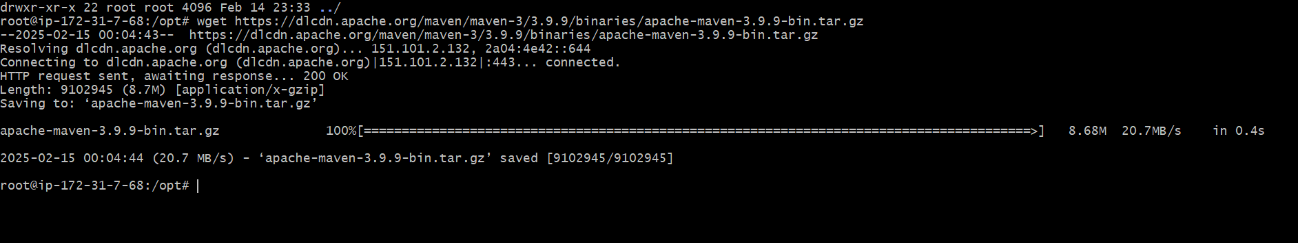

#ll

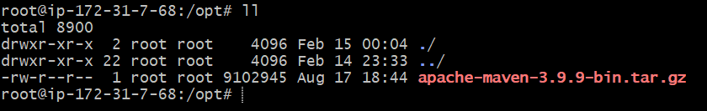

Now u can unzip the .gz file

#tar -xvzf apache-maven-3.9.9-bin.tar.gz

#ll
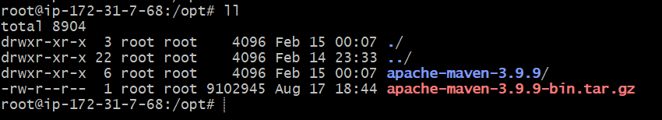

rename the apache-maven-3.9.9 to maven for better usage

#mv apache-maven-3.9.9 maven
#ll

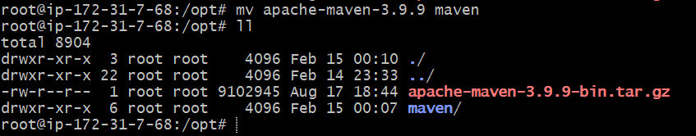

#cd maven
#pwd
#ll

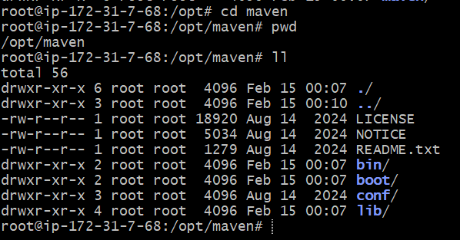

#cd bin
#pwd
#ll
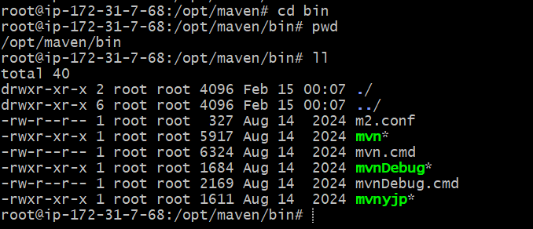

Now check the maven

Mvn --version

It gives maven not found

./mvn --version

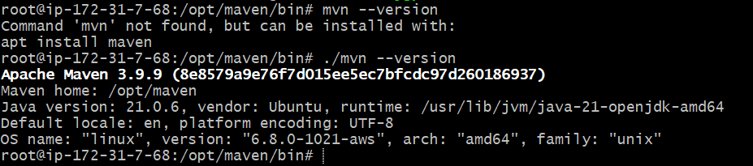

Cd ..

Mvn --version
Again it shows maven not found. So we need to set up environment variable

So go to the root directory

Cd ~

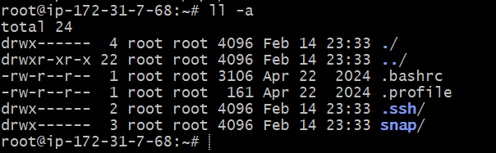

U can see th .profile file u need to edit it

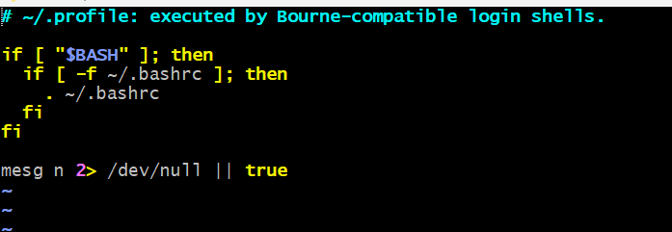

Here u need to add java_home,m2_home and m2 variable. For that u need to open one more terminal and run below command

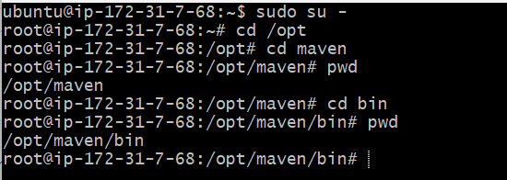

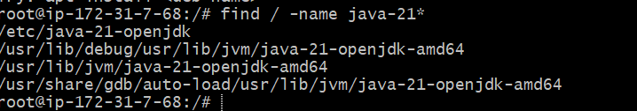

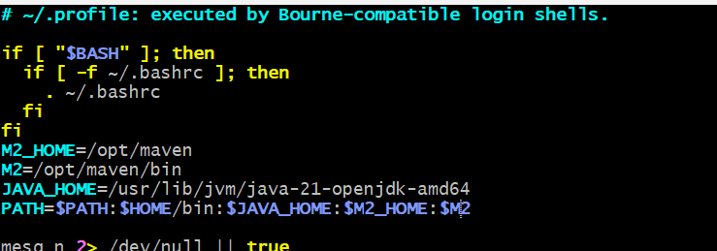

#echo $PATH
It is not showing the java and maven path here
So we need to restart the terminal or run below command

Now we check the maven version
mvn --version

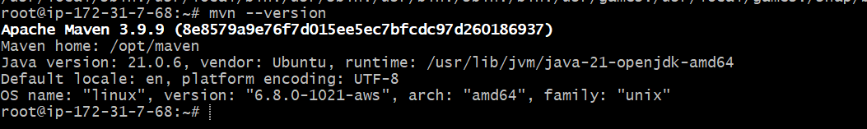

Now start the jenkins in new terminal

Now we need to add the new plugin in jenkins(maven integration)
Without this we can’t see the maven project

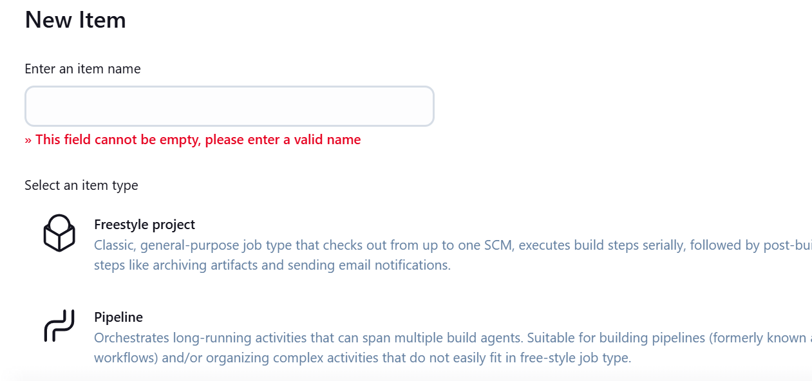

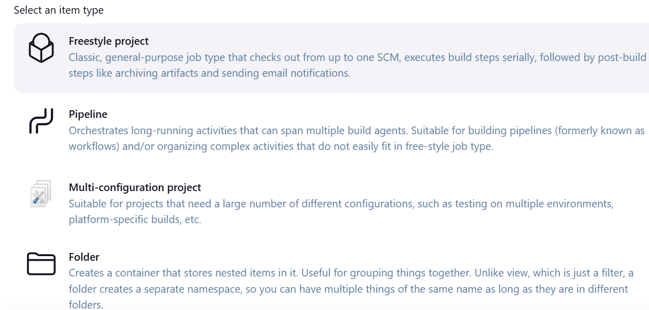

Managejenkins-->plugins--->available pluging-->select maven integration and install it

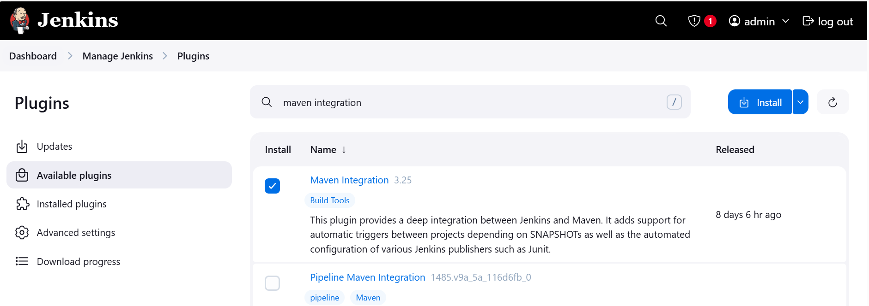

Restart the jenkins or skip it it you click on restart it takes some time

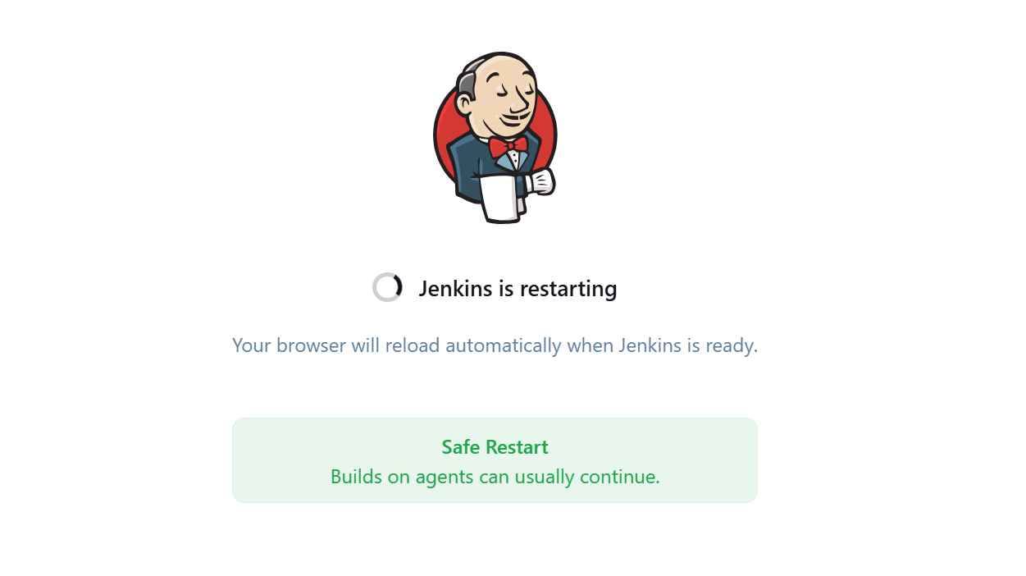
Now u can see the maven project

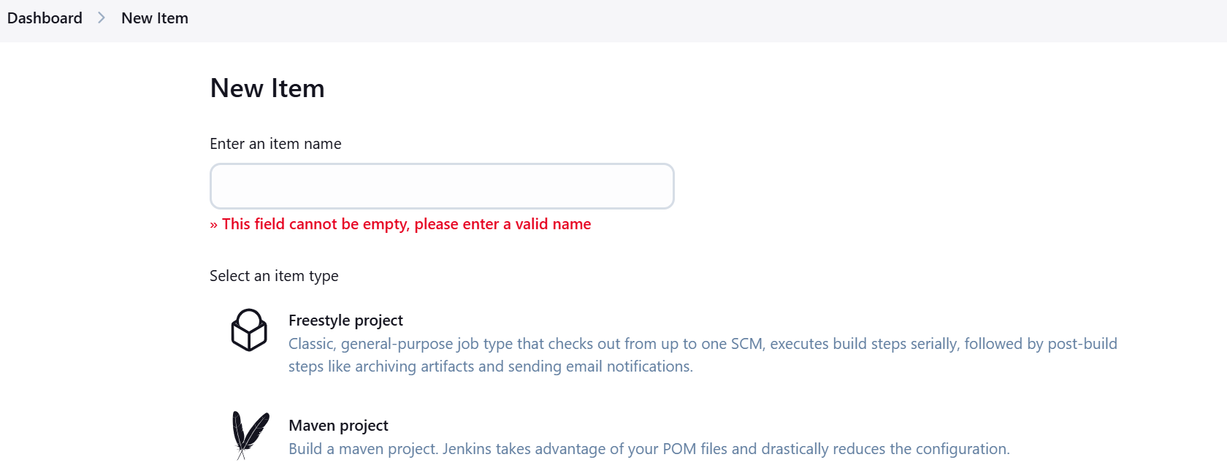

And u need to add the java and maven environment variables in the jenkins

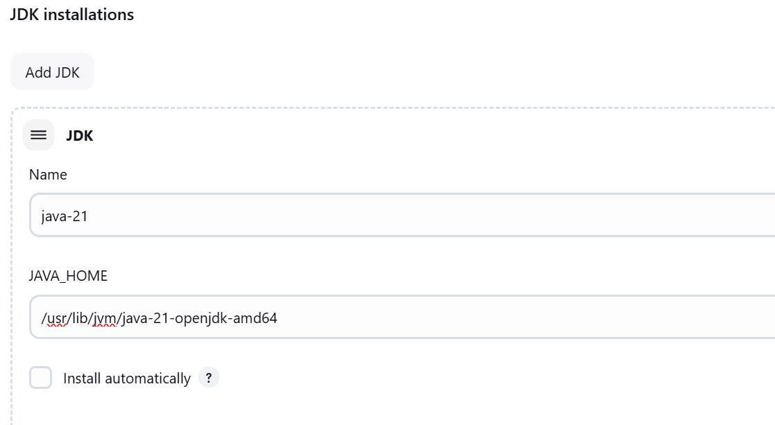

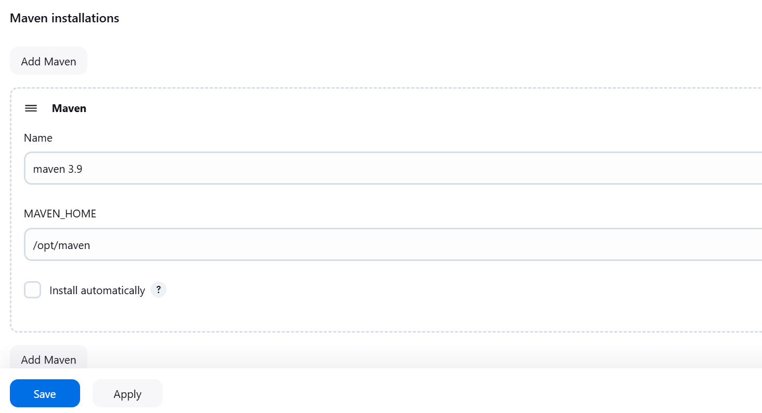

Click on apply and save

Now create maven project

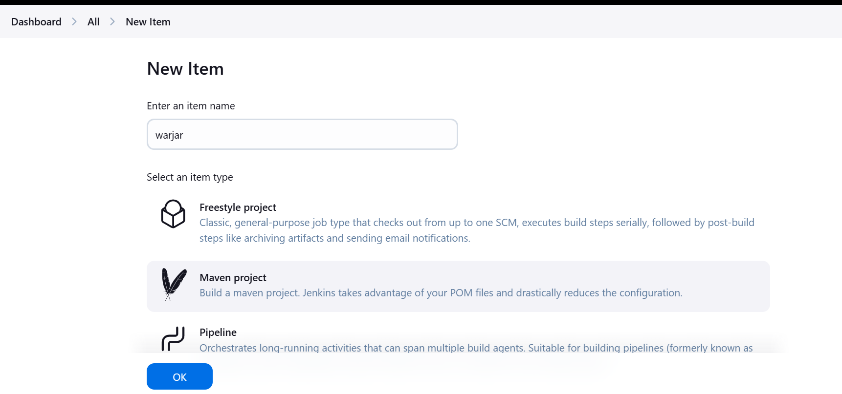

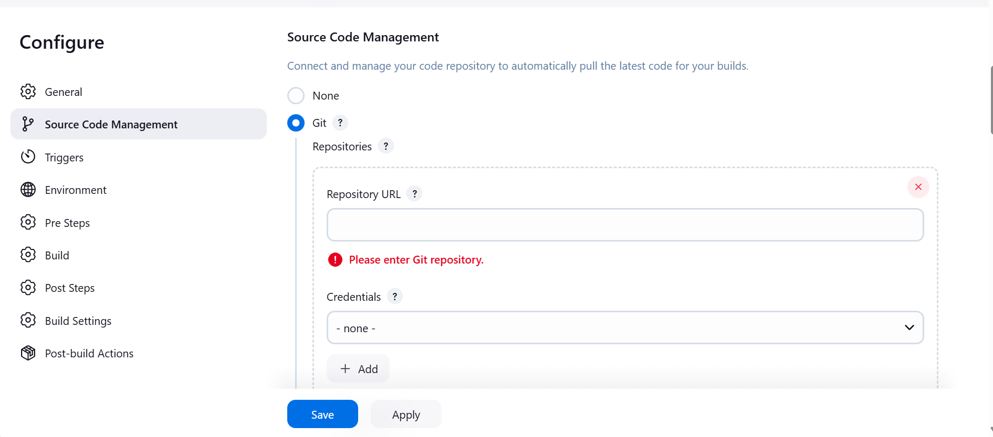

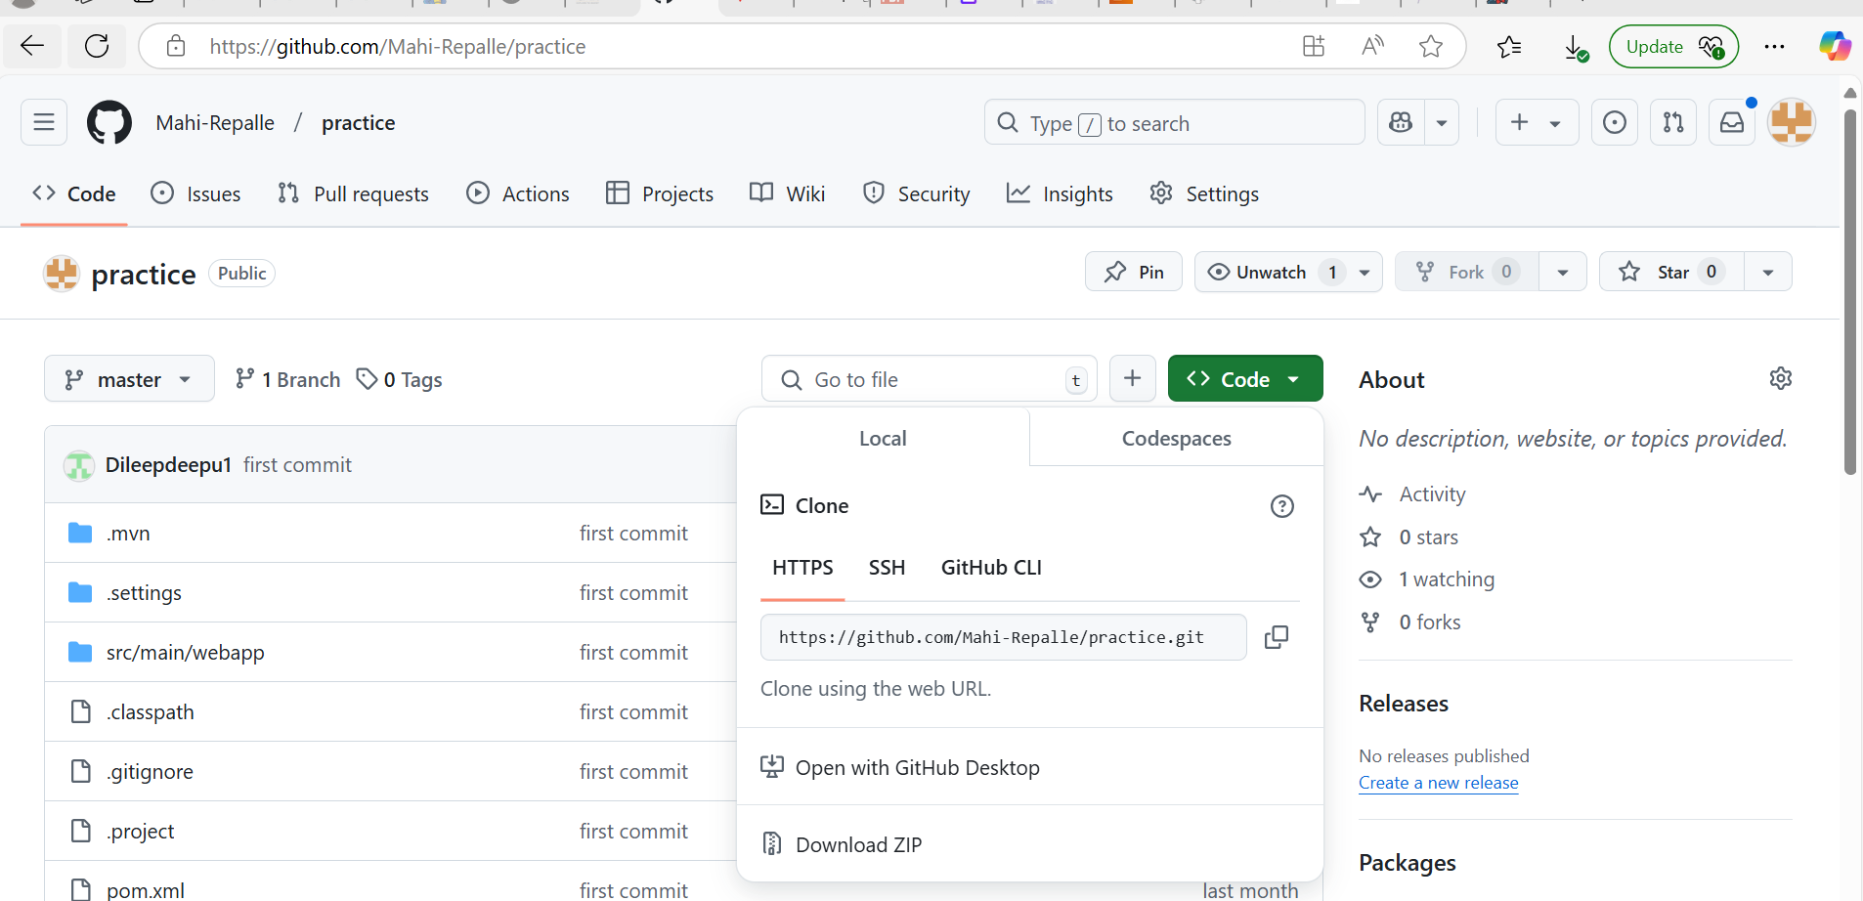

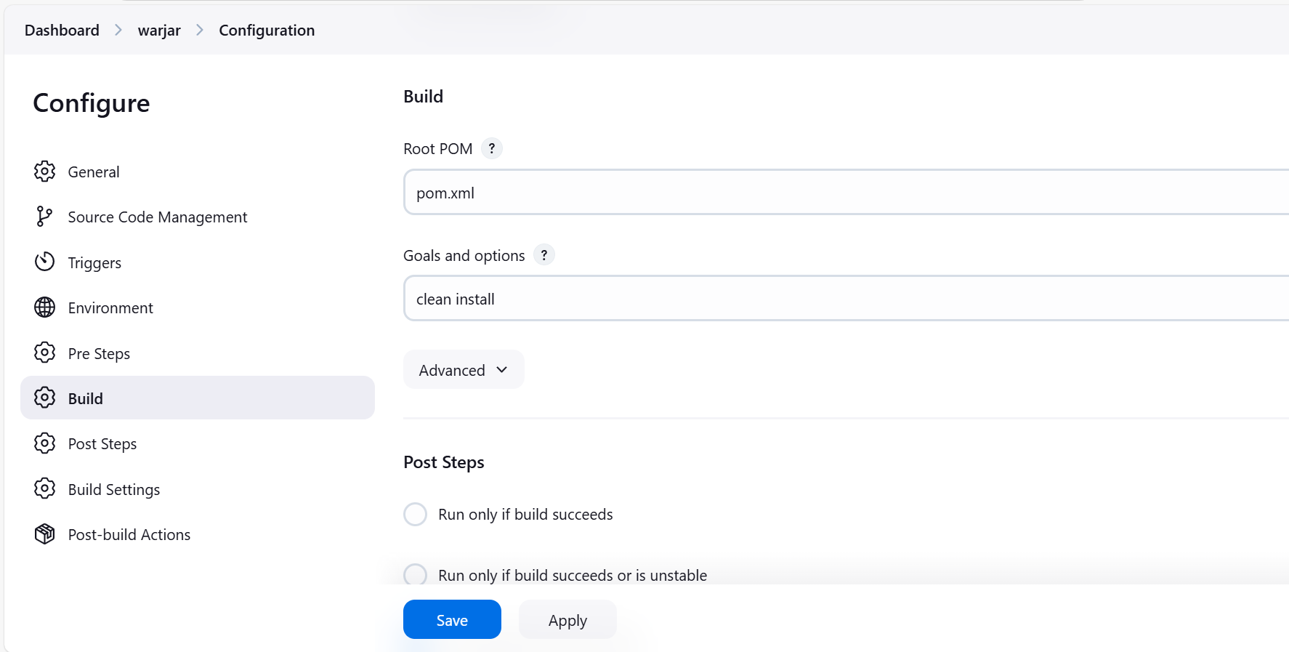

Click on build now

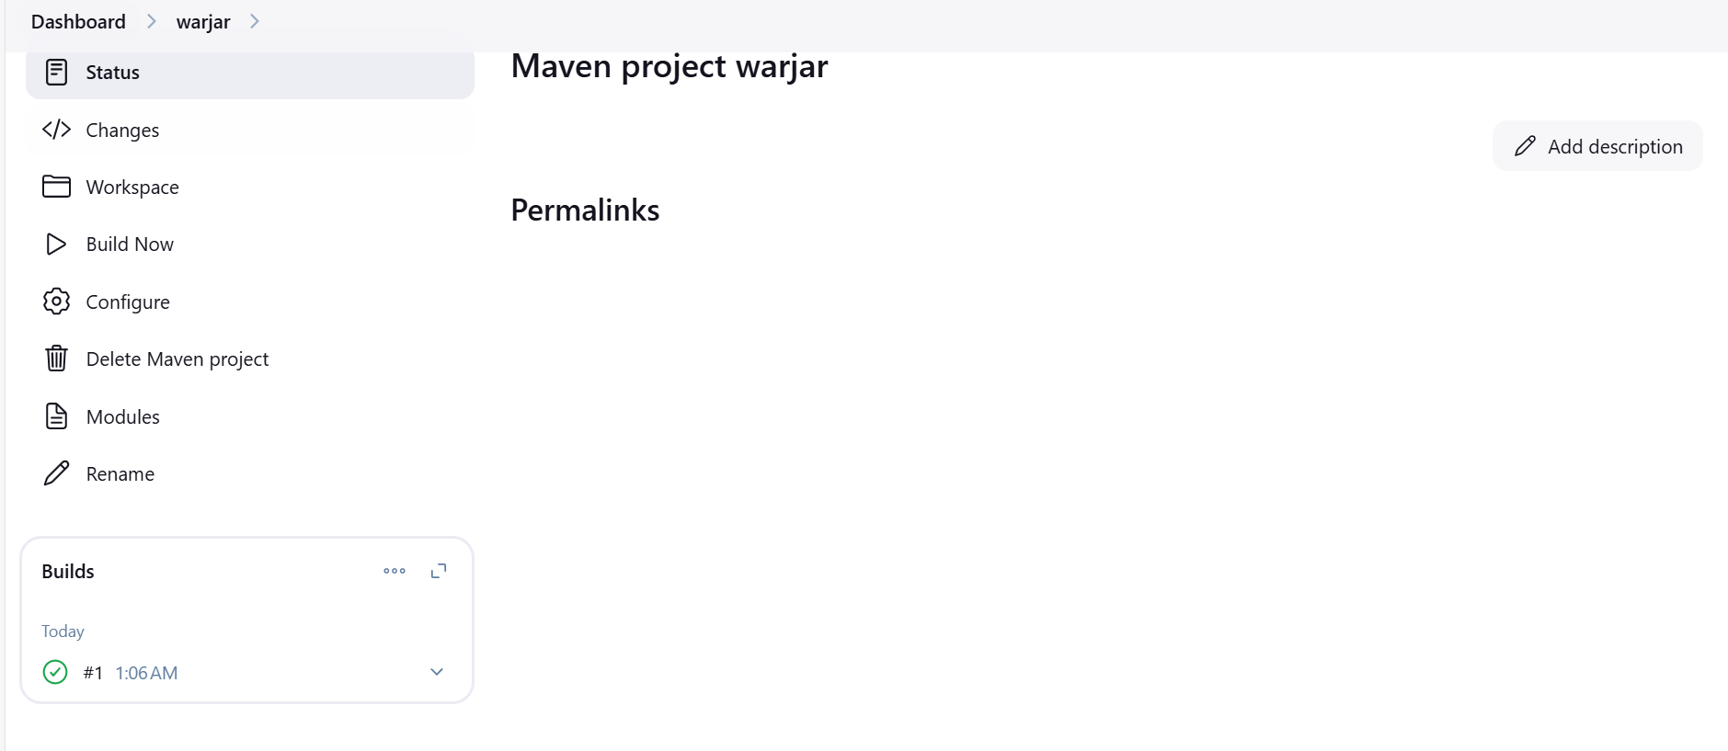

Select Succeeded job drop down -->console output

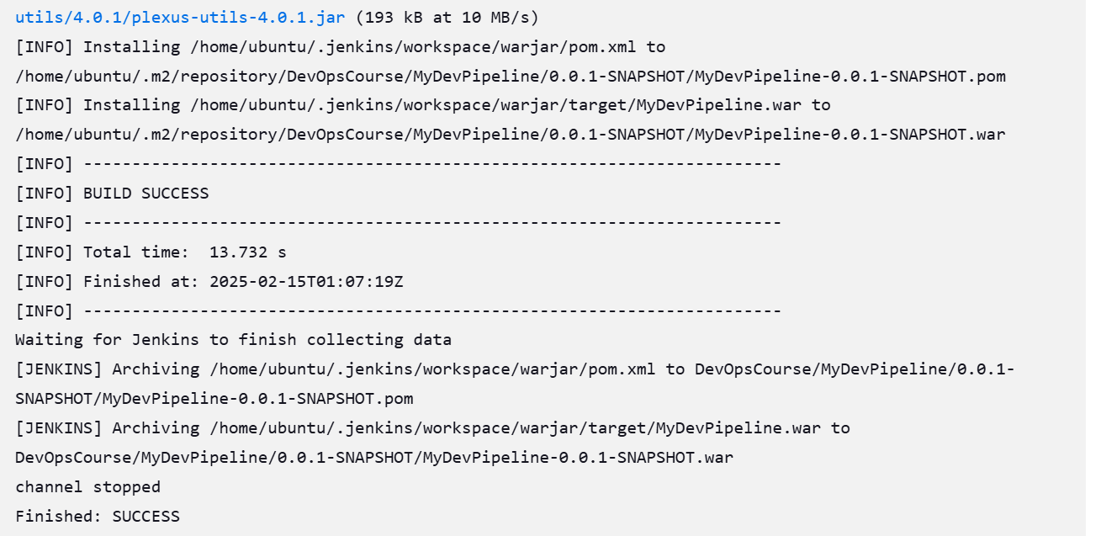

Now go and check in the terminal war file is generated or not

