Федеральное государственное бюджетное образовательное учреждение высшего образования «Сибирский государственный университет телекоммуникаций и информатики»
(СибГУТИ)

Кафедра ПМиК

ОТЧЕТ
по курсовой работе по предмету
Программирование мобильных устройств
Тема «Разработка игры на UNITY»

Выполнил:
студент. гр. ИП-213
Дмитриев А. А.

Проверил:
ст. преподаватель, Осипова У.В.

оценка___________________

подпись__________________

Новосибирск 2025 г.

- Скриншоты игры

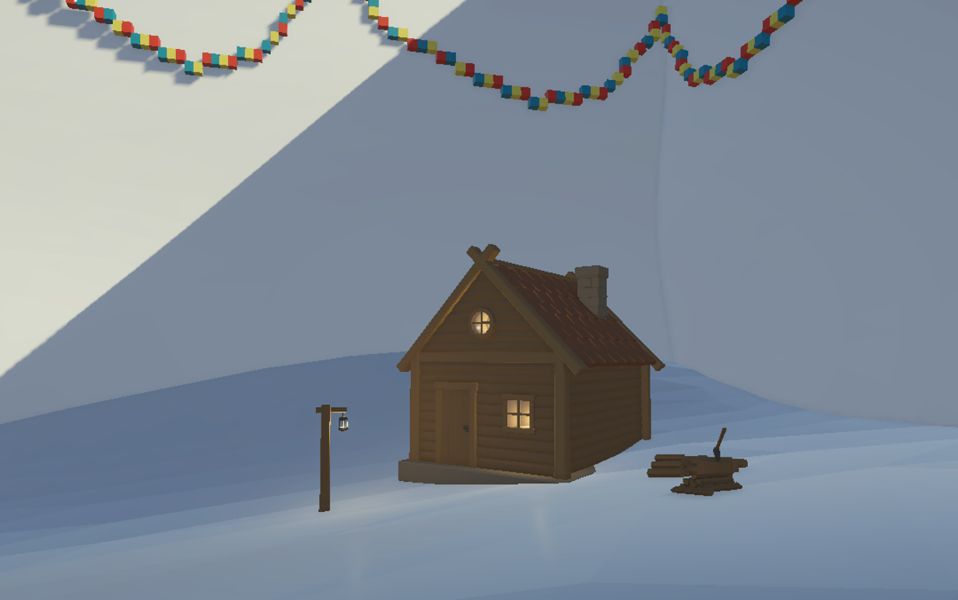

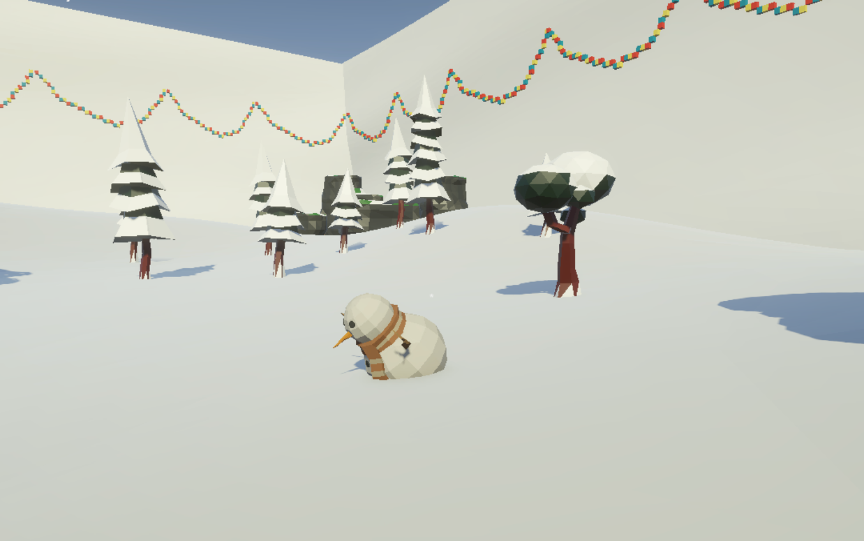

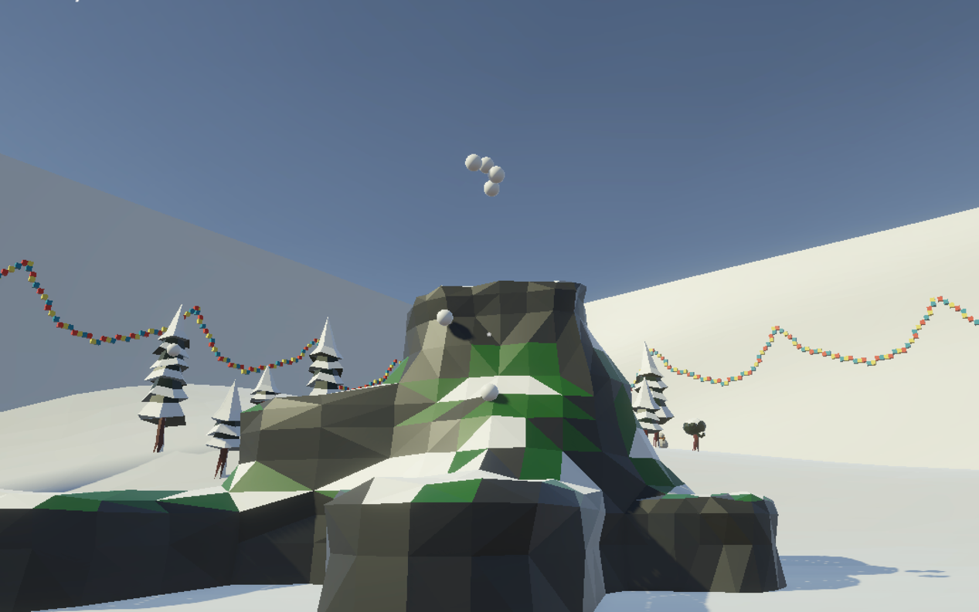

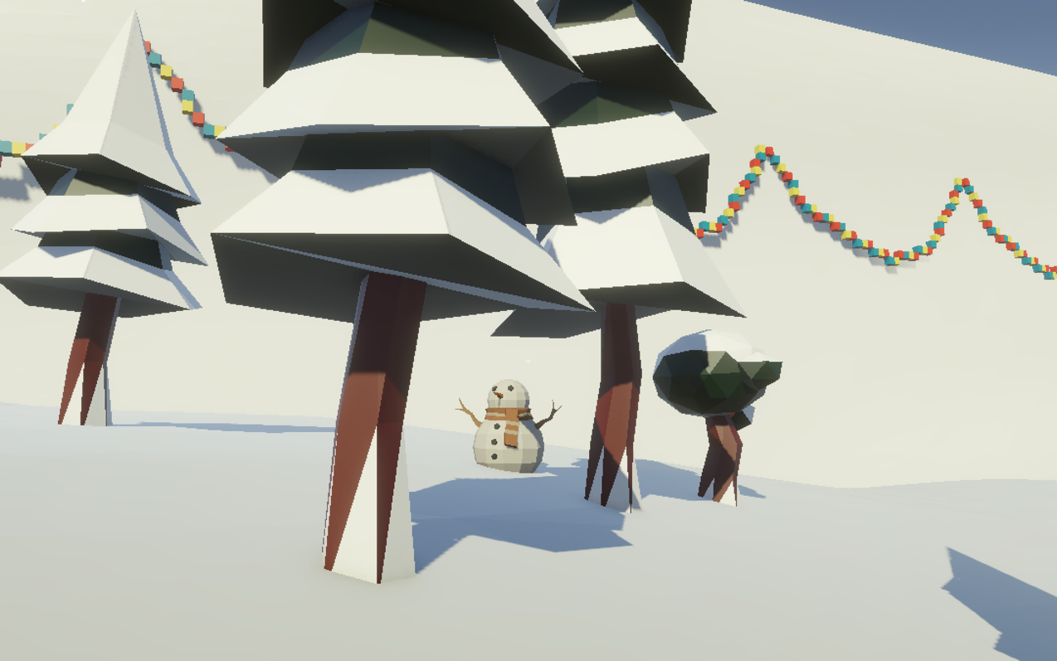
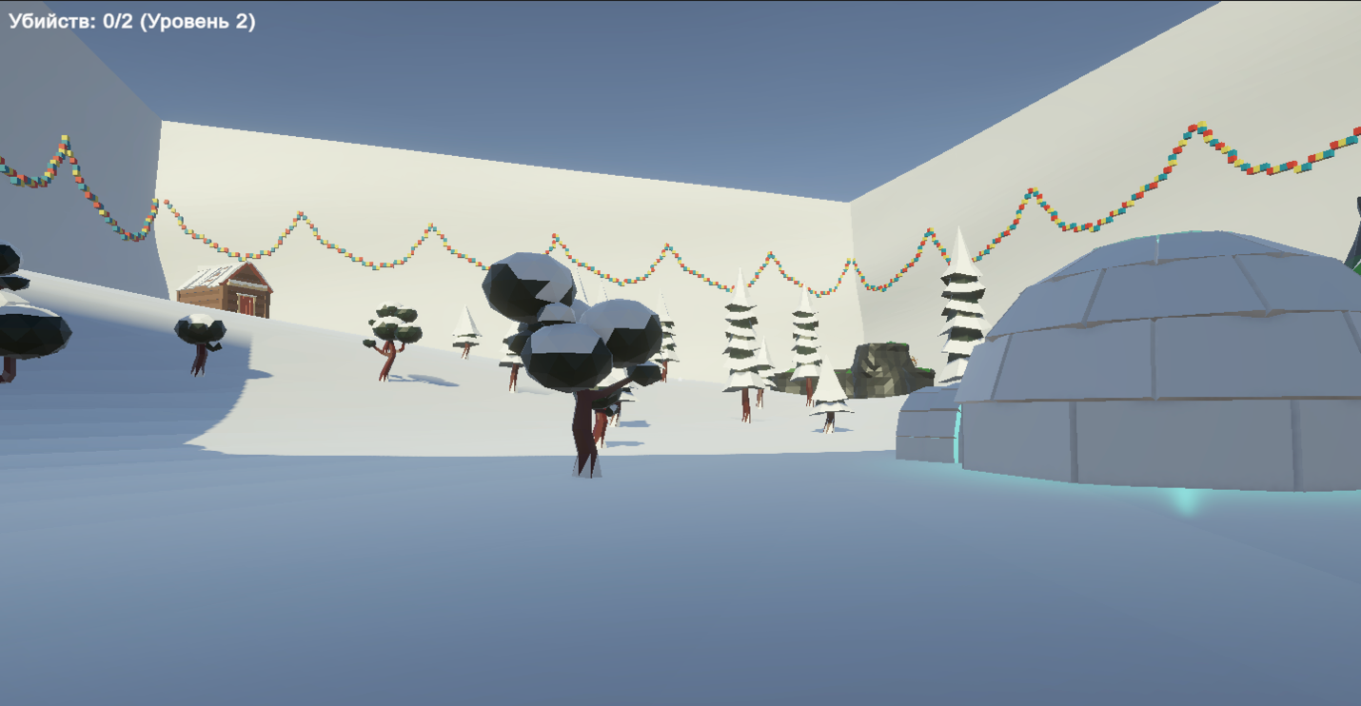

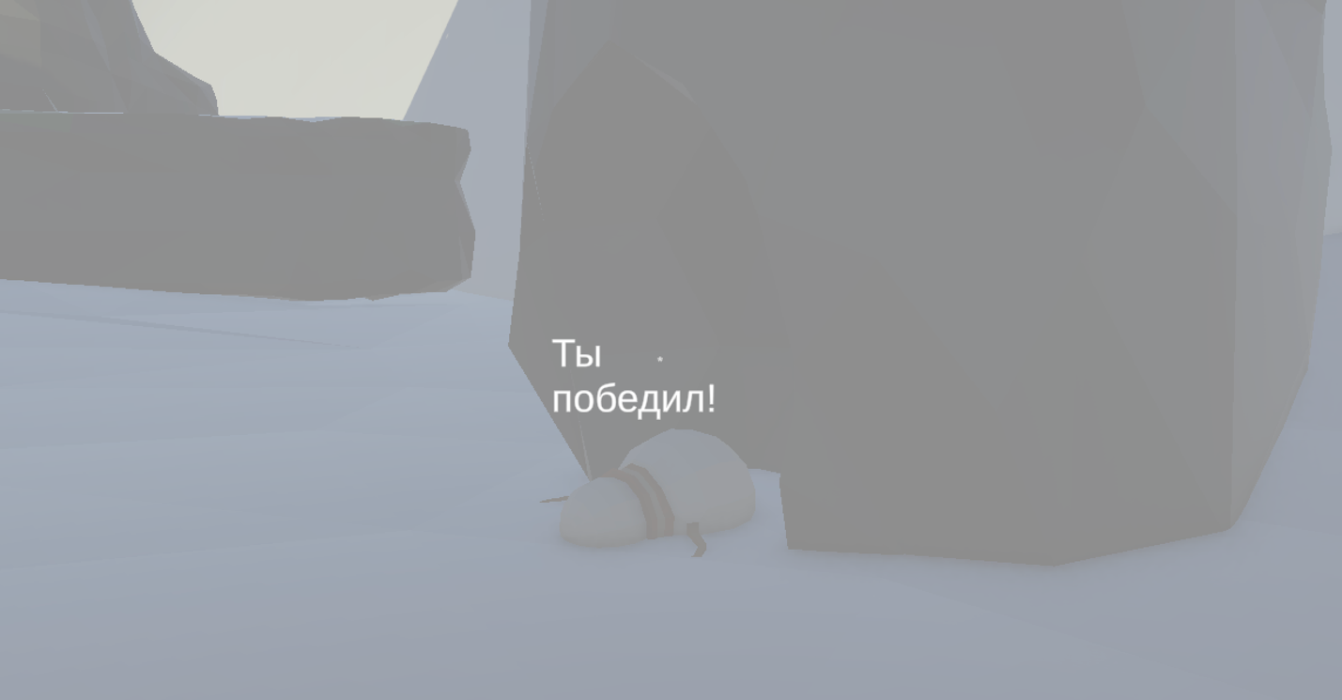

- Листинг кода скриптов

using UnityEngine;
using System.Collections;
using UnityEngine.InputSystem;

public class Look : MonoBehaviour
{
public enum RotationsAxes
{
X_Y,
X,
Y
}

public RotationsAxes _axes = RotationsAxes.X_Y;

public float _rotationsSpeedHor = 5.0f;
public float _rotationsSpeedVer = 5.0f;
public float maxVert = 45.0f;
public float minVert = -45.0f;

private float _rotationX = 0;

private void Start()
{
Rigidbody body = GetComponent<Rigidbody>();

if(body != null)
body.freezeRotation = true;
}

public void Update()
{

if(_axes == RotationsAxes.X_Y)
{
_rotationX -= Input.GetAxis("Mouse Y") * _rotationsSpeedVer;
_rotationX = Mathf.Clamp(_rotationX, minVert, maxVert);

float delta = Input.GetAxis("Mouse X") * _rotationsSpeedHor;
float _rotationY = transform.localEulerAngles.y + delta;

transform.localEulerAngles = new Vector3(_rotationX, _rotationY, 0);
}
else if(_axes == RotationsAxes.X)
{
transform.Rotate(0, Input.GetAxis("Mouse X") * _rotationsSpeedHor, 0);
}
else if(_axes == RotationsAxes.Y)
{
_rotationX -= Input.GetAxis("Mouse Y") * _rotationsSpeedVer;
_rotationX = Mathf.Clamp(_rotationX, minVert, maxVert);

float _rotationY = transform.localEulerAngles.y;

transform.localEulerAngles = new Vector3(_rotationX, _rotationY, 0);
}
}
}

using UnityEngine;

public class Movement : MonoBehaviour
{
public float _speed = 6.0f;
public float _gravity = -9.8f;
private CharacterController _characterController;

private void Start()
{
_characterController = GetComponent<CharacterController>();
// if(_characterController == null)
// Debug.Log("Hi");
}

private void Update()
{
float deltaX = Input.GetAxis("Horizontal") * _speed;
float deltaZ = Input.GetAxis("Vertical") * _speed;

Vector3 movement = new Vector3(deltaX, 0, deltaZ);
movement = Vector3.ClampMagnitude(movement, _speed);
movement.y = _gravity;

movement *= Time.deltaTime;
movement = transform.TransformDirection(movement);

_characterController.Move(movement);
}
}

using System.Collections;
using System.Collections.Generic;
using UnityEngine;

public class ReactiveTarget : MonoBehaviour
{
public void ReactToHit()
{
StartCoroutine(DieCoroutine(3));
}

private IEnumerator DieCoroutine(float waitSecond)
{
this.transform.Rotate(45, 0, 0);
yield return new WaitForSeconds(waitSecond);
Destroy(this.transform.gameObject);
}

}

using UnityEngine;
using System.Collections;
using UnityEngine.UI;

public class RayShooter : MonoBehaviour
{
[SerializeField] private GameObject projectilePrefab;
[SerializeField] private float projectileSpeed = 20f;
[SerializeField] private Transform firePoint;
[SerializeField] private Camera playerCamera;

[SerializeField] private int killsNeededLevel1 = 8;
[SerializeField] private int killsNeededLevel2 = 2;
[SerializeField] private Vector3 level2Position = new Vector3(1, 7, 70);

[SerializeField] private GameObject victoryPanel;

private int killCount = 0;
private bool isLevel2 = false;
private GameObject playerObject;
private bool hasTeleported = false;

private Movement movementScript;
private Look lookScript;
private CharacterController characterController;

private void Start()
{
if (playerCamera == null)
{
playerCamera = Camera.main;
}

Cursor.lockState = CursorLockMode.Locked;
Cursor.visible = false;

if (firePoint == null)
firePoint = transform;

FindAndStorePlayerComponents();

if (victoryPanel != null)
{
victoryPanel.SetActive(false);
}

Time.timeScale = 1f;

UpdateKillCounterUI();
}

private void FindAndStorePlayerComponents()
{
playerObject = GameObject.FindGameObjectWithTag("Player");
if (playerObject == null)
{
playerObject = GameObject.Find("Player");
}
if (playerObject == null && transform.parent != null)
{
playerObject = transform.parent.gameObject;
}
if (playerObject == null)
{
playerObject = this.gameObject;
}

movementScript = playerObject.GetComponent<Movement>();
lookScript = playerObject.GetComponent<Look>();
characterController = playerObject.GetComponent<CharacterController>();
}

private void Update()
{
if (Input.GetMouseButtonDown(0) && playerCamera != null)
{
ShootSnowballForward();
}

if (Input.GetKeyDown(KeyCode.P))
{
StartCoroutine(TeleportWithDisable(new Vector3(1, 7, 70)));
}

if (Input.GetKeyDown(KeyCode.T))
{
AddKillForTest();
}
}

private void ShootSnowballForward()
{
if (projectilePrefab == null) return;

Vector3 spawnPosition = playerCamera.transform.position + playerCamera.transform.forward * 0.5f;
GameObject snowball = Instantiate(projectilePrefab, spawnPosition, playerCamera.transform.rotation);

Rigidbody rb = snowball.GetComponent<Rigidbody>();
if (rb != null)
{
rb.linearVelocity = playerCamera.transform.forward * projectileSpeed;

StartCoroutine(DestroySnowballAfterTime(snowball, 6f));
StartCoroutine(CheckSnowballCollision(snowball));
}
else
{
Destroy(snowball);
}
}

private IEnumerator DestroySnowballAfterTime(GameObject snowball, float time)
{
yield return new WaitForSeconds(time);
if (snowball != null)
{
Destroy(snowball);
}
}

private IEnumerator CheckSnowballCollision(GameObject snowball)
{
while (snowball != null)
{
Collider[] hits = Physics.OverlapSphere(snowball.transform.position, 0.25f);

foreach (Collider hit in hits)
{
if (hit.gameObject == snowball) continue;

ReactiveTarget target = hit.GetComponent<ReactiveTarget>();
if (target != null)
{
target.ReactToHit();

yield return new WaitForSeconds(0.1f);

AddKill();

Destroy(snowball);
yield break;
}
}

yield return null;
}
}

private void AddKill()
{
killCount++;

UpdateKillCounterUI();

if (!isLevel2 && !hasTeleported)
{
if (killCount >= killsNeededLevel1)
{
StartCoroutine(TeleportToLevel2Coroutine());
}
}
else if (isLevel2)
{
if (killCount >= killsNeededLevel2)
{
ShowVictoryScreen();
}
}
}

private IEnumerator TeleportToLevel2Coroutine()
{
if (hasTeleported) yield break;

hasTeleported = true;
isLevel2 = true;

yield return StartCoroutine(TeleportWithDisable(new Vector3(1, 7, 70)));

killCount = 0;

UpdateKillCounterUI();
}

private IEnumerator TeleportWithDisable(Vector3 targetPosition)
{
bool wasMovementEnabled = false;
bool wasLookEnabled = false;
bool wasCharControllerEnabled = false;

if (movementScript != null)
{
wasMovementEnabled = movementScript.enabled;
movementScript.enabled = false;
}

if (lookScript != null)
{
wasLookEnabled = lookScript.enabled;
lookScript.enabled = false;
}

if (characterController != null)
{
wasCharControllerEnabled = characterController.enabled;
characterController.enabled = false;
}

yield return null;

playerObject.transform.position = targetPosition;

yield return null;

if (movementScript != null && wasMovementEnabled)
{
movementScript.enabled = true;
}

if (lookScript != null && wasLookEnabled)
{
lookScript.enabled = true;
}

if (characterController != null && wasCharControllerEnabled)
{
characterController.enabled = true;
}

yield return null;
}

private int GetRequiredKills()
{
return isLevel2 ? killsNeededLevel2 : killsNeededLevel1;
}

private void UpdateKillCounterUI()
{
GameObject killCounterText = GameObject.Find("KillCounterText");
if (killCounterText != null)
{
Text textComponent = killCounterText.GetComponent<Text>();
if (textComponent != null)
{
int required = GetRequiredKills();
textComponent.text = $"Убийств: {killCount}/{required}" + (isLevel2 ? " (Уровень 2)" : " (Уровень 1)");
}
}
}

private void ShowVictoryScreen()
{
Cursor.lockState = CursorLockMode.None;
Cursor.visible = true;

if (victoryPanel != null)
{
victoryPanel.SetActive(true);
}

Time.timeScale = 0f;
}

private void AddKillForTest()
{
AddKill();
}

private void OnGUI()
{
if (playerCamera == null) return;

int size = 12;
float posX = playerCamera.pixelWidth / 2 - size / 4;
float posY = playerCamera.pixelHeight / 2 - size / 2;
GUI.Label(new Rect(posX, posY, size, size), "*");

GUIStyle style = new GUIStyle();
style.fontSize = 20;
style.normal.textColor = Color.white;
style.fontStyle = FontStyle.Bold;

int required = GetRequiredKills();
string levelText = isLevel2 ? " (Уровень 2)" : " (Уровень 1)";
GUI.Label(new Rect(10, 10, 300, 30), $"Убийств: {killCount}/{required}{levelText}", style);
}
}

