Lab 5 Solutions

Problem 1
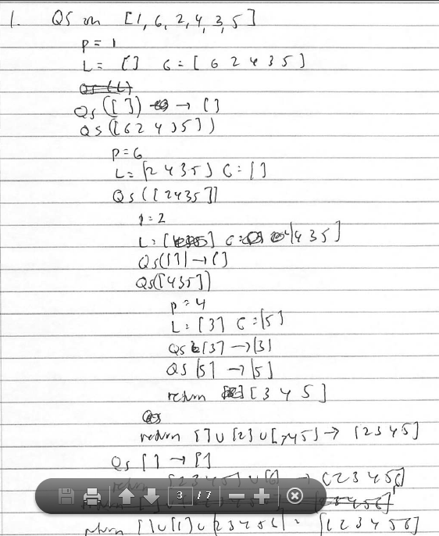

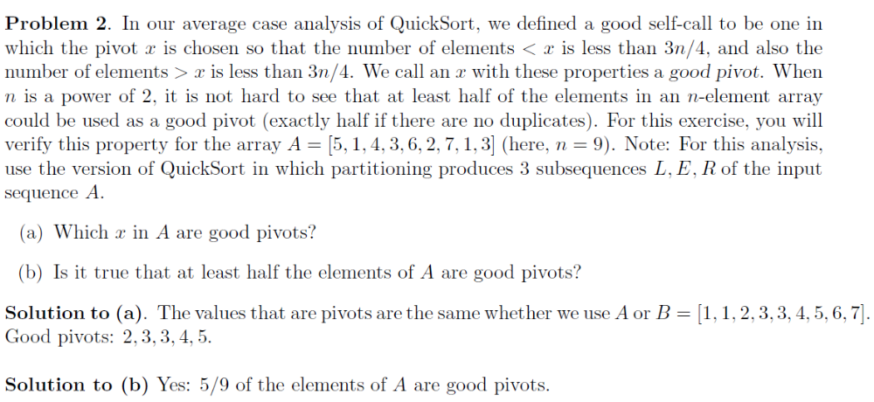

Problem 3.
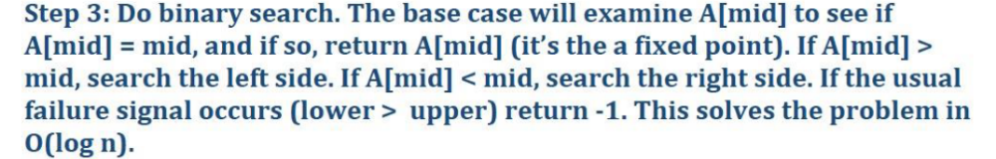

Now see whether it is in o(n). Thus, we need to show that
Lt (n -> infinity) f/g is 0. Here, f is logn and g is n. Take derivative (use L'Opital rule) and show that the linit is 0.

4. Devise a pivot-selection strategy for QuickSort that will guarantee that your new
QuickSort has a worst-case running time of O(nlog n).

Use the super QuickSelect algorithm (with worst case running time O(n)) to select pivots each time. This adds O(k) running time whenever section of the area has length k, so has the same cost as the partition step. Using this algorithm guarantees that all pivots are good pivots, so the recursion tree has height O(log n) and running time is O(n log n) in the worst case.

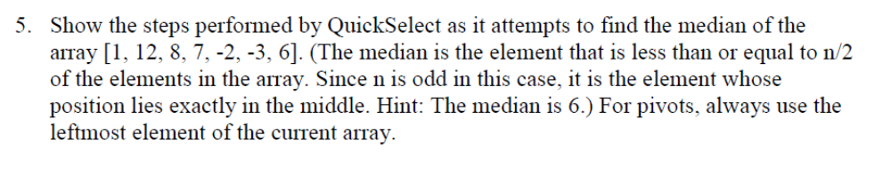
Soln.

