Lab 6
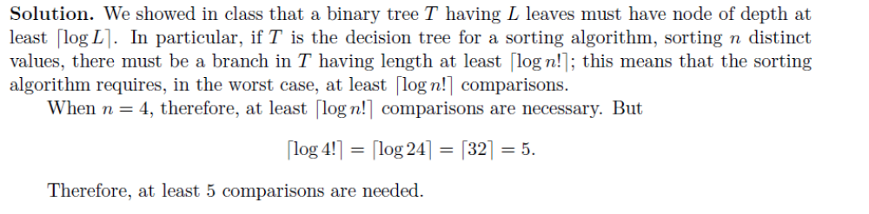
2.
using radix = 9.
Soln.

APPROACH A:
Do it in class using Radix as shown for the IBM solution.
APPROACH B: Use multiple Buckets.
Here the range is very large and one bucket will not work. Even 3 buckets will not work just because of the highest number 729. The max number with 3 buckets with radix 9 is
728 = 9^2.q2 + 9.q1 + r where q2 = q1 = r = 8. The range for q2, q1 and r are, of course 0 to 8.
Alternatively, we can use rdaix 10. To make use of radix 9, let us CHANGE the max number to 728.
The formulae we need to use are as follows:
1. Bucket r - use input values x and remainder using mod 9.
2. Bucket q1 needs to be filled by reading values (left to right) from bucket r but divided by 9 and then mod 9 -> (y / 9) mod 9.
3. Bucket q2 needs to be filled by reading values (left to right) from bucket q1 but divided by 9^2 and no mod operation -> z/81.
Then read data from q1 left to right. See the table below for details.
 | 125 | 27 | 728  (changed from 729) | 1 | 27 | 8 | 64 | 343 | 216
Bucket r | 216  27  27 | 343  64  1 |  |  |  |  |  |  | 8  728  125
 | 0 | 1 | 2 | 3 | 4 | 5 | 6 | 7 | 8
Bucket q1 | 8  1 |  | 343 | 27  27 | 125 |  | 216 | 64 | 728
 | 0 | 1 | 2 | 3 | 4 | 5 | 6 | 7 | 8
Bucket q2  (RETURN RSEULT -  Left to top to bottom to rght) | 64  27  27  8  1 | 125 | 216 |  | 343 |  |  |  | 728
 | 0 | 1 | 2 | 3 | 4 | 5 | 6 | 7 | 8
Div by 9 Quotient  (scratch pad) | 13 | 3 | 80 | 0 | 3 | 0 | 7 | 38 | 24

Solution - please note that in q[0], the first value is 1 and not 0. The same is true in the sorted output i..e the first number is 1 followed by 8.
