Lab 15 - NP-Complete

- Suppose Prob1, Prob2, and Prob3 are decision problems and Prob1 is polynomial reducible to Prob2, and Prob2 is polynomial reducible to Prob3. Explain why Prob1 must be polynomial reducible to Prob3.

- Illustrate the proof that the HamiltonianCycle problem is polynomial reducible to TSP by considering the following Hamiltonian graph—an instance of HamiltonianCycle—and transforming it to a TSP instance in polynomial time so that a solution to the HC problem yields a solution to the TSP problem, and conversely.
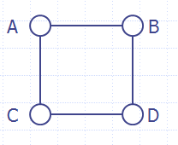

- Show that TSP is NP-complete. (Hint: use the relationship between TSP and HamiltonianCycle discussed in the slides. You may assume that the HamiltonianCycle problem is NP-complete.)

- Find an O(n) algorithm that does the following: Given a size n input array of integers, output the first numbers in the array (from left to right) whose sum is exactly 10 (or indicate that no such numbers can be found).

- Work through the steps of the Dynamic Programming solution to SubsetSum in the case in which S = {3,2,1,5} and k = 4.

