**Lab 11 Graph Theory**

Q1.

Answer questions about the G = (V,E) displayed below.

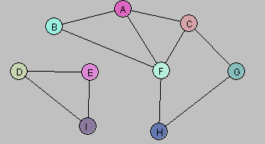

a. Let U = {A, B}. Draw G[U].

b. Let W = {A, C, G, F}. Draw G[W].

c. Let Y = {A, B, D, E}. Draw G[Y].

d. Consider the following subgraph H of G:

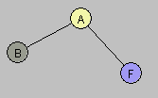

Is there a subset X of the vertex set V so that H = G[X]? Explain.

Q2.



Q1. A.

Additional Lab 11 Question:

Study the discovery and finishing time and then solve the following problem.





(Corman)

Q3.

The following graph has a Hamiltonian cycle. Find it.



Q4.

Consider the problem of computing a *maximum* spanning tree, namely the spanning tree that maximizes the sum of edge costs. Do Prim and Kruskal’s algorithm work for this problem (assuming of course that we choose the crossing edge with maximum cost)?