1. Insert Number to a Heap

Delete Number from a Heap

(Or Insert Number to a Binary Tree - Delete Numer from Binary Tree)

2. Hashing

Insert the following sequence of numbers 23, 46, 12, 21, 75, 5, 3

into a hash table of size 9 using h(x) = x%9 as a hash function. % means

Mod. Use Chaining with Linked List to avoid collision.

3. Chứng minh nếu 1 cây là cây black-red tree, thì nó ko có 1 nút đen, và chỉ có 1 con là nút đen.

**A:** Due to the rules there are limits on how unbalanced a Red Black tree may become. Then draw 1 root node (black) and new node must be red (use black height to prove that the tree become unbalance if new node is black)

4. Knapsack giống final exam khóa trước Question2.a

5. Question 3.b

6. Tính Running Time giống bài Graph, pdage 126 (Minimum Spanning Tree: Greedy Algorithms)

7. Chứng minh là nếu node A là parent của B nếu và chỉ nếu finish Time A > finish Time B && discovery Time A < Discovery Time B

**Academic answer:** From page 606 of Introduction to algorithm book

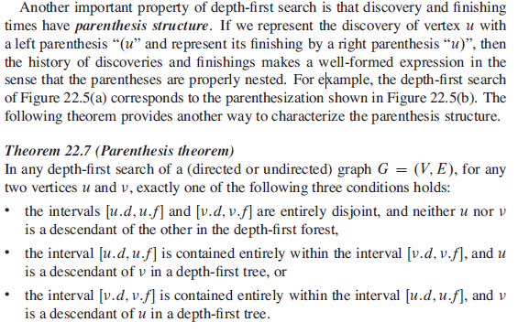

8. Nếu 1 nút lúc discovery là Gray or White thì nó là nút cha (ko nhớ chính xác, nhưng câu này ở đâu đó trong slide or homework)

**Academic answer:** From page 606 of Introduction to algorithm book

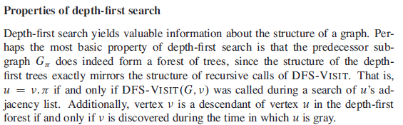

Short answer:

If v is discovered while u is gray, the recursive dfs function called upon u hasn't finished, it means that the dfs function called upon v is inside the dfs function called on u -> v is a descendant of u

9. Question 4b trong exam khóa trước

10. Question 5

11. Big Data – Semantic and Natural Language trong Searching today (ko nhớ chính xác)

Answer: Today’s Search Uses String Match (# of words, IDF,….) – Millions of hits!

Example : "Auto body shops in San Francisco bay area", Google gave the following:

" About 1,200,000 results (0,45 seconds) ".

There are probably not 1.2M Auto body shops in the whole world!

🡪 There are Key Issues!

12. NP Problem: Reduce 3CNF to independent Set

Câu 3



Question 3: If a black node has only one child that child must be a red leaf (why?)

A: Due to the rules there are limits on how unbalanced a Red Black tree may become. Then draw 1 root node (black) and new node must be red (use black height to prove that the tree become unbalance if new node is black)