At this point, assuming you’ve decided to use Azure. So in this tutorial we’ll be going over the steps to get your azure account set up, creating a Resource Group, creating a Storage Account within the Resource Group, creating a Container and uploading a file into the container.

Go to the microsoft Azure portal: <https://azure.microsoft.com/en-us/free/>

You should land on this page:

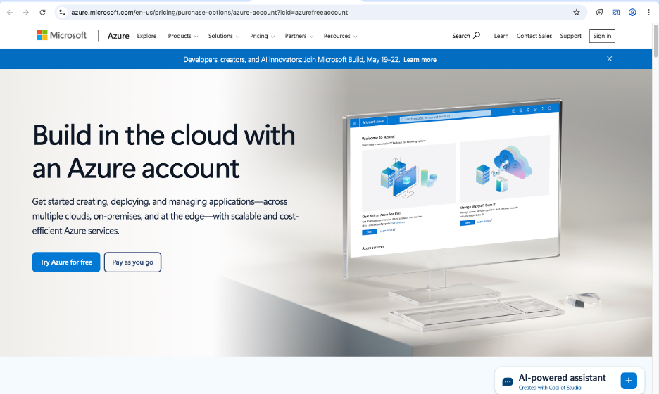

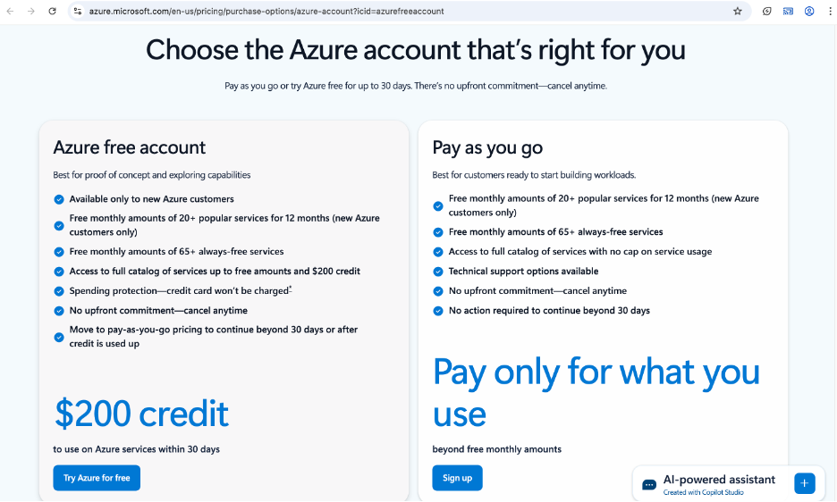

* For purposes of this tutorial, we’ll use the Free Account option:
* You will have to create a Microsoft Account if you don’t have one.
* Be sure to use a personal account and not a work or school account.
* You will need to provide a credit card/debit card to create an account.
* Once you have completed all the required information and you are signed in, you should land on this page:

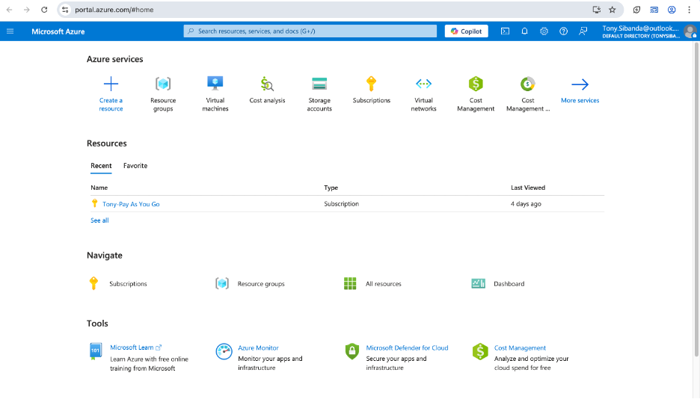

* Create a Resource Group:
* On the Azure Homepage, click on Resource Groups if you see it or search for it in the search field (type Resource Groups).

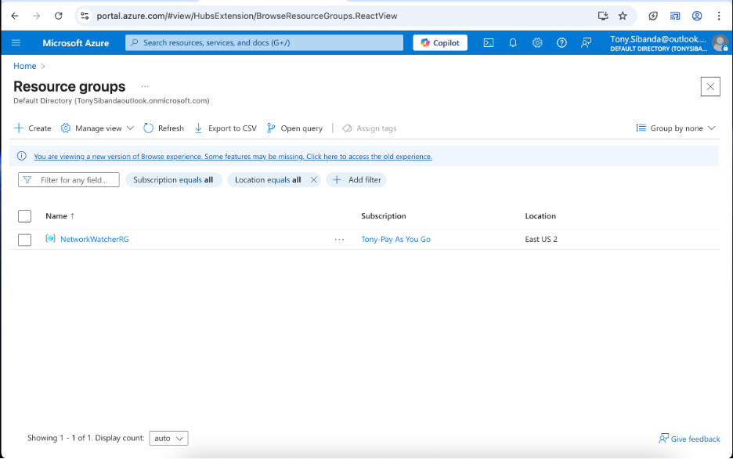

* Top right click “Create.”
* After clicking “create”, this page will load.

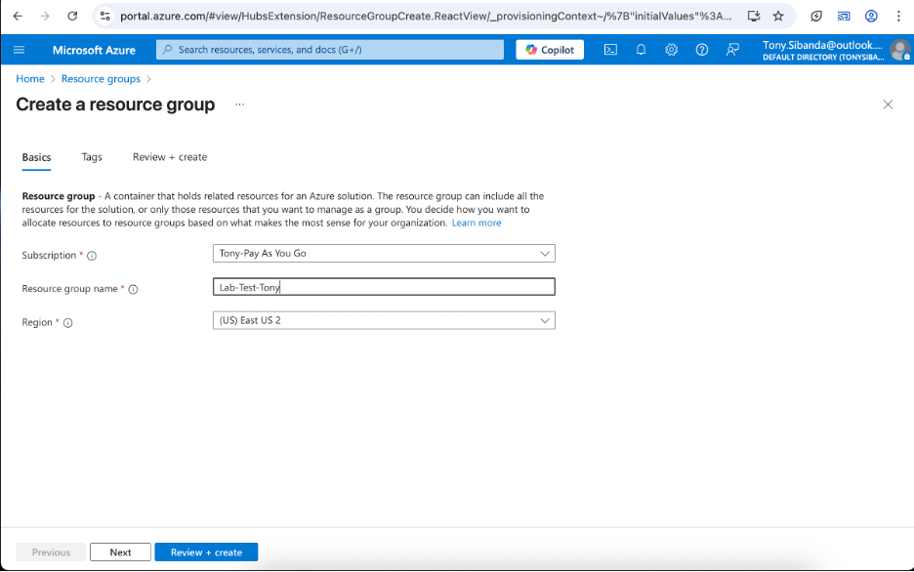

* Begin creating the Resource Group by filling out the fields and choosing the subscription that we just created.
* Select the region the Resource Group will be located in.
* Once all of the fields above have been filled out and you are happy with the name, click “Next.”

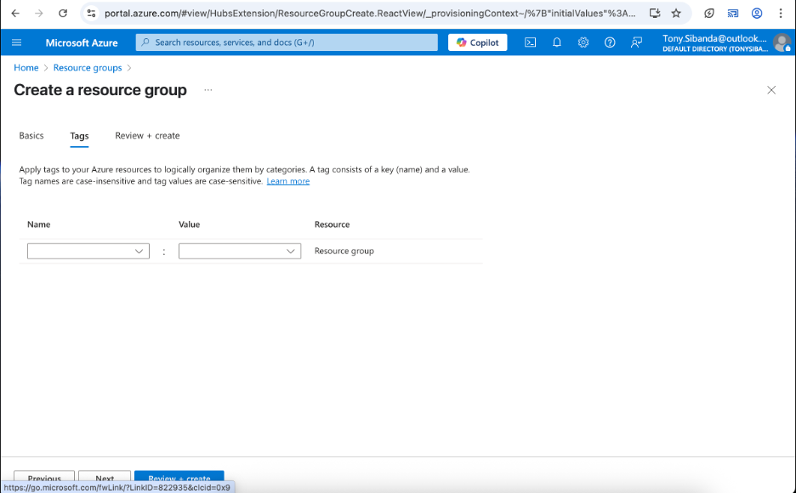

| *Tags: We won’t fill this section out as it is not necessary for this tutorial. Please see a brief explanation of “Tags” below.*  *The Tags section, lets you add simple labels to your resource group using words like Project: Website or Owner:*  *These labels help you keep things organized, find resources faster and track things like costs or who is using what. They’re not required but they make managing everything much easier.* |
| --- |

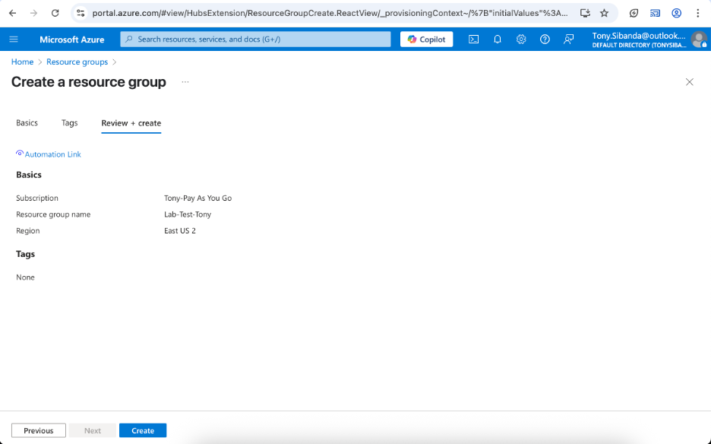

* The next step is Review + Create: This is self explanatory, just double check your work and make sure that everything is as it should be. Then we’ll just click “Create.”
* After clicking “Create” the Resource Group begins to be deployed. If you go back to the Portal. Click Resource Groups. You will see the new Resource Group that was created.

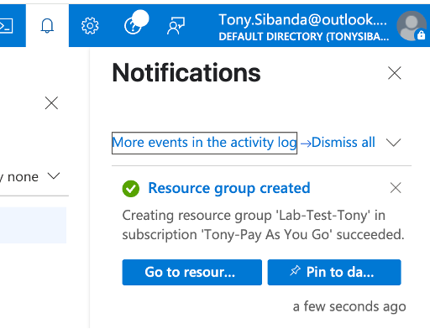

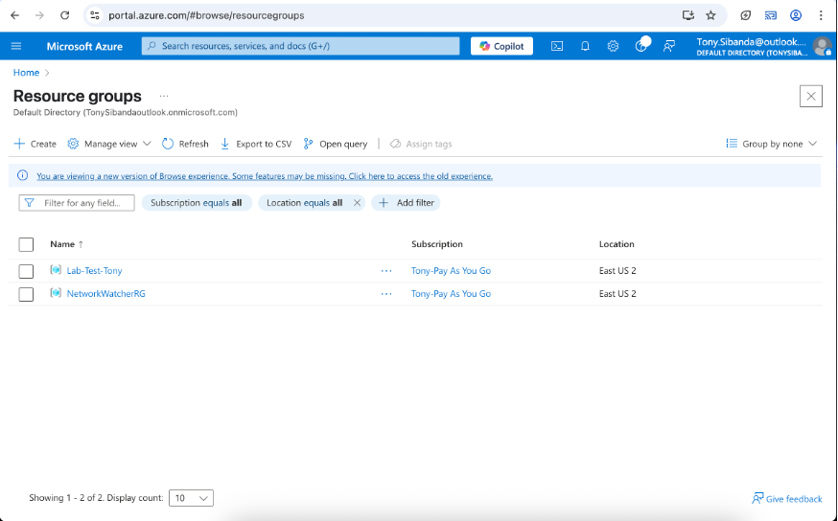

**Now that we’ve completed creating our Resource Group, in the next step we will create a Storage Account within our Resource Group.**

* In the search field, type Storage Accounts

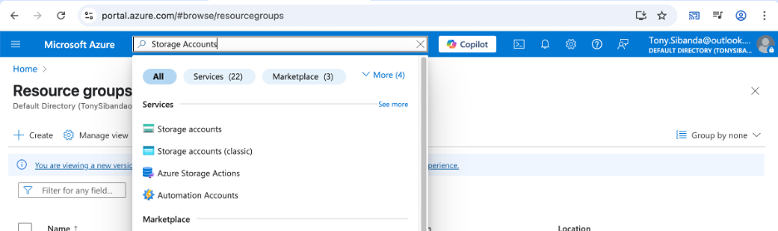

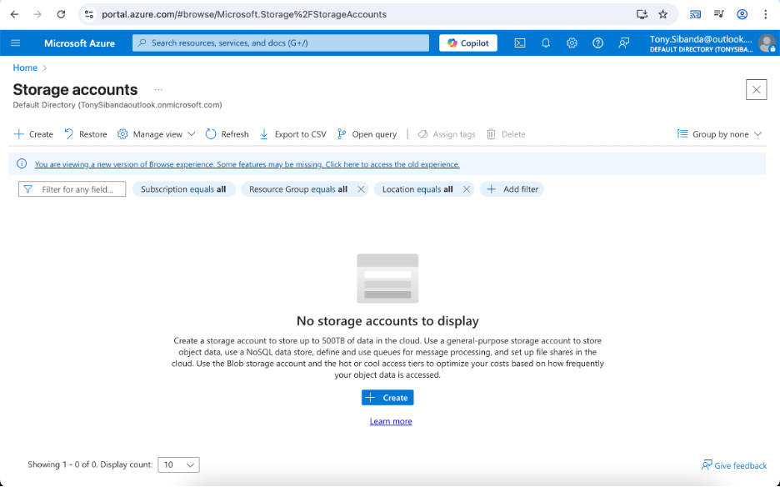

* Click “Create.”

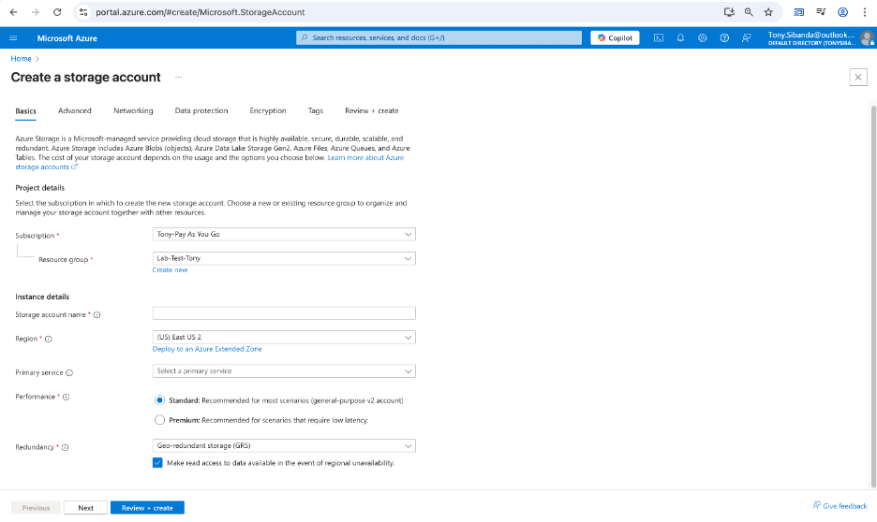

* Fill out the “Basics” section of the “Storage Account” creation:
* “Subscription” - Select the “Subscription” that we created when we created our “Azure Account.”
* “Resource Group” - Select the “Resource Group” that we just created.
* “Storage Account Name” - This has to be unique.
* “Region” - We’ll select “(US) East US 2”

| *The Region section lets you choose the physical location (data center) where your Storage Account and its data will be stored.*  *Choosing the right region helps:*  *Improve speed and performance (closer = faster).*  *Meet data residency or legal requirements*  *Support backups or disaster recovery if using multiple regions.*  *In short, it’s about where your data lives.*  *The Redundancy section lets you choose how your data is copied and protected in case something goes wrong.*  *It controls how many copies of your data Azure keeps and where they’re stored - either in one place or across different regions.*  *It controls how many copies of your data Azure keeps and where they’re stored - either in one place or across different regions.*  *More redundancy = better protection, but it may cost more.* |
| --- |

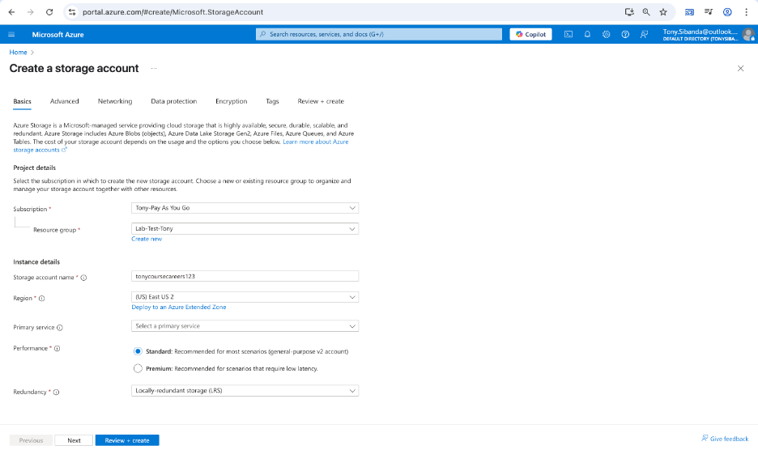

* At this point we’ll just click on review and create. For the purposes of this lab, we do not need the other steps covered in the other tabs.

| ***Advanced*** *– Lets you turn on extra features like large file shares, secure transfer, or setting a default access tier for data.*  ***Networking*** *– Controls who can access the storage account and from where (like from the internet, a private network, or certain IPs).*  ***Data Protection*** *– Helps you set up things like soft delete (to recover accidentally deleted files) and versioning (to keep older versions of data).*  ***Encryption*** *– Makes sure your data is safely locked using encryption, either with Microsoft-managed keys or your own.* |
| --- |

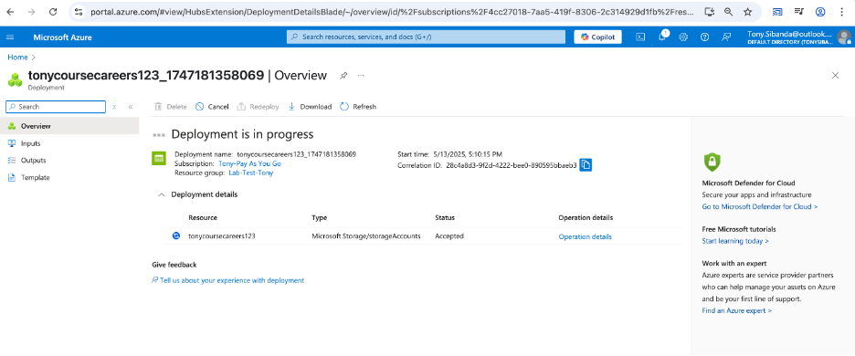

* The Storage Account deployment process has begun and should take a short amount of time to complete.

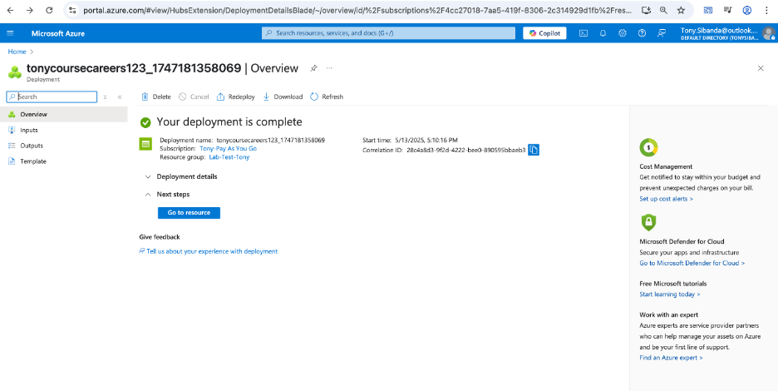

* Storage Account Deployment is complete.
* You can either go to the search field and type in Resource Group and you’ll see the Storage Account in the Resource Group or type Storage Account in the search field and you’ll see the Storage Account in the options.
* Now that we’ve completed the first two steps of creating our Resource Group and Storage Account. We’ll move on to testing/using our Storage Account.

**Testing our Storage Account**

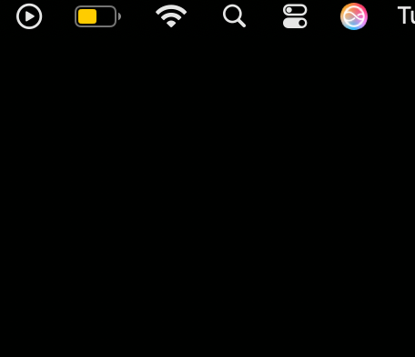

* If you’re using a Mac, click on the search magnifying glass in the top right corner of your screen. Type TextEdit and open the TextEditor.

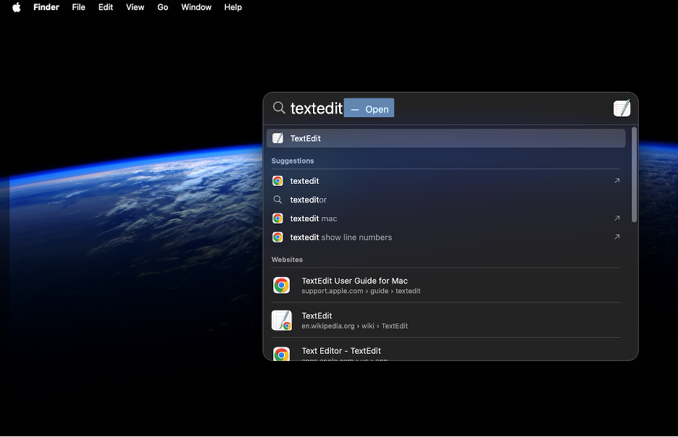

| *If you’re using a Windows machine, click on Start and open Notepad.* |
| --- |

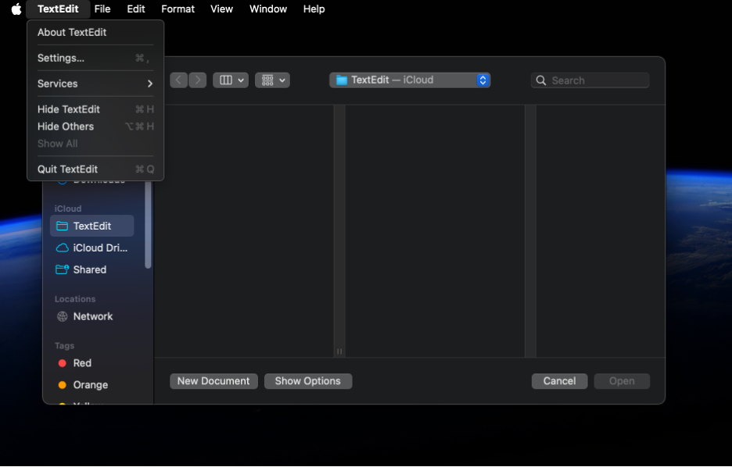

* Once you have “TextEdit” open, click on “TextEdit” at the left of the screen and click on “Settings.”

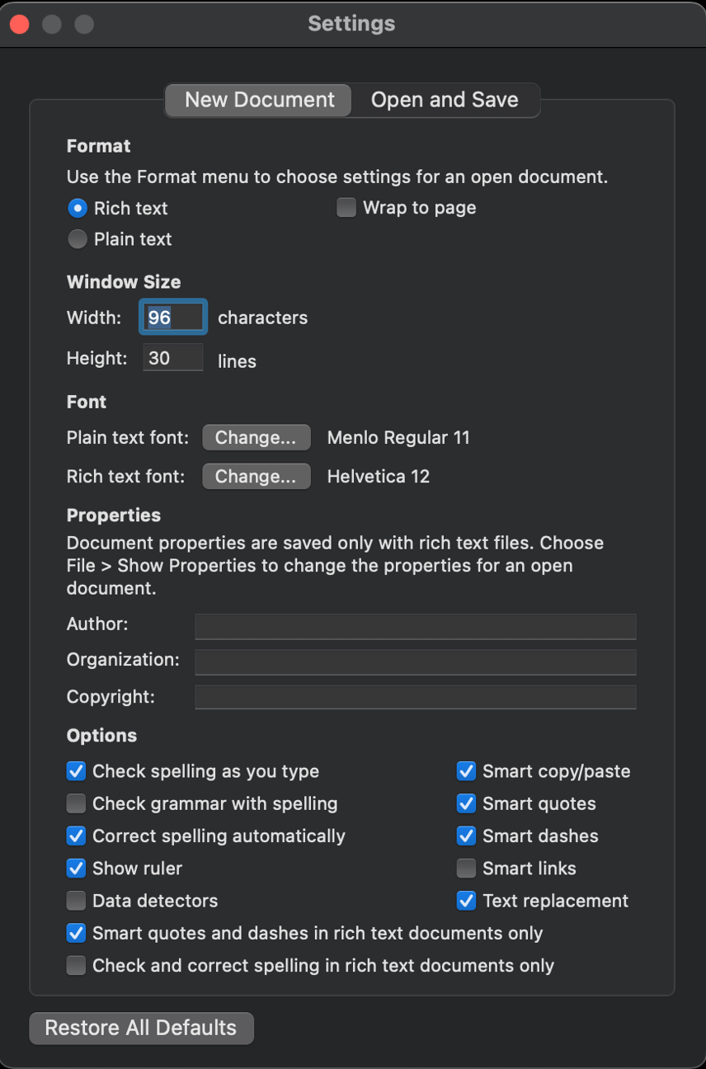

* Once the settings tab opens, change the default setting to “Plain Text” and then close the tab.

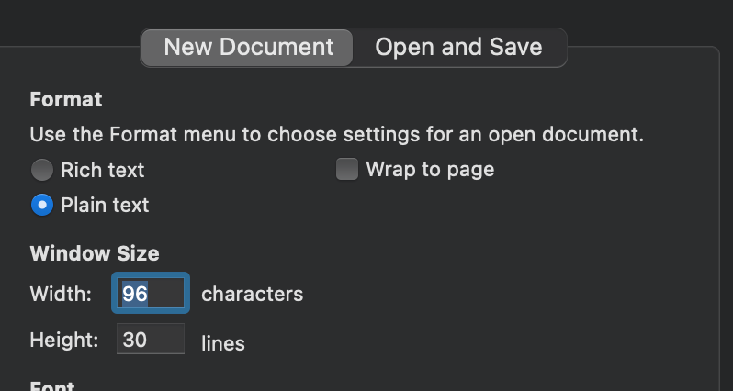

* The only change that needs to be made is the “Plain Text.”

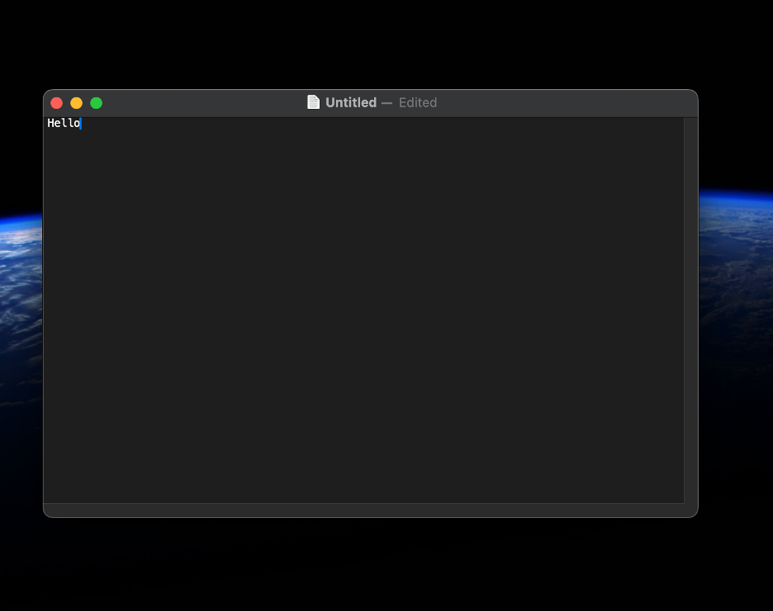

* Open a new “File/Document” and type “Hello.”

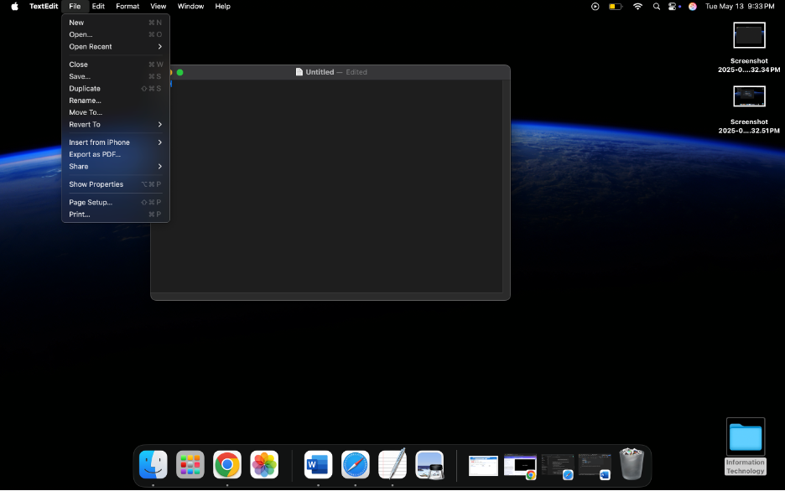

* Click on “File” and “Save” the document to the desktop for ease of locating it for the next step.

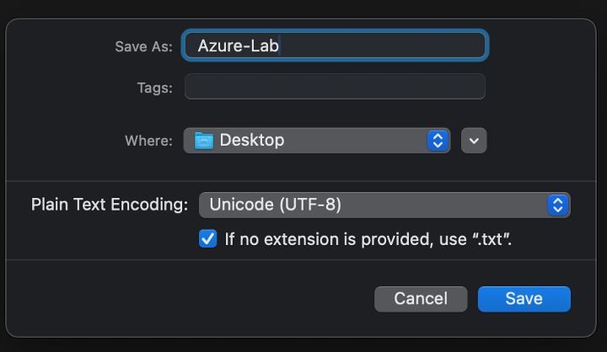

* Save it as Azure-Lab.

**Creating a “Container” in our “Storage Account.”**

* Now, go back to Azure and search for Storage Accounts. Once your Storage Account appears, open it and on the left scroll down to Data Storage, click on it and open the Containers tab.

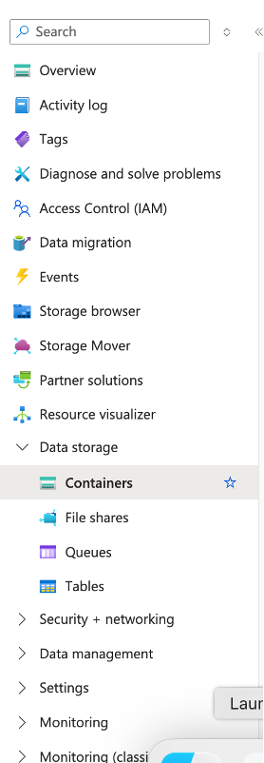

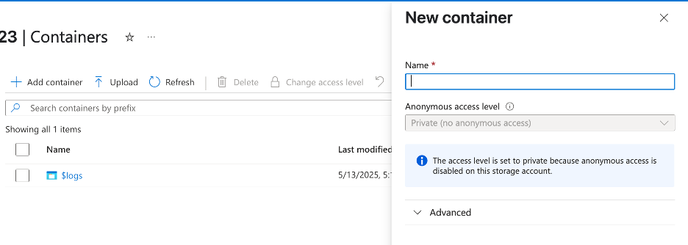

* Click on “Add Container,” and create a new Container under whatever name you’d like. Mine is saved as “lab-test.”

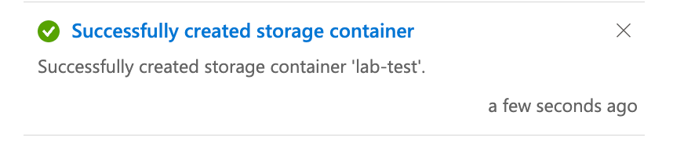

* The Container should take a moment to create.

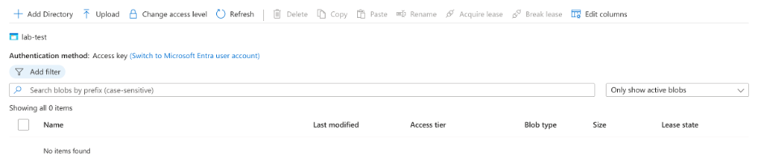

* Once the Container has created. Click on “Upload” and upload the Azure-lab text file that we just created.

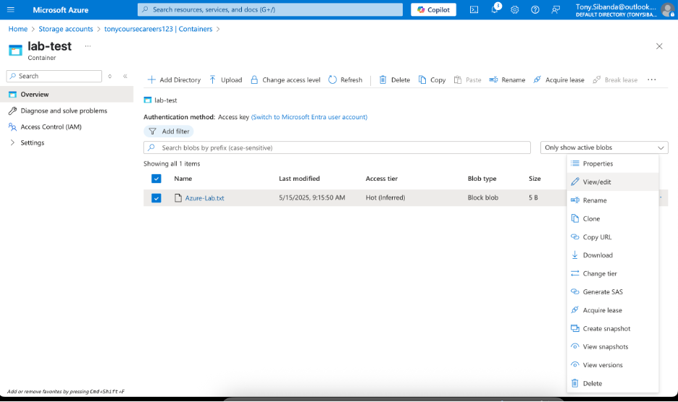

* Now that we have uploaded our Text File. We can go ahead and click on “View/Edit” while it is in the “Storage Container.”

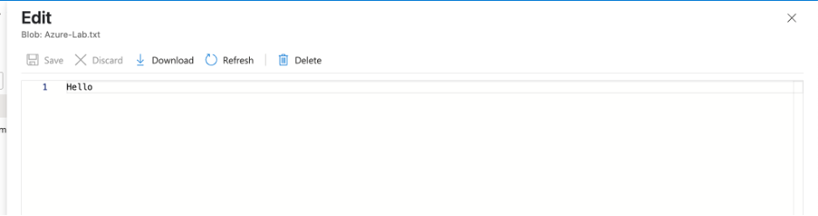

* As you can see the original file that we created with the text “Hello.” So what we’ll do now is go on to “Edit” the file.

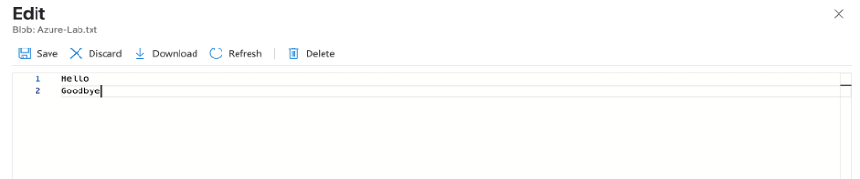

* Type “Goodbye” and then save it while it is still in the “Storage Container.”

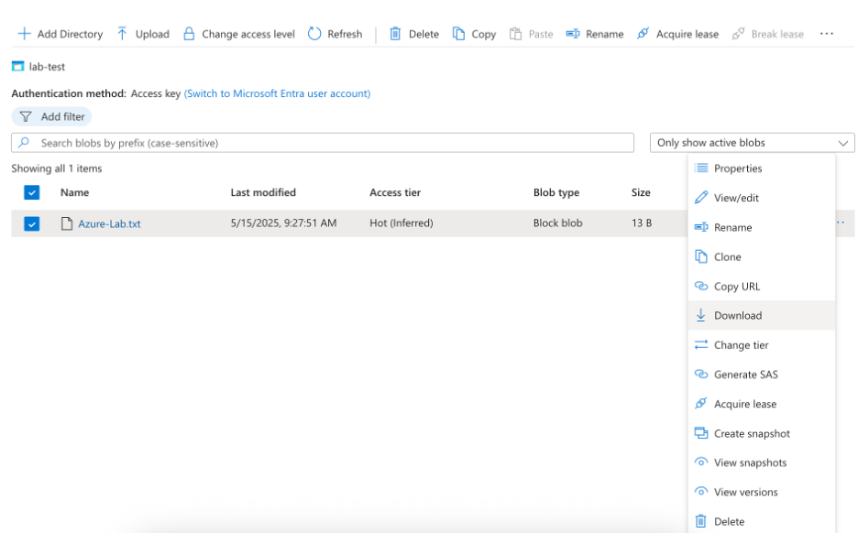

* Now we’ll go back to the Storage Container and download the file that we just edited. And then observe it on our Desktop with the final changes.

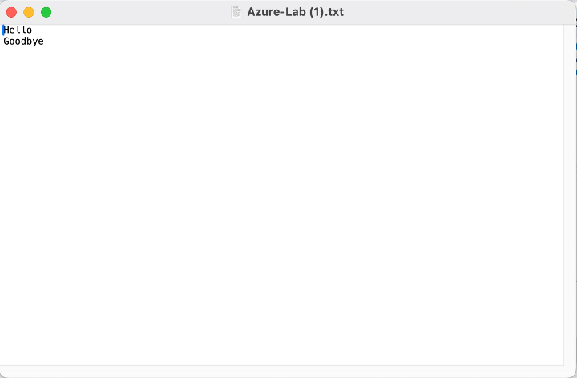

Done.