Genome Wide Association analysis (GWAS)
of Rice (Oryza sativa) traits

Alex Douglas, Tony Travis and Adam Price

University of Aberdeen, Scotland (UK)

Introduction

The aim of this exercise is to identify genes potentially associated with traits (phenotypes) of agricultural importance in rice (Oryza sativa). During this exercise you will gain experience in using the "ParSNP" pipeline to perform a GWAS analysis based on 44,100 SNP variants across 413 diverse accessions of rice (Zhao et al., 2010) and four phenotypic traits. You will also use R to perform further statistical analyses of these data and also generate your own custom manhattan plots. Finally, you will use data from the Rice Genome Annotation Project and the program IGV (Integrative Genome Viewer) to identify potentially significant associations between SNP markers and phenotypes in order to help interpret these in a biological context.

Step 1

In this part of the exercise you will use your newly acquired Bio-Linux skills to:

1. set up a directory structure in which to run ParSNP

2. download files from the internet directly via Terminal commands

3. uncompress zipped files using terminal commands

4. efficiently display the content of these files in the Terminal

As performing a GWAS analysis using many thousands of SNP markers is rather computer intensive you will be connecting to the server "Aryabhatta" for this exercise, with the "x2go" remote desktop client used for the "remote access" exercise. Connect to "Aryabhatta" and open a terminal window from the menu at the top of the remote MATE desktop:

Applications / System Tools / MATE Terminal

[note: Please configure your MATE terminal as a login shell]

Edit / Profile Preferences / Title and Command / Command
[✓] Run command as a login shell

To use ParSNP for GWAS analysis you will first need to download the genotype and phenotype data. Before you do this you should create a directory using the "mkdir" command in the MATE Terminal application in Bio-Linux (within your x2go session). Call this directory rice_GWAS (or something similar). This is the directory where you will download the genotype and phenotype data and also save all files associated with the subsequent GWAS analysis.

mkdir rice_GWAS
cd rice_GWAS

The genotype data are freely available from the Rice Diversity Project website (http://ricediversity.org/data). Use a browser to navigate to this site and follow the links: Data & Tools → Data sets → 44K GWAS Data to locate the 'RiceDiversity.44K.MSU6.Genotypes_PLINK.zip' file. Right click on the filename and select 'Copy Link Location'. You can now use the wget command in the Terminal to download this file directly into our rice_GWAS directory by pasting in the link location

wget http://ricediversity.org/data/sets/44kgwas/RiceDiversity.44K.MSU6.Genotypes_PLINK.zip

Once this file has downloaded you will need to uncompress it using the unzip command

unzip RiceDiversity.44K.MSU6.Genotypes_PLINK.zip

This will create a directory called 'RiceDiversity_44K_Genotypes_PLINK'. To view these files use the ls command to list all the files contained in this directory. You should have three files.

ls -lh RiceDiversity_44K_Genotypes_PLINK

total 59M
-rw-r--r-- 1 nhy163 emma_x 11K Apr 3 2011 sativas413.fam
-rw-r--r-- 1 nhy163 emma_x 830K Nov 9 2010 sativas413.map
-rw-r--r-- 1 nhy163 emma_x 59M Nov 9 2010 sativas413.ped

Use the mv command to move these files into the rice_GWAS directory you created earlier and then delete the RiceDiversity_44K_Genotypes_PLINK directory using rmdir.

mv -i ./RiceDiversity_44K_Genotypes_PLINK/sativas* .
rmdir RiceDiversity_44K_Genotypes_PLINK

The genotype files consist of a PED file and a MAP file in PLINK format (we will not use the FAM file for this practical). The sativas413.ped file is whitespace delimited and contains the genoptype for each accession for each SNP marker. The sativas.map file is also whitespace delimited and contains the name and chromosomal location of each SNP marker. See the PLINK web page for further details on the PLINK format and additional information regarding the different file types (http://pngu.mgh.harvard.edu/~purcell/plink).

Display the contents of each file using the command (press q to quit)

less -S sativas413.ped

and
less -S sativas413.map

You can also check how many accessions are represented in the genotype files using the command wc

wc -l sativas413.ped

413 sativas413.ped

So in the sativas413.ped file we have genotype information for 413 accessions.

In addition to the genotype data, you will also need to copy the file containing the phenotype data into the rice_GWAS directory. Use the "cp" command to copy the rice_phenotype.txt from the shared directory /work/B4G (don’t forget the trailing .):

cp -i /work/B4G/rice_phenotype.txt .

The phenotype file is a tab-delimited file where each line represents an individual accession. The first column represents a unique accession ID and the subsequent columns contain the values for each trait. The traits we are interested in are: Faridpur grain molybdenum concentration (F_grain_Mo), Faridpur grain zinc concentration (F_grain_Zn), Aberdeen flowering time (A_FT) and Aberdeen plant height (A_PH). Take a look at the phenotype file using

less -S rice_phenotype.txt

To check how many accessions we have in the phenotype file you can count the number of lines (remember to subtract 1 from this value as you don't want to count the header).

wc -l rice_phenotype.txt

379 rice_phenotype.txt

So you have phenotype information for 378 accessions. How does this compare with the number of accessions we have genotype information? How are missing data coded?

You now have all the files you need to start using "ParSNP". Your rice_GWAS directory should contain the following files (there will still be the original zip file you downloaded and also possibly a directory named __MACOSX – you can ignore these)

ls -lh

-rw-r--r-- 1 nhy163 emma_x 8.7K Feb 4 13:37 rice_phenotype.txt
-rw-r--r-- 1 nhy163 emma_x 11K Apr 3 2011 sativas413.fam
-rw-r--r-- 1 nhy163 emma_x 830K Nov 9 2010 sativas413.map
-rw-r--r-- 1 nhy163 emma_x 59M Nov 9 2010 sativas413.ped
Step 2

In this part of the exercise you will use the emmax-input program from "ParSNP" to take your genotype and phenotype files and generate all the files needed to perform a GWAS analysis. Specifically you will:

1. convert your ped and map genotype files to tped and tfam format required by "EMMAX"

2. create a kinship matrix file to use in the GWAS analysis to account for relatedness between individual accessions

3. create a covariate file containing the first five eigenvectors of a PCA of the SNP data to account for potential population structure

4. filter the genotype and phenotype data to ensure that only the same accessions are present in all files

The emmax-input program has a number of command-line options used to generate the input files required by "EMMAX". The first thing you need to do is
specify a prefix name for the PED and MAP input files using the -i option. A prefix is also required to name the output files using the -o option. The input and output prefixes should not be the same. You can, optionally, specify a phenotype input filename using -p, but this will default to the input prefix if omitted. You can also use emmax-input to create a kinship file generated from the genotype data using the -k option, and make use of a covariate file based on eigenvectors generated from a principal components analysis (PCA) of the genotype data using the -c option. The number of eigenvectors to retain from the PCA can be specified using -e. For example the following command:

emmax-input -i sativas413 -o sativas_GWAS -p rice_phenotype.txt -k -c -e 5

takes the genoype files sativas413.ped and sativas413.map and the phenotype file named rice_phenotype.txt as input files and generates the output files sativas_GWAS.tped, sativas_GWAS.tfam and sativas_GWAS.pheno. It will also generate a file sativas_GWAS.hIBS.kinf which contains the kinship matrix using the IBS algorithm and a file sativas_GWAS.covar which contains the first five eigenvectors from a PCA of the genotype data to be used as covariates in EMMAX. emmax-input also performs some sanity checks to ensure that each accession occurs in both the genotype and phenotype data. Those accessions not in both data files are reported and removed prior to generating the output files. The emmax-input program will also create a directory with the same name as the output prefix (sativas_GWAS in the example above) which contains further sub-directories named after each of the phenotypes (F_grain_Mo, F_grain_Zn, A_FT and A_PH in our example). These subdirectories contain a correctly formatted phenotype file and will also be the location where all files generated using emmax-run will be saved. This allows you to perform a GWAS analysis on multiple phenotypes simultaneously whilst keeping the results separate.

After completing the steps outlined above you should have the following files in your rice_GWAS directory in addition to those you created in the previous step:

ls -lh

drwxr-sr-x 6 nhy163 emma_x 4.0K Feb 4 15:10 sativas_GWAS
-rw-r--r-- 1 nhy163 emma_x 21K Feb 4 15:09 sativas_GWAS.covar
-rw-r--r-- 1 nhy163 emma_x 42K Feb 4 15:10 sativas_GWAS.emmax-input.log
-rw-r--r-- 1 nhy163 emma_x 1.8M Feb 4 15:10 sativas_GWAS.hIBS.kinf
-rw-r--r-- 1 nhy163 emma_x 54M Feb 4 15:09 sativas_GWAS.ped
-rw-r--r-- 1 nhy163 emma_x 14K Feb 4 15:09 sativas_GWAS.pheno
-rw-r--r-- 1 nhy163 emma_x 9.9K Feb 4 15:10 sativas_GWAS.tfam
-rw-r--r-- 1 nhy163 emma_x 55M Feb 4 15:10 sativas_GWAS.tped

and you should also have the following sub-directories for each phenotype in the sativas_GWAS directory:

ls -lh ./sativas_GWAS

total 16K
drwxr-sr-x 2 nhy163 emma_x 4.0K Feb 4 15:10 A_FT
drwxr-sr-x 2 nhy163 emma_x 4.0K Feb 4 15:10 F_grain_Cu
drwxr-sr-x 2 nhy163 emma_x 4.0K Feb 4 15:10 F_grain_Mo
drwxr-sr-x 2 nhy163 emma_x 4.0K Feb 4 15:10 F_grain_Zn

Step 3

Now you have the input files required by "EMMAX" you can use the program "emmax-run" to perform the GWAS analysis.

In this part of the exercise you will:

1. perform a GWAS analysis for each phenotype with emmax-run using the files you created with emmax-input

2. generate manhattan plots for each phenotype to summarise the results of the GWAS analysis

3. correct the p-values from the GWAS analysis to control for a 5% false discovery rate (FDR) [optional]

4. create a custom manhattan plot with FDR corrected p values [optional]

To use the input files for "emmax-run" you need to specify the prefix name for the .tped, .tfam and .pheno files using the -i option (remember, these were created using "emmax-input"). You can also specify the covariate filename with -c and use the kinship file created with "emmax-input" with -k IBS. If your computer is multi-threaded you can specify the number of threads to use when running "emmax-run" using the -t option. If not specified this defaults to 1. For example, the following command:

emmax-run -i sativas_GWAS -k IBS -c sativas_GWAS.covar -t 4

takes the genotype and phenotype input files sativas_GWAS.tped, sativas_GWAS.tfam, sativas_GWAS.pheno and the file with the kinship matrix sativas_GWAS.hIBS.kinf and the covariate file sativas_GWAS.covar and performs a GWAS analysis using 4 threads on the computer. "emmax-run" will save all output files generated from "EMMAX" in the appropriate phenotype sub-directory created with "emmax-input". You should have four sub-directories in the sativas_GWAS directory (one for each phenotype). For example, if you list the files in the A_FT sub-directory you should see seven files listed:

ls -lh sativas_GWAS/A_FT
total 2.8M
-rw-r--r-- nhy163 emma_x 7.4K Feb 4 15:10 A_FT.pheno
-rw-r--r-- nhy163 emma_x 189K Feb 4 21:27 A_FT_sativas_GWAS.manh.pdf
-rw-r--r-- nhy163 emma_x 55K Feb 4 21:27 A_FT_sativas_GWAS.manhQQ.pdf
-rw-r--r-- nhy163 emma_x 21K Feb 4 21:27 A_FT_sativas_GWAS.log
-rw-r--r-- nhy163 emma_x 1.2M Feb 4 21:27 A_FT_sativas_GWAS.manh
-rw-r--r-- nhy163 emma_x 1.3M Feb 4 21:27 A_FT_sativas_GWAS.ps
-rw-r--r-- nhy163 emma_x 76 Feb 4 21:26 A_FT_sativas_GWAS.reml

See the "ParSNP" manual (https://github.com/minke-informatics/ParSNP) for more detail of what each of these files represent. For this exercise we will concentrate on two of these files. The file A_FT_sativas_GWAS.manh.pdf is a manhattan plot saved in pdf format. To view this from the terminal you can use the program "evince":

evince ./sativas_GWAS/A_FT/A_FT_sativas_GWAS.manh.pdf
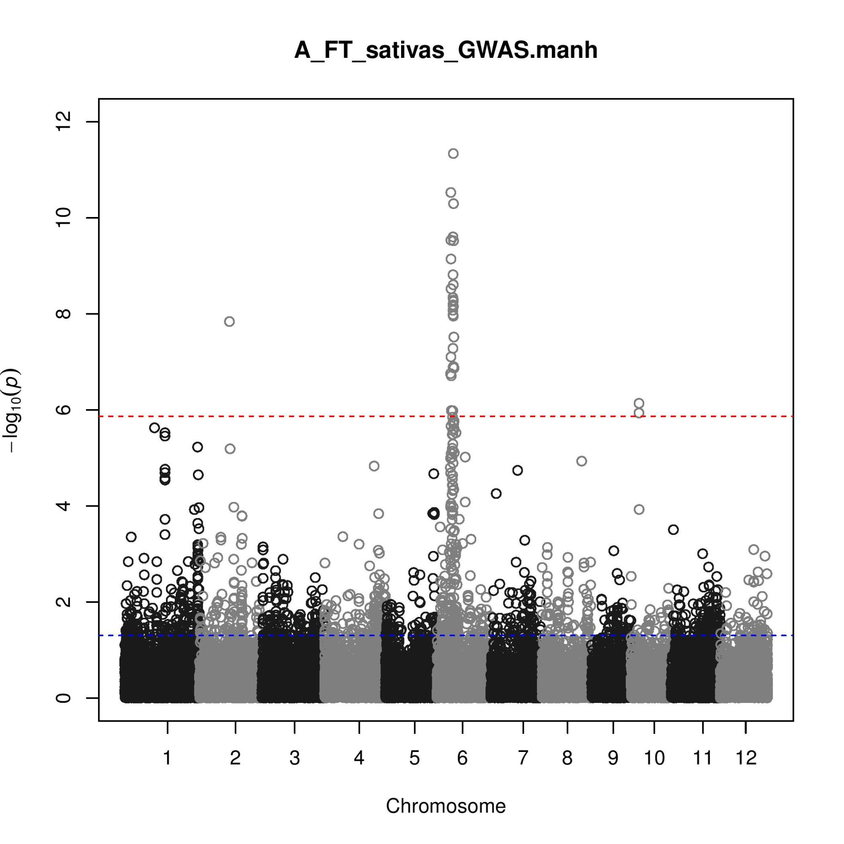

The manhattan plot visualises the -log₁₀ p value of the association for each SNP located across the genome. The red dotted line represents the Bonferroni corrected p value threshold. Can you spot any potentially significant associations? Which chromosome do most occur on?

In addition to the manhattan plot the file A_FT_sativas_GWAS.manh contains the SNP ID, Chromosome, base-pair position, minor and major allele, minor allele frequency (MAF), non-missing allele count and p-value for the association test for each SNP. To check the number of SNPs used in the analysis you can use (remember to subtract 1 so we don't count the header)

wc -l ./sativas_GWAS/A_FT/A_FT_sativas_GWAS.manh
36902 ./sativas_GWAS/A_FT/A_FT_sativas_GWAS.manh

So you have 36901 association tests for 36901 SNPs and therefore 36901 p-values! Obviously the more hypotheses you are testing the greater the chance of making a type I error (finding a significant association by chance where none exists). There are many approaches to address this issue but you will use the Benjamini-Hochberg algorithm to control the false discovery rate (FDR) at 5 %. To do this you can import the A_FT_sativas_GWAS.manh file into R and use the mt.rawp2adjp function which is available in the multtest package. Open "RStudio" and make the multtest package available

Applications / Programming / RStudio

library(multtest)

Set the working directory to the location of the A_FT_sativas_GWAS.manh file e.g. for this example:

setwd("~/rice_GWAS/sativas_GWAS/A_FT/")

and import the file and assign it to an object (called aft in this case)

aft <- read.table("A_FT_sativas_GWAS.manh", header=TRUE, sep="\t")

lets have a look at the structure of the object aft

str(aft)

'data.frame': 36901 obs. of 8 variables:
$ SNP : Factor w/ 36901 levels "dd1000009","dd1000015",...
$ CHR : int 1 1 1 1 1 1 1 1 1 1 ...
$ BP : int 13147 73192 74969 75852 75953 91016 146625 149005
$ A1 : int 1 1 1 1 1 1 1 1 1 1 ...
$ A2 : int 2 2 2 2 2 2 2 2 2 2 ...
$ MAF : num 0.31 0.313 0.159 0.143 0.31 ...
$ NCHROBS: int 754 754 754 756 754 634 754 752 742 752 ...
$ P : num 0.184 0.202 0.162 0.293 0.19 ...

The aft object is a data.frame object and contains 36901 observations and eight variables; SNP ID (SNP), Chromosome (CHR), Base-pair position (BP), minor allele (A1), major allele (A2), minor allele frequency (MAF), non-missing allele count (NCHROBS) and p-value (P). You can now use the mt.rawp2adjp function to adjust our p-values and create a new object (aft_p) to store them in

mt <- mt.rawp2adjp(aft$P, proc="BH")
ind <- mt$index
aft_p <- cbind(aft[,-8], P=mt$adjp[order(ind),2])

To display the first six lines in the new object

head(aft_p)

SNP CHR BP A1 A2 MAF NCHROBS P
1 id1000001 1 13147 1 2 0.3103 754 0.9999695
2 id1000003 1 73192 1 2 0.3130 754 0.9999695
3 id1000005 1 74969 1 2 0.1592 754 0.9999695
4 id1000007 1 75852 1 2 0.1429 756 0.9999695
5 id1000008 1 75953 1 2 0.3103 754 0.9999695
6 id1000011 1 91016 1 2 0.1009 634 0.9999695

To generate a manhattan plot to display these new p-values you first need to source the code for the manhattan function into R

source("/work/B4G/GWAS_manhattanplots.R")

Now create the manhattan plot

manhattan(aft_p,limitchromosomes = 1:12,suggestiveline = -log10(0.05), genomewideline = FALSE, main="AFT")

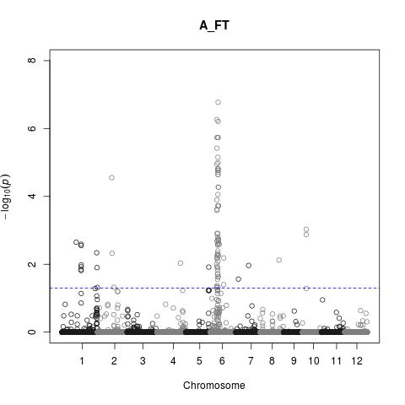

You can also plot just chromosome six to visualise the potential QTL in more detail.

manhattan(aft_p,limitchromosomes = 6:6,suggestiveline = -log10(0.05), genomewideline = FALSE, main="AFT Chromosome 6")

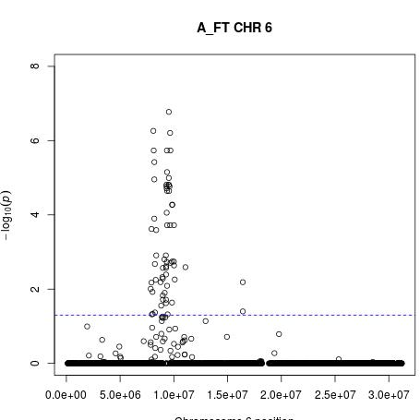

In addition to the Aberdeen flowering time (A_FT) phenotype, take a look at the manhattan plot for Aberdeen plant height (A_PH) in the "rice_GWAS/sativas413/A_PH" directory. Can you identify a potentially significant association? Which chromosome is it on? [optional] Use the code above to help you apply a Benjamini-Hochberg correction for A_PH and re-plot the adjusted p-values in a manhattan plot.

Step 4

In this section you do some simple exercises to see if you can identify good candidate genes for associations revealed in the GWAS. We will concentrate on the flowering time (A_FT) and plant height (A_PH) traits which were measured on plants grown the greenhouse in Aberdeen. Specifically you will:

1. identify where the most significant SNPs associated with these traits are located on the genome (their coordinates in the RGP version 6 annotation).

2. examine a list of genes near these SNPs to see if there are any candidate genes that are immediately obvious.

3. for the plant height association on chromosome 1 examine the next generation sequence alignments of cultivars Azucena and Bala and identify a well characterised polymorphism in a candidate gene.

Examining the Manhattan plot of A_FT shown above indicates an association on chromosome 6. To find out exactly where this association is on the genome we must first order the SNPs according to their significance (p-value), with the most significant first. This can be done easily in R. First set your working directory to the location of "A_FT_sativas_GWAS.manh" for the A_FT phenotype e.g. in this example:

setwd("~/rice_GWAS/sativas_GWAS/A_FT/")

and import the file and assign it to an object (called aft in this case)

aft <- read.table("A_FT_sativas_GWAS.manh", header=TRUE, sep="\t")

and order the object by ascending p-value

aft.ord <- aft[order(aft$P),]

take a look at the top six SNPs with the lowest p-value

head(aft.ord, n=6)

SNP CHR BP A1 A2 MAF NCHROBS P
21574 id6006091 6 9531374 1 2 0.2128 592 4.567229e-12
21436 id6005265 6 8093540 1 2 0.1120 732 2.953794e-11
21579 id6006118 6 9651785 1 2 0.1476 752 5.043541e-11
21564 id6005963 6 9353534 1 2 0.3479 756 2.493561e-10
21438 id6005271 6 8126688 1 2 0.1124 756 2.905629e-10
21585 id6006146 6 9683473 1 2 0.1877 746 2.991852e-10

The most significant SNP is id6006091 which is at 9,531,374 bp on chromosome 6. Note that the MAF value for this SNP is 0.2128, which means 21.3 % of accessions which had one or other allele, had the minor allele. Since this is above the 5 % threshold which we consider statistically dubious, we can continue considering this a reliable association. The second most significant is at 8,093,540. Since the distance between these SNPs in nearly 1.5 million bases, it is not likely that this represents the same underlying causal polymorphism, given that LD is considered to be between 100 and 300 kbp on average for different subpopulations (Zhao et al. 2011). The next most significant marker is at 9,651,785 and the next at 9,353,534 bp so are most likely within the same linkage block as the most significant marker. All of these SNPs have MAF values above 5 % so are reliable. This means there should be a gene within about 200 kbp of 9.53 Mbp, from 9.33 to 9.73.

Now we will obtain a list of the genes on chromosome one from the Rice Genome Annotation Project using the following steps; in a web browser navigate to the Rice Genome Annotation Project web page:

http://rice.plantbiology.msu.edu/

Hover over 'Downloads' on the top right and the click on:

Downloads / Pseudomolecule FTP site

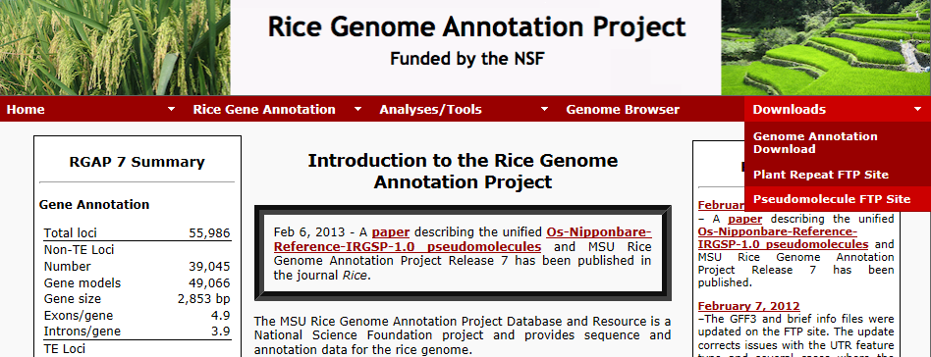

On the left side, click on the 'pseudomolecules' directory, then click on 'version 6.1' and then click on 'chr06.dir'. This gives a list of zipped files containing different information on the annotation of this chromosome.

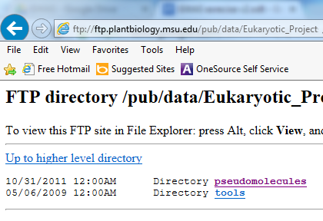

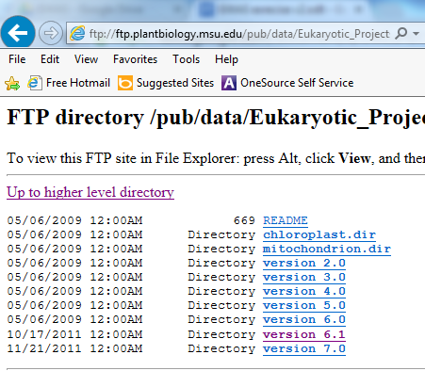
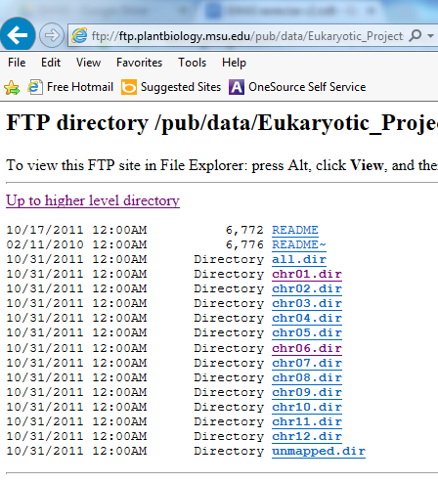

Right click on 'chr06.TU.model_brief_info.6.1.gz' and choose 'Copy Link Location' or “Copy Shortcut” depending on web browser

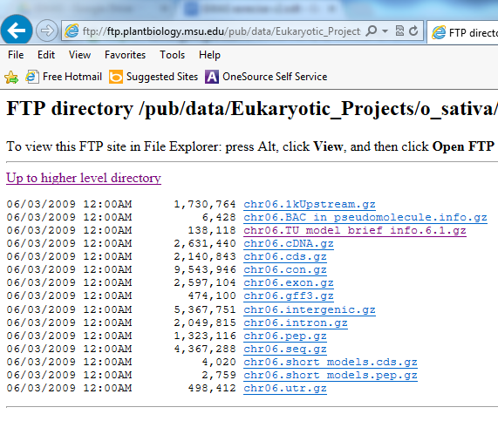

In the Terminal, use the command wget to download this file into an appropriate directory, e.g in this example:

~/rice_GWAS/sativas_GWAS/A_FT

wget ftp://ftp.plantbiology.msu.edu/pub/data/Eukaryotic_Projects/o_sativa/annotation_dbs/pseudomolecules/version_6.1/chr06.dir/chr06.TU_model_brief_info.6.1.gz

Now uncompress this file

gunzip chr06.TU_model_brief_info.6.1.gz

and open it in LibreOffice Calc:

Applications / Office / Libre Office Calc
File / Open

[Press Ctrl+L] then paste into the location:

~/rice_GWAS/sativas_GWAS/A_FT/chr06.TU_model_brief_info.6.1

[Open] to import the tab-delimited file

[Separator Options]
[✓] Tab [ ] Comma [ ] Semicolon [ ] Space [ ] Other

[OK]

Spend a bit of time changing the column widths so you can see the column headings clearly.

Examine the file, it contains every annotated gene on chromosome 6 listed in order. Column A indicates the chromosome and B gives the locus name. Column E and F give the start and end positions on the genome while column L gives the annotation - a computer-generated description of what the gene most likely is. Note, while most genes have only one row in this spreadsheet, some have more than one when there is evidence that more than one sequence is produced from the same gene. An example is LOC_Os06g01304 which has three rows as three splice variants are recognised, named LOC_Os06g01304.1, LOC_Os06g01304.2 and LOC_Os06g01304.3.

Go down the list until in column E you get to around 9,300,000 (should be lines 1790-1841). Then highlight the rows between 9,330,000 and 9,730,000. That is the genes within 200 kbp of the most significant marker. How many genes in this list? (I make it 52). How many are transposon or retro-transposons? (I make it 15). That leaves 37 candidate genes. Are any of these good candidate genes for a flowering time QTL? The chances are that if you do not study flowering time, you will not know this. But if you did, you might think LOC_Os06g16370, annotated as 'CCT/B-box zinc finger protein, putative, expressed' is an excellent candidate, especially if you knew it is one of the best rice orthologs of the Arabidopsis gene 'CONSTANS' which is a master regulator of flowering time. This gene was the first ever cloned rice QTL and is called Hd1. See Takahashi et al., 2009 and cited references for more information on Hd1, and Zhao et al., 2011 for the GWAS mapping of flowering time to Hd1.

The next step in deciding if this gene is a good candidate is to examine if there are polymorphisms within the population either at the level of gene expression or at the level of the protein sequence. If neither exist, this cannot be the causative gene. There is a problem with this gene for us, however. That is, there are 17 recognised alleles of this gene (Takahashi et al., 2009) making it difficult to examine in a workshop like this. For this reason, we will turn our attention to another well studied phenotype, plant height.

Examine the Manhattan Plot you created in step 3 for plant height (This should be in the rice_GWAS/sativas413/A_PH directory).

evince ~/rice_GWAS/sativas_GWAS/A_PH/A_PH_sativas_GWAS.manh.pdf

There is only one SNP with an association that takes it above the Bonferroni adjusted p-value threshold. Perhaps some of you have an idea what the gene responsible is. First let’s see where on the genome this SNP is located. As you did for flowering time import the file "A_PH_sativas_GWAS.manh" in the A_PH sub-directory into R e.g. in this example:

setwd("~/rice_GWAS/sativas_GWAS/A_PH")

and import the file and assign it to an object (called aph in this case)

aph <- read.table("A_PH_sativas_GWAS.manh", header=TRUE, sep="\t")

and order the object by ascending p-value

aph.ord <- aph[order(aph$P),]

take a look at the top six SNPs with the lowest p-value

head(aph.ord, n=6)

SNP CHR BP A1 A2 MAF NCHROBS P
5010 id1024441 1 38537795 1 2 0.06720 744 1.185591e-06
5009 id1024438 1 38516211 1 2 0.06283 748 1.795310e-06
5172 id1025292 1 39798777 1 2 0.14130 750 2.822680e-06
5177 id1025321 1 39823606 1 2 0.14100 752 2.990665e-06
5182 id1025336 1 39829095 1 2 0.14020 742 4.467350e-06
4952 id1024159 1 38111539 1 2 0.05291 756 7.834389e-06

The most significant marker is id1024441 at 38,5377,795 bp. Its MAF value is low at 6.7% but it is still above our 5% threshold. Download the chromosome 1 annotation using the same steps you used for chromosome 6. Once you have opened the annotation of chromosome 1 in LibreOffice Calc, go down to about 38,500,000 base pairs (line 7167). Look at the annotation of genes within 200 kbp of this location. Is there anything that you think is a good candidate gene for a plant height QTL?

The gene LOC_Os01g66100 at 38.38 Mbp and which is annotated as 'gibberellin 20 oxidase 2, putative, expressed' is a very well-known gene, sd1 the semi-dwarfism gene used in the green revolution in rice (Sasaki et al 2002). The molecular characterisation of sd1 by Sasaki et al. (2002) identified that a 383 bp deletion was responsible for semi-dwarfism in many short cultivars. Using the program IGV (Integrative Genome Viewer) you will now look at the alignment of next generation sequence reads in cultivars Bala and Azucena, the parents of a mapping population where QTLs for plant height also map to this region (Price 2006).

The Integrative Genomics Viewer (IGV) is a high-performance visualization tool for interactive exploration of large, integrated genomic datasets. It supports a wide variety of data types, including array-based and next-generation sequence data, and genomic annotations.

http://www.broadinstitute.org/igv/

IGV can be run directly on your own Windows, Mac or Linux PC/laptop.

http://www.broadinstitute.org/software/igv/download

However, for this exercise, we will be using the stand-alone version of IGV installed on "Aryabhatta" with the "x2go" remote desktop client. Open a new MATE terminal on the "x2go" desktop as before and type:

igv

This will start IGV and display the main IGV window. IGV has the Human genome loaded by default. Replace this with the Oryza sativa (release 7) genome from the menu at the top of the IGV window:

Genomes / Load Genome From Server / O. Sativa (release 7)

[note: Do not download the sequence data, just the genome annotations]

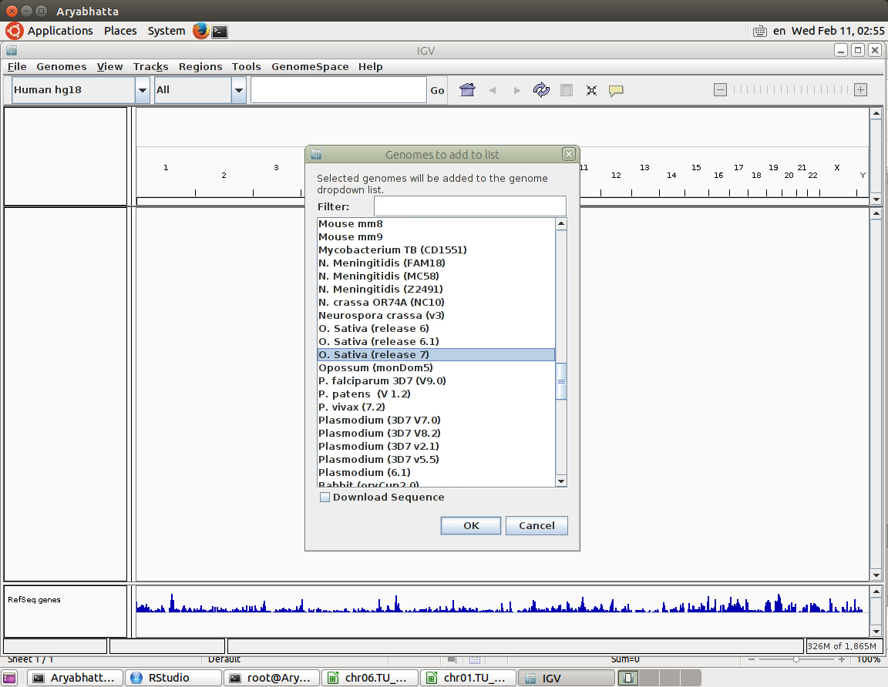

Now load the Azucena and Bala alignments in 'BAM' files from:

Aryabhatta:/work/version_7_Bam_files

Use the menu at the top of the main IGV window:

File / Load from File /

Azucena_v7.bam
Bala_final.bam

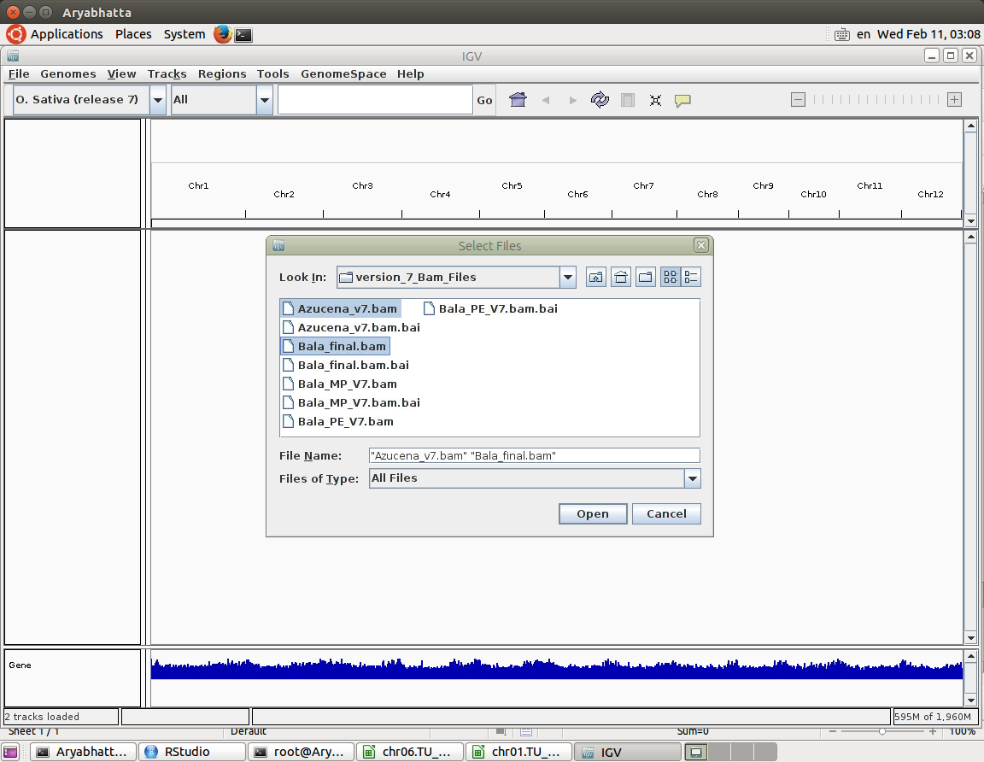

Once you have opened the BAM files for these two cultivars you need to navigate to the gene of interest. In the second box, where it says 'INSERT LOCUS NAME HERE' in the figure below, put the name of the gene we are interested in; i.e. 'LOC_Os01g66100' and press 'ENTER'.

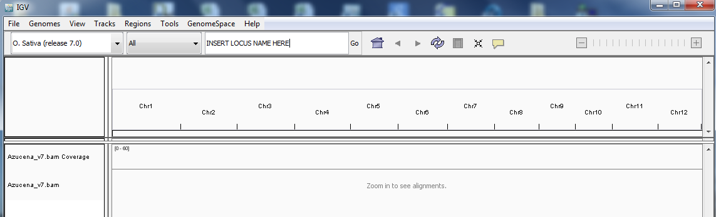

You will be taken to a view of approximately 7,000 bp of the genome centred on the gene of interest. At the very bottom is the reference 'Nipponbare' gene model in blue, indicating the direction of transcription, the location of the introns (thin lines) untranslated regions (medium thick lines) and exons (thick lines). Above that for both Azucena and Bala are two windows, the lower one giving individual sequence reads of 50-120 bp in size. Above that is a window displaying read depth (average of 25 in Azucena, 56 in Bala).

This data was sequenced using an approach called 'Paired Ends'. That means each sequence is read from both ends, giving two sequences of opposite direction which should both align near each other. For the aligned reads there is a colour coding system. Reads with good quality alignment are in grey while reads where alignment is poor are white (and should not be considered reliable). Reads are given a colour when they align well but their paired read does not align to the same region. These might be unreliable or an indication of some structural alteration in the genome between this cultivar and the reference. SNPs and small insertions and deletions are visible.

Try moving around this region of the genome, and try zooming in and zooming out until you get a good feel for the way IGV works to allow you to see sequence and how it highlights difference between the sequence of interest and the reference.
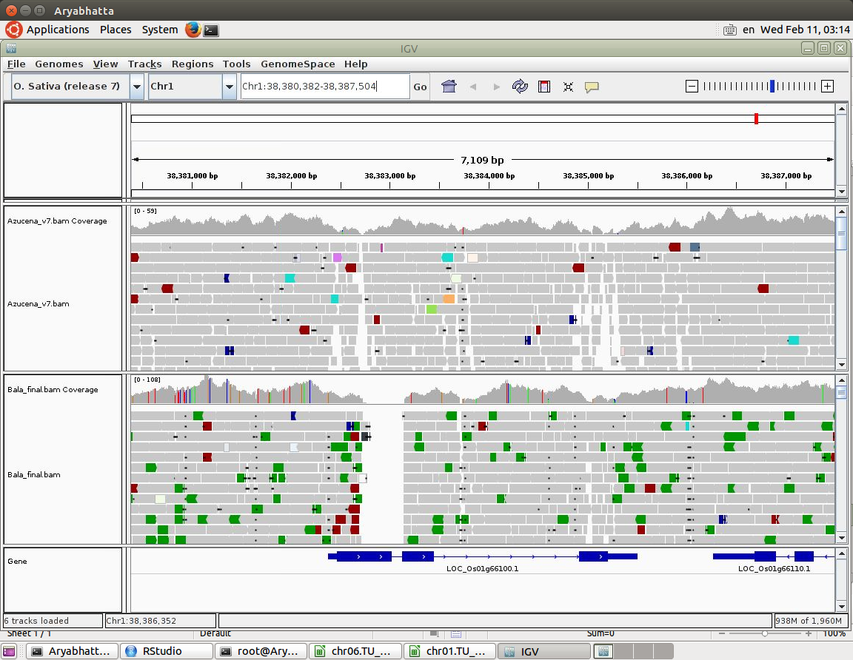

Zoom out again until you can see the whole gene (should be a range of about 3,500 bp). Observe the gap in the Bala sequence between the end of the first exon and the start of the second. Can you work out the size of the gap? Zoom in over that region to make it easier. You should find it rather hard to decide the size of the gap. The right end appears to be at 38,383,142 bp but it is not easy to be sure exactly where the start of the deletion is. None the less, it is clear there does seem to be a section of the genome about 400 bp missing in Bala and this is powerful evidence that it has the 383 bp deletion that was identified by Sasaki et al., 2002 and that it has a non-functional allele of this gene.

Use IGV to look at Hd1 (LOC_Os06g16370). Notice with this gene that Azucena and Bala differ from each other but not as much as they both differ from Nipponbare, perhaps reflecting the fact that both are tropical while Nipponbare is a temperate plant. There is a strong suggestion that there is a deletion in both Azucena and Bala in the first exon. To confirm this it would probably be best to PCR amplify this region and sequence it using Sanger Sequencing.

References

Kang HM, Sul JH, Service SK, Zaitlen NA, Kong SY, Freimer NB, Sabatti C, Eskin E. (2010) Variance component model to account for sample structure in genome-wide association studies. Nat. Genet. 42:348-54
Norton, G. J., Douglas, A., Lahner, B., Yakubova, E., Guerinot, M. Lou, Pinson, S. R. M., Tarpley, L., et al. (2014). Genome wide association mapping of grain arsenic, copper, molybdenum and zinc in rice (Oryza sativa L.) grown at four international field sites. PloS one, 9(2).

Price AH (2006) Believe it or not, QTLs are accurate. Trends in Plant Science 11: 213-216

Sasaki, A. et al. (2002) Green revolution: A mutant gibberellin-synthesis gene in rice - New insight into the rice variant that helped to avert famine over thirty years ago. Nature 416, 701-702

Takahashi Y, Teshima KM, Yokoi S, Innan H, Shimamoto K (2009) Variations in Hd1 proteins, Hd3a promoters, and Ehd1 expression levels contribute to diversity of flowering time in cultivated rice. PNAS 106: 4555-4560

Zhao K, Wright M, Kimball J, Eizenga G, McClung A, Kovach M, Tyagi W, Ali ML, Tung CW, Reynolds A, Bustamante CD, McCouch SR (2010). Genomic Diversity and Introgression in O. sativa Reveal the Impact of Domestication and Breeding on the Rice Genome. PLoS One. 2010; 5(5): e10780. Published online 2010 May 24. doi: 10.1371/journal.pone.0010780

Code for the Manhattan plots has been modified from the original code created by Stephen Turner (http://StephenTurner.us/)

