一：hibernate介绍
持久层框架（数据层）
持久化：将程序数据在瞬时状态（内存）和持久状态（磁盘）之间转换的机制
ORM思想：(Object/Relation Mapping): 对象/关系映射
完成对象数据到关系型数据映射的机制称为对象-关系映射，简称ORM。
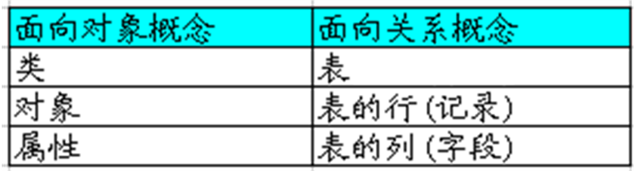
将关系数据库中表中的记录映射成为对象，以对象的形式展现，程序员可以把对数据库的操作转化为对对象的操作。也就是开发者采用面向对象的方式来操作关系数据库。
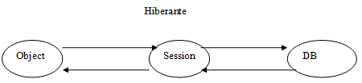

二：hibernate插件安装
1. 在线更新
打开eclipse工具，选择HELP---Install new software----输入网址，如我们这里要安装hibernate tools进行逆向工程的建立，输入http://download.jboss.org/jbosstools/updates/development 选择hibernate tools----安装更新。
2. 手动安装
①通过网络下载好需要的插件，比如我们这里要安装的hibernate tools插件的网址为：
http://sourceforge.net/projects/jboss/files/JBossTools/JBossTools3.1.x/HibernateTools-3.3.0.v201003050540R-H56-GA.zip/download将文件下载下来。
②（直接安装方法）解压文件后，将其中的plugins和features文件夹分别复制到eclipse安装路径（或当前使用时的存放路径）下的plugins和features文件夹内，重启eclipse.（一般不推荐使用这种方法）
③（扩展安装发放）解压文件后，在eclipse安装路径（或当前使用时的存放路径）下新建一个名为links的文件夹，在links下新建一个hibetnate.link文件和eclipse文件夹。将解压后得到的plugins和features文件夹放入eclipse文件夹内。新建的hibetnate.link文件的主要内容为：
Path=<F:/tkyky/eclipse/links/eclipse>
重启eclipse工具即可。

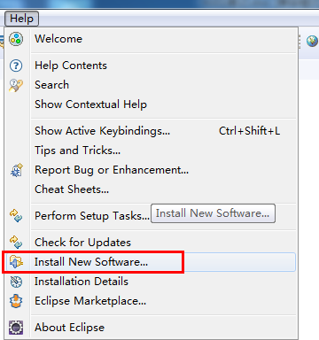

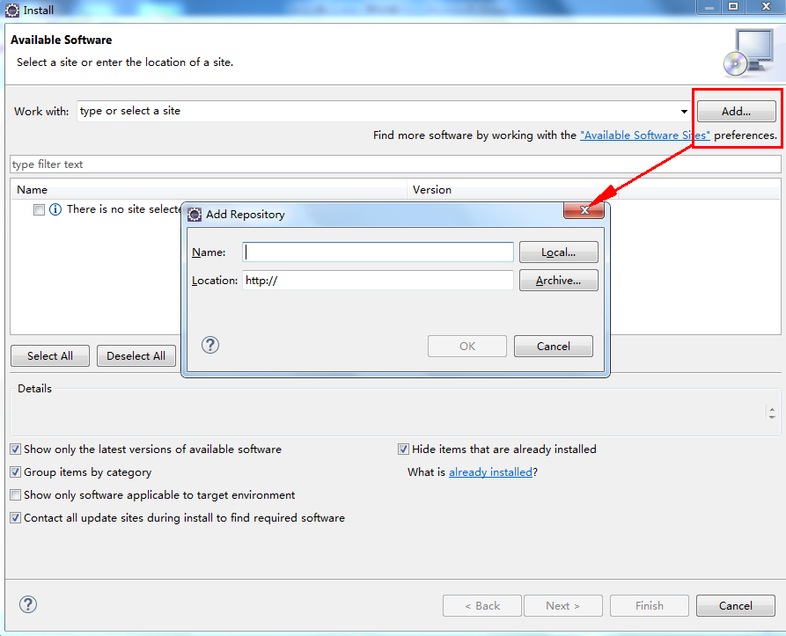

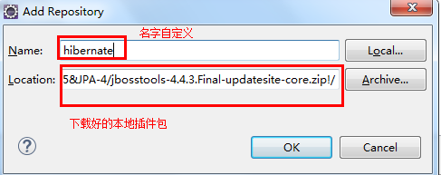
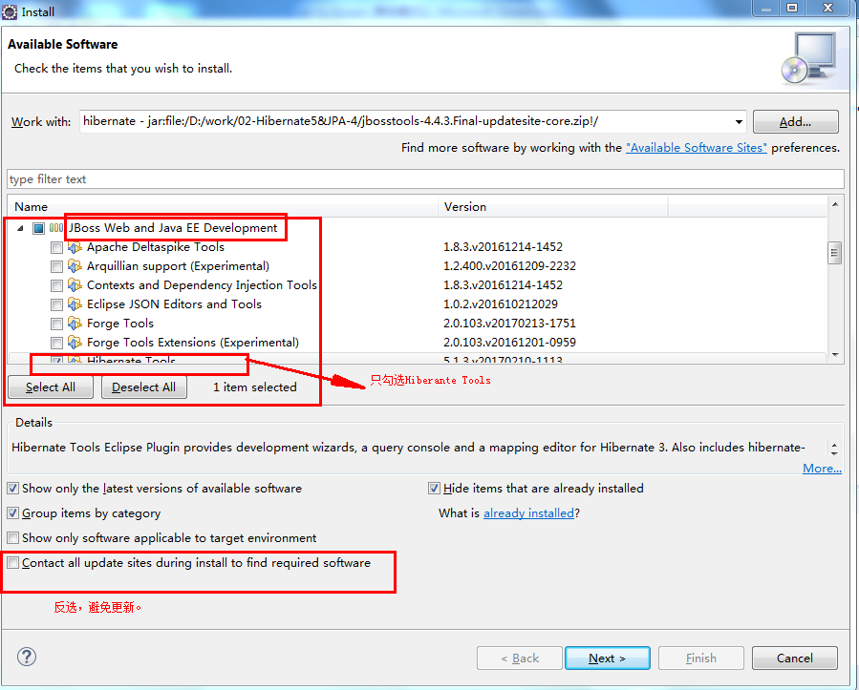

三：测试插件

1，创建hibernate配置文件、console配置文件
选中新建的Hibernate项目，右键“New”-->“Other”-->“Hibernate”，选择“...(cfg.xml)”,选择目录(src),保持原有名称不变,确认即可。
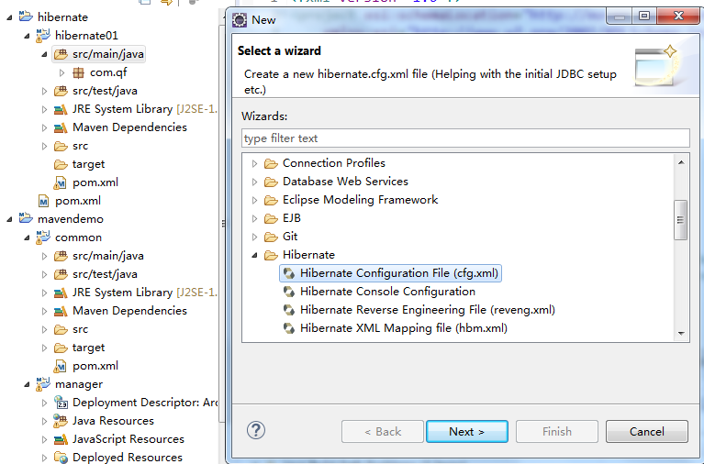
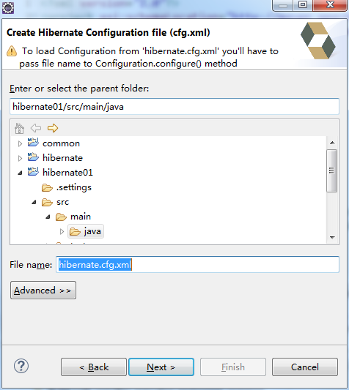

Hibernate.cfg.xml配置文件说明：
<?xml version="1.0" encoding="UTF-8"?>
<!DOCTYPE hibernate-configuration PUBLIC
"-//Hibernate/Hibernate Configuration DTD 3.0//EN"
"http://hibernate.sourceforge.net/hibernate-configuration-3.0.dtd">
<hibernate-configuration>
<session-factory>
<!-- 数据库连接配置 -->
<property name="hibernate.connection.driver_class">com.mysql.jdbc.Driver</property>
<property name="hibernate.connection.url">jdbc:mysql://localhost:3306/qf</property>
<property name="hibernate.connection.username">root</property>
<property name="hibernate.connection.password"></property>
<!-- SQL 方言 -->
<property name="dialect">org.hibernate.dialect.MySQL5Dialect</property>
<!-- 在控制台输出sql语句 -->
<property name="show_sql">true</property>
<!-- 在启动时根据配置更新数据库 -->
<property name="hbm2ddl.auto">update</property>
<mapping resource="com/qf/pojo/Userinfo.hbm.xml"/><!-- 注册我们的实体映射类-->
</session-factory>
</hibernate-configuration>

2，链接数据库MySQL
用户名为root，密码为“”，端口号为默认端口号。填写会自动生成配置文件:
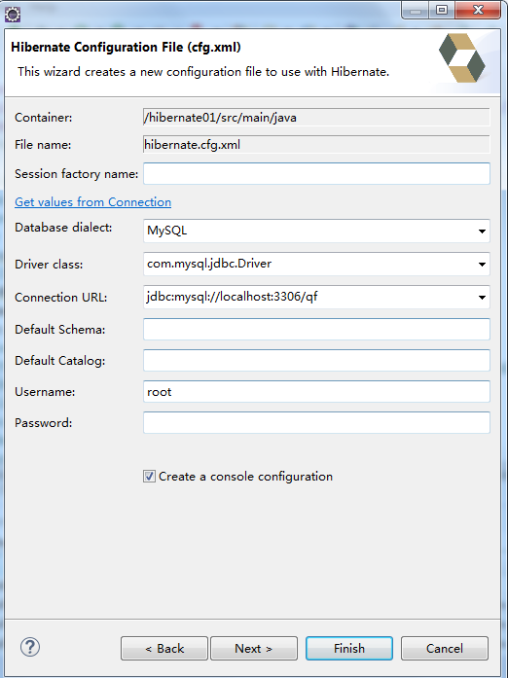

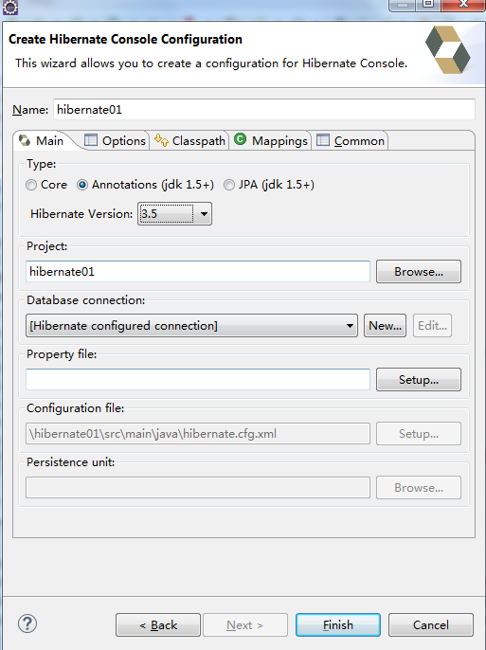
注意这里选择约束插件是Hibernate3.5，annotation1.5.
反向工程有问题可以用MySQL5的默认链接org….Driver来测试。

3, 创建reverse文件。
选中项目右键->new->other->Hibernate->Hibernate Reverse Engineering file
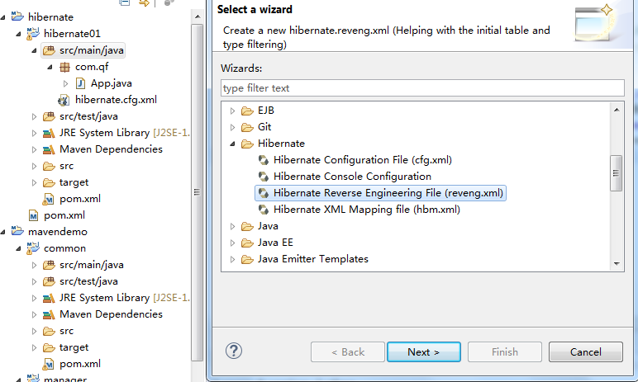
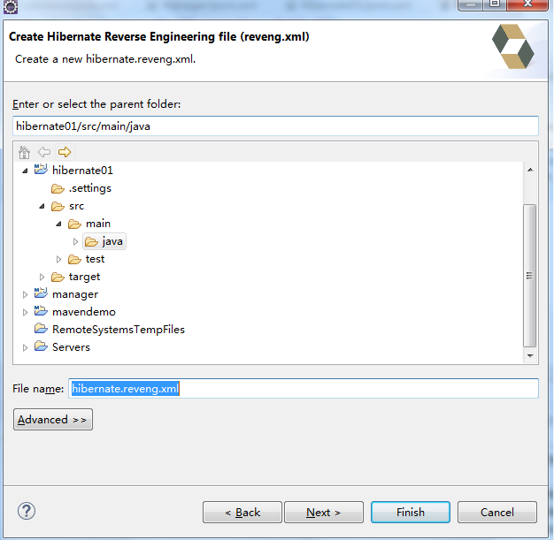
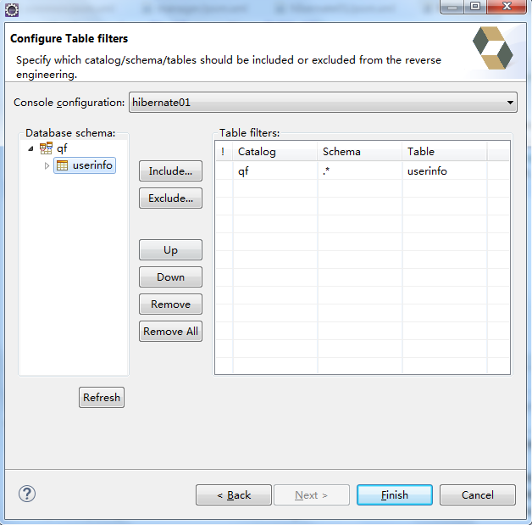

4，增加Hibernate Code Generation按钮
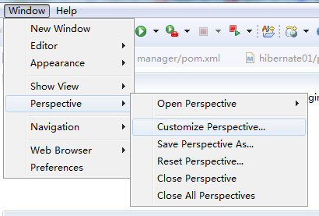
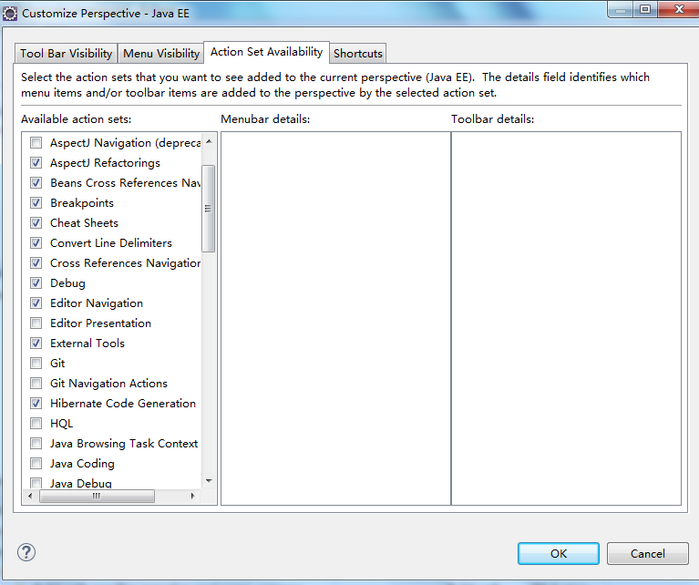
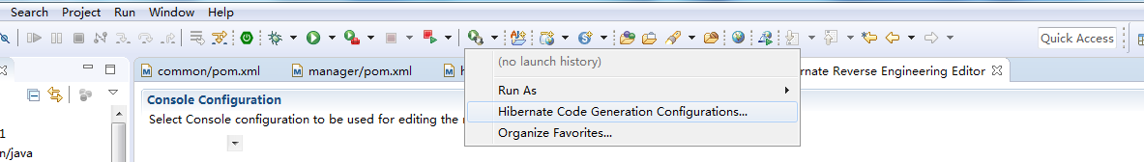
点击Hibernate Code Generation configuration

5，反向工程创建POJO
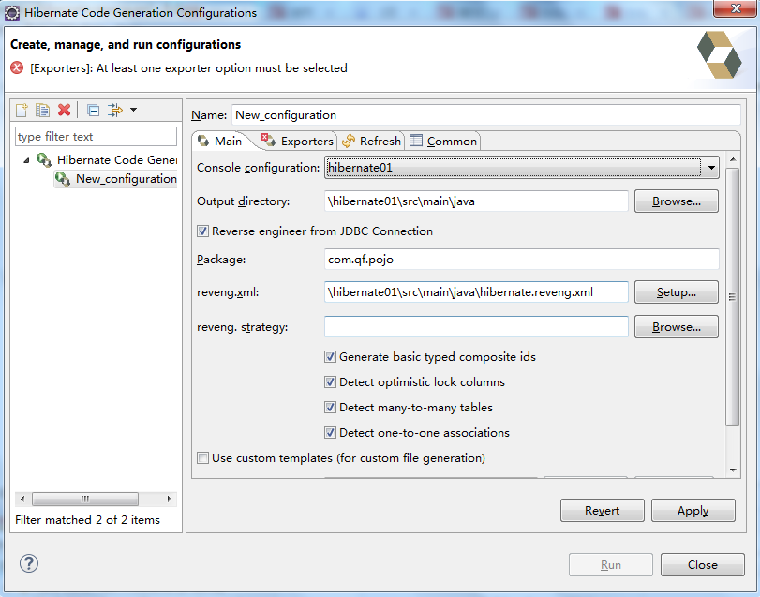
- console configuration：选择在第二点中我们创建的数据库连接。
- output directory：配置执行后输出的目录，生成hbm、PO类等。
- package：包名，这里请输入PO类存放的路径。
- reveng.xml：生成mapping和PO类的重要配置文件。
reveng.xml若没生成可以在这里创建。

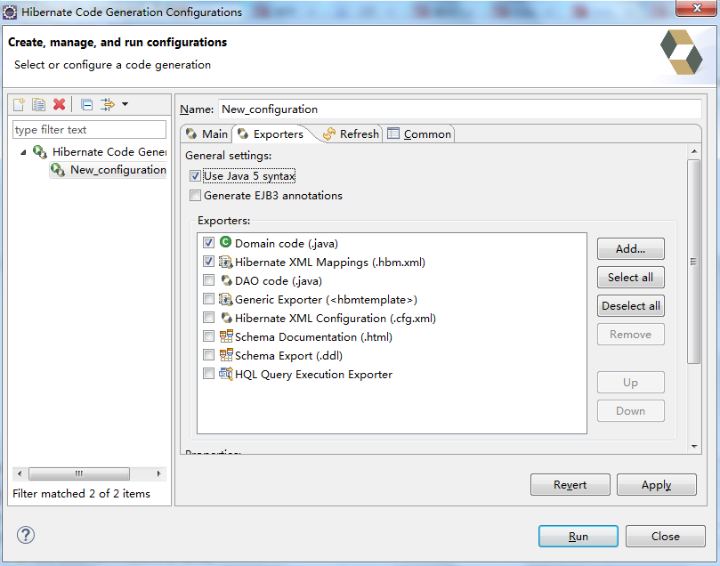
然后点击RUN，生成相应的文件。一般来说自动生成的mapping文件需要修改后才能用。
反向工程具备记忆能力：
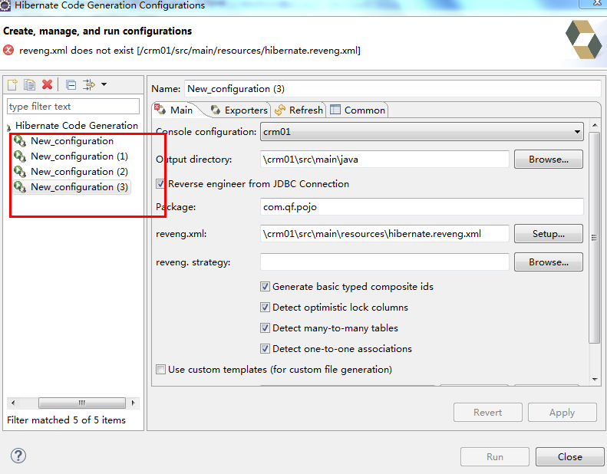
新建立的时候建议删除后再生成。

四：案例

1,表：
orders和customer两张表(即订单、客户表，一个客户可以有多个订单)，customer和orders是一对多的关系。
create table customer(
id int(11) primary key auto_increment,
name varchar(20),
phone_number varchar(20)
);

create table orders(
id int(11) primary key auto_increment,
order_id varchar(20),
create_time datetime,
customer_id int(11)
);

2,POJO类
public class Customer {
private int id;
private String name;
private String phoneNum;
private Set<Order> orderSet;
//setter and getter
}
public class Order {
private int id;
private String orderId;
private Date createTime;
private Customer customer;

public Order() {}

public Order(int id, String orderId, Date createTime) {
this.id = id;
this.orderId = orderId;
this.createTime = createTime;
}
//setter and getter
}

3.hbm文件配置
Customer.hbm.xml：
<?xml version="1.0" encoding="UTF-8"?>
<!DOCTYPE hibernate-mapping PUBLIC
"-//Hibernate/Hibernate Mapping DTD 3.0//EN"
"http://www.hibernate.org/dtd/hibernate-mapping-3.0.dtd">

<hibernate-mapping>
<!-- 指定类和表的映射 -- >
<class name="com.demo.hibernate.one2many.Customer" table="customer">
<!-- 指定持久化类的OID(Object identifier对象标识) 和表的主键的映射 -- >
<id name="id" type="int">
<generator class="increment"></generator>
</id>
<!-- 映射类的属性和表的字段 -- >
<property name="name" type="string" column="name"></property>
<property name="phoneNum" type="string" column="phone_number"></property>
<!-- inverse=true表示由对方去维护关联关系 -->
<set name="orderSet" inverse="true">
<key column="customer_id"></key>
<one-to-many class="com.demo.hibernate.one2many.Order"/>
</set>
</class>
</hibernate-mapping>
Order.hbm.xml：
<?xml version="1.0" encoding="UTF-8"?>
<!DOCTYPE hibernate-mapping PUBLIC
"-//Hibernate/Hibernate Mapping DTD 3.0//EN"
"http://www.hibernate.org/dtd/hibernate-mapping-3.0.dtd">

<hibernate-mapping>
<class name="com.demo.hibernate.one2many.Order" table="orders">
<id name="id" type="int">
<generator class="increment"></generator>
</id>
<property name="orderId" column="order_id" type="string"></property>
<property name="createTime" column="create_time" type="timestamp"></property>
<many-to-one name="customer" class="com.demo.hibernate.one2many.Customer" column="customer_id"></many-to-one>
</class>
</hibernate-mapping>

主键生成策略：
The optional <generator> child element names a Java class used to generate unique identifiers for instances of the persistent class.
All generators implement the interface org.hibernate.id.IdentifierGenerator. This is a very simple interface;
some applications may choose to provide their own specialized implementations. However, Hibernate provides a range of built-in implementations. There are shortcut names for the built-in generators:
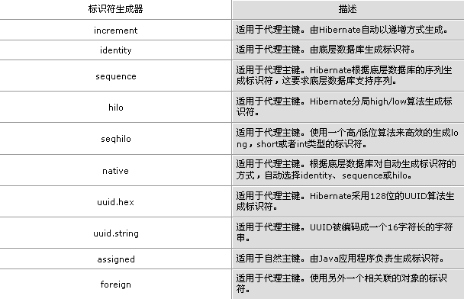

4,工具类：

public class SessionUtils {
//获取SessionFactory
public static SessionFactory getSessionFactory(){
StandardServiceRegistry registry = null;
SessionFactory sessionFactory = null;
try{
registry = new StandardServiceRegistryBuilder().configure("hibernate.cfg.xml").build();
//不指定文件名默认是找hibernate.cfg.xml文件
//registry = new StandardServiceRegistryBuilder().configure().build();
sessionFactory = new MetadataSources(registry).buildMetadata().buildSessionFactory();
}catch(Exception ex){
ex.printStackTrace();
StandardServiceRegistryBuilder.destroy(registry);
}
return sessionFactory;
}

//打开并返回一个Session
public static Session openSession(){
return getSessionFactory().openSession();
}

//关闭Session
public static void closeSession(Session session){
if(null != session){
session.close();
}
}
}

5,HQL
A.获取所有的Order对象，得到一个List集合
public void list(){
String hql = "from Order";
Query<Order> query = session.createQuery(hql, Order.class);
List<Order> list = query.getResultList();
for(Order o : list){
System.out.println(o.getOrderId() + "::" + o.getCreateTime());
}
}

B获取Order的分页数据，得到一个List集合
public void pageList(){
String hql = "from Order";
Query<Order> query = session.createQuery(hql, Order.class);
/**
* setFirstResult() 是设置从第几条开始
* setMaxResults() 是设置每页多少条数据
*/
query.setFirstResult(0).setMaxResults(4);
List<Order> list = query.getResultList();
for(Order o : list){
System.out.println(o.getOrderId() + "::" + o.getCreateTime());
}
}

C.多条件查询，返回List集合(第一种形式：索引占位符)
public void multiCretiera(){
String hql = "from Order where orderId like ? and createTime between ? and ?";
Query<Order> query = session.createQuery(hql, Order.class);
String beginDateStr = "2016-07-26 00:00:00";
String endDateStr = "2016-07-26 23:59:59";
SimpleDateFormat sdf = new SimpleDateFormat("yyyy-MM-dd hh:mm:ss");
Date beginDate = null;
Date endDate = null;
try {
beginDate = sdf.parse(beginDateStr);
endDate = sdf.parse(endDateStr);
} catch (ParseException e) {
e.printStackTrace();
}
query.setParameter(0, "%D%").setParameter(1, beginDate).setParameter(2, endDate);
List<Order> list = query.getResultList();
for(Order o : list){
System.out.println(o.getOrderId() + "::" + o.getCreateTime());
}
}

D多条件查询，返回List集合(第二种形式：命名占位符)
public void multiCretiera1(){
String hql = "from Order where orderId like :orderId and createTime between :beginDate and :endDate";
Query<Order> query = session.createQuery(hql, Order.class);
String beginDateStr = "2016-07-26 00:00:00";
String endDateStr = "2016-07-26 23:59:59";
SimpleDateFormat sdf = new SimpleDateFormat("yyyy-MM-dd hh:mm:ss");
Date beginDate = null;
Date endDate = null;
try {
beginDate = sdf.parse(beginDateStr);
endDate = sdf.parse(endDateStr);
} catch (ParseException e) {
e.printStackTrace();
}
query.setParameter("orderId", "%D%").setParameter("beginDate", beginDate).setParameter("endDate", endDate);
List<Order> list = query.getResultList();
for(Order o : list){
System.out.println(o.getId() + "::" + o.getOrderId());
}
}

E：大于条件的查询，使用索引占位符
public void gt(){
String hql = "from Order where id > ?";
Query<Order> query = session.createQuery(hql, Order.class).setParameter(0, 3);
List<Order> list = query.getResultList();
for(Order o : list){
System.out.println(o.getId() + "::" + o.getOrderId());
}
}

F：更新操作
public void update(){
String hql = "update Order set createTime = ? where id = ?";
Transaction tx = session.beginTransaction();
Query<?> query = session.createQuery(hql).setParameter(0, new Date()).setParameter(1, 1);
int i = query.executeUpdate();
System.out.println(i);
tx.commit();
session.close();
}

G：删除操作
public void delete(){
//in 后面的括号可加可不加
String hql = "delete from Order where id in (:idList)";
Transaction tx = session.beginTransaction();
List<Integer> list = new ArrayList<Integer>();
list.add(1);
list.add(2);
Query<?> query = session.createQuery(hql).setParameter("idList", list);
int i = query.executeUpdate();
System.out.println(i);
tx.commit();
session.close();
}

H：获取某一列的值
public void singleValue(){
String hql = "select orderId from Order";
Query<String> query = session.createQuery(hql, String.class);
List<String> list = query.getResultList();
for(String o : list){
System.out.println(o);
}
}

I：获取关联对象的结果集
public void getCustomer(){
String hql = "select o.customer from Order o where o.customer.id = 6";
Query<Customer> query = session.createQuery(hql, Customer.class);
List<Customer> list = query.getResultList();
for(Customer o : list){
System.out.println(o.getId() + ";;");
}
}

J：多列数据的查询
public void getObjectArray(){
//String hql = "select o.orderId, o.createTime from Order o";
//String hql = "select o.customer.name, o.customer.phoneNum, o.orderId, o.createTime from Order o";
//String hql = "select o.orderId, o.createTime from Order o join o.customer c";
String hql = "select c.name, c.phoneNum, o.orderId, o.createTime from Order o join o.customer c";
Query<Object[]> query = session.createQuery(hql, Object[].class);
List<Object[]> list = query.getResultList();
for(Object[] o : list){
System.out.println(o[0] + ";;" + o[1] + ";;");
}
}

L：函数查询
public void functionQuery(){
String hql = "select max(id), count(*) from Order";
Query<Object[]> query = session.createQuery(hql, Object[].class);
Object[] obj = query.getSingleResult();
System.out.println(obj[0] + "::" + obj[1] + "::");
}

M：排序
public void descQuery(){
String hql = "from Order order by id desc";
Query<Order> query = session.createQuery(hql, Order.class);
List<Order> list = query.getResultList();
for(Order o : list){
System.out.println(o.getId() + "::" + o.getOrderId());
}
}

N：连接
public void rightJoin(){
String hql = "select o.customer from Order o right join o.customer";
Query<Customer> query = session.createQuery(hql, Customer.class);
List<Customer> list = query.getResultList();
for(Customer c : list){
System.out.println(c.getId());
}
}

