National Cheng Kung University
Department of Electrical Engineering

Introduction to VLSI CAD (Spring 2018)

Lab Session 3

Design and Simulation of DEMUXes

Name | Student ID
劉宥辰 | E24056310
Practical Sections: |  | Points | Marks
Prob A |  | 25
Prob B |  | 25
Prob C |  | 50
Notes

Due Date: 15:00, March 28, 2018 @ moodle

Deliverables
- All Verilog codes including testbenches for each problem should be uploaded.
NOTE: Please DO NOT include source code in the paper report!
- All homework requirements should be uploaded in this file hierarchy or you will not get the full credit.
NOTE: Please DO NOT upload waveforms!
- Important! TA will use the command in Appendix B to check your design under SoC Lab environment, if your code can not be recompiled by TA successfully using the commands, you will not get the full credit.
- If you upload a dead body which we can’t even compile you will get NO credit!
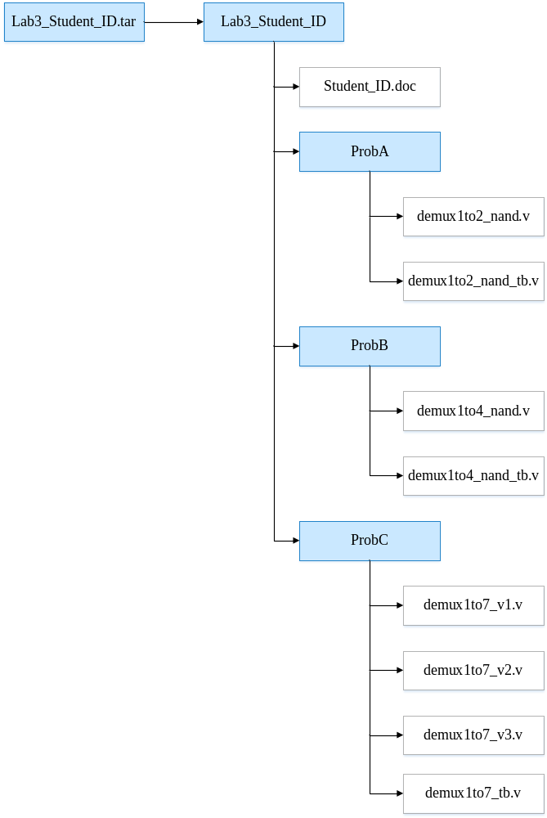
Fig.1 File hierarchy for Homework submission
Objectives:
Help students get familiar with the CAD tools (NC-Verilog & Verdi) for digital logic design. Please go through the hands-on exercise step-by-step.
Prob A: Design Steps
- Understand the function of the target component.
A demultiplexer is a device that takes a single input line and routes it to one of several digital output lines.
Exercise 1-1: Hand draw the symbol of a 1-to-4 DEMUX.
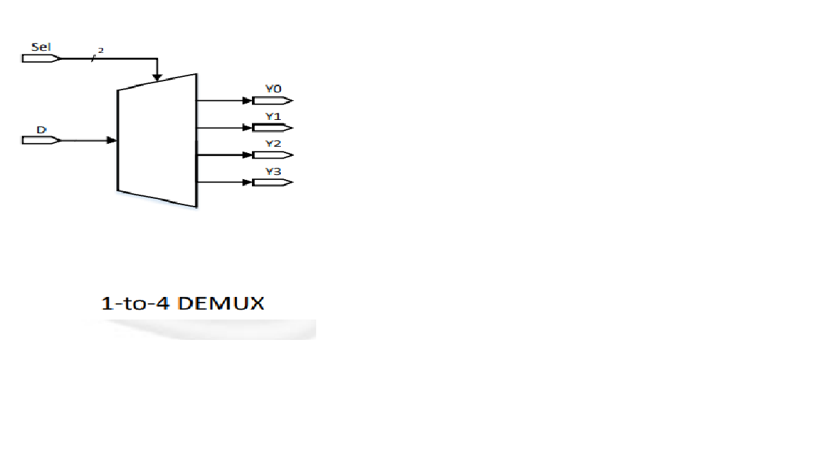

Exercise 1-2: Hand draw the data flow from the input to one of 4 outputs.

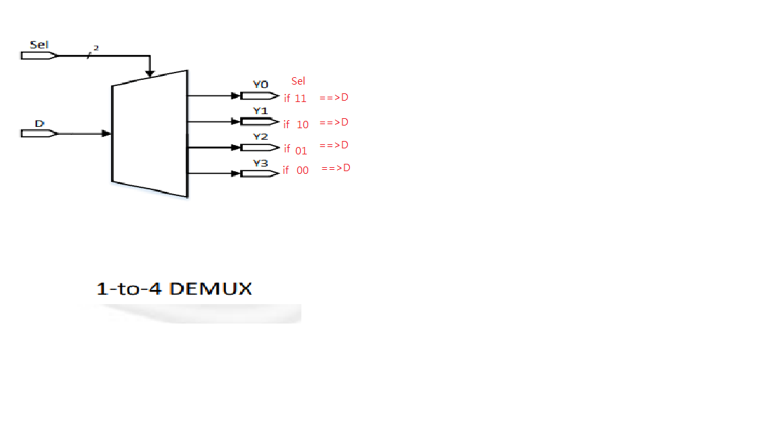

- Describe in digital logic manner for a simple component. Please fill the blank cells in the truth table and complete the Boolean equation of 1-to-2 DEMUX.

Truth Table of 1-to-2 DEMUX
Sel | D | Y0 | Y1
0 | 0 | 0 | 0
0 | 1 | 0 | 1
1 | 0 | 0 | 0
1 | 1 | 1 | 0

Boolean Equation of 1-to-2 DEMUX
Y0 = Sel & D
Y1 = ~Sel & D

- Derive a gate-level implementation

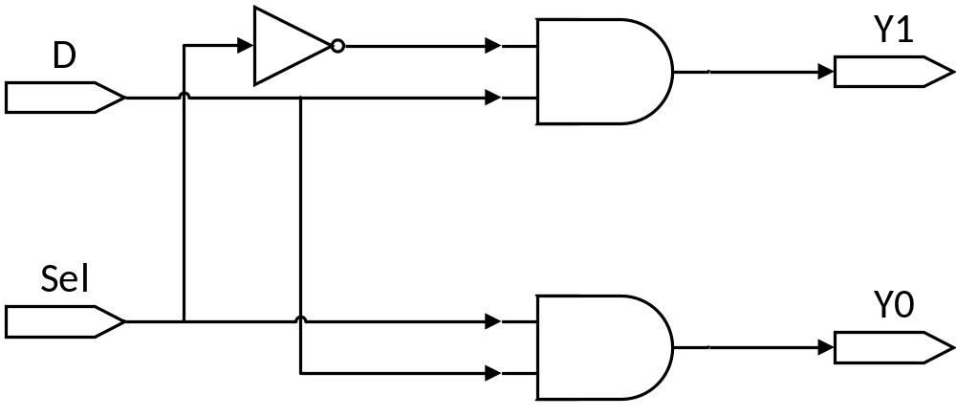
Redraw the gate-level diagram by using 2-input NAND gate.

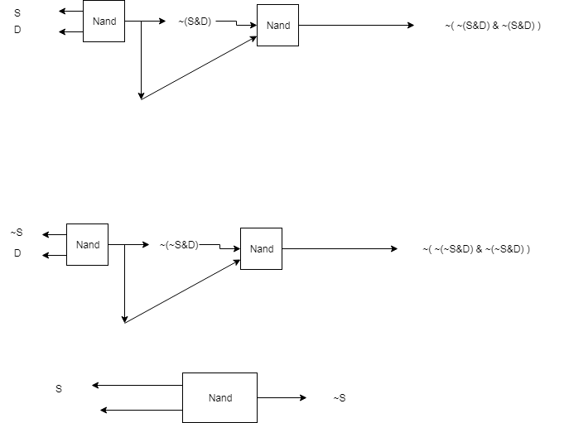

- Implement 1-to-2 DEMUX based on the gate-level diagram you drawn in 3) by verilog code. (The module name should be demux1to2_nand)
- You only need to upload your v-code file to moodle, do not paste your code here.

- Write a testbench for 1-to-2 DEMUX you implemented in 4). (You must write a new TB which is different from Lab3 example source code. The module name should be demux1to2_nand_tb)
- You only need to upload your v-code to moodle, do not paste your code here.

- Compile the code you implemented in 4) using NC-Verilog. If there are errors, please go back to 4) to debug your code and re-compile again. (Hint : The command for compiling is % ncverilog demux1to2_nand.v)

- Simulate your design in 4) with your own testbench in 5).
(Hint: The command for simulation is
% ncverilog demux1to2_nand_tb.v +define+FSDB +access+r)

- Verify your design by comparing the simulation results with the results you predicted. If the results are not the same, please go back to 4) and revise your code. If the simulation results are correct please snapshot the simulation result on the terminal and the waveform you dumped and explain your waveform. (Hint : The command to open nWave is % nWave &)

Your simulation result on the terminal. ( You should $monitor the I/O port like the example TB code does! )
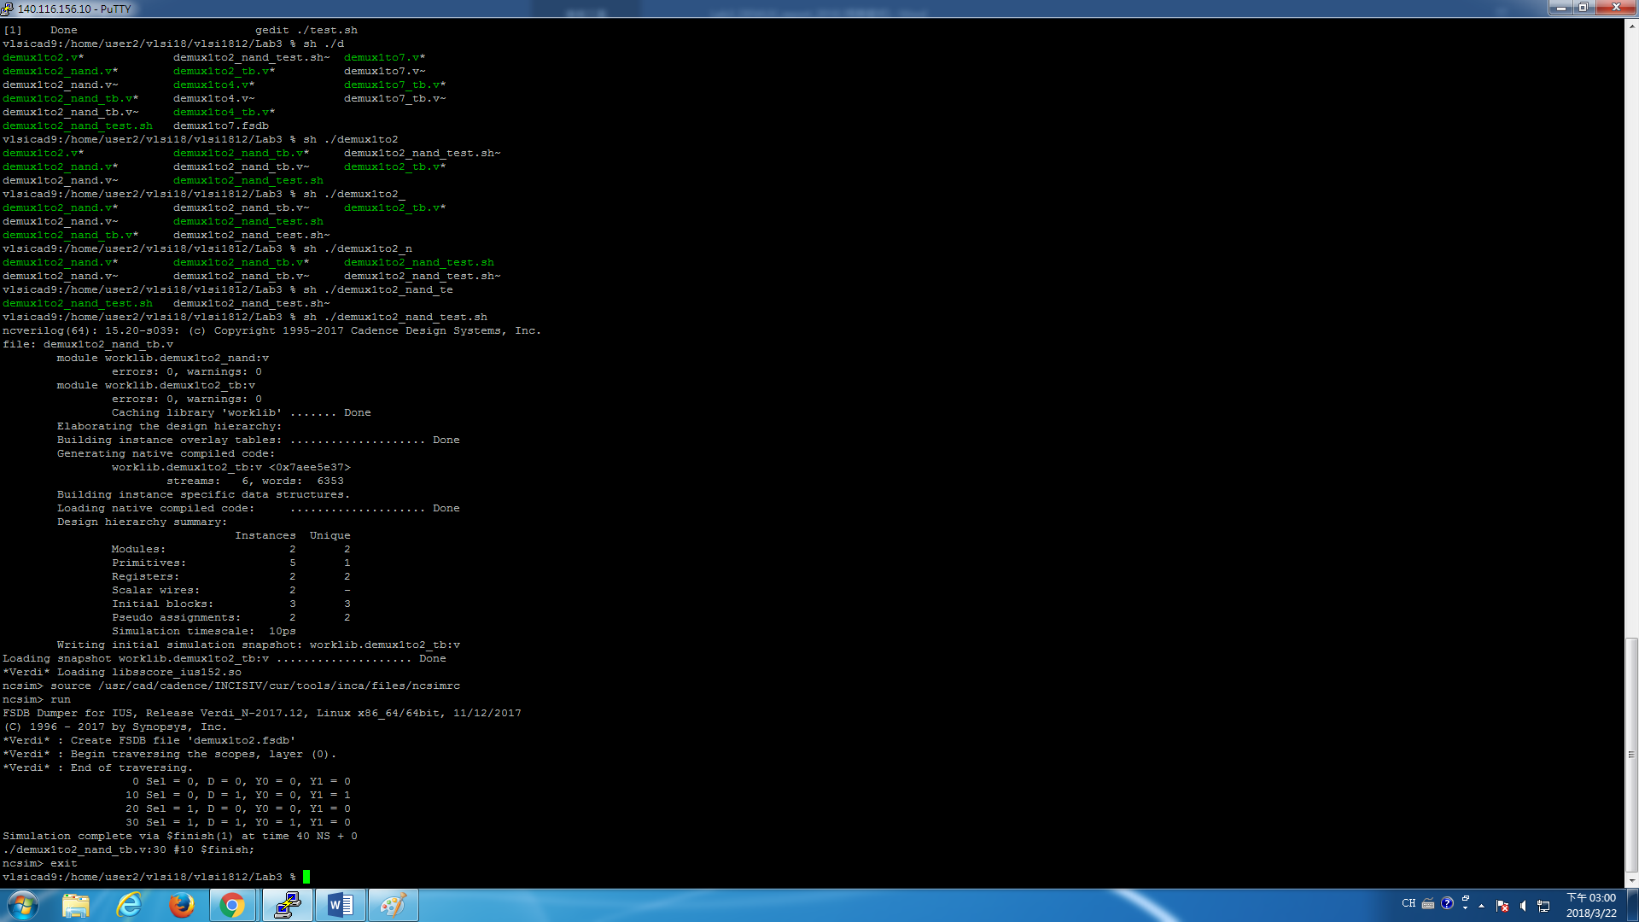
Your waveform :
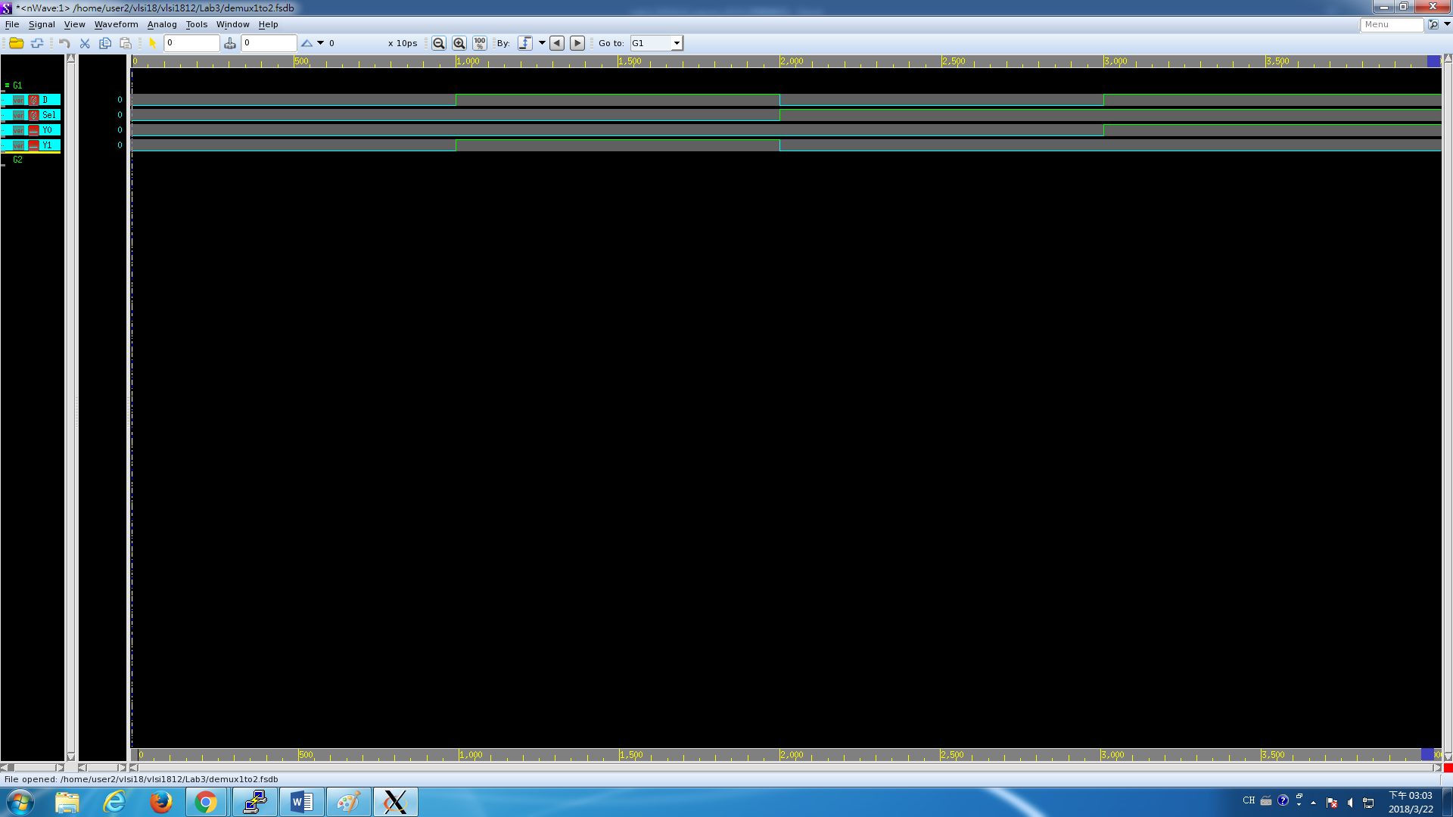

Explanation of your waveform :
Sel | D | Y0 | Y1
0 | 0 | 0 | 0
0 | 1 | 0 | 1
1 | 0 | 0 | 0
1 | 1 | 1 | 0
My Verilog code implement follow the truth table above.
So is the waveform

Prob B: Hierarchical Coding
- Hand draw a 1-to-4 DEMUX using three 1-to-2 DEMUXes.
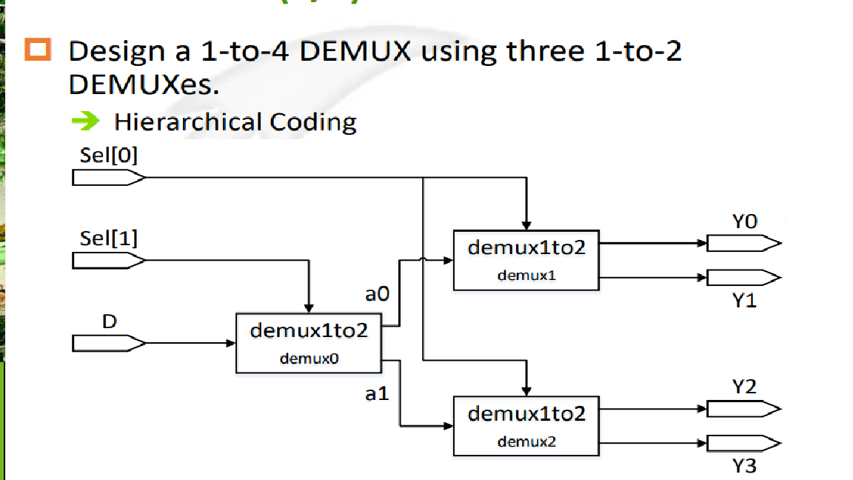

- Implement 1-to-4 DEMUX based on the diagram you drawn in 1) by verilog code. You should use the 1-to-2 DEMUX you designed in Prob A. (The module name should be demux1to4_nand. And the file you include should be demux1to4_nand.v)
- You only need to upload your v-code to moodle, do not paste your code here.

- Write a testbench for 1-to-4 DEMUX you implemented in 2). (You must write a new TB which is different from Lab3 example source code. The module name should be demux1to4_nand_tb)
- You only need to upload your v-code to moodle, do not paste your code here.

- Compile the code you implemented in 2) using NC-Verilog. If there are errors, please go back to 2) to debug your code and re-compile again. (Hint: The command for compiling is % ncverilog demux1to4_nand.v)

- Simulate your design in 3) with your own testbench in 4).
(Hint: The command for simulation is
% ncverilog demux1to4_nand_tb.v +define+FSDB +access+r)

- Verify your design by comparing the simulation results with the results you predicted. If the results are not the same, please go back to 2) and revise your code. If the simulation results are correct please snapshot the simulation result on the terminal and the waveform you dumped and explain your waveform. (Hint : The command to open nWave is % nWave &)

Your simulation result on the terminal. (You should $monitor the I/O port like the example TB code does!)
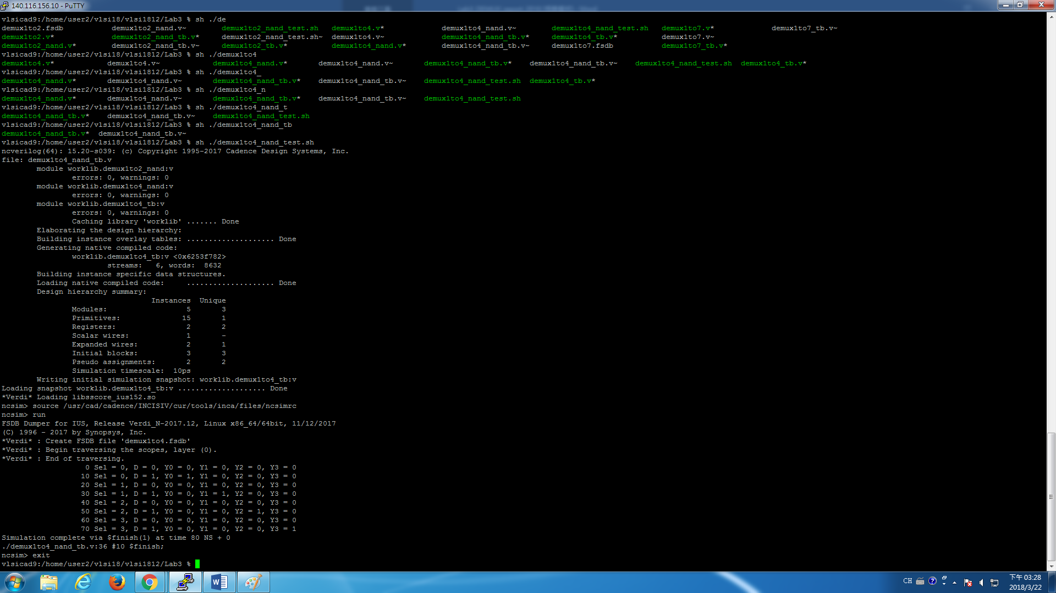
Your waveform :
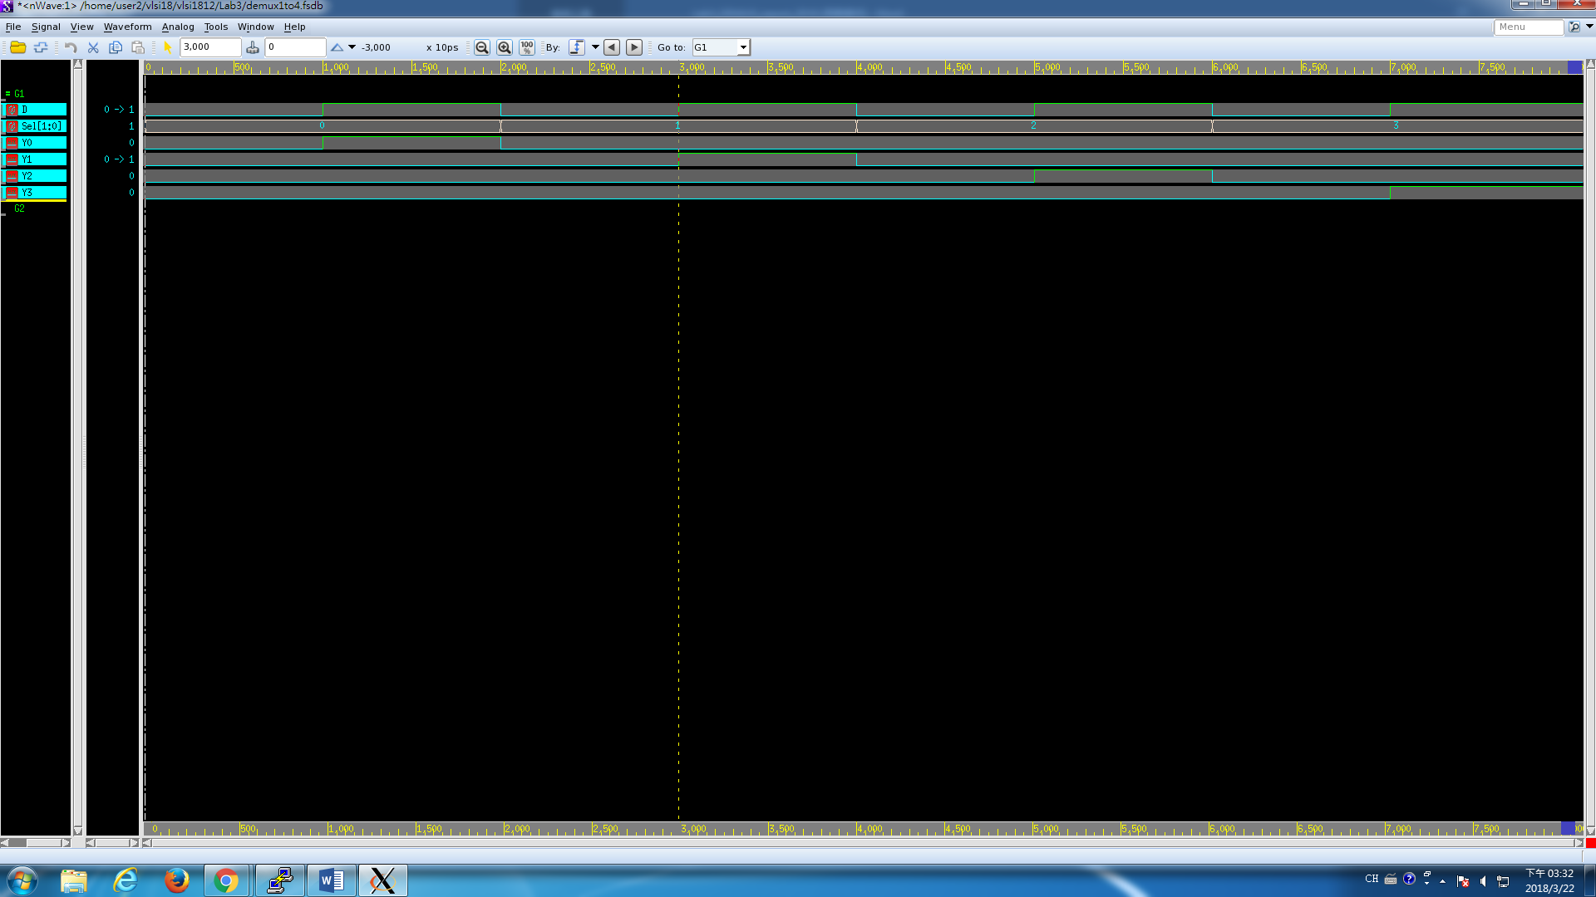

Explanation of your waveform :
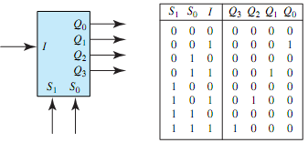
My Verilog code implement follow the truth table above.
So is the waveform.
Prob C: 1-to-7 DEMUX Implementation
- Design a 1-to-7 DEMUX in three ways under gate level. You can use any primitive instantiation, for example, the NOT gate, AND gate, OR gate, XOR gate and etc. You can use hierarchical coding, too.
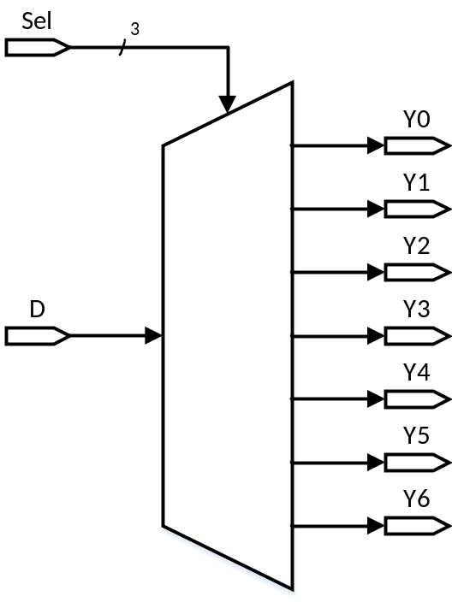
- This time we provide a demux1to7_tb skeleton code for you to use. To implement the missing test patterns please look at the table in Appendix A.
- Please follow these rules or you might have trouble using the provided testbench.
- File names of your design should be named as demux1to7_v1.v, demux1to7_v2.v, demux1to7_v3.v
- Module names in those three files should all be named as demux1to7
- You must follow the port names in the testbench
- Compile command
% ncverilog demux1to7_v1.v (or demux1to7_v2.v or demux1to7_v3.v)
- Simulation command
# For first version of your design
% ncverilog demux1to7_tb.v +define+v1+FSDB +access+r
# For second version of your design
% ncverilog demux1to7_tb.v +define+v2+FSDB +access+r
# For third version of your design
% ncverilog demux1to7_tb.v +define+v3+FSDB +access+r
- In each design, please report:
- The schematic of the design.
- The Verilog code of the design.
(You only need to upload your v-code to moodle, do not paste your code here.)
- The simulation result of the design. Please snapshot the terminal result and the simulation waveform.
- At last, please write the lesson you learned from Lab 3.

I have learned how to implement three kind of demux in various way.
And the URL below is the note I take.

https://hackmd.io/NkBpgQATTom-dpkDhakhxA

My github for LAB3
https://github.com/tony2037/Lab3

Appendix A : Test Patterns for ProbC 1-to-7 DEMUX
select signal | Input | Output
Sel [ 2:0 ] | D | Y0 | Y1 | Y2 | Y3 | Y4 | Y5 | Y6
3b’000 | 0 | 0 | 0 | 0 | 0 | 0 | 0 | 0
3b’000 | 1 | 1 | 0 | 0 | 0 | 0 | 0 | 0
3b’001 | 0 | 0 | 0 | 0 | 0 | 0 | 0 | 0
3b’001 | 1 | 0 | 1 | 0 | 0 | 0 | 0 | 0
3b’010 | 0 | 0 | 0 | 0 | 0 | 0 | 0 | 0
3b’010 | 1 | 0 | 0 | 1 | 0 | 0 | 0 | 0
3b’011 | 0 | 0 | 0 | 0 | 0 | 0 | 0 | 0
3b’011 | 1 | 0 | 0 | 0 | 1 | 0 | 0 | 0
3b’100 | 0 | 0 | 0 | 0 | 0 | 0 | 0 | 0
3b’100 | 1 | 0 | 0 | 0 | 0 | 1 | 0 | 0
3b’101 | 0 | 0 | 0 | 0 | 0 | 0 | 0 | 0
3b’101 | 1 | 0 | 0 | 0 | 0 | 0 | 1 | 0
3b’11x | 0 | 0 | 0 | 0 | 0 | 0 | 0 | 0
3b’11x | 1 | 0 | 0 | 0 | 0 | 0 | 0 | 1

Appendix B : Commands we will use to check your homework
Problem |  | Command
ProbA | Compile | % ncverilog demux1to2_nand.v
ProbA | Simulate | % ncverilog demux1to2_nand_tb.v +define+FSDB +access+r
ProbB | Compile | % ncverilog demux1to4_nand.v
ProbB | Simulate | % ncverilog demux1to4_nand_tb.v +define+FSDB +access+r
ProbC | Compile | % ncverilog demux1to7_v1.v
ProbC | Simulate | % ncverilog demux1to7_tb.v +define+v1+FSDB +access+r

