

专业课程实验报告

课程名称：面向对象程序设计语言(C++)

开课学期： 2021 至 2022 学年 第 一 学期

专业：计算机科学与技术 年级班级：01班

学生姓名：廖润泽 学号：222020321102007

实验教师：邹佺

计算机与信息科学学院 软件学院

实验项目名称 | Functions、Arrays and Pointer
实验时间 | 2021 年 月 日 | 实验类型 | □验证性 □设计性 R综合性
一、实验目的
- Understand how to test and debug a C++ program. Learn to compile their program and correct their program based on error messages. Understand the layout and importance of pre/postcondition.
- Understand the definitions of variables, flow of control, data types and expressions, Explore the input and output stream.
- Understand the predefined functions. Learn to use call-by-reference parameters
- Understand the definition and application of Arrays in Functions, and pointer variables and array variables.
- Able to create and use dynamic arrays.

二、实验要求
- Write an overloaded function max that takes either two or three parameters of type double and returns the largest of them.

- In the land of Puzzlevania, Aaron, Bob, and Charlie had an argument over which one of them was the greatest puzzler of all time. To end the argument once and for all, they agreed on a duel to the death. Aaron is a poor shooter and only hits his target with a probability of 1/3. Bob is a bit better and hits his target with a probability of 1/2. Charlie is an expert marksman and never misses. A hit means a kill and the person hit drops out of the duel.
To compensate for the inequities in their marksmanship skills, it is decided that the contestants would fire in turns starting with Aaron, followed by Bob, and then by Charlie. The cycle would repeat until there was one man standing. And that man would be remembered as the greatest puzzler of all time.
a. Write a function to simulate a single shot. It should use the following declaration: void shoot(bool& targetAlive, double accuracy); This would simulate someone shooting at targetAlive with the given accuracy by generating a random number between 0 and 1. If the random number is less than accuracy, then the target is hit and targetAlive should be set to false.
For example, if Bob is shooting at Charlie, this could be invoked as:
shoot(charlieAlive, 0.5);
Here, charlieAlive is a Boolean variable that indicates if Charlie is alive. Test your function using a driver program before moving on to step b.
b. An obvious strategy is for each man to shoot at the most accurate shooter still alive on the grounds that this shooter is the deadliest and has the best chance of hitting back. Write a second function named startDuel that uses the shoot function to simulate an entire duel using this strategy. It should loop until only one contestant is left, invoking the shoot function with the proper target and probability of hitting the target according to who is shooting. The function should return a variable that indicates who won the duel.
c. In your main function, invoke the startDuel function 1000 times in a loop, keeping track of how many times each contestant wins. Output the probability that each contestant will win when everyone uses the strategy of shooting at the most accurate shooter left alive.
d. A counterintuitive strategy is for Aaron to intentionally miss on his first shot. Thereafter, everyone uses the strategy of shooting at the most accurate shooter left alive. This strategy means that Aaron is guaranteed to live past the first round, since Bob and Charlie will fire at each other. Modify the program to accommodate this new strategy and output the probability of winning for each contestant.

- Write a function to concatenate the content of two dynamic integer arrays. Your function should contain parameters for two reference pointers to the arrays and the size of both arrays. Your function should return a pointer to a new array which contains a copy of the elements of both arrays. Test your function using a driver program.

三、实验内容与设计（主要内容，操作步骤、算法描述或程序代码。请（1）先分析，列出流程，包括输入和输出，所用公式等信息；（2）分步展示算法描述和代码）
1. Two functions or three functions to find the largest algorithm
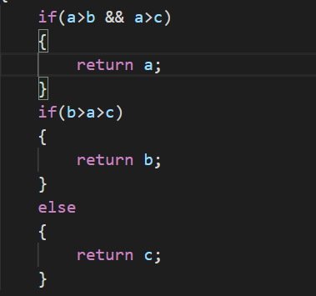
In fact, if you need to judge more, use the tournament algorithm in the data structure and algorithm, and its time complexity is o(n), here because there are only 2, 3 time complexity is actually about the same
Use function overloading, complete code:
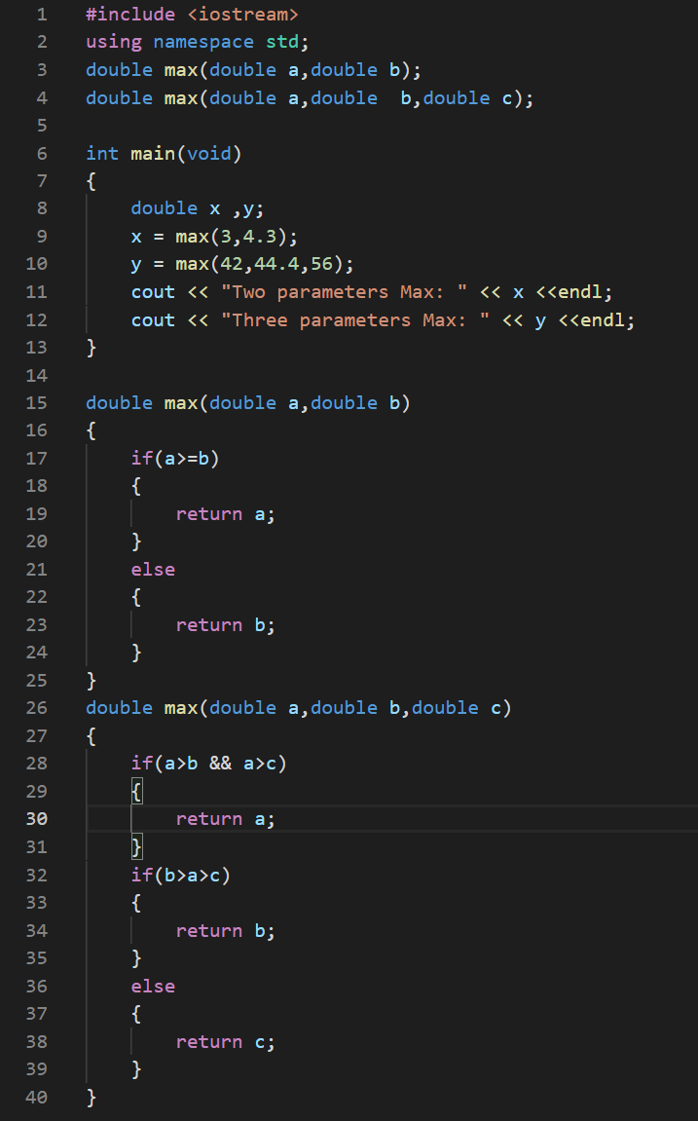
2. A game that simulates Aaron, Bob, and Charlie shooting each other
Simulate a single shot through a random seed
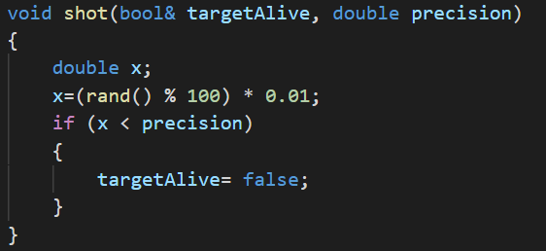
Strategy1:kill the best
Flowchart：
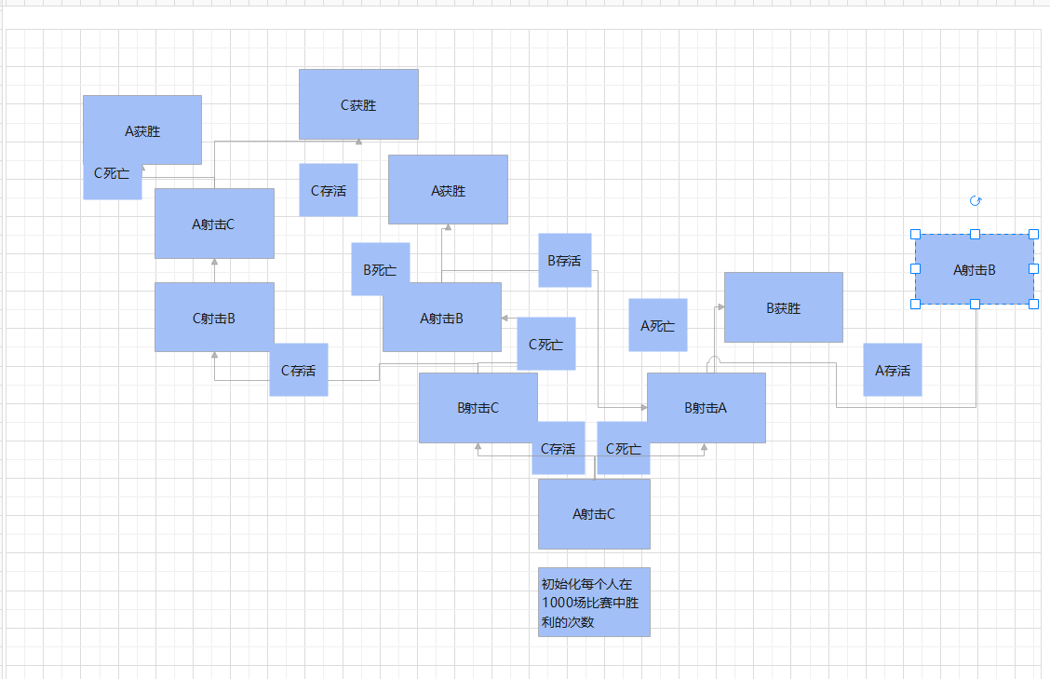
int startDuel()//step b ,strategy:菜的都先杀最强的
{
int result=0;

while (((charlielive) && (aaronlive) && (boblive)) ||
((charlielive) && (aaronlive) && (!boblive)) ||
((aaronlive) && (boblive) && (!charlielive)) ||
((charlielive) && (boblive) && (!aaronlive))) //在这个循环条件中一人胜出
{

if ((charlielive) && (aaronlive) && (boblive))//第一轮
{
shot(charlielive, aaronacc); //charlie 第一次
if (charlielive)
{ //charlie第一次没死
shot(charlielive, bobacc);//charlie 第二次
}
else//charlie 死了
{
shot(aaronlive,bobacc);
}
if (charlielive) //charlie第二次没死
{
shot(boblive, characc);
}
}

if ((!charlielive) && (boblive) && (aaronlive))//在第一轮中charlie死
{
shot(boblive, aaronacc);
if (boblive)
{
shot(aaronlive, bobacc); //循环继续执行这次判断
}
else
{
break; // aaron wins
}
}

if ((charlielive) && (!boblive) && (aaronlive)) //第一轮中bob死
{
shot(charlielive, aaronacc);
if (charlielive)
{
shot(aaronlive, characc);//charlie wins
}
else
{
break;//aaron wins
}
}

if ((charlielive) && (!aaronlive) && (boblive))
{
shot(charlielive, bobacc);
if (charlielive)
{
shot(boblive, characc);//charlie wins
}
else
{
break; // bob wins
}
}

}

if ((!charlielive) && (!boblive) && (aaronlive))
{
result=1;
}
else if ((!charlielive) && (boblive) && (!aaronlive))
{
result=2;
}
else if ((charlielive) && (!boblive) && (!aaronlive))
{
result=3;
}

return result;
}
Strategy2:kill the best, but aaron miss the first shot on purpose，to prove himself alive in first round
Flowchart：
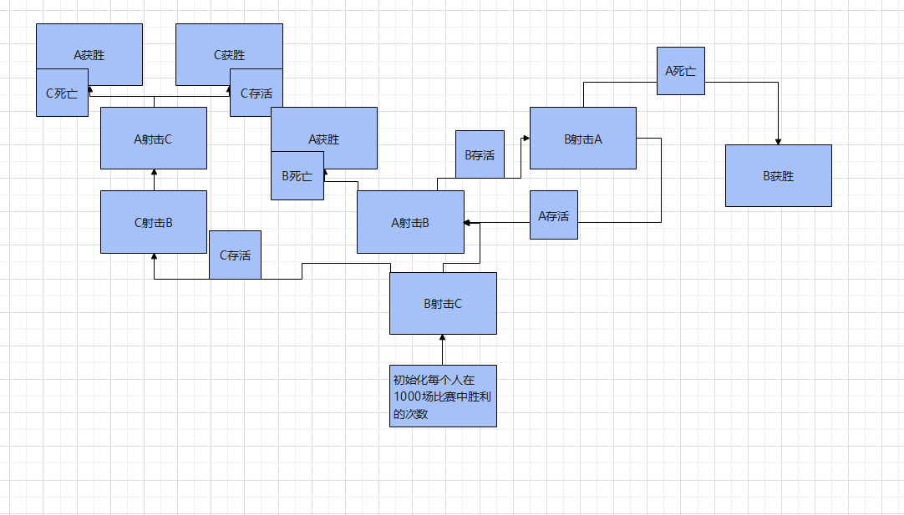
int startDuel()
{
bool aliveAaron = true, aliveBob = true,
aliveCharlie = true;
while ((aliveAaron && aliveBob) ||
(aliveAaron &&aliveCharlie) ||
(aliveBob &&aliveCharlie))
{

if (aliveBob)
{
if (aliveCharlie)
{
shot(aliveCharlie, bobacc);
}
else if (aliveAaron)
{
shot(aliveAaron, bobacc);
}
}
if (aliveCharlie)
{
if (aliveBob)
{
shot(aliveBob, characc);
}
else if (aliveAaron)
{
shot(aliveAaron, characc);
}
}

if (aliveAaron)
{
if (aliveCharlie)
{
shot(aliveCharlie,aaronacc);
}
else if (aliveBob)
{
shot(aliveBob, aaronacc);
}
}
}
if (aliveAaron) return 0;
else if (aliveBob) return 1;
else if (aliveCharlie) return 2;
}

Calculate the percentage and format the output: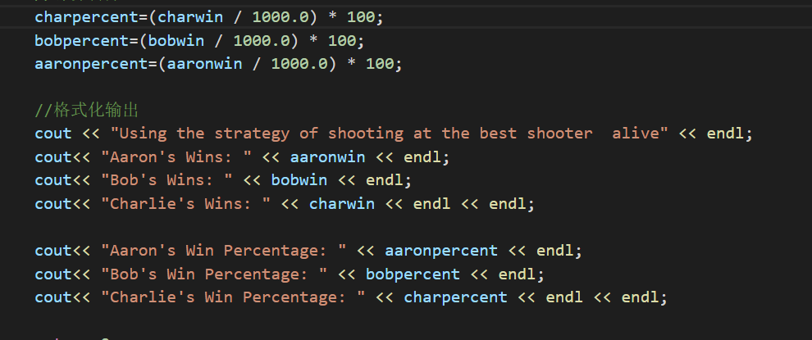
3. Create two dynamic arrays and complete initialization:
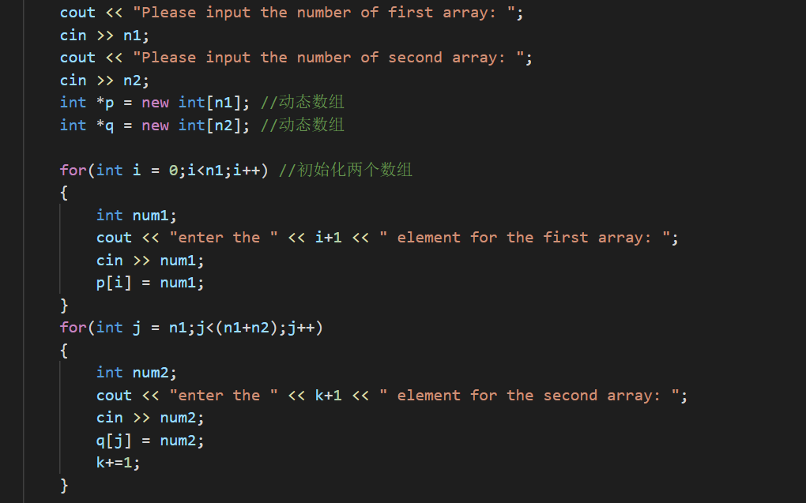
Copy two dynamic arrays to a new dynamic array:
Complete code:
#include<iostream>
using namespace std;

int* connect(int *&p1,int *&p2,int a,int b)
{
int *p3 = new int[10];
for(int i = 0;i < a;i++)
{
p3[i] = p1[i];
}
for(int j = 9;j>=b;j--)
{
p3[j] = p2[j];
}
return p3;
//delete []p3;
}

int main(void)
{
int *m,n1,n2;
int k = 0;//计数
cout << "Please input the number of first array: ";
cin >> n1;
cout << "Please input the number of second array: ";
cin >> n2;
int *p = new int[n1]; //动态数组
int *q = new int[n2]; //动态数组

for(int i = 0;i<n1;i++) //初始化两个数组
{
int num1;
cout << "enter the " << i+1 << " element for the first array: ";
cin >> num1;
p[i] = num1;
}
for(int j = n1;j<(n1+n2);j++)
{
int num2;
cout << "enter the " << k+1 << " element for the second array: ";
cin >> num2;
q[j] = num2;
k+=1;
}

m = connect(p,q,n1,n2);
cout << "new array:";
for(int k = 0;k<n1+n2;k++)
{
cout << m[k] << " ";
}
//delete []p;
//delete []q;//动态数组需要利用完回收空间，否则会导致栈溢出

return 0;
}

四、测试数据和执行结果 （在给定数据下，执行操作、算法和程序的结果，可使用数据、图表、截图等给出。请展现算法的鲁棒性）
1.Overloading function
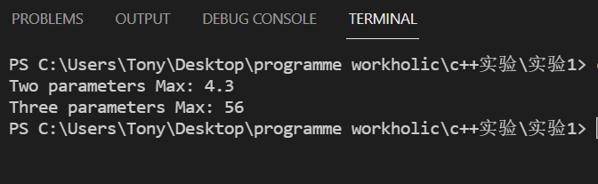
2.strategy a:first
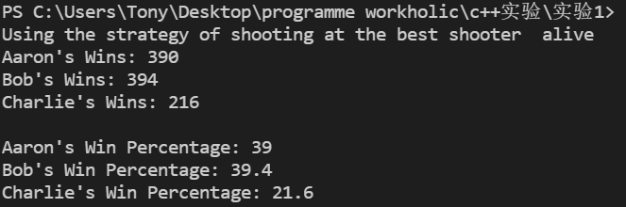
second
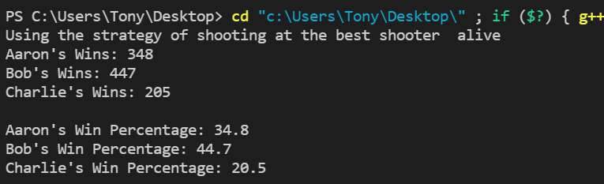
third
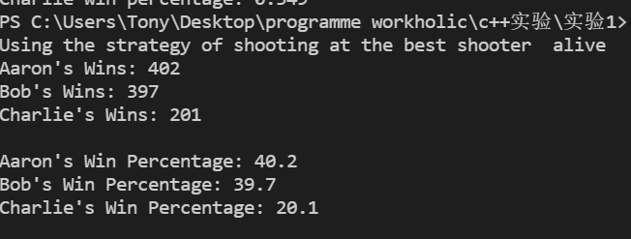
Strategy b:first
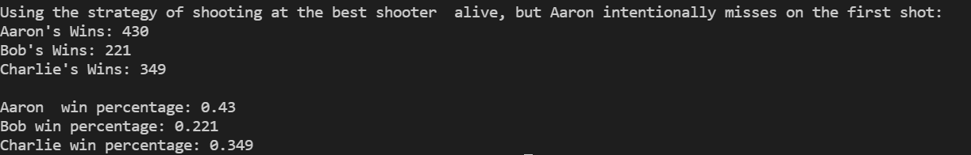
second
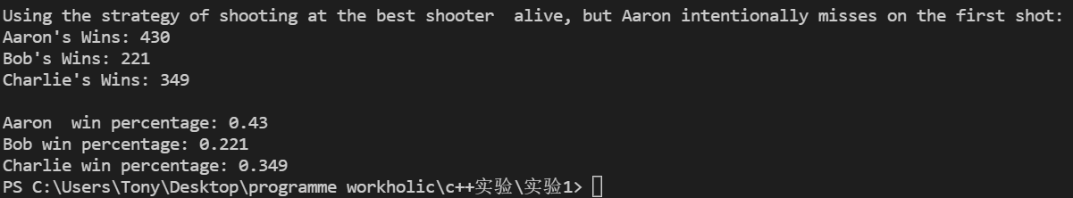
third
3. Create two dynamic arrays and assign them:
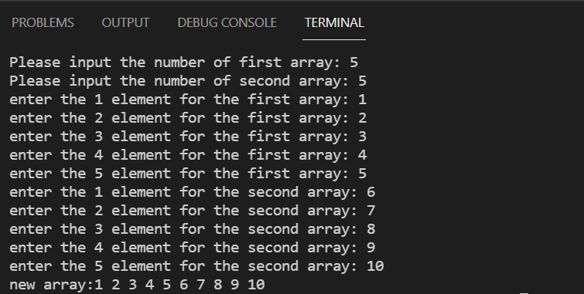
五、实验结果分析及总结（对实验的结果是否达到预期进行分析，总结实验的收获和存在的问题等）
1. The first task of the experiment is to learn to use and write overloaded functions, a feature of the function overloading programming language, which allows the creation of multiple functions of the same name with different implementations. The call to the overloaded function will run its specific implementation applicable to the calling context, that is, allowing a function call to perform different tasks according to the context. I used the max function overload in the experiment, which can make the function of the same name judge the maximum value of 2 or 3 parameters, and realize the foolishness of user input. I learned that function overloading can be used in large-scale project development. I am also thinking about whether there are other effects of overloaded functions
2. The second task of the experiment is to simulate the game where Aaron, Bob, and Charlie shoot at each other. Shooting sets the rules of the game and the hit rate of several characters, so of course we can use const to define constants and put them in global variables. First of all, we need to use the random seed to generate a random number between 0 and 1, so that we can simulate whether the shot is hit or not when compared with the hit rate. Establish a shot function to simulate whether the shot and whether the shot was alive or not, and directly return True or False by referring to the parameters. When the probability of surviving was obtained by simulating shooting in 1000 games, two strategies were used, and the probabilities obtained have different results. They are:
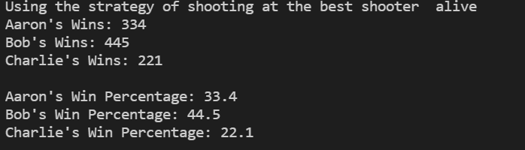
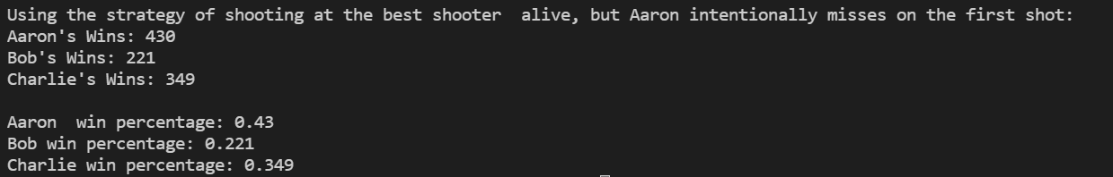
We can clearly see that Aaron’s winning percentage has increased by 10%, but Bob’s winning percentage has dropped by nearly half, because strategy2 was deliberately missed by Aaron. If Bob also missed, then the next Charlie will die when he hits Bob, so the winning percentage has dropped drastically. Here we also need to use a little knowledge of probability theory to test this question. In this small project, I have used a lot of loop branches and alternative branch structures, reviewed and combined a lot of knowledge of the C language, and wrote functions and in the function parameters. Using references, it is really convenient to use references in C++. But I still have problems in this project. For example, the statements in the function at the beginning of the execution design are too complicated, which caused me to forget what I wrote without reading it for a week, and there are too many types of situations, and I haven’t thought of a better one yet. Algorithm to solve.
3. The third task of the experiment is to create two dynamic arrays and assign values, and then use a function to assign the values ​​of the two arrays to the new array and return a pointer to the array. The third array also needs to be a dynamic array In this experiment, I applied how to use the new and delete operations in C++ so that I have greater control over the memory and can better adjust the memory space, but at the same time, I need to pay attention to the use of new and the delete operation must be used, otherwise it will cause Serious situations such as stack overflow or even memory leak. At the same time, copying and merging arrays reminds me of operations such as sequential storage of data structures. In the function algorithm, I copy the first array directly, and I copy the other array in reverse to achieve the simplest time complexity. Therefore, we must learn the data structure and algorithm, which is the basis of programming. I also had problems completing the third experiment. I required the use of references in the passed parameters, but I could not complete the operation by directly quoting the "pointer", so I added an * before the reference, which made me puzzled.
教  师  评  阅 | 实验内容和设计（A-E）：
教  师  评  阅 | 操作过程、算法或代码（A-E）：
教  师  评  阅 | 实验结果（A-E）：
教  师  评  阅 | 实验分析和总结（A-E）：
教  师  评  阅 | 实验成绩（A-E）：  反馈评语：

