

专业课程实验报告

课程名称：面向对象程序设计语言(C++)

开课学期： 2020 至 2021 学年 第 一 学期

专业： 年级班级：

学生姓名： 学号：

实验教师：邹佺

计算机与信息科学学院 软件学院

实验项目名称 |  | I/O Stream、Strings and Vectors、Objects and Class
实验时间 |  | 2020 年 月 日 | 实验类型 |  | □验证性 □设计性 R综合性
一、实验目的
- Master the application of iostreams library, and know and master the format output with stream functions
- Master C-String input and output, understand the applications of String and Vector class, compare differences between arrays and vector
- Understand the different components of a structure and a class; Be able to define a class, and understand the characteristics of public and private member variables or member function in a class; Understand a function may have formal parameters of a class or structure type.

二、实验要求
- Write a program to create a file called cplusad.dat that is identical to the file cad.dat, except that all occurrences of 'C' are replaced by "C++"( Except for ‘C’ in the word, eg: Computer). We can’t assume that the uppercase letter 'C' does not occur in cad.dat except as the name of the C programming language.
- Write a program that will read in a line of text and output the number of words in the line and the number of occurrences of each letter. Define a word to be any string of letters that is delimited at each end by either whitespace, a period, a comma, or the beginning or end of the line. You can assume that the input consists entirely of letters, whitespace, commas, and periods. When outputting the number of letters that occur in a line, be sure to count upper- and lowercase versions of a letter as the same letter. Output the letters in alphabetical order and list only those letters that do occur in the input line. For example, the input line
I say Hi.
should produce output similar to the following:
3 words
1 a
1 h
2 i
1 s
1 y
- （1）Define a class called BookInfo that is an abstract data type for storing information about a book. Your class should have two fields of type String, the first to store the author name and the second to store the book title. Include the following member functions: a constructor to set the book title and author, a second constructor which sets the book title to a parameter passed in and the author to “unknown”, and a method to get the author and title concatenated into a single C++ String. Write a driver program to test your class by creating a few book objects and printing them out using your member functions.
三、实验内容与设计（主要内容，操作步骤、算法描述或程序代码。请（1）先分析，列出流程，包括输入和输出，所用公式等信息；（2）分步展示算法描述和代码）
Question1:
Question Description: We need to input the strings to file and read the file by using the iostream & fstream, then we should edit the strings by using the strings function(in this case, turn “C” to “C++”), when we meet the strings Computer, we cannot edit the ‘C’ in Computer.
Flowchart: 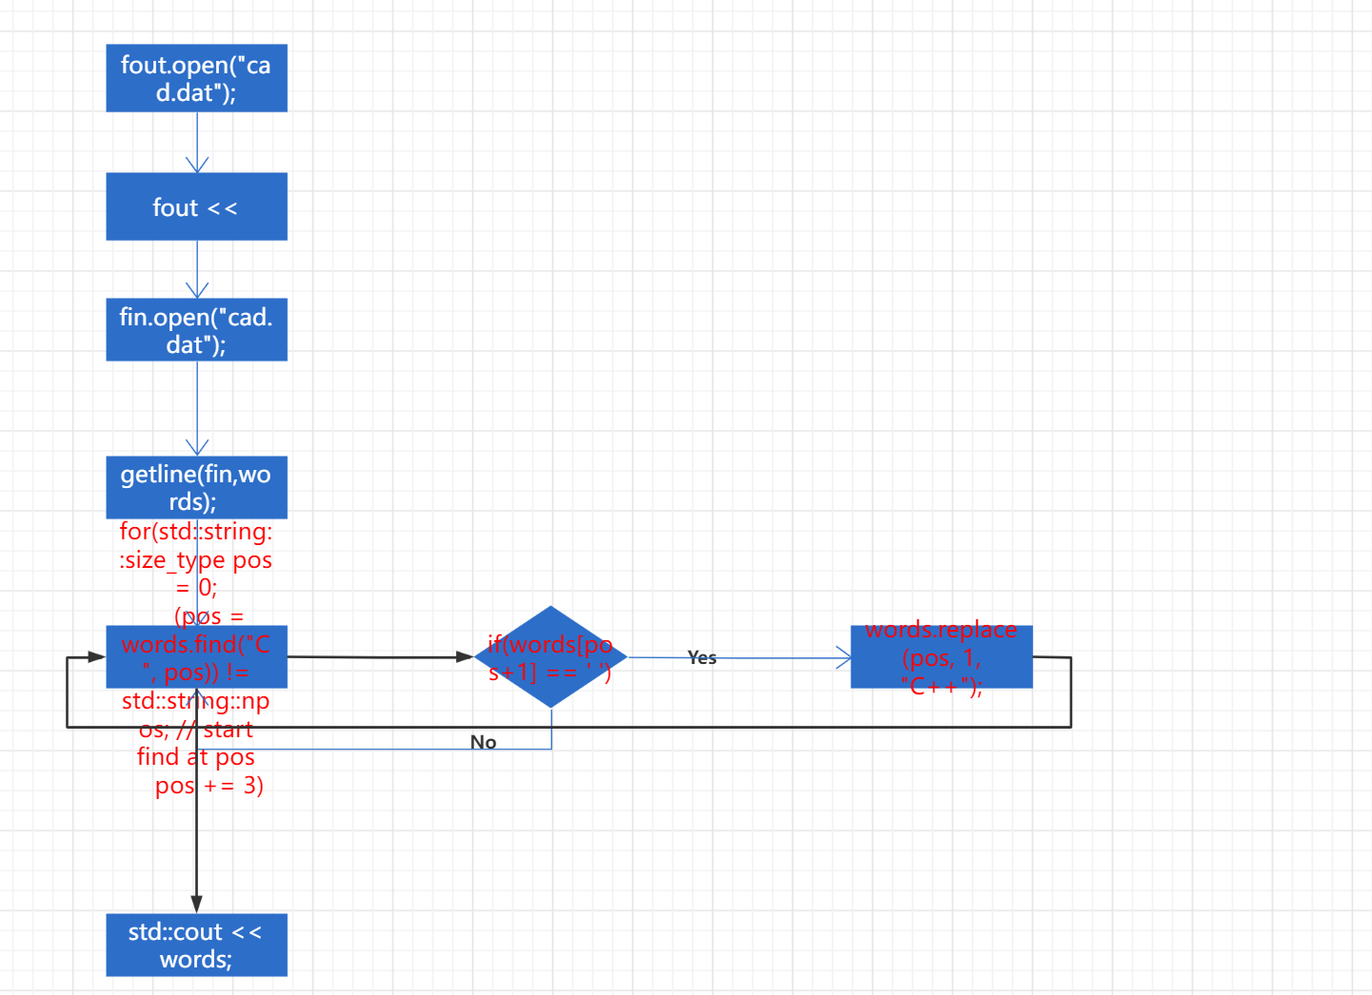

Code:
#include <iostream>
#include <fstream>
#include <string>
int main(void)
{
// initialize
std::ofstream fout;
std::ifstream fin;
//file output
fout.open("cad.dat");
fout << "C is a Computer Programming Language which is used worldwide, Everyone should learn how to use C !" << std::endl;

//file input
fin.open("cad.dat");
std::string words;
getline(fin,words);
std::cout << words << std::endl;

for(std::string::size_type pos = 0;
(pos = words.find("C", pos)) != std::string::npos; // start find at pos
pos += 3) // skip "C++"
{
if(words[pos+1] == ' ')
words.replace(pos, 1, "C++");
}

std::cout << words;
}

Question2:
Question Description:
Enter the strings, judge the separate letters(including the lowercase cand uppercase), and store it in alphabet array(defined by self) to count the number of it, then use the ‘ ’, ‘,’, ‘.’ this kind of Delimiter to test how many words we have, at last we output it on the screen.

Flowchart: 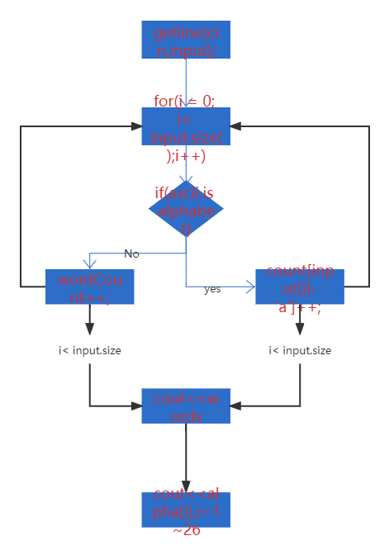
Code:
#include<iostream>
#include<cstring>
#include<cctype>
using namespace std;

int main()
{
string input;
cout<<"Enter a sentence: ";
getline(cin,input); //语法是输入流和字符串
int count[26] = {0},i,wordCount=0; //定义字母，读取的位数，单词数目
for(i = 0; i< input.size();i++)
{
if(((input[i]>='a' && input[i] <= 'z')||(input[i]>='A' && input[i] <= 'Z'))&&(input[i+1]=='.'||input[i+1]
==','||input[i+1]==' '))//通过分割判断单词的个数
wordCount++;
//鲁棒性，大小写转化成相同的
if(input[i]>='a' && input[i] <= 'z') // 记录每个字母存了多少个，大写
count[input[i]-'a']++;
if(input[i]>='A' && input[i] <= 'Z') // 小写
count[input[i]-'A']++;
}

cout<<endl<<wordCount+1<<" words "<<endl; //单词数目输出

for(i=0; i<26; i++) // 每个字母数目输出
{
if(count[i]>0)
cout<<count[i]<<" "<<(char)('a'+i)<<endl; //通过转化ASCii0~26输出字符
}

}

Question3:
Question Description:
Define a class, use the constructor and store the string information. a constructor to set the book title and author, a second constructor which sets the book title to a parameter passed in and the author to “unknown”, and a method to get the author and title concatenated into a single C++ String.

Flowchart: 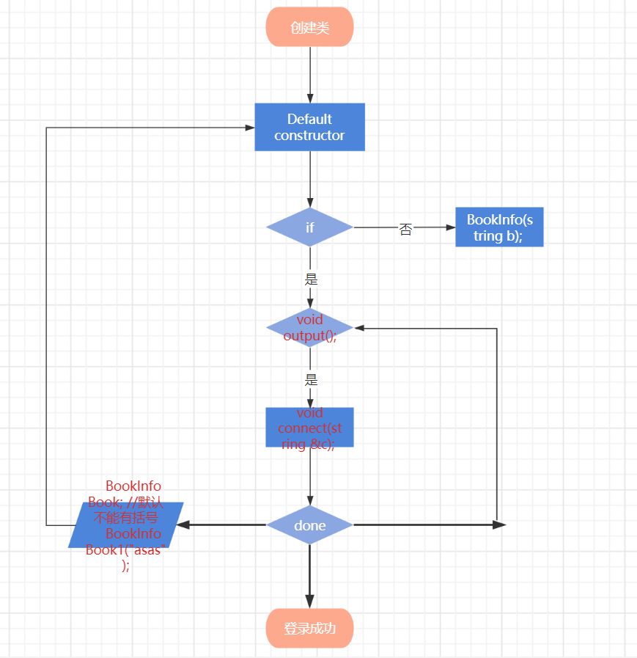
Code:
#include<iostream>
#include<cstring>
#include<string>
using namespace std;
class BookInfo
{
public:
BookInfo();
BookInfo(string b); // 1 parameter

void connect(string &c);
void output();

private:
std::string authername;
std::string bookname;
};

int main(void)
{
string c = "Null";
BookInfo Book; //默认不能有括号
BookInfo Book1("Gone with the wind");
Book.output();
Book1.output();
Book1.connect(c);
cout << "After connecting:" << c;
}

BookInfo::BookInfo() //Default Constructors
{
authername = "Tony";
bookname = "Peaky Blinders";
}

BookInfo::BookInfo(string b) //Constructors
{
this ->authername = "unknown";
this ->bookname = b;
}

void BookInfo::output(void)
{
std::cout << "the authername: " << authername << ",the bookname: "<< bookname << endl;
}

void BookInfo::connect(string &c)
{
c = this -> authername + " "+ this ->bookname; //通过this指针直接访问 private
}
四、测试数据和执行结果 （在给定数据下，执行操作、算法和程序的结果，可使用数据、图表、截图等给出。请展现算法的鲁棒性）
1. 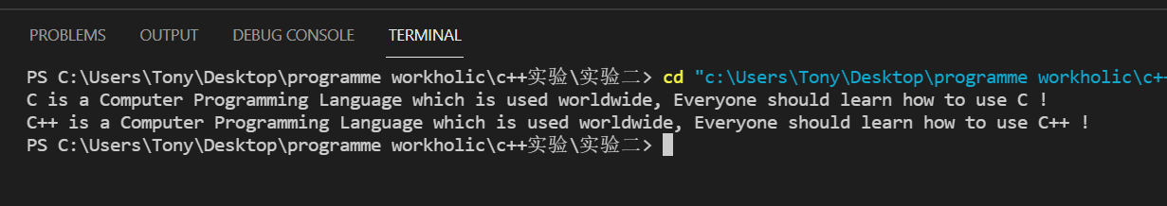
We can see that the Computer ‘C’ is not been replaced while others are replaced to “C++”。
2. 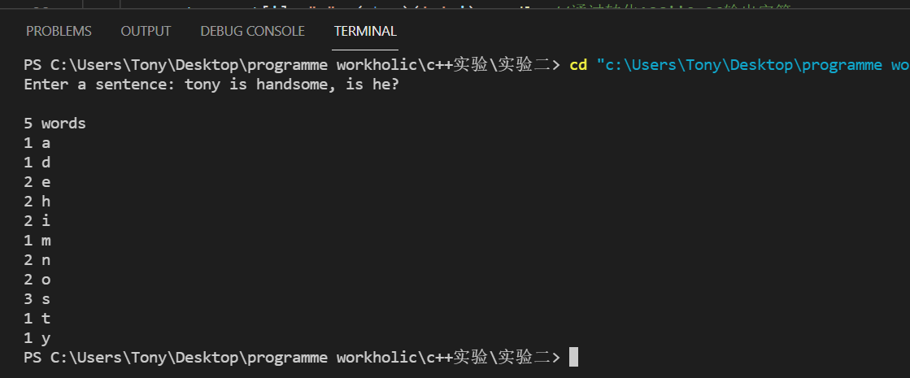
The whole sentence has ,? And ‘ ’, we can see that the output how many words, and the letters numbers.
3. 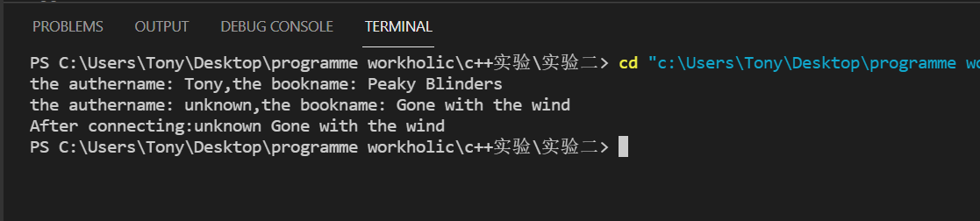
五、实验结果分析及总结（对实验的结果是否达到预期进行分析，总结实验的收获和存在的问题等）
Question1:
The first question lets us to use the string function and some programming skills, if we use the string, we can easily using the words[i] to check the specific char, this lets us to change the C and see the latter char is ‘ ’(空格), I learned how to use string library functions proficiently, like words.find(), words.replace(), they are all useful. And use the loop to traverse the entire string. In this experiment, we reviews some fstream usage. During this experiment, I was puzzled so I go to stackoverflow.com to ask question, which helps me a lot!

Question2:
The second question lets us to write a program that will read in a line of text and output the number of words in the line and the number of occurrences of each letter. Define a word to be any string of letters that is delimited at each end by either whitespace, a period, a comma, or the beginning or end of the line. I use the arrays[26] to solve this problem, using array to store 26 letters to count the number, and judge the ‘’,’,’, these kind of delimited to count the words number. From this experiment, I learn how to Relate data structure to actual problems

Question3:
The last question lets us to define the class BookInfo, enlarge the class, we can build the whole Library management system. Using the constructor and Overloaded function and define some Member functions, like add the two strings, Using a little tricky method. In this experiment, I am familiar with the class’s application, and in default constructor, in the main function we may use BookInfo Book, just like define string A, they are the same form. We need pay attention to the Parameter passing of member functions, which is vital!

教  师  评  阅 | 实验内容和设计（A-E）：
教  师  评  阅 | 操作过程、算法或代码（A-E）：
教  师  评  阅 | 实验结果（A-E）：
教  师  评  阅 | 实验分析和总结（A-E）：
教  师  评  阅 | 实验成绩（A-E）：  反馈评语：

