

专业课程实验报告

课程名称：面向对象程序设计语言(C++)

开课学期： 2021 至 2022 学年 第 一 学期

专业： 计算机科学与技术 年级班级：大二

学生姓名：廖润泽 学号：222020321102007

实验教师：邹佺

计算机与信息科学学院 软件学院

实验项目名称 |  | Friends,Overloaded Operators,Inheritance,Templates
实验时间 |  | 2021 年 月 日 | 实验类型 |  | □验证性 □设计性 R综合性
一、实验目的
- Understand a friend function of a class, which is an ordinary function except that it has access to the private members of the class.
- Master overloading operators. Operators (e.g., + and =) can be overloaded so they can be used with objects of a class type that you define.
- Understand the function of destructor and copy constructor, which are special kind of member function for a class
- Understand the function of inheritance that provides a tool for code reuse by deriving one class from another by adding features to the derived class.
- Understand the application of protected members in the base class, which are directly available to a publicly derived class’s member functions.
- Understand the templates for functions and syntax for templates
二、实验要求
- Overload the operator >> and the operator << for the BookInfo class created in lab2-3.
- Define a class called UpdatedBook which inherits the BookInfo class created in lab2-3. This new class should contain an integer field for the edition number of the book, a constructor to create the UpdatedBook object accepting as input the author, title, and edition number of the book, and a getter method to return the edition number. Write a driver program to test each component of your class.
- Write a template version of a stack class. Use a type parameter for the type of data that is stored in the stack. Use dynamic arrays to allow the stack to grow to hold any number of items.

三、实验内容与设计（主要内容，操作步骤、算法描述或程序代码。请（1）先分析，列出流程，包括输入和输出，所用公式等信息；（2）分步展示算法描述和代码）
Experment1:
From the experiment 1,we use the class defined in last experiment, but we should add the operator overloading function like “<<” and “>>”, the “<<” let us output the whole data in class BookInfo while “>>” allows us input the author name + book name, the programme need a function/method to split the whole string into book name and author name respectively.
Flowchart: 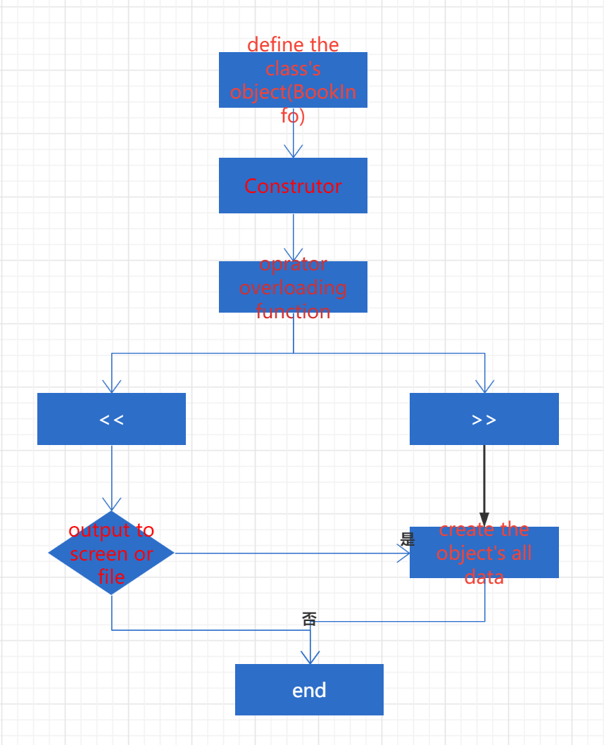
Experiment2:
We should define a class called UpdatedBook which inherits the BookInfo class created in lab2-3. This new class should contain an integer field for the edition number of the book, a constructor to create the UpdatedBook object accepting as input the author, title, and edition number of the book, and a get function to return the edition number.
Flowchart: 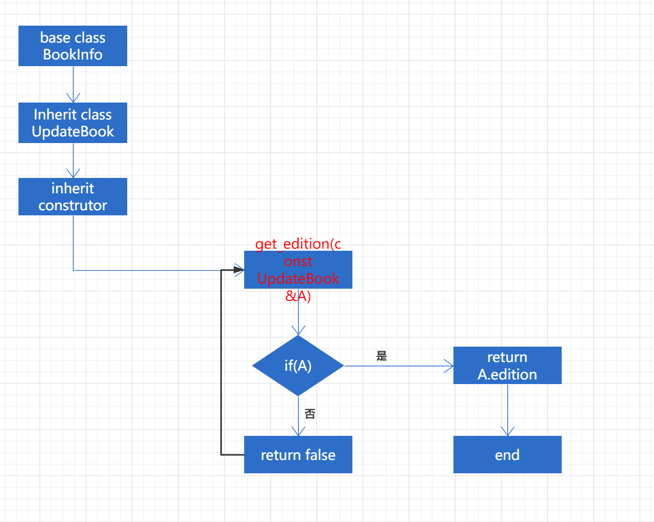
Code(1&2): #include<iostream>
#include<cstring>
#include<string>
using namespace std;
class BookInfo
{
public:
BookInfo();
BookInfo(string b); // 1 parameter
BookInfo(string a,string b):authername(a),bookname(b){}; // 1 parameter

void output();

friend ostream& operator<<(ostream &outs,const BookInfo &d); //只能写成友元函数形式，若成员函数
friend istream& operator>>(istream &ins,BookInfo &d);

private:
std::string authername;
std::string bookname;
};

class UpdateBook:BookInfo
{
public:
UpdateBook(string a,string b,int c):BookInfo(a,b),edition(c){};
int get_edition(const UpdateBook &A);
private:
int edition;
};

int main(void)
{
string c = "Null";
BookInfo Book("Tony","Gone with the wind"); //后面是
BookInfo Book1;
UpdateBook Book2("python","probility",9);
//Book.output();
cin >> Book1;
cout << Book << endl;
cout << Book1 << endl;
cout << Book2.get_edition(Book2);
return 0;
}

BookInfo::BookInfo() //Default Constructors
{
authername = "Tony";
bookname = "Peaky Blinders";
}

void BookInfo::output(void)
{
std::cout << "the authername: " << authername << ",the bookname: "<< bookname << endl;
}

ostream& operator<<(ostream &outs,const BookInfo &d)//只能写成友元函数形式，若成员函数
{
string s = d.authername + "&" + d.bookname;
outs << s;
return outs;
}

istream& operator>>(istream &ins,BookInfo &d)
{
cout << "use auther name + book name" << endl;
string s;
ins >> s;
int pos = s.find("+",0);
string tem = s.substr(0,pos);
d.bookname = tem;
tem = s.substr(pos+1,s.length()-pos-1);//分割出剩下的串
d.authername = tem;

return ins;
}

int UpdateBook::get_edition(const UpdateBook &A)
{
//return this->edition;为啥这段代码不行
return A.edition;
}

Experiment 3:
We write a template version of a stack class. Use a type parameter for the type of data that is stored in the stack. Use dynamic arrays to allow the stack to grow to hold any number of items.
Flowchart:
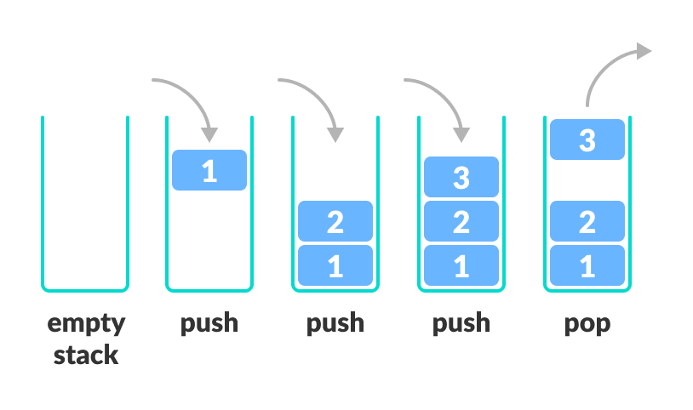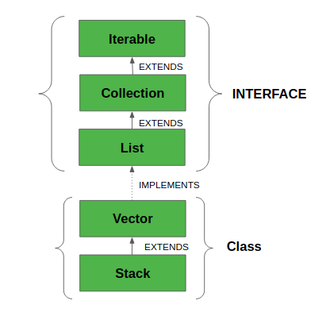
CODE:
Main: #include <string>
#include "mystack.h"
#include <iostream>
int main()
{
Stack<std::string> notes;
notes.push("Hey");
notes.push("what's");
notes.push("up.");

std::cout << notes.pop();
return 0;
}
Stack.h:
template<class T>
class Stack
{
private:
T* storage;
int capacity;
int n;

public:

void resize(int capacity_r)
{
T* temp = new T[capacity_r]; //according to the parameter dynamic allocate the memory
for(int i = 0;i<n;i++)
{
temp[i] = storage[i];
}
delete[] storage; // after using it ,must delete
storage = temp;
capacity = capacity_r;
}

Stack() // construcor
{
capacity = 1;
storage = new T[1];
n = 0;
}

~Stack() //析构
{
delete[] storage;
}

void push(T i) //in
{
if(n == capacity)
{
resize(capacity * 2);
}
storage[n++] = i; //2 steps
}

T pop() //out
{
T i = storage[--n]; //2 steps
if(n>0 && n == capacity/4)
{
resize(capacity/2);
}
return i;
}
};

四、测试数据和执行结果 （在给定数据下，执行操作、算法和程序的结果，
可使用数据、图表、截图等给出。请展现算法的鲁棒性）
Experiment1&2:
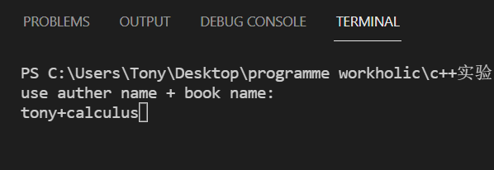
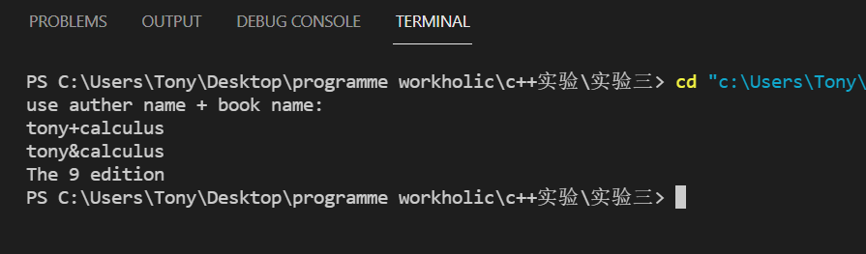
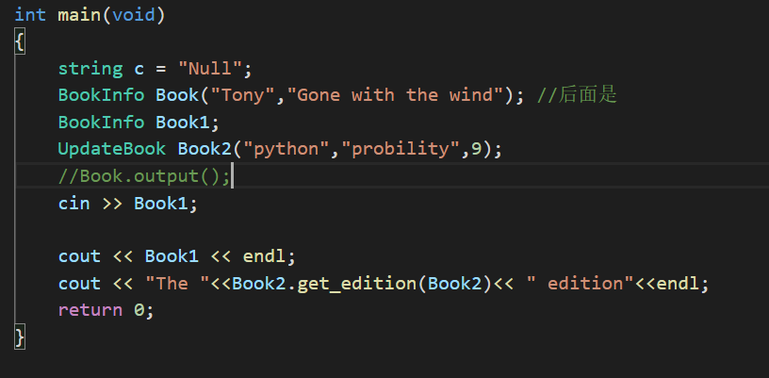
Experiment3:
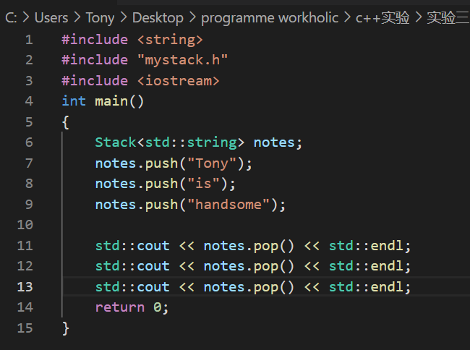
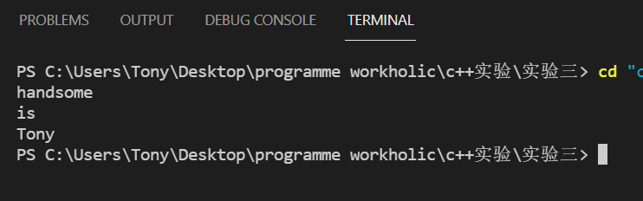
五、实验结果分析及总结（对实验的结果是否达到预期进行分析，总结实验的收获和存在的问题等）
Experiment1:
Form these two experiments I just overload 2 operator functions, << & >> respectively, and in << input stream, I split the input string into author name and book name by create a new function (in python and other modern language, there’s a Library Function can do this), and store them into the private data in class. In >> output stream, I combine the book name and author name with’+’, in fact, it is also an overloading operator in library. It is worthy to notice that the << & >> need a i/o stream type return value which allows the programme to use many << or >>. Last thing I know that some overloading operators can only be written in friend function, because the if not, cin.operator<<(const F& f) is not right.
Experiment2:
The experiment 2 lets me use the inherit class. Firstly, know the connection between base class and derived class, the Derived class is inheriting the base class. The UpdateBook is derived class, and BookInfo is base class, the derived class can inherit all information, the data, the function &etc. The constructor is a question, if base class has a constructor for its data, and the derived class can use UpdateBook(string a,string b,int c):BookInfo(a,b),edition(c){}; to do the initialization. The member function for returning the data is easy.
Experiment3:
The experiment 3 makes us write a STL ‘stack’. In computer science, it is a linear table that is limited to insert or delete operations at the end of the table. The stack is a data structure that stores data in accordance with the principle of last-in, first-out. We are familiar with the template. And template has some syntax requirements, you should let computer know it is template so use template<class T>.

My gain:
- Learn how to implement operator overloading. And Input and output stream overloading function can only use the friend function and we should pay attention to its return value.
- Understand the inheritance relationship. Know the role of base class and derived class. Reduce the amount of code. No need to write member functions repeatedly.
- Defines a standard template.
3.1. Before defining a template, you need to declare Template<class T> in front
3.2. If the template is used in the Pair class, you need to define the object in Pair<int>student;
3.3 In member function's definition, you need to add Template<class T>, and pair<T>::function before the function.

Prombles:
- In experiment2, I did not know why this code works (the function that return the edition)
int UpdateBook::get_edition(const UpdateBook &A)
{
//return this->edition;为啥这段代码不行
}
- In experiment3, Iterators are not used to traverse the container, but simplify the code.

Last but not least experiment is easy, hope Increase difficulty!!!!!
教  师  评  阅 | 实验内容和设计（A-E）：
教  师  评  阅 | 操作过程、算法或代码（A-E）：
教  师  评  阅 | 实验结果（A-E）：
教  师  评  阅 | 实验分析和总结（A-E）：
教  师  评  阅 | 实验成绩（A-E）：  反馈评语：

