**Group 4 – Communications System**

Software Requirements Specification

Revision History

| **Date** | **Revision** | **Description** | **Author** |
| --- | --- | --- | --- |
| 02/19/2022 | 1.0 | Initial Version | Owen Casebeer |
| 02/20/2022 | 1.1 | Added Requirements | Anthony Lopez |
| 02/20/2022 | 1.1.2 | Updated Overall Description | Matthew Baron |
| 02/21/2022 | 1.1.3 | Updated non-functional requirements | Owen Casebeer |
| 02/21/2022 | 1.1.4 | Added Sequential Diagrams | Anthony Lopez |
| 2/25/2022 | 1.1.5 | Added internal/external reqs | Owen Casebeer |
| 2/25/2022 | 1.1.6 | Added Class Diagrams | Matthew Baron |
| 3/1/2022 | 1.1.7 | Updated requirements | Owen Casebeer |
| 4/30/2022 | 1.2 | Updated Class Diagram and Requirements | Maxwell Wu |
| 5/1/2022 | 1.2.1 | Updated Class Diagram | Maxwell Wu |
|  |  |  |  |
|  |  |  |  |
|  |  |  |  |
|  |  |  |  |
|  |  |  |  |
|  |  |  |  |
|  |  |  |  |
|  |  |  |  |

Table of Contents

**1.** **Purpose 4**

1.1. Scope 4

1.2. Definitions, Acronyms, Abbreviations 4

1.3. References 4

1.4. Overview 11

**2.** **Overall Description 12**

2.1. Product Perspective 12

2.2. Product Architecture 12

2.3. Product Functionality/Features 12

2.4. Constraints 12

2.5. Assumptions and Dependencies 12

**3.** **Specific Requirements 13**

3.1. Functional Requirements 13

3.1.1. Common Requirements: 13

3.1.2. Client Module Requirements: 13

3.1.3. Server Module Requirements: 13

3.2. External Interface Requirements 13

3.3. Internal Interface Requirements 13

**4.** **Non-Functional Requirements 14**

4.1. Security and Privacy Requirements 14

4.2. Environmental Requirements 14

4.3. Performance Requirements 14

# Purpose

## Scope

This document will catalog the user, system, and hardware requirements for the Communications System. It will not however, document how these requirements will be implemented.

## Definitions, Acronyms, Abbreviations

CS – Communications System

## References

Use Case ID: 1000U

Use Case Name: Create a chat room

Relevant Requirements: 3.1.2

Primary Actor: User

Pre-conditions: User is logged in.

Post-conditions: Chat room is created.

Basic Flow or Main Scenario:

1. The user selects participants from the user directory to create a chat room.
2. The system responds by creating a chat room on the server.

Extensions or Alternate Flows:

1. The user creates an empty chat room.
2. The user invites users from the user directory to join the room.

Exceptions: None.

Related Use Cases: 2000U

Use Case ID: 2000U

Use Case Name: Send a message

Relevant Requirements: 3.1.2

Primary Actor: User

Pre-conditions: User is logged in.

Post-conditions: The message is delivered to the chat room.

Basic Flow or Main Scenario:

1. The user opens an existing chat room.
2. The user inputs the desired message and sends it.
3. The server receives the message and delivers it to the chat’s participants.

Extensions or Alternate Flows: None.

Exceptions: The message fails to send.

Related Use Cases: 1000U

Use Case ID: 3000U

Use Case Name: Access chat history

Relevant Requirements: 3.1.1

Primary Actor: Supervisor

Pre-conditions: Supervisor is logged in.

Post-conditions: The supervisor is granted access to all chat logs.

Basic Flow or Main Scenario:

1. The supervisor attempts to access user chat logs.
2. The system responds by granting a directory of logs.

Extensions or Alternate Flows: None.

Exceptions: None.

Related Use Cases: None.

Use Case ID: 4000U

Use Case Name: Change password

Relevant Requirements: 4.1.4

Primary Actor: User, Supervisor

Pre-conditions: The User or Supervisor is logged in.

Post-conditions: The account password is changed.

Basic Flow or Main Scenario:

1. The actor requests a password change.
2. The system responds by prompting for the actor’s current password and desired password.
3. The actor enters their current password and new password.
4. The system stores the new password for future log ins.

Extensions or Alternate Flows: None.

Exceptions: The current password is entered incorrectly.

Related Use Cases: None.

**Use Case Diagram**

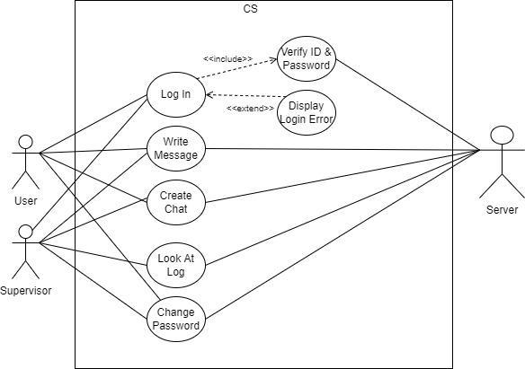

**Class Diagrams**

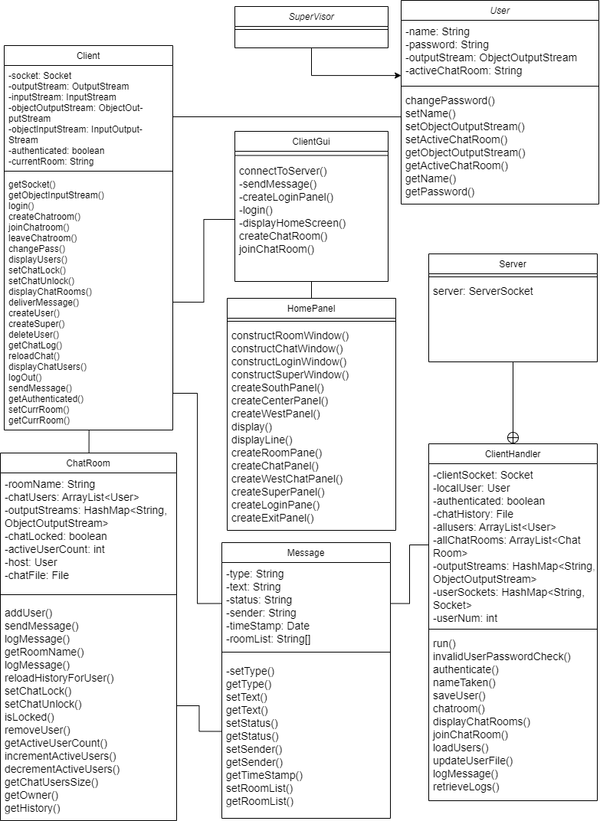

**Sequential Diagrams**

**Sequential Diagram Use Case #1000**

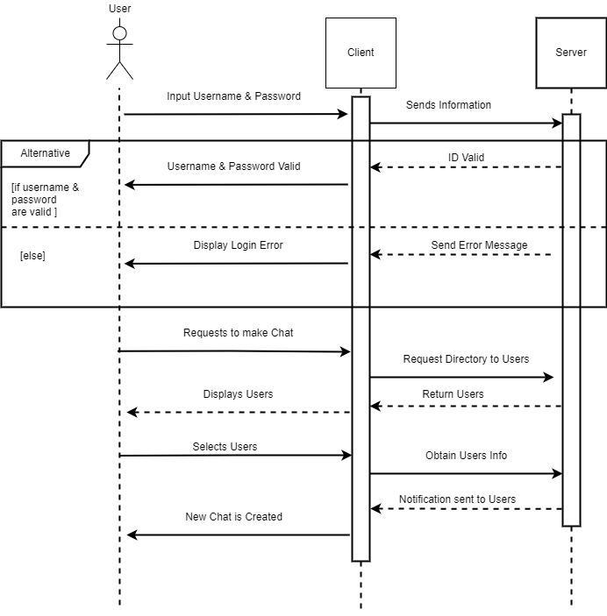

**Sequential Diagram Use Case #2000**

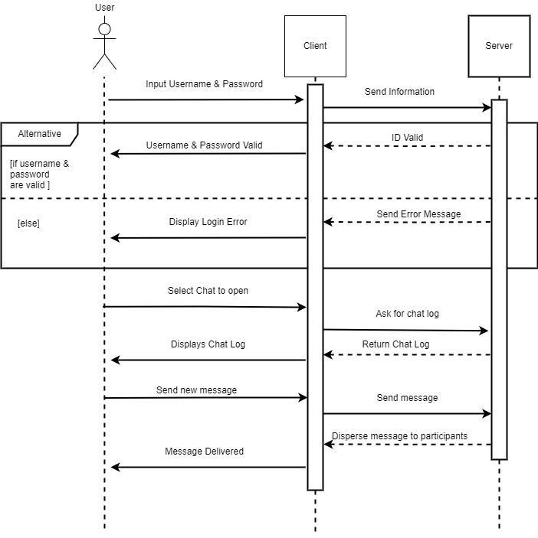

**Sequential Diagram Use Case #3000**

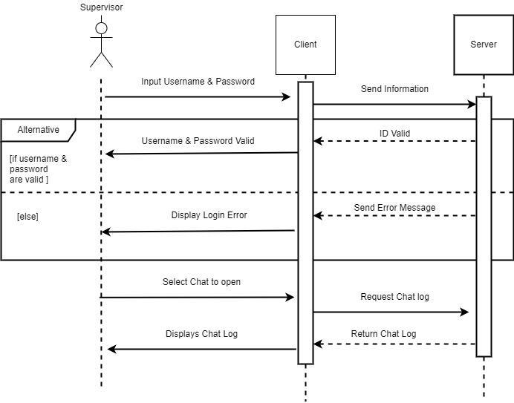

**Sequential Diagram Use Case #4000**

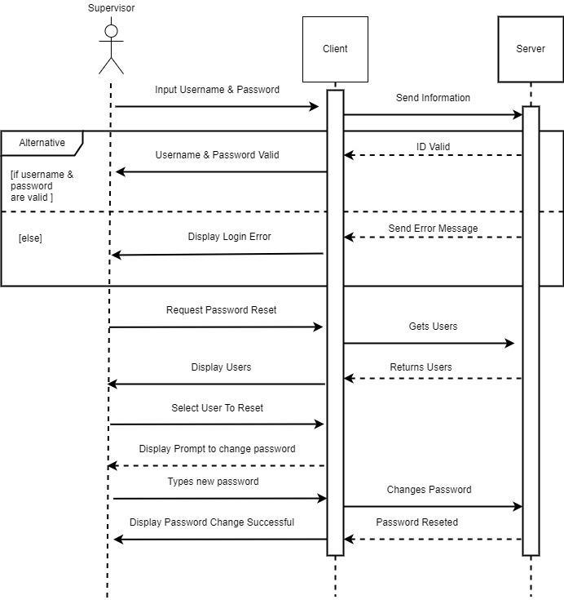

## Overview

The Communications System (CS) is designed to interconnect corporate communications nationwide through a text-based messaging system.

# Overall Description

## Product Perspective

## Product Architecture

The system will be organized into 2 major modules: the client module and the server module.

## Product Functionality/Features

The high-level features of the system are as follows:

* All employees have a unique login
* Chat rooms consisting of 2 or more users
* Strictly text-based
* Asynchronous messaging
* All chatrooms are logged
* Delivery/Read receipts

## Constraints

2.4.1 The project must be completed by 5/4/2022.

## Assumptions and Dependencies

No current assumptions.

# Specific Requirements

## Functional Requirements

### Common Requirements:

3.1.1.1 All chats are recorded and stored in a database.

### Client Module Requirements:

3.1.2.1 Users should be allowed to log in using their username and password.

3.1.2.2 Multiple users can use the communication systems at once.

3.1.2.3 Users should be allowed to create chat rooms.

3.1.2.4 The user who created a chat room is the chat room's host.

3.1.2.5 A chat room host can lock and unlock the room to prevent other users from joining.

3.1.2.6 Users should be allowed to enter and leave chat rooms as they please.

3.1.2.7 There can be multiple users in a single chat room.

3.1.2.8 Users can send messages to other users in a chat room.

3.1.2.9 Chat room messages are made of text.

3.1.2.10 Users can send messages in a chat room while other users are using the chat room.

3.1.2.11 Chat rooms should have a participants list

3.1.2.12 Users can be in multiple chat rooms at once.

3.1.2.13 New messages will be labeled as read if the chat is opened.

3.1.2.14 Users should have access to a directory of users.

3.1.2.15 Users can receive and send messages at any time.

3.1.2.16 Users can log out of their account at any time.

3.1.2.17 Users can change the passwords to their accounts.

3.1.2.18 New user accounts can be created.

### Server Module Requirements:

3.1.3.1 The server will communicate with the client.

3.1.3.2 Messages are asynchronous and will be labeled as delivered if successfully sent.

3.1.3.4 The server will validate user logins.

3.1.3.3 The server will save user information.

## External Interface Requirements

3.2.1 The system must provide a GUI to allow users to access communications features.

## Internal Interface Requirements

3.3.1 The system must process outgoing messages from the client to ensure messages are delivered to all applicable parties.

3.3.2 The system must process requests for past chat logs from users with the appropriate access level.

# Non-Functional Requirements

## Security and Privacy Requirements

4.1.1 The CS may only be accessed with a successful log in with a username and password.

4.1.2 The CS will be stored on a private corporate server.

4.1.3 Only supervisors accounts may access the chat logs.

4.1.4 All users may change their own passwords.

4.1.5 Encryption is not to be used within the system.

## Environmental Requirements

4.2.1 The CS will be built with the Java programming language.

## Performance Requirements

4.3.1 Message logging must not reduce the performance of the chat system.

4.3.2 Chat rooms must support an unlimited number of participants.