ASECS 2012 THATCamp
Omeka Workshop
Wednesday, March 21, 2012
San Antonio, TX
ASECS 2012 THATCamp Omeka Workshop by Tonya Howe is licensed under a Creative Commons Attribution-NonCommercial-ShareAlike 3.0 Unported License.
Based on a work at docs.google.com.

What is Omeka?
Essentially, Omeka is an open-source and extensible software tool that allows you to create digital archives and collections of resources. For instance, a museum might want to create an accessible web-based repository of some of their collections in a way that makes research (or just more information) about them possible without being physically present in the museum. This archive might include, in addition to a high-quality image of the item, a descriptive essay and other detailed information about the object. A curator might even select a variety of paintings, decorative objects, sculptures, and so on to include in the web archive according to a thematic logic. Conversely, an oral history project might use Omeka to collect, maintain, and make accessible the various audio recordings, videos, and/or transcripts collected as the project continues. Omeka can make these resources into quality primary source materials for scholars, teachers, and students across the globe to work with. You might find this site, from Teaching History, informative–it includes a variety of sample uses for the tool.
Here is a very brief video introducing Omeka, put together by the folks at George Mason’s Roy Rosensweig Center for History and New Media who created the software.

Omeka can also be a very useful tool to stimulate student collaboration and to dramatize some of the basic methods, practices, and preconditions of scholarship. As a tool to help students learn the nature of research from a perspective invested in the architecture of knowledge, Omeka is most potentially interesting to me as a means for teaching research methodologies (especially how information is organized, what that means for conducting research, and how that might help us create our own knowledge more effectively) and scholarly collaboration. One of the challenges we often face as teachers of students at all levels is a certain taken-for-grantedness about knowledge–it just “is” or someone (not really a person, subject to history and ideology) creates it, and I look it up so I can use it in my essay. The infrastructure of knowledge creation is not transparent, visible.

Omeka vs. Omeka.net?
There are two versions of Omeka that one can use. The first is less flexible but it has the benefit of not requiring much knowledge on the user’s part. You can create a free account at Omeka.net and create archives from that centralized installation of the platform.
Each site is allocated a certain amount of space, and the process of creating an archive is fairly straightforward. You can invite multiple other users to collaborate with you on the creation of your site–however, those invited users will have to sign up for a free plan with Omeka.net, and the way to move through that is not intuitive. Your student, once clicking the accept invitation link sent via email, will be taken to a page that requires them to sign up–but there is no information indicating whether this will then connect them as users to your site.
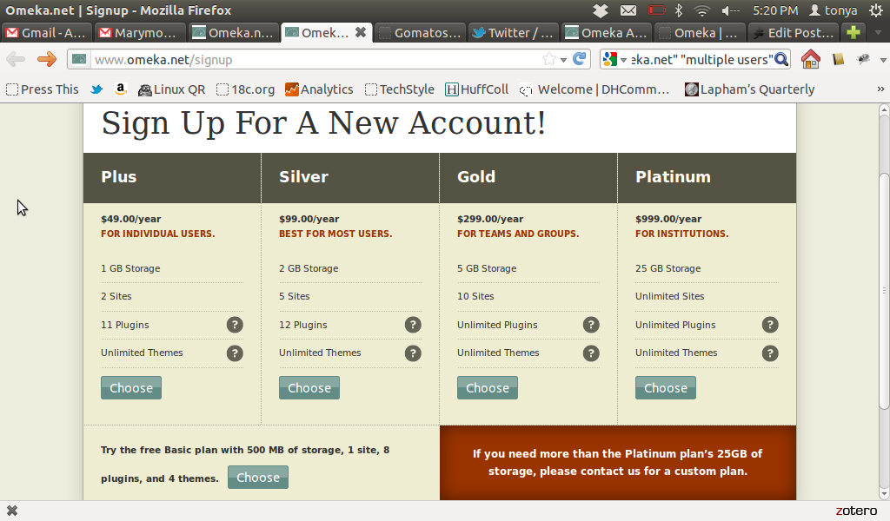

Newly-invited users will be directed to this page when clicking the emailed link. Note the different levels of service. If possible, you should have your institution reimburse you for a more robust Omeka.net account.

New users will be taken to a page with the sites they're contributors to, researchers on, or creators/admins of, but they'll have to sign up first. (A free plan allows you to create one site, but I believe you can be a contributor to multiple sites.) Be sure to inform your students to fill out the signup fields responsibly--real names and appropriate usernames only! It may be helpful to encourage students to use their institutional usernames.
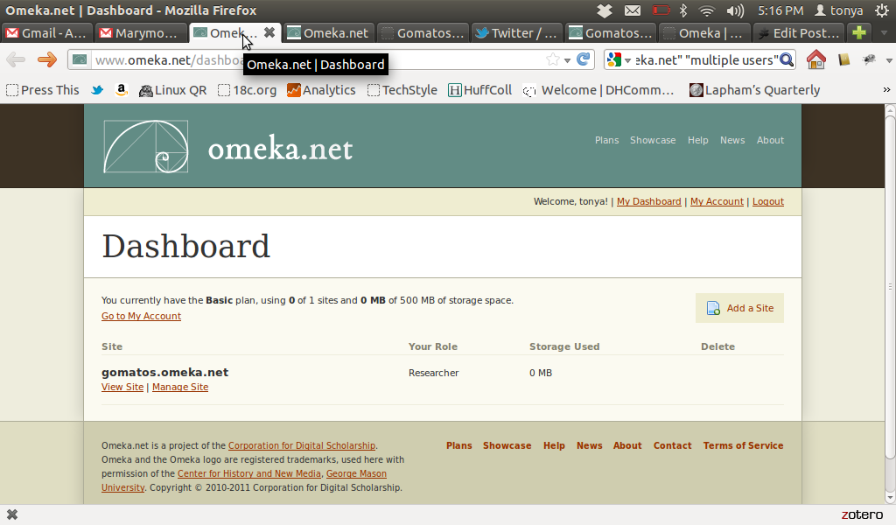

This is what your newly-invited user will see after having signed up for a user account with Omeka.net

The second is much more flexible, but it requires the user to download and install Omeka on her own server (it requires supporting resources, like MySQL, PHP, and so on). With an individual instllation of Omeka, you can also activate any plugin you would like. There is a robust online community--I can particularly recommend using the hashtag #omeka on twitter--but you will be responsible for maintaining the installation, adding and updating plugins, making any tweaks to the code that will generate just the site you want the world to see. If something on your server doesn't work or isn't configured properly, then your install may not exhibit full functionality. For beginning users, Omeka.net is probably a better way to go.

Here is an excellent example of a public collaborative memory bank created with Omeka, the Hurricane Digital Memory Bank, which preserves personal stories about hurricanes Rita and Katrina.

Here are two of my personal installations of Omeka--one, I used as a trial run in a research methodologies course, and one, I am currently working on as a digital face for my university's small special collections room. In the future, I plan to revise the research methodologies course around this second project--though I will probably move to an Omeka.net account instead of hosting it on my own server (who has the time to troubleshoot--or get friends to help you out?) Students in the class will ultimately be responsible for slowly populating the archive and making these somewhat rare materials accessible to other students and scholars beyond the walls of our campus, and in the process, also contributing their own voices to an ongoing conversation. For instance, students will be required to craft a researched descriptive essay that becomes part of the resource they create. This kind of process, however, also requires that students learn about simple cataloging processes, metadata, and controlled vocabularies; how to create quality digital facsimile page images; how to create an XML version of the textual resource they've chosen; how to link this resource to existing catalog entries and free-web resources (like ESTC and Google Books). Of course, all this requires time, infrastructure, and either money for hosting, monye/credits for student workers, or (more) time to learn how to troubleshoot server issues, PHP weirdness, and so on. Despite my desire to run my own domain, it may be time to admit that I need more help... Hence, the recommendation that, at least in the beginning, we turn to the handy and professional Omeka.net.

Sample Omeka.net Archives
- Documenting the Gilded Age: New York City Exhibitions at the Turn of the 20th Century, http://gildedage.omeka.net/
- Land of Plenty: Bringing History to the Table, Pennsylvania Historical and Museums Commission, http://pafoodways.omeka.net/
- Harding University Brackett Library Digital Archives, http://brackettarchives.omeka.net/

Describing Your Resources: Controlled Vocabularies and Metadata
What is a controlled vocabulary, and why is it important? More detailed information from Wikipedia

What is metadata? According to the National Informational Standards Organization,
Metadata is structured information that describes, explains, locates, or otherwise makes it easier to retrieve, use, or manage an information resource. Metadata is often called data about data or information about information. Omeka uses the Dublin Core Element Set to structure the metadata associated with each resource you create. Here is some documentation about the elements in that metadata set. Some elements have recommended controlled vocabularies associated with them, though some do not:
- Internet File Type (Format) vocabulary
- Date and time vocabulary
- Language vocabulary
- Type vocabulary
Omeka also includes the ability to further describe your items with Item Type metadata. These fields are not necessary, and they may sometimes even duplicate or (in the case of page images, for instance) confuse the information in the Dublin Core. But, depending on the nature of your resources, you may find the additional descriptive tools helpful.

Note that there is a plugin for self-hosted installs that allows you to draw on LOC subject headings to help you generate controlled metadata.

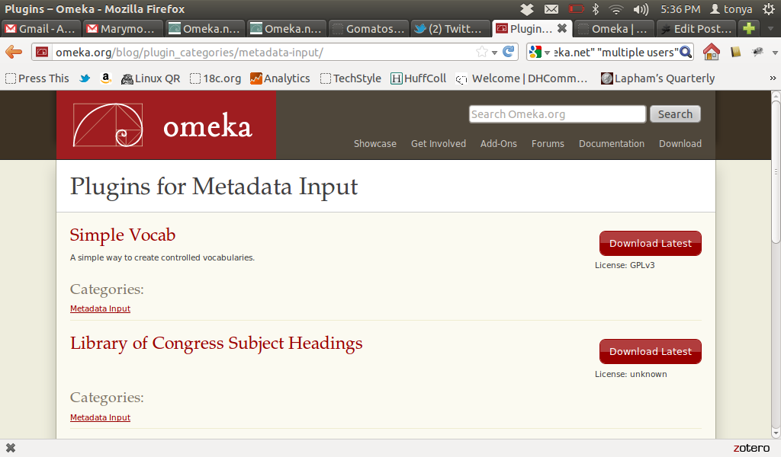
Plugins can help you create your metadata using controlled vocabularies. Try Simple Vocab and the LOC Subject Headings, in particular.

Let's build a collection!
- Give me your email address. I will add you as a researcher contributor to the test site I've set up--this will be more in line with what your students will see and have access to; you can play with building your own site later.
- Check your email, and click the link to accept the invitation. Create a free Omeka.net account for yourself.
- Check your email to activate and login.You will now have the ability to create records in my collection.
- Browse over either to Flickr Commons, the VAM, or Vimeo and find a resource that you want to work with. Alternatively, you might choose a website to include in our collection. (If your resource has a specific license, be sure to abide by that copyright license completely.)
- Keep this page open in one tab, so you can work with the information it provides. Download the image or video to your desktop, or copy the URL of your website.
- Create a record in Omeka.net for your resource. Work through the Dublin Core element set to add metadata about your resource. You might want to take a look at the links above for sample vocabularies.
- Be sure to save your work periodically! Omeka.net will time out and you can lose all your work.
- When you have finished a draft of your resource, let me know. I will make it public, and we'll take a look at what we've created together.

Conclusion
How might you imagine using Omeka in the classroom? For your own scholarship or research?

