1.

a. Adresa IPv4: 10.150.2.151

b. Adresa MAC: 2C-27-D7-40-45-EA

c. Tipuri de interfete: Ethernet

d. Numarul de pachete trimise: 4

e. Exemplificari de rute de conectivitate:

2.

a. 3 procese in ordinea consumului de resurse:

1. Acrobat Update Service

2. Antimalware Service Executable

3.AnyDesk

b. 3 servicii in ordinea consumului de resure:

1. svchost.exe Service Host: CaptureService_5456e53

2. CaptureService_5456e53 CaptureService_5456e53

3. svchost.exe Service Host: Clipboard User Service_5456e53

c. 3 aplicatii in ordinea consumului de resurse:

1.Microsoft Teams

2.Microsoft Word

3.Task Manager

d. Performanta CPU

e. Conexiuni in retea si specificatii:

Active Connections

Proto Local Address Foreign Address State

TCP 10.150.2.151:60270 relay-82295404:https ESTABLISHED

TCP 10.150.2.151:60275 20.199.120.151:https ESTABLISHED

TCP 10.150.2.151:60323 20.190.177.82:https TIME_WAIT

TCP 10.150.2.151:60353 20.91.147.72:https TIME_WAIT

TCP 10.150.2.151:60359 hosting:http TIME_WAIT

TCP 10.150.2.151:60360 hosting:https TIME_WAIT

TCP 10.150.2.151:60364 13.107.42.16:https TIME_WAIT

TCP 10.150.2.151:60369 hosting:http TIME_WAIT

TCP 10.150.2.151:60370 hosting:https TIME_WAIT

TCP 10.150.2.151:60377 204.79.197.239:https TIME_WAIT

TCP 10.150.2.151:60378 fra24s05-in-f14:https TIME_WAIT

TCP 10.150.2.151:60380 fra24s05-in-f14:https TIME_WAIT

TCP 10.150.2.151:60383 fra16s50-in-f1:https TIME_WAIT

TCP 10.150.2.151:60385 fra16s50-in-f1:https TIME_WAIT

TCP 10.150.2.151:60387 152.199.21.175:https TIME_WAIT

TCP 10.150.2.151:60390 4.156.0.85:https TIME_WAIT

TCP 10.150.2.151:60393 52.236.189.96:https TIME_WAIT

TCP 10.150.2.151:60395 192.229.221.95:http TIME_WAIT

TCP 10.150.2.151:60396 204.79.197.239:https TIME_WAIT

TCP 10.150.2.151:60401 a92-123-103-96:https ESTABLISHED

TCP 10.150.2.151:60402 192.229.221.95:http ESTABLISHED

TCP 10.150.2.151:60408 a92-123-103-81:https CLOSE_WAIT

TCP 10.150.2.151:60414 20.189.173.23:https ESTABLISHED

TCP 10.150.2.151:60418 20.223.35.26:https TIME_WAIT

TCP 10.150.2.151:60419 20.223.35.26:https TIME_WAIT

TCP 10.150.2.151:60421 192.229.221.95:http TIME_WAIT

TCP 10.150.2.151:60427 204.79.197.239:https TIME_WAIT

TCP 10.150.2.151:60428 204.79.197.239:https ESTABLISHED

TCP 10.150.2.151:60429 20.190.181.5:https TIME_WAIT

TCP 10.150.2.151:60432 vip0x008:http ESTABLISHED

TCP 10.150.2.151:60433 20.190.181.5:https TIME_WAIT

TCP 10.150.2.151:60437 204.79.197.222:https ESTABLISHED

TCP 10.150.2.151:60440 fra16s48-in-f10:https TIME_WAIT

TCP 10.150.2.151:60441 fra16s48-in-f10:https TIME_WAIT

TCP 10.150.2.151:60442 13.107.253.254:https ESTABLISHED

TCP 10.150.2.151:60443 13.107.246.44:https CLOSE_WAIT

TCP 10.150.2.151:60444 40.126.212.197:https ESTABLISHED

TCP 10.150.2.151:60445 68.219.88.225:https ESTABLISHED

TCP 10.150.2.151:60446 a92-122-17-38:https ESTABLISHED

TCP 10.150.2.151:60451 a92-122-17-38:https ESTABLISHED

TCP 10.150.2.151:60452 192.229.221.95:http ESTABLISHED

TCP 10.150.2.151:60453 hosting:http TIME_WAIT

TCP 10.150.2.151:60454 hosting:https TIME_WAIT

TCP 10.150.2.151:60457 13.107.42.16:https TIME_WAIT

TCP 10.150.2.151:60460 13.107.21.239:https ESTABLISHED

TCP 10.150.2.151:60461 hosting:http TIME_WAIT

TCP 10.150.2.151:60462 hosting:https TIME_WAIT

TCP 10.150.2.151:60463 20.190.177.148:https TIME_WAIT

TCP 10.150.2.151:60464 20.190.177.148:https TIME_WAIT

TCP 10.150.2.151:60470 192.229.221.185:https TIME_WAIT

TCP 10.150.2.151:60471 13.107.246.44:https TIME_WAIT

TCP 10.150.2.151:60472 152.199.21.175:https TIME_WAIT

TCP 10.150.2.151:60473 192.229.221.185:https TIME_WAIT

TCP 10.150.2.151:60474 52.236.189.96:https TIME_WAIT

TCP 10.150.2.151:60475 20.42.65.84:https ESTABLISHED

TCP 10.150.2.151:60478 52.182.141.63:https ESTABLISHED

TCP 10.150.2.151:60484 52.182.141.63:https ESTABLISHED

TCP 10.150.2.151:60485 20.50.201.201:https TIME_WAIT

TCP 10.150.2.151:60486 hosting:http TIME_WAIT

TCP 10.150.2.151:60487 hosting:https TIME_WAIT

TCP 10.150.2.151:60488 20.50.201.201:https TIME_WAIT

TCP 10.150.2.151:60491 20.223.35.26:https ESTABLISHED

TCP 10.150.2.151:60494 hosting:http ESTABLISHED

TCP 10.150.2.151:60495 hosting:https ESTABLISHED

TCP 10.150.2.151:60496 hosting:http ESTABLISHED

TCP 10.150.2.151:60497 hosting:https ESTABLISHED

TCP 10.150.2.151:60498 52.123.129.14:https ESTABLISHED

TCP 10.150.2.151:60506 10.129.3.183:ms-do SYN_SENT

Port: Ethernet

Specificatii:

3. Tip- LAN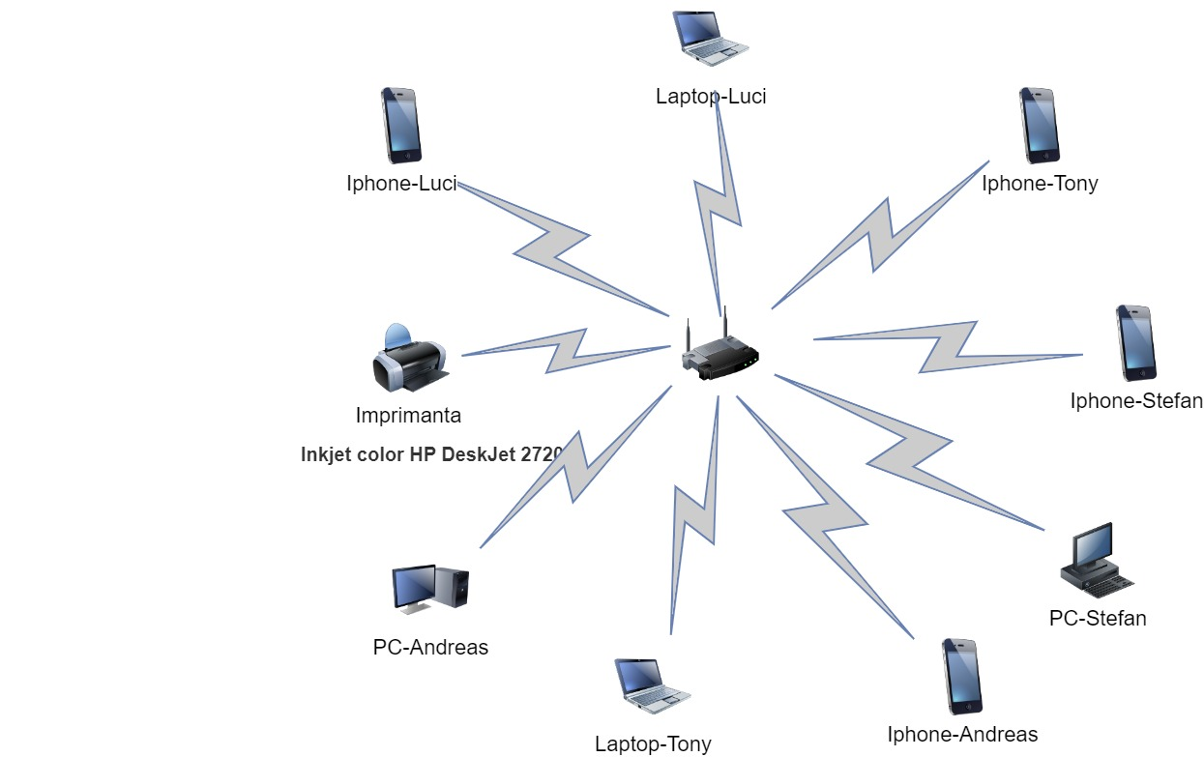

4.1Dimensiunea imaginii:

1600 pixeli * 1200 pixeli * 8 biți/pixel = 15,360,000 biți

Timpul necesar pentru diferite rate de transfer:

a) La 56 kbps:

15,360,000 biți / 56,000 bps = 273,214,29 secunde

b) La 1 Mbps:

15,360,000 biți / 1,000,000 bps = 15,36 secunde

c) La 10 Mbps:

15,360,000 biți / 10,000,000 bps = 1,536 secunde

d) La 100 Mbps:

15,360,000 biți / 100,000,000 bps = 0,1536 secunde

e) La 1 Gbps:

15,360,000 biți / 1,000,000,000 bps = 0,01536 secunde

4.2

5*4*100=2000ms=2s