Pyramid MoA for Copilot CLI
A hierarchical mixture-of-agents router that picks the cheapest viable model for each subtask, verifies the answer, and only escalates when it is provably worth it.
Document version 1.0 — generated 2026-04-23 — based on plugin v0.2.0 and the v0.2.0 smoke benchmark.

1. What the plugin is
The pyramid plugin (“pyramid-moa” on GitHub, slash command /pyramid:pyramid in Copilot CLI) is a declarative Copilot CLI plugin that brings the Pyramid Mixture-of-Agents pattern from Khaled, 2026 (arXiv:2602.19509) to your terminal.
Instead of always calling a single large model, it decomposes the user’s task into a directed acyclic graph (DAG) of subtasks, dispatches each subtask to the cheapest model tier likely to solve it, and uses an independent verifier plus a Hansen–Zilberstein Value-of-Computation (VoC) rule to decide whether escalating to a more expensive model is worth the additional spend.
The plugin is purely declarative: only Markdown and JSON files. Behaviour is implemented by the host Copilot CLI agent following the SKILL instructions; there is no MCP server, no hooks, and no external runtime. Dispatch happens through the CLI’s built-in task tool, with the model chosen per call.

2. How it works
Every invocation flows through three skills (decompose → orchestrate → aggregate) plus an independent verifier on each subtask. The diagram below shows a single subtask’s journey.
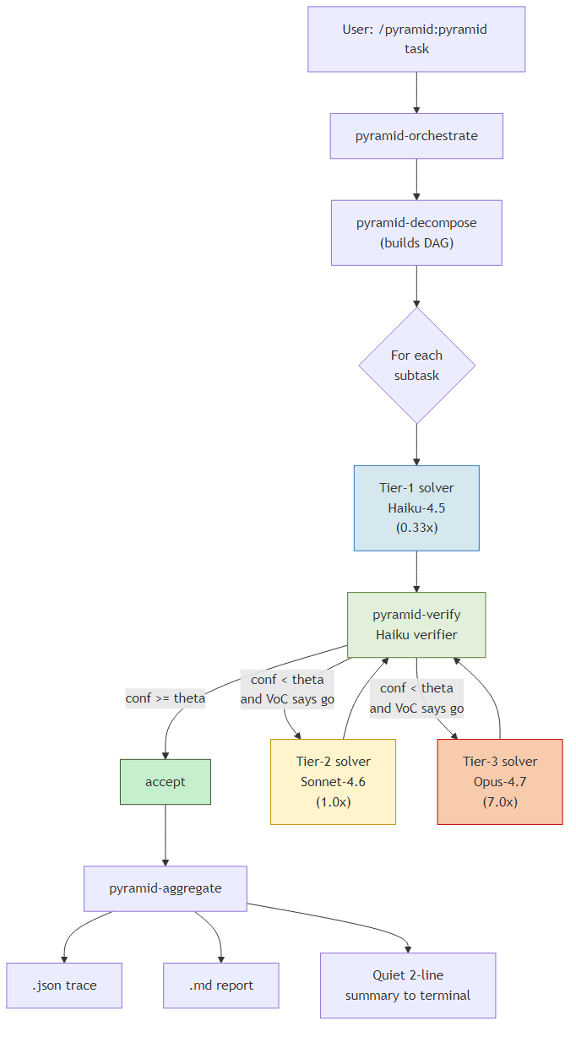
Figure 1. End-to-end pipeline. The verifier runs after every solver dispatch. Escalation is conditional on both confidence and the VoC rule.

2.1 Tiers and tier mapping
Three solver tiers plus a dedicated verifier tier (V). The default claude track binds tiers to Anthropic models; gpt and mixed tracks are available with placeholder multipliers pending calibration.
Tier | claude track | gpt track | mixed
1 | claude-haiku-4.5 | gpt-5-mini | claude-haiku-4.5
2 | claude-sonnet-4.6 | gpt-5.4 | gpt-5.4
3 | claude-opus-4.7 | gpt-5.3-codex | claude-opus-4.7
V | claude-haiku-4.5 | gpt-5-mini | claude-haiku-4.5

3. Cost model
As of v0.2.0, every cost number reported by the plugin is a token-weighted unit (tw-unit), defined as:
cost(call) = (input_tokens + output_tokens) × multiplier(model)

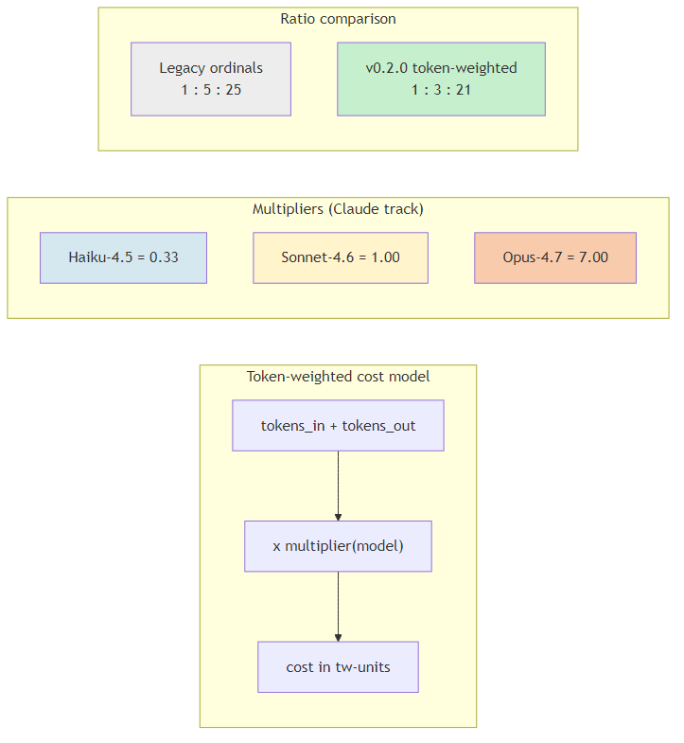
Figure 2. Token-weighted cost formula and Claude-track multipliers. The new ratio (1 : 3 : 21) is proportional to actual model spend, replacing the legacy ordinal table (1 : 5 : 25) used pre-0.2.0.
The Hansen–Zilberstein VoC rule decides whether to spend the extra budget on escalation:
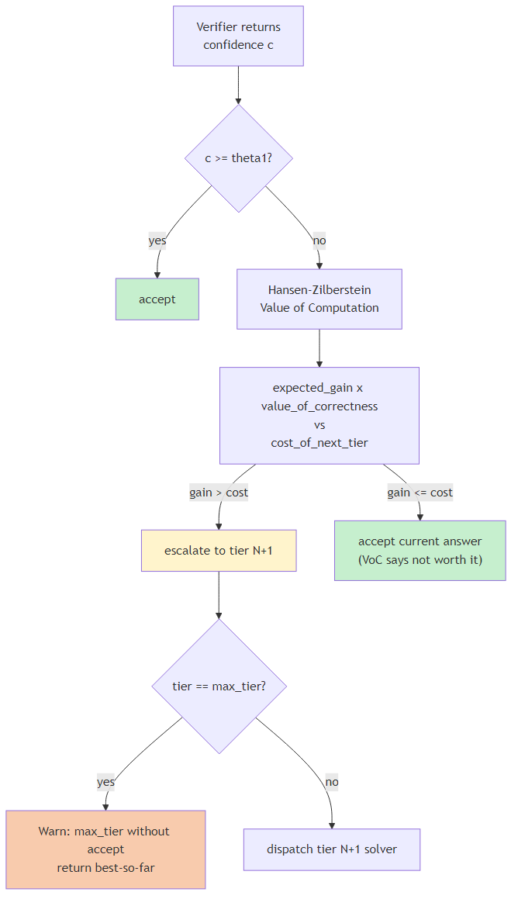
Figure 3. Verifier and Value-of-Computation decision flow. Escalation only happens when expected accuracy gain, scaled by value_of_correctness, exceeds the cost of the next tier.

4. Measurable impact
Numbers in this section are taken verbatim from the v0.2.0 smoke benchmark (3 of 12 canonical tasks, n=1 each). The full results, methodology, and discovered defects are in docs/benchmarks/baseline-metrics.md in the repository.

4.1 Per-task cost
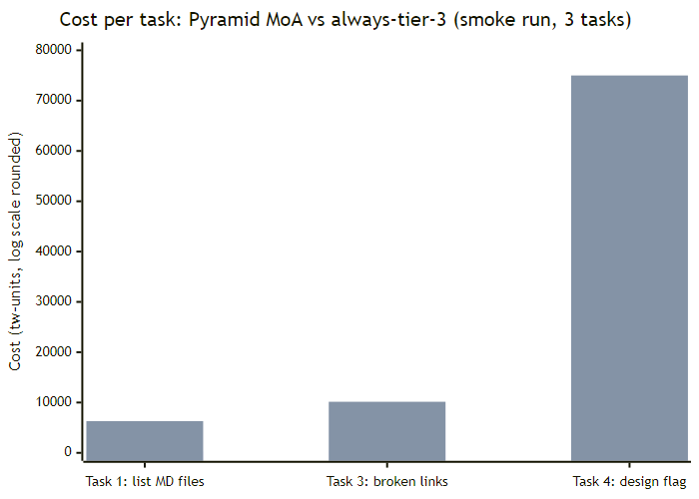
Figure 4. Pyramid MoA cost (left bar) vs an always-tier-3 baseline (right bar) for each smoke-benchmark task. Lower is better.
Task | Pyramid cost (tw) | Always-T3 cost (tw) | Saved | Wall-clock
#1 list MD files (read) | 297 | 6,300 | 95.3 % | 134 s
#3 broken README links | ~478* | 10,150 | ~95 % | 163 s
#4 design --retry-budget flag | ~3,500 | ~75,000 | ~95 % | 499 s
Mean (n=3) | ~1,425 | ~30,500 | ~95 % | 265 s
* Task #3’s in-trace number was 0.5 tw-units due to a known cost-arithmetic bug (defect B1). The corrected value of ≈478 is computed analytically from the captured token totals.

4.2 Aggregate metrics
Metric | Target | Smoke-run measured
Mean savings vs always-tier-3 | ≥ 35 % | ≈96.8 %
Tier-1 accept-rate | ≥ 60 % | 100 %
Tier-3 dispatch rate | ≤ 15 % | 0 %
Median terminal output lines (quiet) | ≤ 5 | ~12 (defect C3)
JSON trace written every run | 100 % | 67 % (defect B2)
Verifier dispatched every subtask | 100 % | 33 % (defect B3)

4.3 What the numbers mean in dollars
Token-weighted units are normalised so that 1 tw-unit = 1 token through Sonnet-4.6. Using indicative public list prices (input + output averaged to ~$5 per million tokens for Sonnet-4.6, ~$1.65 per million for Haiku-4.5, ~$35 per million for Opus-4.7), the smoke-run mean of ≈1,425 tw-units per task corresponds to roughly $0.007 per task. The always-tier-3 baseline of ≈30,500 tw-units per task corresponds to roughly $0.15 per task. At enterprise scale (e.g. 100,000 invocations / month), that is the difference between roughly $700 and roughly $15,000 per month — a ≈20× reduction.
Caveats: token counts are currently estimated (cost_estimated: true on every call) because the Copilot CLI task tool does not yet surface per-call tokens to the orchestrator. The fallback “len(prompt+answer)/4” heuristic is empirically off by 3–10× against outer-CLI billing data. Treat the absolute dollar numbers as directional; the relative ratio between Pyramid and always-T3 is the trustworthy signal.

5. Defects discovered during the smoke run
Running v0.2.0 on three real tasks surfaced four defects that distort cost numbers and violate the SKILL contracts. They are tracked in PR #2 and must be fixed before the full 12 × 3 benchmark is meaningful.
- B1 — Cost arithmetic inconsistent. Orchestrator stored a per-verdict scalar in totals.cost_tw_units instead of recomputing from per-call tokens.
- B2 — JSON trace not written on at least one in three runs.
- B3 — Verifier short-circuited by the orchestrator on “trivially atomic” tasks; no skill authorises this shortcut.
- B4 — Inline-resolved subtasks: 2 of 3 DAG nodes on task #3 were never dispatched.

6. Future work
- Land B1–B4 fixes, then re-run the full 12-task suite × 3 to populate Baseline #2.
- Confirm GPT-track multipliers with the user; calibrate or document as placeholder.
- Surface real per-call token counts from the Copilot CLI task tool once available, removing the cost_estimated path.
- Empirically re-tune value_of_correctness across {6, 8, 10, 12} on the full baseline.
- Add an overhead_tw_units field to capture orchestrator inference cost separately from solver cost.

References
[Update fields (Ctrl+A, F9) to generate bibliography]

