Multiplatform Kanban Taskboard

SRS

Version: 1.0

Date: 9-13-10

Presented by: Team CAIK

Team Member 1’s Name | Christopher Wood
Team Member 2’s Name | Kyle Storck
Team Member 3’s Name | Ian Hunt
Team Member 4’s Name | Anthony Barone
Team Member 5’s Name

System Summary
The goal for the Kanban Taskboard is to provide software development teams with a tool that allows for more transparency towards project requirements, tasks, and milestones. Kanban is an agile methodology for visualizing, managing and optimizing the flow of software requirements for a given application and for distributing the associated work among the development team. This application can be synchronized between multiple platforms.

Existing Competition
An existing Kanban Taskboard application out on the market is called “Simple Kanban” and features a lightweight solution to project visualization and organization. All projects are one simple HTML file; however, the graphical user interface has much to be desired.

Outside the realm of computers, real-life physical taskboards are also a competition to our software if the users prefer a more hands-on approach. Physical post-it notes are easy to replace and modify without the need for complex software; however, it is not very portable.

User Classes and Characteristics

User Class: Software Developers
Background: | Computer literacy, education, other profile characteristics. Be specific, even with ranges as relevant.  This people group is very literate with computers, having much experience throughout schooling and the industry. Education could vary, for example, these developers could be fresh out of high school starting college, or they could be post-graduate doctorates with computer degrees.
Expectations: | Of the system (what the system will do for them in terms of their goals) – such as helping them do X faster.  They expect a usable application that acts as a clear roadmap towards project requirements and milestones. They also expect this application to optimize the flow of development as well as distributing the work load accordingly.
System Preferences: | In terms of features and of the UI (this is different from their goals) such wanting to access printing with a keyboard shortcut  The GUI will feature keyboard shortcuts for almost all commands possible since most developers are used to using some set of keyboard shortcuts in their daily-used applications. The Taskboard will also include drag-and-drop functionality across all the post-it note objects on the screen. Furthermore, tasks can be easily editable via a shortcut button appearing besides tasks.
Domain Knowledge: | ___ low ___ medium ___ high
Interaction Profile: | Frequency: ___ low ___ medium ___ high (how often used)
Interaction Profile: | Intensity: ___ low ____ medium ____ high (when system is used)
Usability Objectives (rank in order of preference): | reliability  efficiency  clarity ___  accuracy  comprehensibility  learnability (lower since their short learning curve) ___ ___ ___  memorability ___  attractiveness ___

User Class: Project Managers
Background: | Computer literacy, education, other profile characteristics. Be specific, even with ranges as relevant.  This people group is mostly literate with computers, having significant experience throughout schooling and the industry. Education could vary, for example, these managers could hold any kind of technical or business undergraduate/graduate degree.
Expectations: | Of the system (what the system will do for them in terms of their goals) – such as helping them do X faster.  They expect a usable application that acts as a clear roadmap towards project requirements and milestones. These managers expect to have project visibility improved by using this application. They expect a somewhat attractive and very organized user interface, more than the developers. The team productivity reports are extremely important to these managers by having a quick check on the team’s project progress.
System Preferences: | In terms of features and of the UI (this is different from their goals) such wanting to access printing with a keyboard shortcut  These managers usually take advantage of the simple mouse-and-keyboard approach versus keyboard shortcuts, unlike the developers. UI elements will be laid out clearly and comprehensively since efficiency is very critical to project managers.
Domain Knowledge: | ___ low ___ medium ___ high
Interaction Profile: | Frequency: ___ low ___ medium ___ high (how often used)
Interaction Profile: | Intensity: ___ low ____ medium ____ high (when system is used)
Usability Objectives (rank in order of preference): | efficiency  clarity  comprehensibility ___  reliability  attractiveness  accuracy  memorability  learnability _

System Features

- “As a software developer or project manager, I want to access this Taskboard either through my web browser on my PC or mobile device while I’m on-the-go. Having plugins for my commonly used applications, such as Firefox and Eclipse, would be beneficial too.”

- “As a software developer or project manager, I want an interface that looks similar to a real-life Taskboard with draggable sticky notes attached. I desire a simple way to manage tasks as the lifecycle progresses.”

- “As a software developer, I would have much interest in the support of versioning for the purpose of comparing previous states of the Taskboard with the current one, just like I can with my source code.”

- “As a project manager, I want to be able to generate progress reports on-the-fly so I can better gauge my team’s productivity and progress.”

- “As a software developer or project manager, I would like to be able to subscribe to the Taskboard to be notified of updates, task completions, state changes, etc.”

- “As a product manager, being able to import and export a complete backlog a version of the Taskboard would be ideal. This is important for referencing the Taskboard when offline and not able to navigate to the web-app.”

Task Analysis
Task 1: Creating a New Project – Textual HTA
- Creating a New Project
  - Open the Kanban Taskboard application via any web browser.
  - Login to the system.
    - Enter the username
    - Enter the password
    - Click the “Login” button
  - Click the “Create New Project” button at the top-left corner.
  - Fill in the general information about the project.
    - Enter the project name
    - Enter the company name
    - Enter the project manager name
    - Enter the start date
    - Enter the end date
  - Define the taskboard layout.
    - Click the “Add Column…” button
    - Fill in the name for the column
    - Specify the number of post-it note spaces allowed
    - Specify the time threshold before warning about stagnate tasks
  - Define the post-it note layout.
    - Specify the desired color of the post-it note
    - Select a font / font color
  - Click the “Finish” button at the bottom of the window.

Plan 0: do 1-2-3 in that order, 4-6 in any order. Step 5 must be completed at least once (at least 1 column is required for creation of the taskboard). Do 6 if desired (default values will be provided, so this step is optional). When 4-6 are all done, do 7.
Plan 2: do 2.1-2.2 in any order, then do 2.3. This repeats until the user logs in successfully.
Plan 4: do 4.1 (required field), do 4.2-4.5 in any order if desired (all four of these are optional fields)
Plan 5: do 5.1-5.2 in that order; do 5.3-5.4 in any order if desired (default values will be provided, so these two steps are optional); Repeat for all necessary columns
Plan 6: do 6.1-6.2 in any order if desired (default values will be provided, so these two steps are optional)

Task 1: Creating a New Project – Graphical HTA

0. Creating a New Project

1. Open Kanban Taskboard App via any web browser

3. Click “Create New Project” in top-left corner

4. Fill in general info

5. Define the taskboard layout

6. Define the post-it note layout

7. Click “Finish”

2. Login to the system

4.1 Enter the project name

2.1 Enter the username

5.1 Click “Add Column…”

4.1 Enter the company name

2.2 Enter the password

5.2 Fill in column name

6.1 Specify post-it note color

6.2 Select a font / font color

2.3 Click “Login”

4.1 Enter the project manager name

4.1 Enter the
start date

4.1 Enter the
end date

5.3 Specify number of
post-it note spaces allowed

5.4 Specify time threshold
of tasks

Task 2: Subscribing to Task Notifications – Textual HTA
- Subscribe to a set of work items for notifications.
  - Log in to the Kanban Taskboard.
    - Navigate to the Kanban Taskboard website.
    - Enter login username.
    - Enter login password.
    - Click “Login” to initiate the login process.
  - Open the desired Kanban project.
    - Select the desired project from the list of available projects.
    - Click “Open” to display the chosen project.
  - Configure the default notification settings.
    - Click on the menu item labeled “Notification Settings”.
    - Select the notification mediums (RSS, email, etc.).
    - Choose the notification frequency (once per day, week, etc.).
    - Choose the notification priority (e.g. notify upon certain changes).
    - Click “OK” to save the settings.
  - Flag a work item that is to be watched for notifications.
    - Choose the desired work item from the taskboard.
    - Click on the “Flag” button located next to the item.
    - Configure the work item notification settings.
      - Click the “Edit Task” button located next to the item.
      - Click on the “Notification Settings” tab in the popup menu.
      - Select the “Custom Notification Settings” checkbox.
      - Select the notification mediums (RSS, email, etc.).
      - Choose the notification frequency (once per day, week, etc.).
      - Choose the notification priority (e.g. notify upon certain changes).
      - Click “OK” to save the settings.

Plan 0: do steps 1 and 2 in order, followed by steps 3 and 4 in any order. Step 3 is optional and should only be done if the default notification settings are already configured and do not need to be changed. Repeat step 4 for each work item you wish to subscribe to.
Plan 1: do step 1, followed by steps 2 and 3 in any order, and finish with step 4. Repeat steps 2, 3, and 4 until the login procedure is successful.
Plan 2: do steps and 1 and 2 in order.
Plan 3: do step 1, followed by steps 2, 3, and 4 in any order, and finish with step 5. This step is optional if the default notification settings are already configured and don’t need to be changed. Changing the default values in steps 2, 3, and 4 is optional.
Plan 4: do steps 1 and 2 in order. Only perform step 3 if you wish to change the notification settings for the work item from their default settings. Repeat steps 1, 2, and 3 as necessary for each work item you wish to subscribe to.
Plan 4.3: do steps 1, 2, and 3 in order, followed by steps 4, 5, and 6 in any order, and finish with step 7. This step is optional based on whether or not the default notification settings will be used for the chosen work item. Changing the default values in steps 4, 5, and 6 is optional.
Task 2: Subscribing to Task Notifications – Graphical HTA

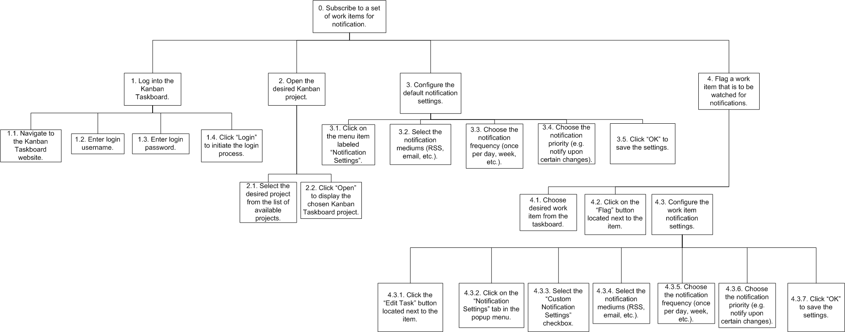

Task 3: Reverting to a Previous Version – Textual HTA
- Open a Kanban Taskboard
  - Open the Versions screen
    - Click the menu
    - Select view versions
  - Select desired version
    - Browse through the descriptions of previous workspace versions
    - Click to select a version and view more detail
    - Click back to see versions list
  - Revert to a Version
    - Select revert to this version

      - Select ‘Make this the current version’
    - Select ‘Discard all changes since this version and revert’
  - Return to the workspace to see changes reflected

Plan 0: Do 1-4 in order
Plan 1: Do 1.1 and 1.2 in order
Plan 2: Do 2.1 and 2.2. If not desired version do 2.3, then repeat.
Plan 3: Do 3.1
Plan 3.1: Do 3.1.1 OR 3.1.2 depending on desired outcome

Task 3: Reverting to a Previous Version – Graphical HTA
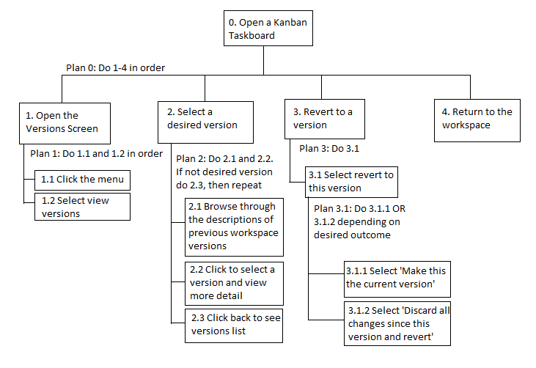
Task 4: Creating a New Task – Textual HTA
0. Creating a new task
- Open Kanban Taskboard
- Select “New Task” option (icon of a post-it with a star)
- New Task information
  - Enter name of task
  - Enter description of task
  - Enter group member(s) responsible for task
  - Enter a deadline for the task
  - Select which column task will go under
  - Select priority of task
- Select “Add Task”

Plan 0: Do 1-2-3-4, in that order.
Plan 3: 3.1 must be completed; 3.2, 3.3, 3.4, 3.5, 3.6 can be completed in any order, or not at all. By default, a task will be created in the first column under medium priority.

Task 4: Creating a New Task – Graphical HTA
Open Kanban Taskboard
2. Select “New Task” option (icon of a post-it with a star)
4. Select “Add Task”
3.5. Select which column task goes under
3.3. Enter group member(s) responsible for task
3.1. Enter name of task
3. New Task Information
3.2. Enter description of task
3.6. Select priority of task
3.4. Enter deadline for task

Task 5: Generating History Reports – Textual HTA
0. Generating History Reports
- Open existing Kanban project
- Select “Reports” option
- Enter date range
  - Enter dates manually in xx/xx/xxxx format
  - Select dates using Date Chooser
- Select report type
  - Team Progress
  - User Progress
    - Select User
- Select “Generate Report”

Plan 0: Do 1-2-3-4-5, in that order
Plan 3: Either do 3.1 or 3.2.
Plan 4: Either do 4.1 or 4.2 & 4.2.1

Task 5: Generating History Reports – Graphical HTA
0. Generating History Reports
1. Open existing Kanban project
4.1 Team Progress
4. Select report type
3.1 Enter dates manually in xx/xx/xxxx format
2. Select “Reports” option
3.2 Select dates using Date Chooser
3. Enter date range
4.2.1 Select User
4.2 User Progress
5. Select Generate Report
Task 6: Export Version Backlog to Excel file – Textual HTA
0. Export version backlog to Excel file
1. Log into KanbanTaskboard
1.1. Navigate to Kanban Taskboard website
1.2. Enter username
1.3. Enter password
1.4. Click the “Login” button
2. Open the desired project
2.1. Select a project from the list of available projects
2.2. Click the “Open” button
3. Open versions menu
3.1. Click the menu
3.2. Select view versions
4. Export version backlog
4.1. Click on “Export” button
4.2. Select backlog option
4.3. Select output file format (e.g. Excel)
4.4. Click on “Ok” button
5. Return to workspace

Plan 0: Do 1-3 in order
Plan 1: Do 1.1, followed by 1.2 and 1.3 in any order, and finish with 1.4.
Plan 2: Do 2.1 and 2.2 in order
Plan 3: Do 3.1 and 3.2 in order
Plan 4: Do 4.1, followed by 4.2 or 4.3 in any order, and finish with 4.4.

Task 6: Export Version Backlog to Excel file – Graphical HTA

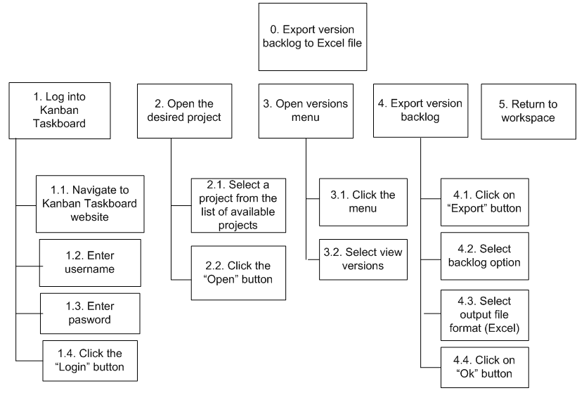

Nonfunctional Requirements

Usability Requirements

- UI models a physical taskboard (whiteboard with post-it notes).
- Taskboard is neatly divided into different stages.
- It should be possible for a user to specify all of the details about a newly created task in 60 seconds.
- It should possible for a user to move a task between stages in 5 seconds.
- It should be possible for a user to retrieve a previous version of the project for comparison in 60 seconds.
- It should be possible for a manager to update the version number in 20 seconds.
- It should be possible for a user to generate reports regarding project changes in 30 seconds.
- It should be possible for the user to perform a set of tasks 50% faster the second time they use it.

Prototypes

Figure 1: Login Screen
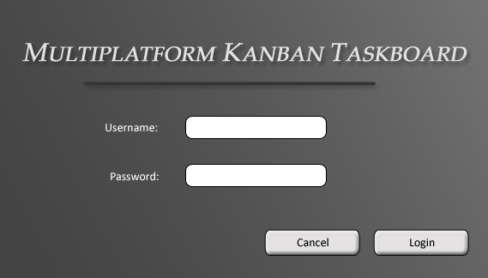

This is the login screen for the web application where a registered user will enter his or her username and password information to access their project database. Pressing the Login button will check the inputted text from the text box fields for a match in the user database. Pressing the Cancel button will redirect the user back to an informational home page.

Figure 2: Project Selection Screen
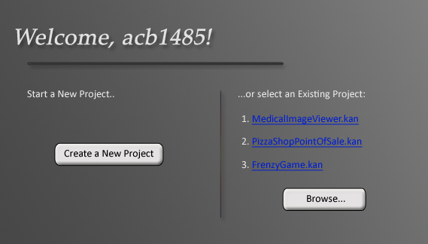

This is the project selection dialog where a user can specify if they want to create a new project, or simply open an existing project, with the 3 most recently modified projects listed on the right-hand side. Creating a new project is as simple as clicking on the left Create button; whereas browsing saved projects tied to your username can be viewed clicking on ‘Browse…”.

Figure 3: New Project Creation Screen

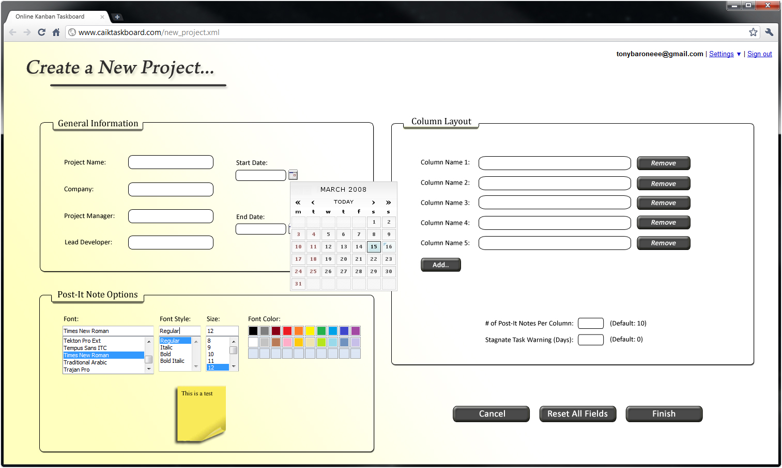

This is the form for creating a new project if the user clicked the “Create a New Project” button in Figure 2. This form will collect all of the necessary information regarding the general information, column layout, and post-it note layout of the project. The customization options are presented to the users in a clear and organized fashion.

Figure 4: Main Taskboard Screen
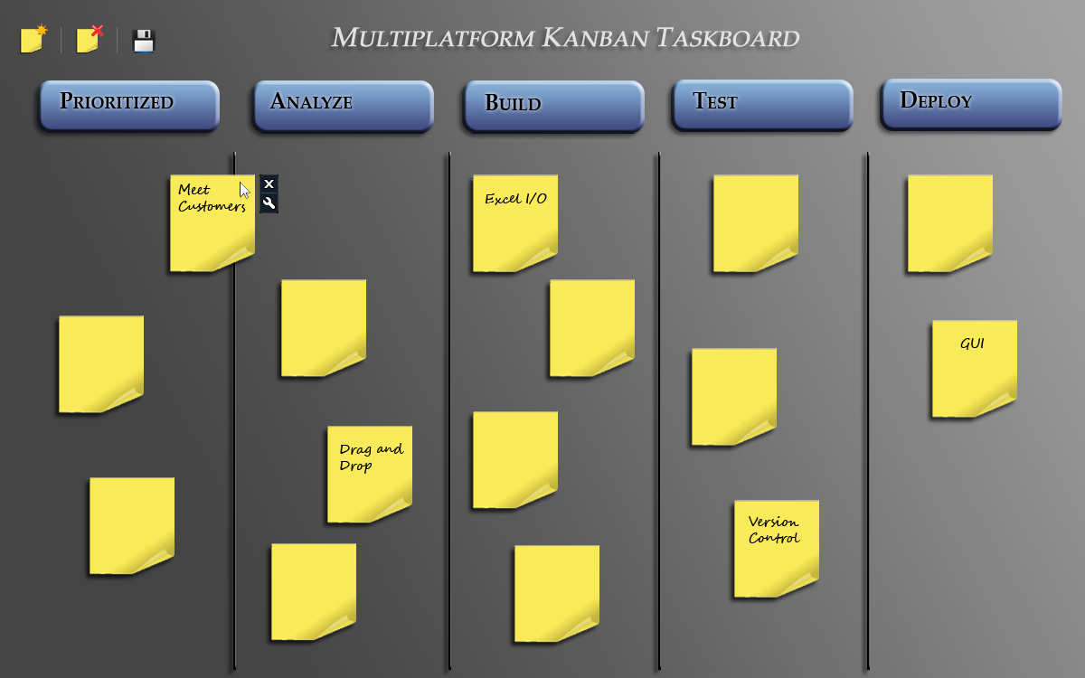

This is the main screen of the application where the visual event taskboard is presented to the user with methods of creating, deleting, repositioning, and modifying tasks. The project title will be displayed at the top of the taskboard and the actual columns reflect the users’ choices (via the ‘Column Layout’ panel in Figure 3).

