Relational Model

Resident (Health Insurance Number, Date of registration, gender, date of birth, rname, priority group, phone, address)

Nurse (license number, nname, employer)

Employer is the foreign key referncing vaccination venues

Vaccination Venue (vname , address, zip code, city)

Day (vname, date, number of available vaccines)

vname is the foreign key referencing vaccination venues

Vaccine Type (Manufacturer, No. of required doses)

Batch (Manufacturer, Batch No., manufacturing date, expiry date)

Manufacturer is the foreign key referencing vaccine types

Vial (Manufacturer, Batch No., Vial No.)

Batch No. and manufacturer together is the foreign key referencing batches

Nurse assignment(goes to) (license number, vname, date)

license number is the foreign key referencing nurses

date and vname together is the foreign key referencing days

Batch assignment(sends to) (Manufacturer, Batch No., vname, date)

Manufacturer and Batch No. together is the foreign key referencing batches

Vname is the foreign key referencing days

Vaccination_Slot (license number, Health Insurance Number, Manufacturer, Batch No., Vial No., vname, date, time interval, room number)

license number is the foreign key referencing nurses

Health Insurance Number is the foreign key referencing residents

Manufacturer, Batch No., and Vial No. together is the foreign key referencing vials

vname, date, time interval, room number together is the foreign key referencing vaccination slots.

For better visualization when grading, all sql commands called by the java program are printed out when they get called.

a)i)

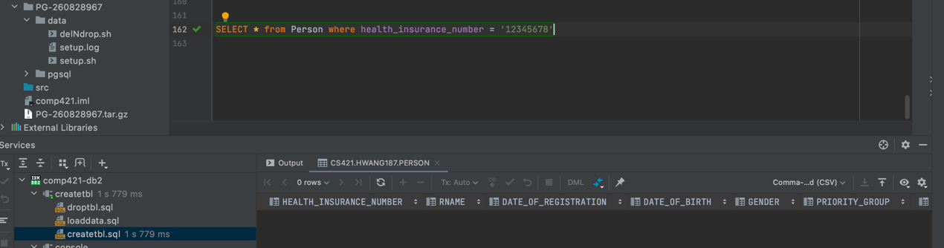

ii)

iii)

iv)

v)

b)i)

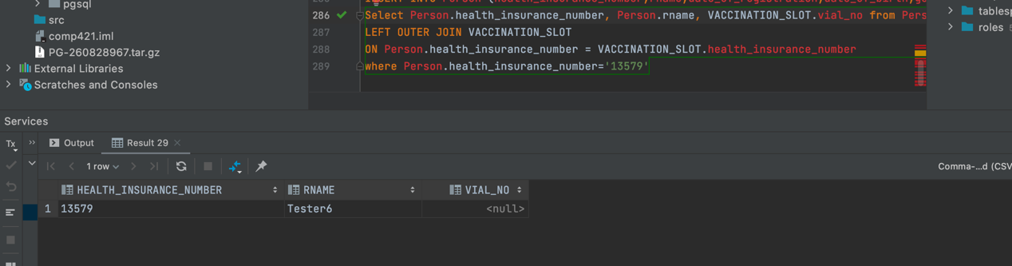

ii) 

iii)

iv)

v)

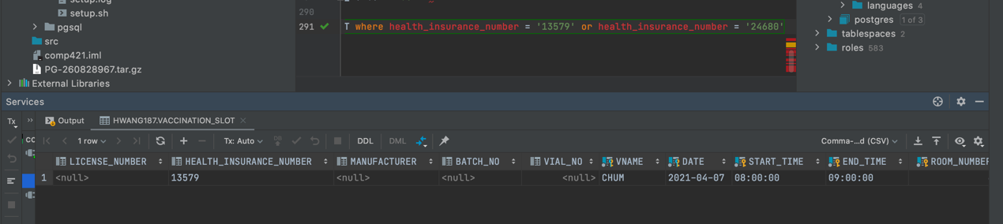

c)i)

ii)

iii)

iv)

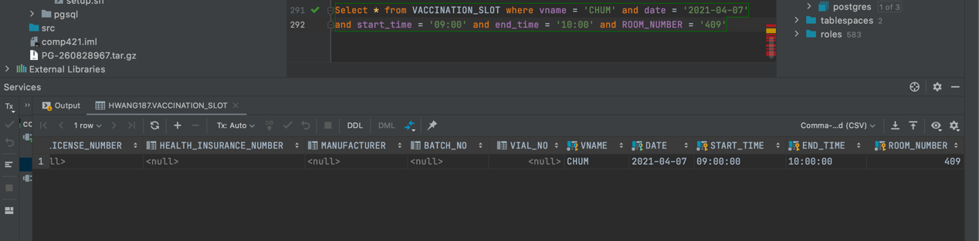

d)i)

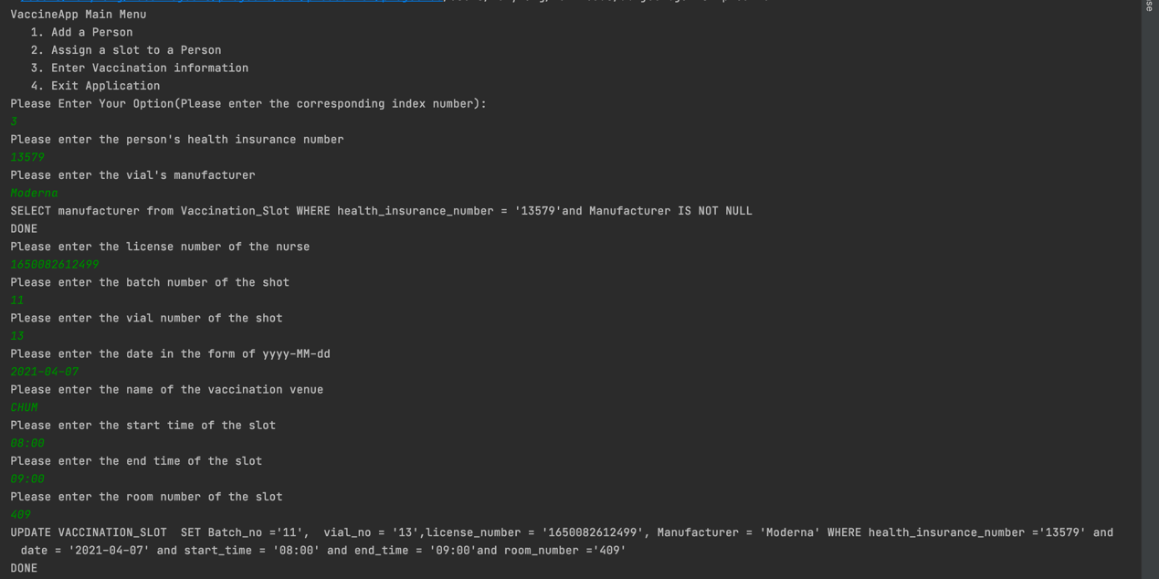  
ii)

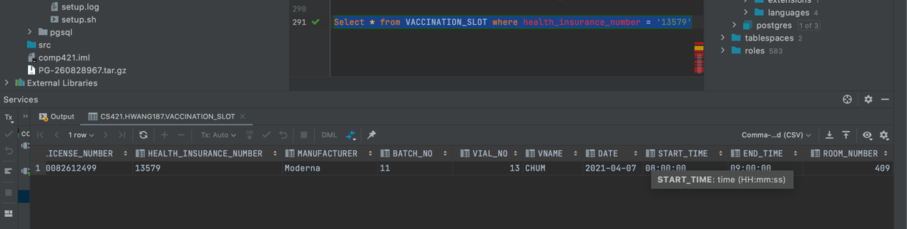

e)i)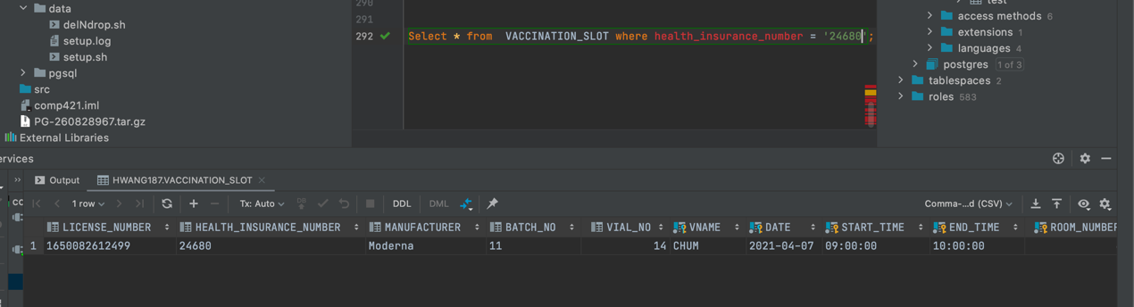

ii)

iii)

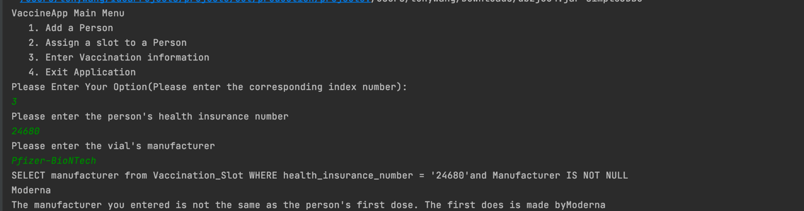

3. Indexing

This index will be about the same as index directly on the primary key(insurance number).

This is because the phone number is also unique to each person, just like insurance number.

In real-life situations, using the phone number might be worse. Because a person can have multiple phone numbers, he/she can also change his/her phone number. Some person might not even have phone numbers. But a person must have a unique health insurance number that never changes.

4. Data Analytics

