Apps4NSW – informal notes – tony.caine@water.nsw.gov.au
About 10 teams worked at UTS to the stage of presenting a ‘Pitch’ for their App. Of these about 4 used Public Data. Two used live data and both of these used data from NSW Office of Water. Two others used data harvested from PDF’s or csv files at http://www.data.nsw.gov.au/.
The weekend ‘winner’ was alpha version of ‘Pump Alert’ App. As part of the competition they are encouraged to ‘Pitch’ their App to the Office of Water. A functioning funding model as well as clarification of responsibilities will be required to take the App to completion.
The other water App enabled data discovery related to Coal Seam Gas (CSG) wells.
The competition continues till end of March.

Importance of Data Availability and Promotion

General comments
- If people don’t know data there will not use it.
- If data is there but not accessible will not use it.
- If data gets old then people will either complain or produce old analysis.
- If we want people to use the data (and why make data publically available if we don’t want it used) then need to make it usable and promote it.

Strategy for weekend

We tried to make it easy for attendees to use water data
- Wrote simple web pages to demonstrate different calls into web service that is used as backend to the http://realtimedata.water.nsw.gov.au/mobile site.
- These scripts were promoted via the Apps4NSW twitter feed and provided as an open code repository at https://github.com/tonycaine/pages-for-appchallenge
These scripts demonstrated how to find and then get data about;
- site info (siteid, names, lat, long and elev),
- data available for sites (siteid, varid, startdate, enddate),
- sites near a location (given a lat, long and radius then filter a sitelist)
- what is latest data for a sitelist( sitelist, varfrom, varto)
- retrieve daily data for a daterange(sitelist, varfrom, varto, startdate, enddate)

We promoted the data that was available
- Turned up to event and stayed till final pitch.
- Patched code that broke
- Pitched data to audience to get some interest in water data.
- Talked to attendees

What else could be done?

Work with Data NSW to promote the data.
  - Various discussion highlighted that just delivering data is not a simple solution if the data changes. Where the data is dynamic a catalogue approach is needed.
  - Mechanisms are needed to manage data and system changes. What happens if the data or API’s change? Who supports the data hosting arrangements?
  - How is the data promoted if ‘Delivered’ to Data NSW. This requires ongoing cooperation with ‘Owner’ agencies?

What other services does NOW have available that could use for the Apps that under development over the weekend.
  - What GIS layers. We tried and failed to access the data layers of the NRAtllas directly. This was because the specific knowledge to link to data not known. Layers were there and visible in NRAtlas.
  - What other NOW applications could have been used – offline – to assist the CSG reporting. There are tools for both the Driller logs and Hydrograph plotting tools.
  - Eg. http://is2.dnr.nsw.gov.au/proxy/dipnr/gwworks?GWWID=GW080433
  - Data to answer a number of Licencing and WSP questions was available on http://water.nsw.gov.au site.

The Water Apps Written

Pump Alert (weekend winner)

System logic
- Collect site info to a cloud data store.
- Provide subscription service to register users interest in sites and flows.
- Get latest flow data for sites that have interest – how frequently. If flow goes through alert level for subscriptions send email.
- If users log in – see their sites with indication of status
- If data not available do what?

System structure
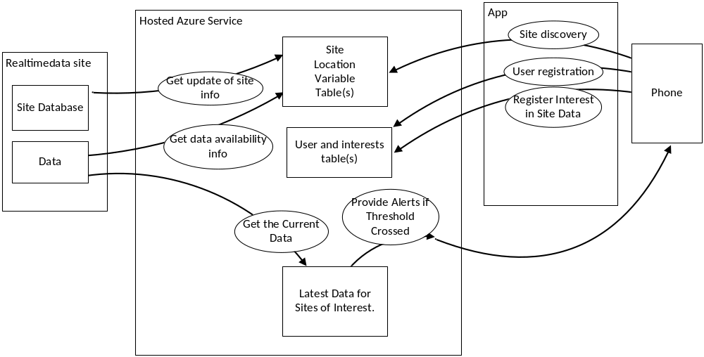

What Next?
The App building team are keen to take their work to market and make it pay. They are aware the NOW publishes the data for free and will continue to do so. The Gap in the market is that NOW does not yet provide the alerting service.
Their question is should they build the App as a private venture or should NOW contract them to complete App, generalising it and branding it with a NSW brand.

Coal Seam Gas map
Two layers. One of CSG licence ‘locations’. The other of NOW water monitoring bore locations loaded from the RealTimeData web service. Both layers cached to Google Table service.
- See the map http://groundwaterwatch.in/
- http://groundwaterwatch.in/about.html - describes the sources
- The Now sites link through to data download for the monitoring bores.

Structure
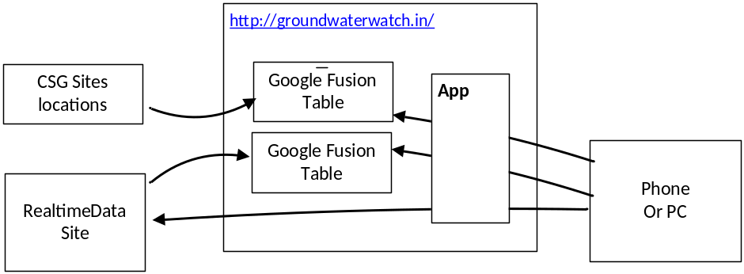

What next?
- Add layer: All GW Holes
- Add links: Drillers logs
- Enhance Data: hydrographs
- More information regarding why there are disconnect between locations of two layers.

NOT at the APPs4NSW
- Hunter River Salinity Trading Scheme – will launch on any phone or install as App. http://www.appcatch.com/app_hrsts-244269.html
- Realtimedata Mobile site http://realtimedata.water.nsw.gov.au/mobile
- ‘River Level’ iphone App and others working remotely on competition.

Issues with ‘doing’ Apps

What platforms
- There are issues targeting high performance Apps (eg. Games). Need to be written in platform specific tools. This requires developers with specific skills and tools for each platform/device. Is NOW in that market?
- If have a general App it needs to be discoverable so it need to be in App. Stores.
- Can get into the App store using web standards (Currently HTML5, CSS and Javascript) and wrapping the App, for example using PhoneGap. Need web developers with specific skills but these are more general and Apps work across devices – to a degree. Can also wrap simple web sites such as the HRSTS App using for example AppsBar.
- If have a specific known user base can promote to them directly. For example the ‘Pump Alert’ could be promoted via the direct contact NOW already has with the Irrigators.
- If want the ‘Water alert’ App to have a wider usage (the same App could be used to alert others (SES, BOM, Kayakers, Water-skiers, Fisher folk or others) of specific levels of variables of interest. It could be extended to provide general information.) Then it needs to be discoverable which means App stores. NSW Dept. of Education actively promotes it Apps in combination with Samsung and have over 250,000 downloads for kids games.
- As Apps and the underlying web services are changing, evolving or being fixed, and if known user base, can write Mobile code which is hosted and promote directly to users. The http://realtimedata.water.nsw.gov.au/mobile is one example.

Are they all the Apps on small form devices?
- Phones, A5, A4, Notebooks, TV screens

Are they all live data
- Not all data needs to be live.
- Depends on what the App does.

Recommendations
- Inventory of what NOW Datasets are publically available and how to access that data.
- Need to publish starter guides – set of how to use documents.
- Inventory of Internal known users.
- Inventory of other Agencies that might use water data. What data don’t they know we have available and what gaps exist that NOW needs to fill?
- Inventory of Data ‘Mentors’ that can assist in freeing the data. There are people interested and skilled in Open data with missions to act as enablers.
- Put these enablers together with the data users and providers.
- Workshops within and across agencies. Invite data accessibility people – and I don’t mean just Standards compliance, I do mean people with track record of assisting building tools to access open data.
- Attend more Public data Hacks.
Distributed to
Tony Caine - At Apps4NSW | tony.caine@water.nsw.gov.au
Bruce Cooper – Deputy Commissioner Wt Res | bruce.cooper@water.nsw.gov.au
Ray Boyton - Manager - Water Monitoring | ray.boyton@water.nsw.gov.au
John Hayes - Manager Water Systems | john.hayes@water.nsw.gov.au
Grant Robinson - Information Quality Management Coord. | grant.robinson@water.nsw.gov.au
Event Co-ordination
Ray Evans: Director Strategy ICT Policy | ray.evans@services.nsw.gov.au
Orchid Dunne Event Co-ordinator | orchid.dunne@services.nsw.gov.au
Steve King. Rewired State. Event Co-ordinator | steve@rewiredstate.com.au
Stephen Steneker: 10gen. Data Mentor | stennie@10gen.com
Water Apps:
Adam Stiskala and Kris Splittgerber - Pump Alert | adam@stiskala.id.au  kris@splittgerber.id.au
Jean-Jacques Halans – GroundwaterWatch App | halans@gmail.com
Interested:
Forugh Dorani – HRSTS App | forugh.dorani@water.nsw.gov.au
Peter Heweston - Kisters | Peter.Heweston@kisters.com.au
Denby Angus – Kisters | Denby.angus@kisters.com.au
Chris Miles- River Levels App | Miles.chris@gmail.com
Nathan Jenkins | web@nathanjenkins.com.au

