THE UNIVERSITY OF ZAMBIA

SCHOOL OF NATURAL SCIENCES

DEPARTMENT OF COMPUTER

SCIENCE



**Name:** TONY MULENGA CHIBESAKUNDA

**Computer Number:** 13031104

**Lecturer:** Mr. MARTIN PHIRI

**Course:** CSC 4630 Assignment 4

**Due Date:** 14th June 2018

**Question 5.7**

Based on your experience with a bank ATM, draw an activity diagram that models the data processing involved when a customer withdraws cash from the machine.

Answer:

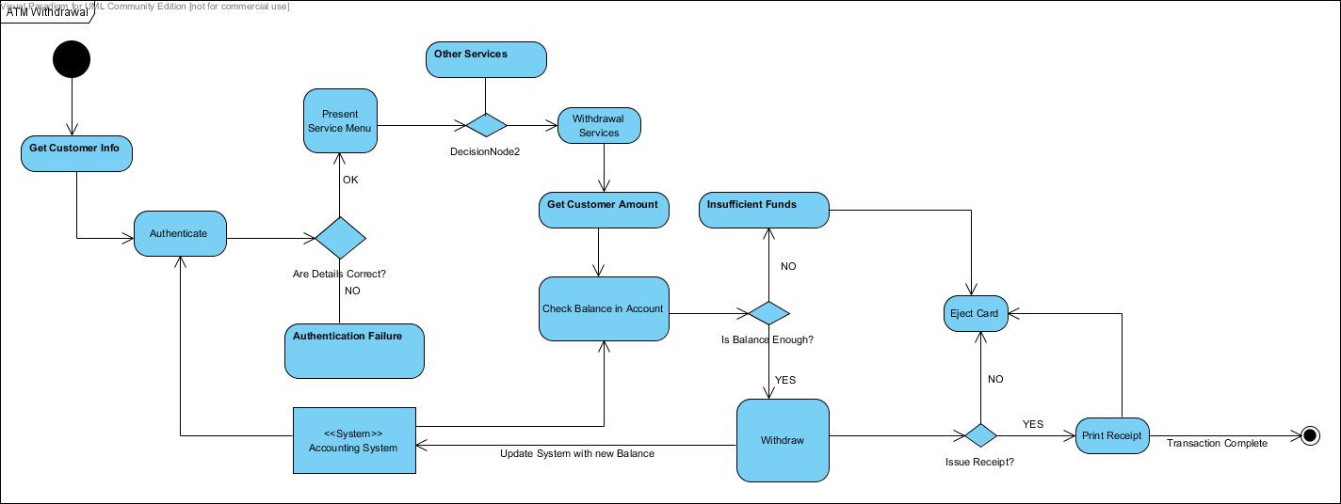

**Question 5.8:**

Draw a sequence diagram for the same system. Explain why you might want to develop both activity and sequence diagrams when modeling the behavior of a system.

Answer:

Both activity and sequence diagrams should be used when modeling a system because it will give a fuller description of the system structure. The activity diagram will give every possibility and show the flow of control within the system. Sequence diagrams on the other hand give a more detailed look at a system but only for a single use case.  Thus if they are combined, there can be an overarching view through the activity diagrams and more specific instances with the sequence diagrams.

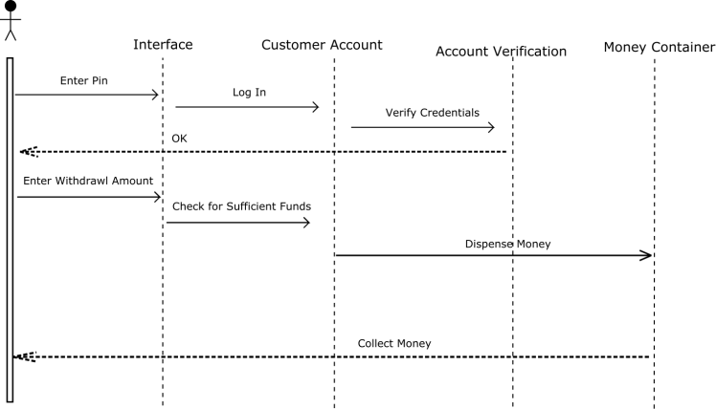

**Question 5.9**

Draw state diagrams of the control software for:

* an automatic washing machine that has different programs for different types of clothes;

Answer:

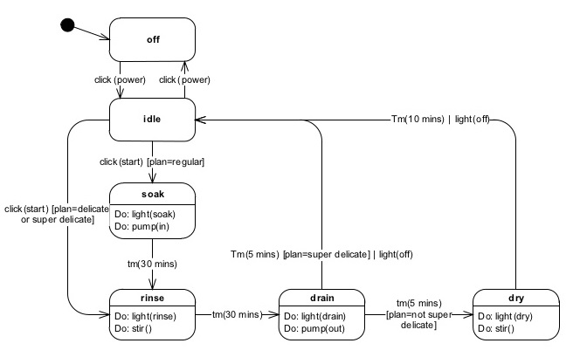

* the software for a DVD player;

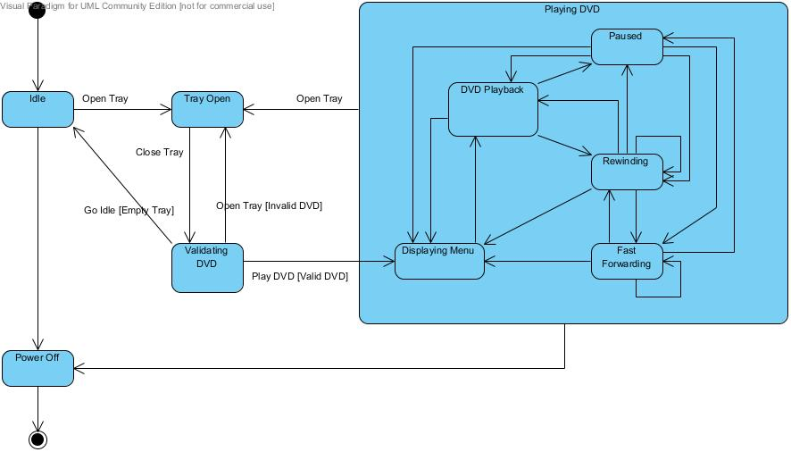

* the control software for the camera on your mobile phone. Ignore the flash if you have one on your phone.

