JNI to AKI transformation
V0.1
- Project and Document by - Ruturaj R Raval

Catalog
1. User code Java 1
1.1. JNI 1
1.1.1 MainActivity.java 1
1.2 AKI 1
1.2.1 index.ts 1
1.2.2 index.d.ts 2
2. User code CPP 3
2.1 JNI 3
2.1.1 native-lib.cpp 3
2.1.2 test_djinni_wrapper.cpp 3
2.2 AKI 4
2.2.1 hello.cpp 4
2.2.2 test_djinni_wrapper.cpp 5
3. Djinni generated Java 6
3.1 JNI 6
3.1.1 ISayHello.java 6
3.1.2 MyRecord.java 8
3.1.3 Gender.java 9
3.2 AKI 9
3.2.1 index.d.ts 9
3.2.2 index.ts 11
4. Djinni generated CPP 12
4.1 JNI 12
4.1.1 ISayHello.cpp 12
4.1.2 JNIISayHello.cpp 13
4.1.3 JNIMyRecord.cpp 15
4.2 AKI 16
5. Djinni generated HPP for CPP 17
5.1 JNI 17
5.1.1 JNIISayHello.h 17
5.1.2 JNIMyRecord.h 19
5.1.3 JNIGender.h 20
5.2 AKI 20
6. Djinni generated HPP for user code 21
6.1 JNI 21
6.1.1 ISayHello.h 21
6.1.2 MyRecord.h 22
6.1.3 Gender.h 22
6.2 AKI 23
6.2.1 ISayHello.h 23
6.2.2 MyRecord.h 24
6.2.3 Gender.h 25
7. CMakeLists.txt file 27
7.1 JNI 27
7.2 AKI 28
8. Notes 29

User code Java

JNI

1.1.1 MainActivity.java
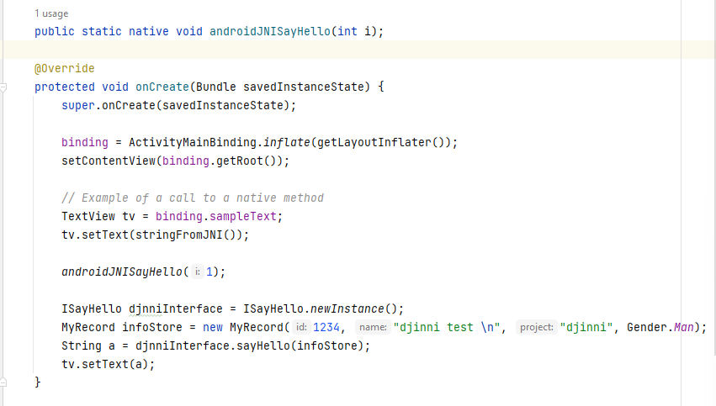

1.2 AKI

1.2.1 index.ts
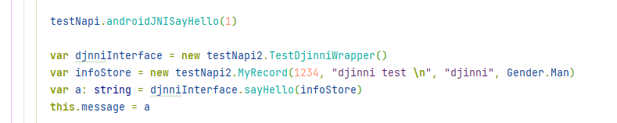

1.2.2 index.d.ts
Additionally, in TS, we need to define the *.d.ts file as well.

User code CPP

2.1 JNI

2.1.1 native-lib.cpp
This file is transformed to hello.cpp in 2.2.1 hello.cpp.

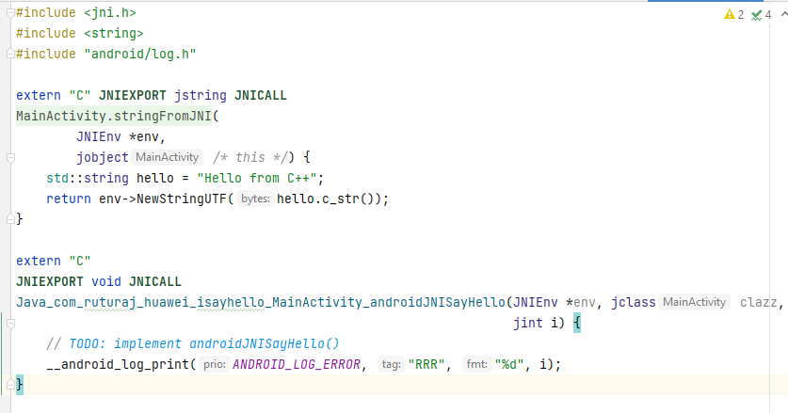

2.1.2 test_djinni_wrapper.cpp
This file is transformed to 2.2.2 test_djinni_wrapper.cpp.

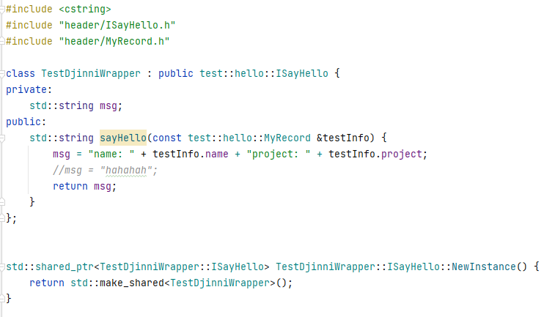

2.2 AKI

2.2.1 hello.cpp
This file is transformed from native-lib.cpp as in 2.1.1 native-lib.cpp.

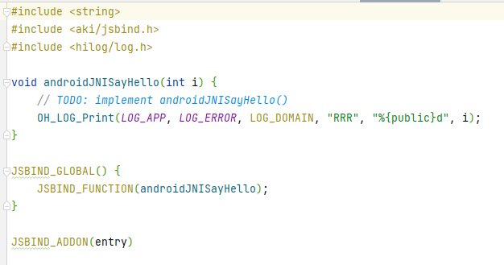

2.2.2 test_djinni_wrapper.cpp
This file is transformed from 2.1.2 test_djinni_wrapper.cpp.

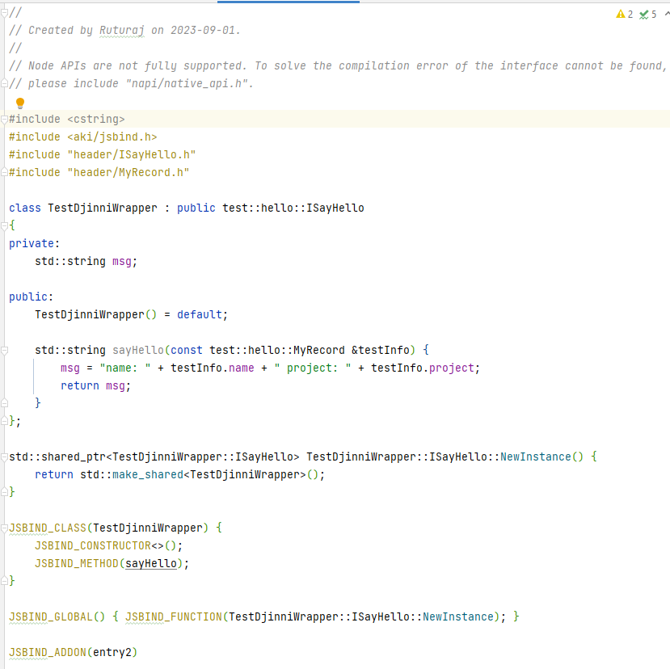

Djinni generated Java

3.1 JNI

3.1.1 ISayHello.java
Here, CppProxy nested class is completely ignored during the TS transformation as in 1.2.2 index.d.ts.

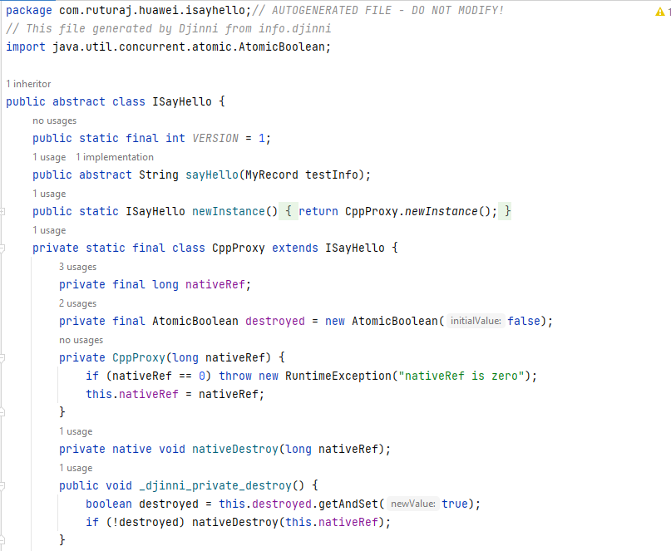
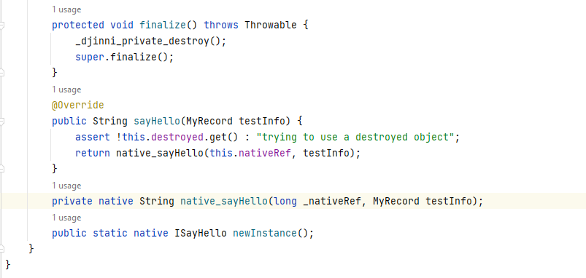

3.1.2 MyRecord.java
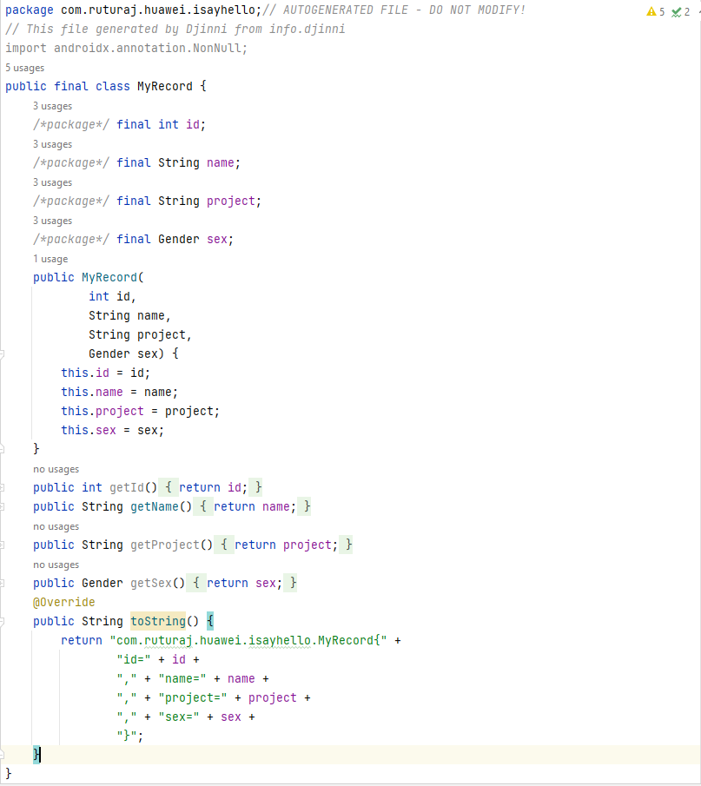

3.1.3 Gender.java
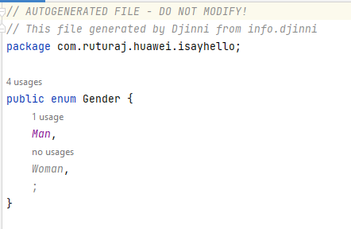

3.2 AKI
All the code in Java as in sections 3.1.1 ISayHello and 3.1.2 MyRecord and 3.1.3 Gender are transformed to definitions in 3.2.1 index.d.ts and Gender.java is also transformed in 3.2.2 index.ts.

3.2.1 index.d.ts
Additionally here, TestDjinniWrapper class which is a user code is added in the index.d.ts file so that the user defined code can be called in the index.ts as in the section 2.2.2 test_djinni_wrapper.cpp.
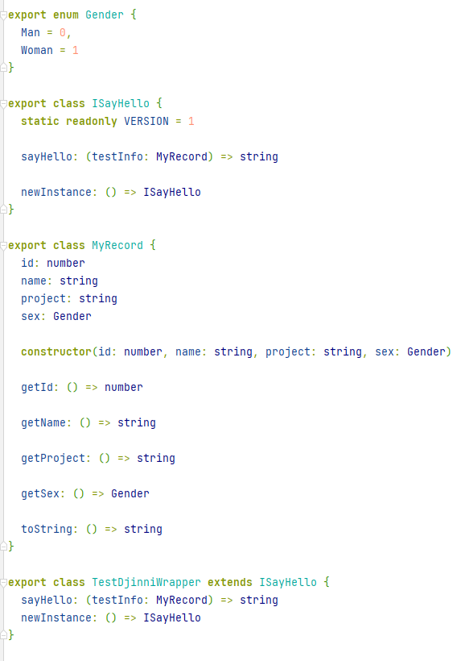

3.2.2 index.ts
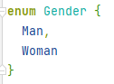

Djinni generated CPP

4.1 JNI

4.1.1 ISayHello.cpp
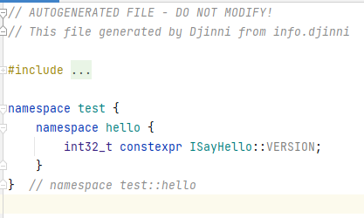

4.1.2 JNIISayHello.cpp
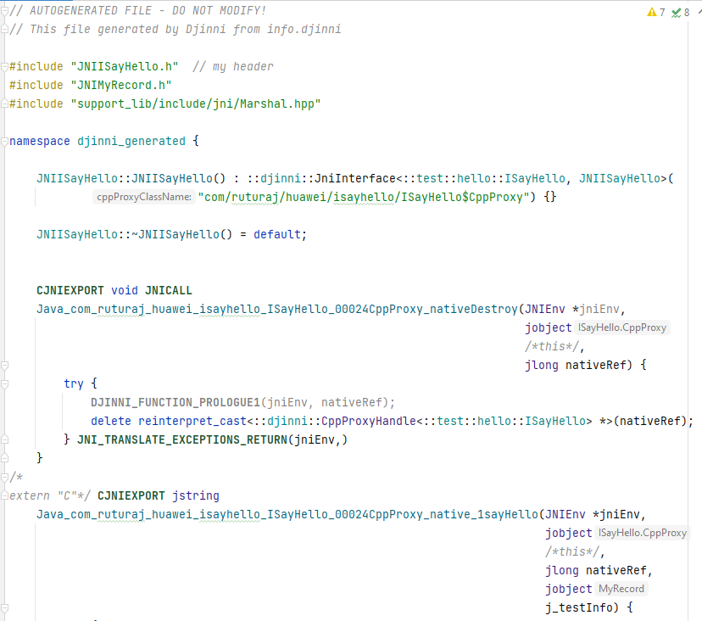
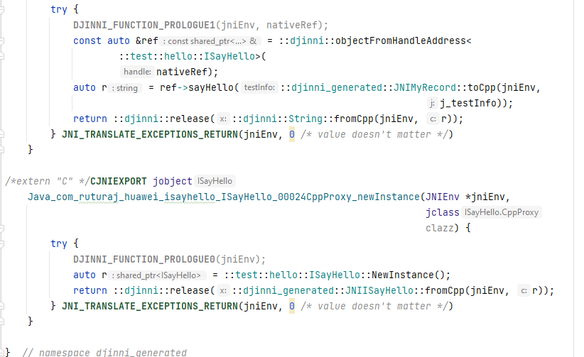

4.1.3 JNIMyRecord.cpp
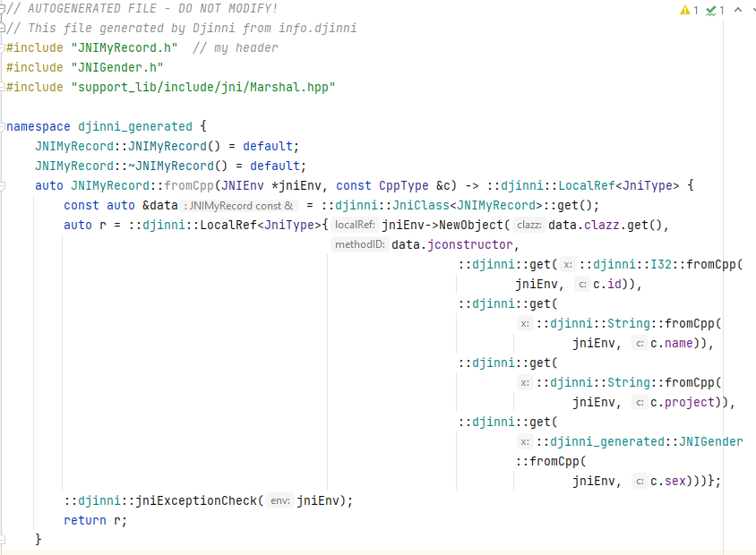
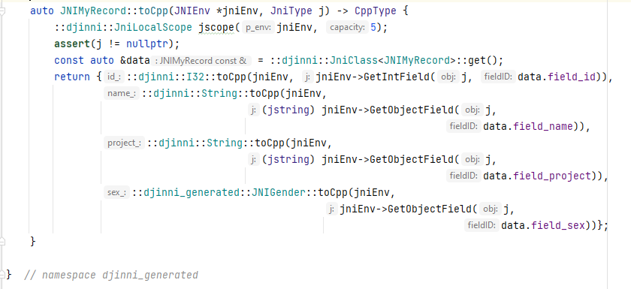

4.2 AKI
All these files as in sections 4.1.1 ISayHello.cpp and 4.1.2 JNIISayHello.cpp and 4.1.3 JNIMyRecord.cpp have been ignored, as they are dependent on Djinni support libraries and those support libraries contain JVM (Java Virtual Machine) usage, hence no direct transformation is available.

Djinni generated HPP for CPP

5.1 JNI

5.1.1 JNIISayHello.h
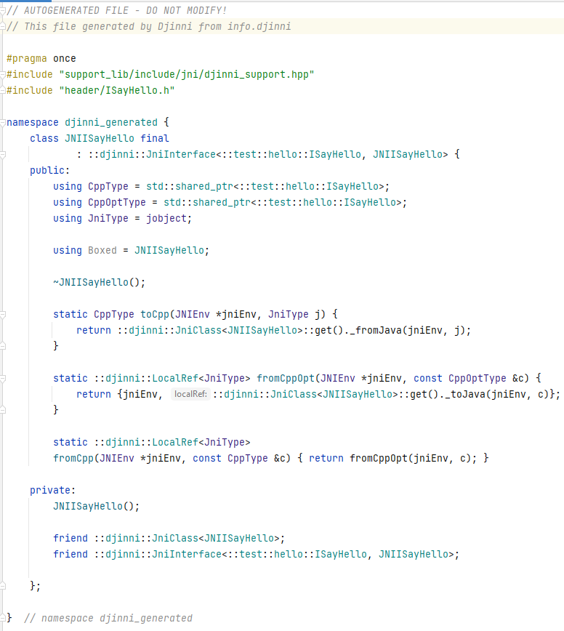

5.1.2 JNIMyRecord.h
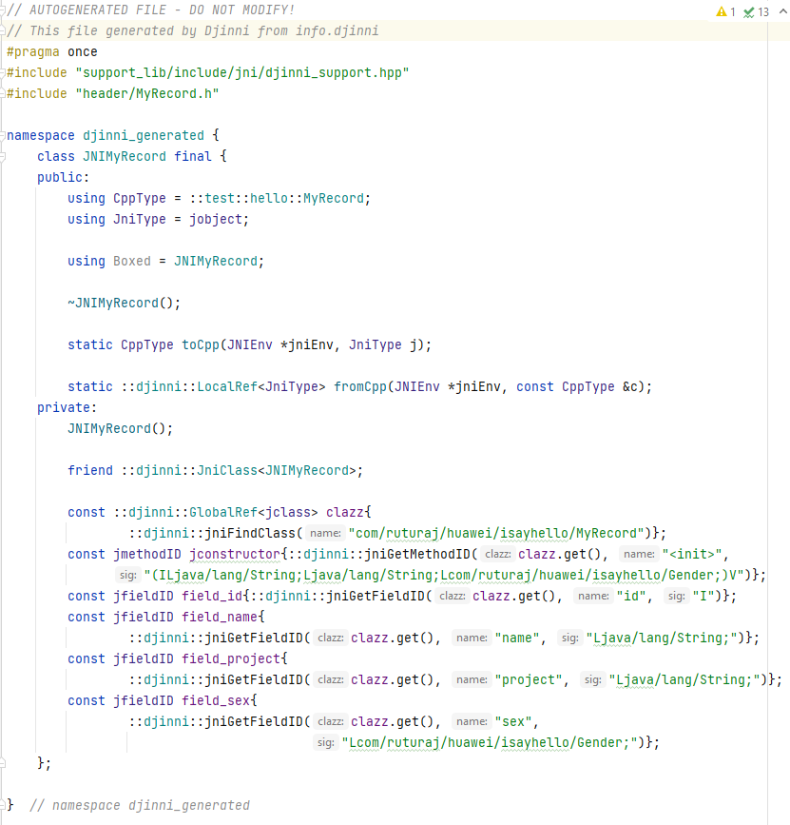

5.1.3 JNIGender.h
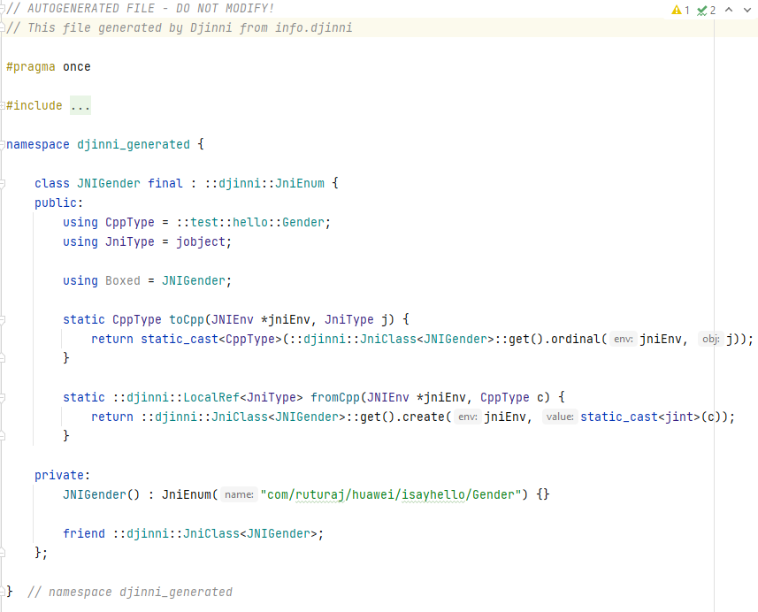

5.2 AKI
All these files as in sections 5.1.1 JNIISayHello.h and 5.1.2 JNIMyRecord.h and 5.1.3 JNIGender.h have been ignored, as they are dependent on Djinni support libraries and those support libraries contain JVM (Java Virtual Machine) usage, hence no direct transformation is available.

Djinni generated HPP for user code

6.1 JNI

6.1.1 ISayHello.h
This file is transformed to section 6.2.1 ISayHello.h.

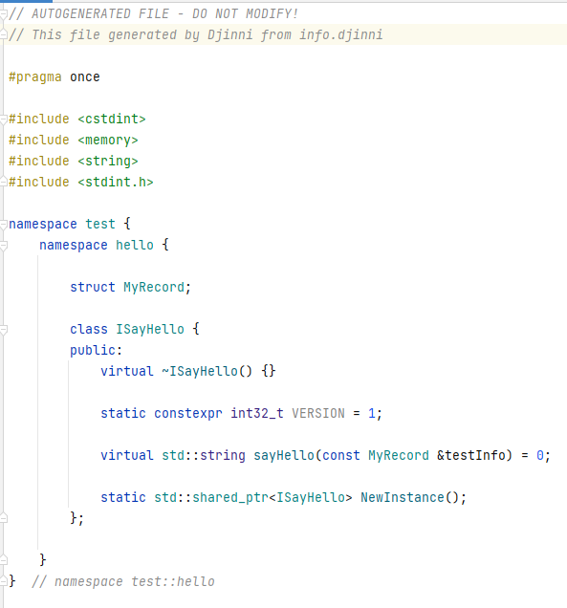

6.1.2 MyRecord.h
This file is transformed to section 6.2.2 MyRecord.h.

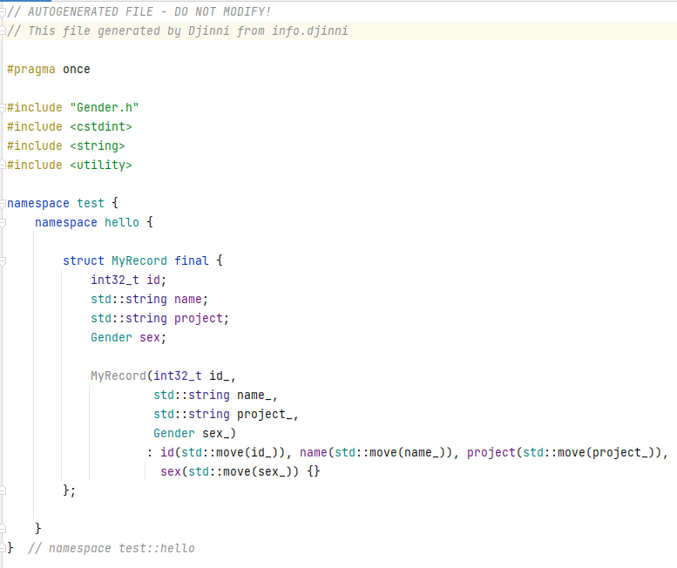

6.1.3 Gender.h
This file is transformed to section 6.2.3 Gender.h.

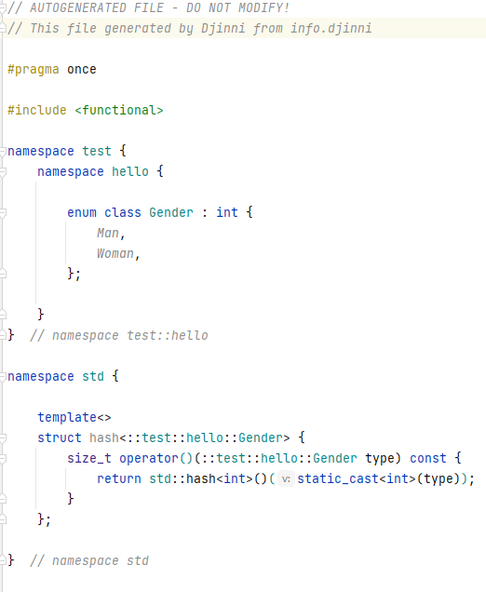

6.2 AKI

6.2.1 ISayHello.h
This file is transformed from section 6.1.1 ISayHello.h.

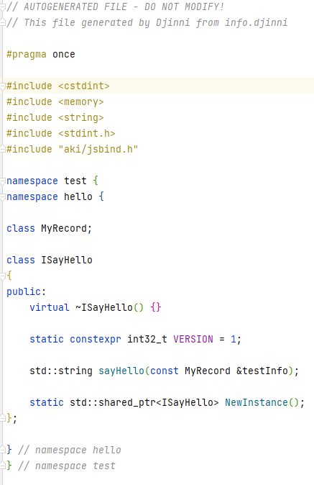

6.2.2 MyRecord.h
This file is transformed from section 6.1.2 MyRecord.h.

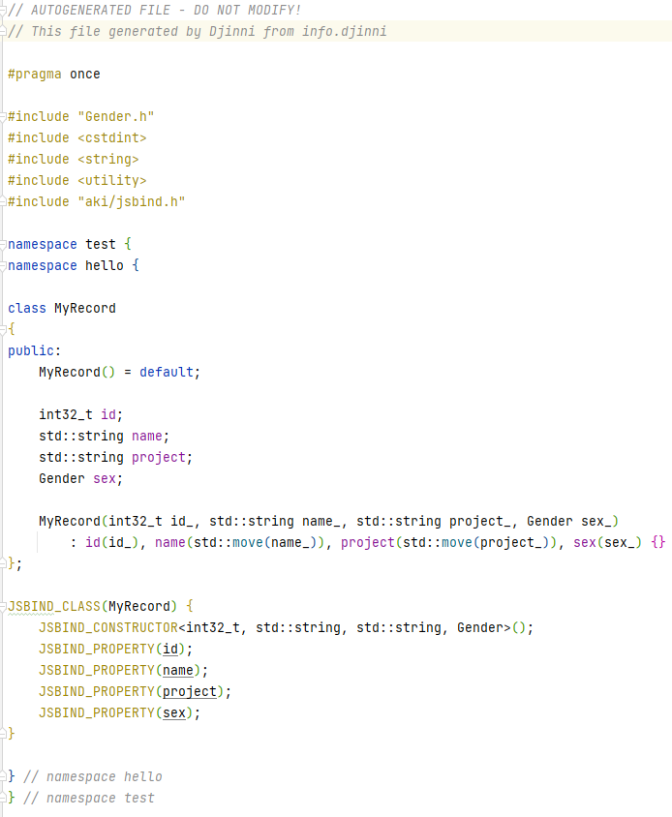

6.2.3 Gender.h
This file is transformed from section 6.1.3 Gender.h.

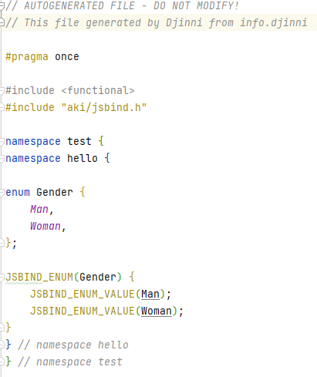

CMakeLists.txt file

7.1 JNI
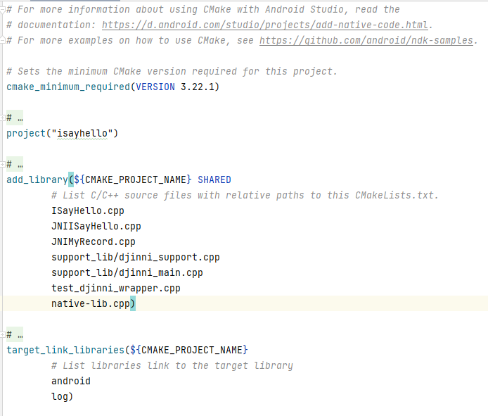

7.2 AKI
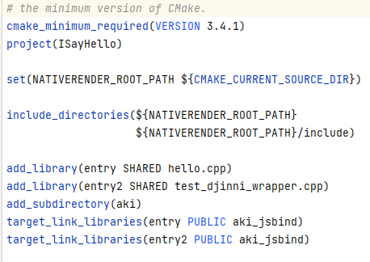

Notes
For mapping instructions, please refer ANDROIDDJINNIJNI 2 AKI.XLSX file attached in the same folder.

