JNA to AKI transformation
V0.1
- Project by - Jacky Jiang
- Document by - Ruturaj R Raval

Catalog
1. User code Java 1
1.1. JNA 1
1.1.1 MainActivity.java 1
1.2 AKI 4
1.2.1 index.ets 5
1.2.2 index.d.ts 7
2. User code CPP 9
2.1 JNA 9
2.1.1 native-lib.cpp 9
2.2 AKI 11
2.2.1 hello.cpp 11
3. CMakeLists.txt file 14
7.1 JNA 14
7.2 AKI 15
4. Notes 16

User code Java

JNA

MainActivity.java
MainActivity.java in Android is transformed to index.ets and index.d.ts respectively as in section 1.2.1 index.ets and 1.2.2 index.d.ts.
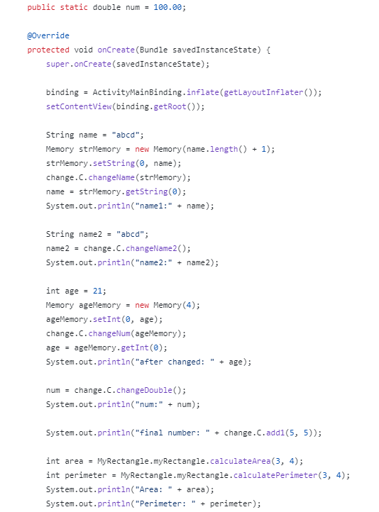
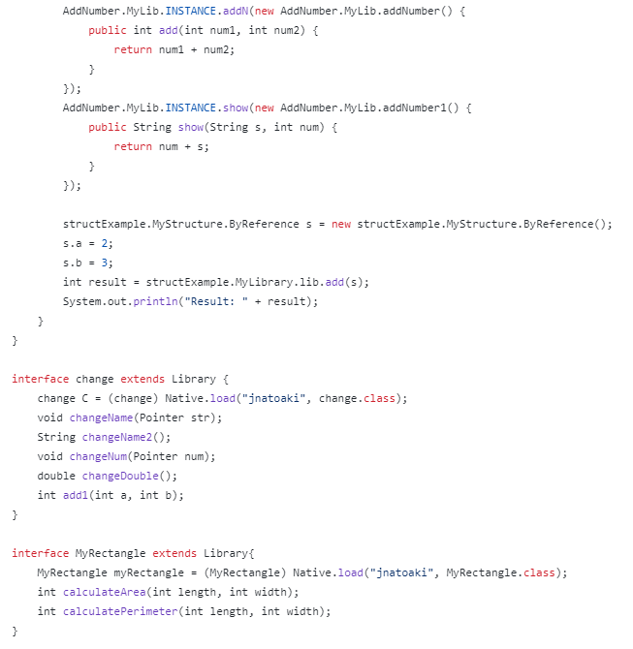
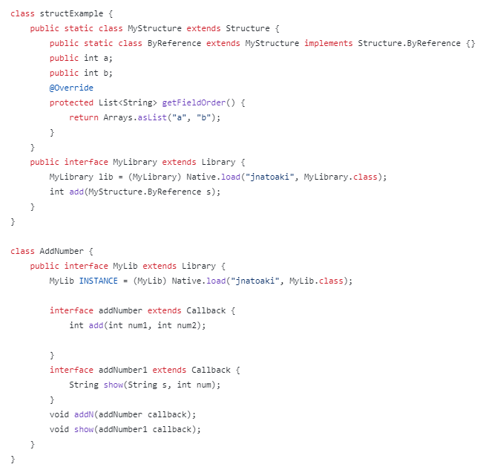

AKI
These index.ets and index.d.ts are transformed from section MainActivity.java.

1.2.1 index.ets
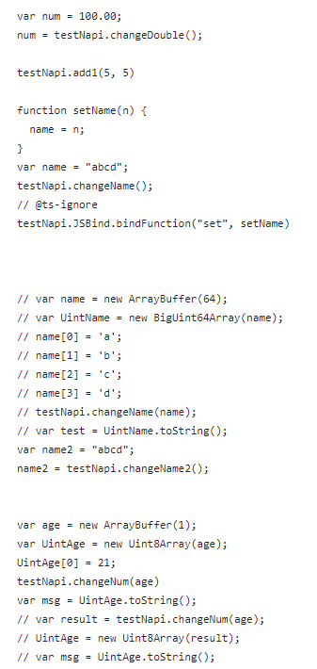
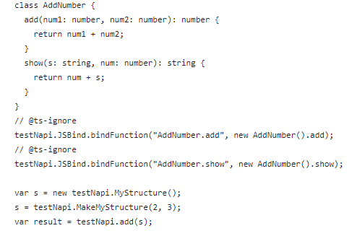
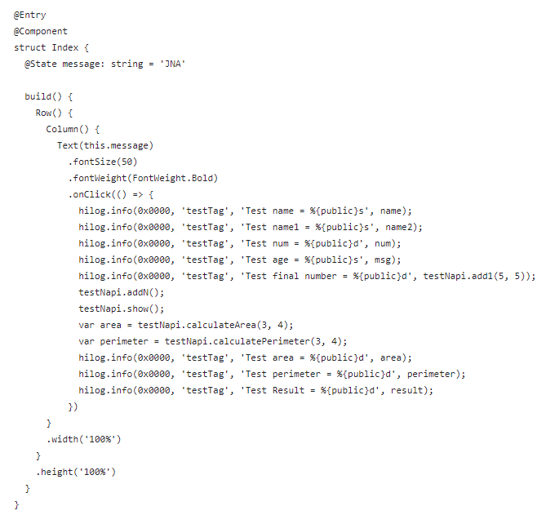

1.2.2 index.d.ts
Additionally, in TS, we need to define the *.d.ts file as well.

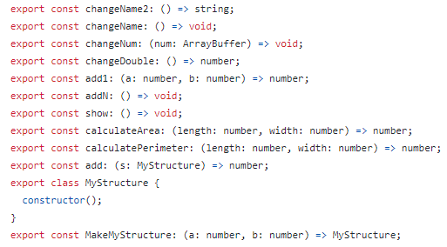

User code CPP

2.1 JNA

2.1.1 native-lib.cpp
This native-lib.cpp is transformed to hello.cpp in section 2.2.1 hello.cpp.

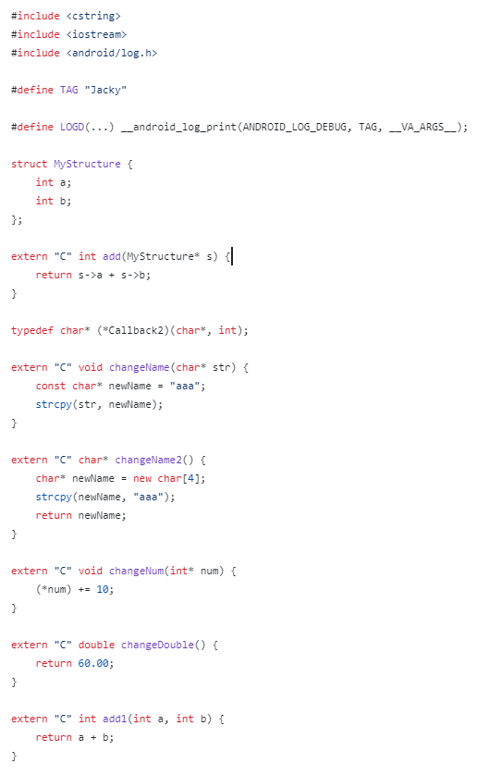
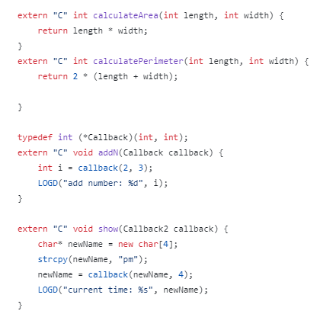

2.2 AKI

2.2.1 hello.cpp
This hello.cpp is transformed from native-lib.cpp in section 2.1.1 native-lib.cpp.

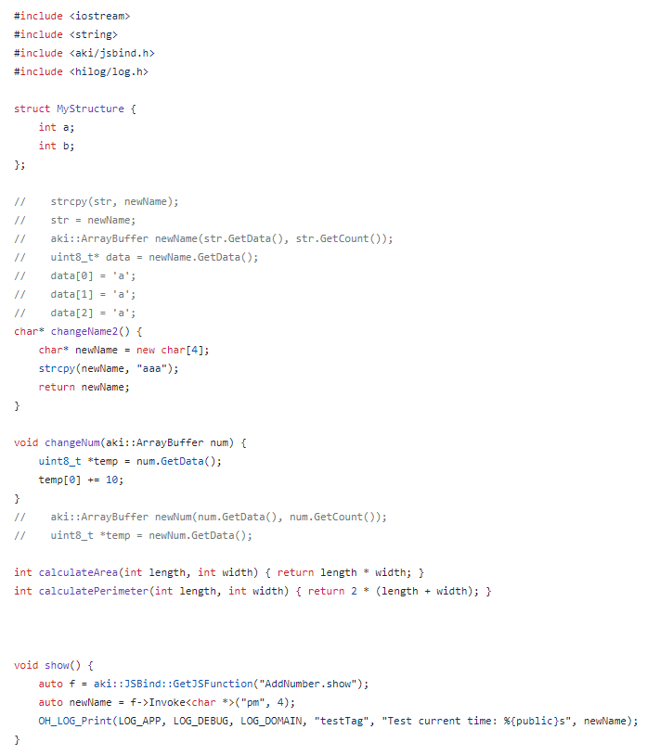
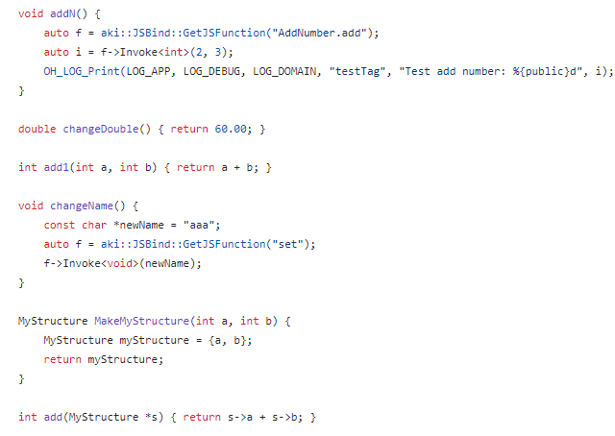
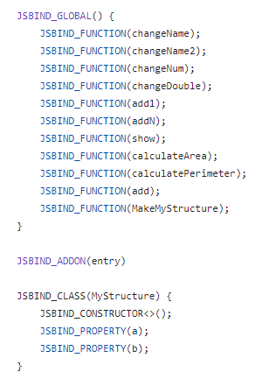

CMakeLists.txt file

7.1 JNA
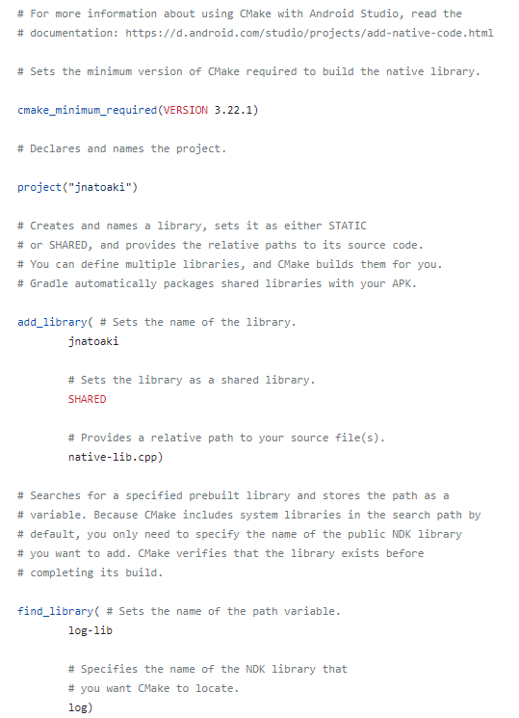
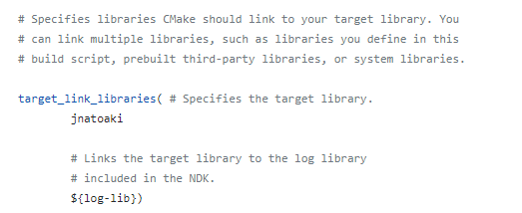

7.2 AKI

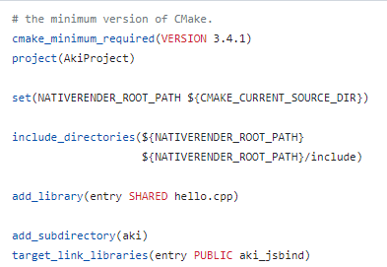

Notes
In Android project we need to add JNA dependency like this in the build.gradle file.



