29 November 2021

# Conversation

？= you good erh? (While natives (to power-equal peers): Hi!)

。。= I good. Thank Thank. (Natives: Hi.)

# Characters

Despite early humans all attempted pictographic writing systems, all switched to phonetic systems except for Chinese. The separation of visual signal from auditory modality gives this language double redundancy such that pronunciations surely have mutated drastically in the intervening years but stories and wisdoms from thousands of years ago can still be deciphered easily by today’s speakers.

Many modern Chinese characters have undergone mutation from their ancient pictographs. The character for water, , still resembles how the ancient drew the wavy pattern of fluid. Similarly, the character for man/human/person, , mimics one standing (with legs open).

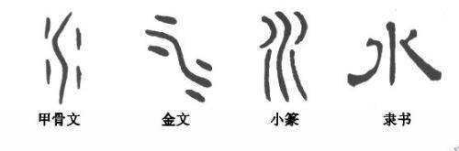 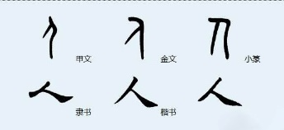

Chinese characters can also form by ideography. Instead of a scholarly definition, I give an example: . A reader may guess that it roughly means “one man after another man”. Indeed, this character means 1. to follow (base meaning) and 2. to obey (extension meaning).

## Radicals

is the proper spelling if you meant for this character to occupy its own, one-character-wide, space. During many character forming processes, we want “human” to occupy only half a space in order to fuse with the other half to form a square-looking character. In order to achieve this goal, the spelling/drawing of 人 deforms to 亻and must now attach itself to something else. It is similar to the Greek/English prefix anthrop- as in anthropology. One must not leave anthrop on its own to mean human but must attach it to -ology. Human deforms to anthrop-; water deforms to hydro-. Chinese radicals can therefore be thought as prefixes.

is the character for tree—it clearly retained its pictographic root. Using the knowledge of radical, one can conjecture that means “a man leaning against a tree”. Indeed, means to rest, to take a break.

There are six ways Chinese characters can form. Today, you have seen two (a third of the journey is already done): pictography and ideography. Learners are not expected to know by heart which character is formed through which route but only to appreciate the stories behind many characters, at least for the purposes of stimulating interest.