# About

The purpose of this module is to provide content editors with a mechanism to create content with one or more placeholders which references content outside the current field.  
  
Consider the following use cases.

* Shared content such as company name, copyright, email, etc.
* Dynamic copyright dates – a date that reflects the current year.
* Content contained within a query string parameter.
* Content stored in session.

Additionally, this module was created to be an extensible framework. So, if you are a developer and you need functionality that isn’t offered out-of-the-box, you can add that functionality with relatively little effort.

# Getting to know this module

## Variable Content Template

It all starts with the Variable Content Template, found under sitecore->Templates->Variable Content. Use this template in place of the Standard Template for any content items you wish to have variable content support.  
  
Items created from the Variable Content Template will contain a section called Variable Content (show below). This new section contains fields that specify a Mapping Set and the maximum recursion depth for variable content. By default, Mapping Set is set to the Default Mapping Set and the Max Recursion Depth is set to 1. The mapping set is a collection of mappings used to replace content placeholders. The max recursion depth determines how many nested placeholders will be supported.  
  
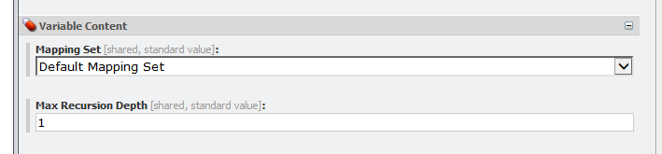

## Mapping Set

A mapping set specifies two types of mappings 1) explicit variable mappings and 2) implicit variable mappings. Explicit variable mappings are specified on the Folder tab. Implicit variable mappings are specified on the Content tab in the System Mappers field of the Data section. Mapping Sets are defined under sitecore->Content->Variable Content.

## Explicit Variable Mappings

An explicit variable mapping is a mapping where the name of the content placeholder or variable is defined in the mapping. Out-of-the-box the, module comes with five explicit variable mappings.

* Content Mapping – maps to rich text context
* DateTime Mapping – maps to the current date time
* Field Mapping – maps to content from a specified field on a specified item
* Query String Mapping – maps to content from a specified query string parameter
* Session Mapping – maps to content from a specified session variable

## Implicit Variable Mappings

An implicit variable mapping is a mapping where the name of the content placeholder or variable is not defined in the mapping, but rather is the pass on implicitly into the mapping. Out of the box, the module comes with three implicit variable mappings.

* Dictionary Mapping – maps to dictionary item
* Query String Mapping – maps to query string parameter
* Session Mapping – maps to session variable

# Extensibility

This module has be design in such a way that developers can create additional mappings, both explicit variable mappings and implicit variable mappings.

# Configurability

There are several points of configurability to this module.

## Variable Content

Starting with the configuration of variable content. The enclosures of the placeholders, by default, are an open curly brace “{“ and close curly brace “}”. However, they can be configured to whatever value you wish. Additionally, the field types to support variable content can be specified. By default, rich text, single-line text, and multi-line text are the only field types supported.

## Mapping Handlers

The mechanisms that allows for extensibility of mapping items, also allows for configurability of those same items. Existing mapping items can be reconfigured to use different mapping handlers.