ETL Vs ELT:

<https://cloud.google.com/learn/what-is-etl>

ETL Advantages:  
1) Maturity: ETL was developed first and has been in practice for more than two decades. This means that there are more engineers with experience in ETL implementations and more ETL tools in the marketplace to build data pipelines within organizations.  
  
2) Compliance: ETL transforms data before it reaches its destination. When companies are subject to data privacy regulations such as GDPR, ETL allows them to remove, mask, or encrypt sensitive data before it' s loaded to the data warehouse to ensure compliance.  
  
ETL Drawbacks:  
1) Frequent maintenance: ETL data pipelines handle both extraction and transformation. But they have to undergo refactors if analysts require different data types or if the source systems start to produce data with deviating formats and schemas.  
  
2) Higher upfront cost. Defining business logic and transformations can increase the scope of a data integration project.  
  
ELT Advantages:  
1) High speed: ELT allows for all of the data to go into the system immediately, and from there, users can determine the exact data they need to both transform and analyze.  
  
2) Lower cost: Requires a less-powerful server for data transformation and takes advantage of resources already in the warehouse. This results in cost savings and resource efficiencies.  
  
3) Flexibility. Analysts no longer have to determine what insights and data types they need in advance but can perform transformations on the data as needed in the warehouse.   
  
ELT Drawbacks:  
1) Security gaps: Storing all the data and making it accessible to various users and applications come with security risks. Companies must take steps to ensure their target systems are secure by properly masking and encrypting data.  
  
2) Increased latency: The need to continually transform data slows down the overall time it takes to perform queries/analysis.

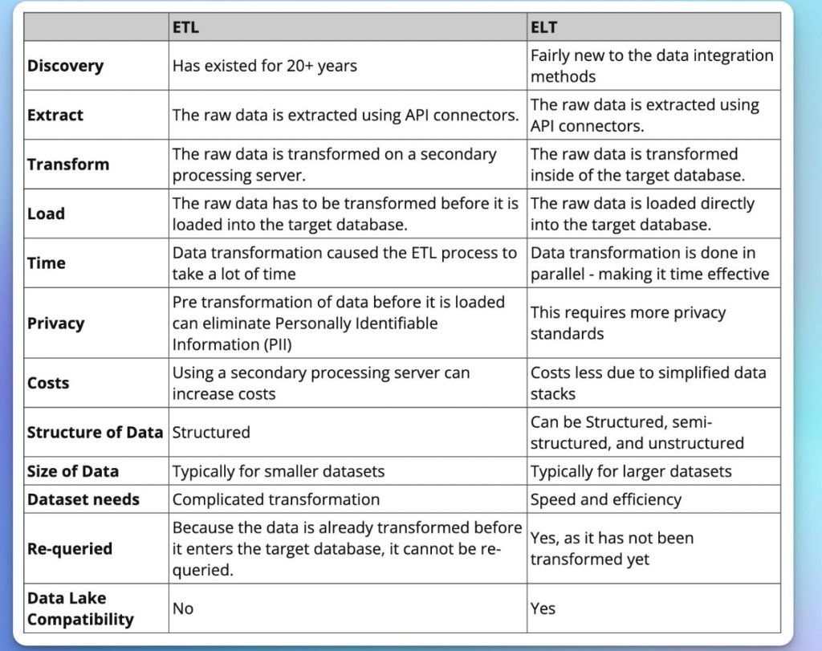

<https://www.geeksforgeeks.org/difference-between-elt-and-etl/>

<https://www.qlik.com/us/etl/etl-vs-elt>

<https://www.integrate.io/blog/etl-vs-elt/>

<https://www.ibm.com/cloud/blog/elt-vs-etl-whats-the-difference>

<https://www.guru99.com/etl-vs-elt.html>

<https://www.talend.com/resources/elt-vs-etl/>

<https://blog.panoply.io/etl-vs-elt-the-difference-is-in-the-how>

<https://www.snowflake.com/guides/etl-vs-elt>

<https://www.javatpoint.com/data-warehouse-etl-vs-elt>

<https://www.ibm.com/cloud/learn/elt>

<https://blog.hubspot.com/website/etl-tools>

<https://hevodata.com/learn/best-elt-tools/>

Data Hour:

1. What is Data Engineer and types of services in Data Engineering? (~5 -7 mints)
2. What is ETL and ELT?
3. Difference between ETL and ELT?
4. Google Cloud Services for ETL and ELT
   1. Dataproc
   2. Dataflow
      1. <https://partner.cloudskillsboost.google/focuses/11581?catalog_rank=%7B%22rank%22%3A1%2C%22num_filters%22%3A0%2C%22has_search%22%3Atrue%7D&parent=catalog&search_id=17853488>
         1. <https://github.com/GoogleCloudPlatform/professional-services/tree/main/examples/dataflow-python-examples/batch-examples/cookbook-examples>
      2. <https://partner.cloudskillsboost.google/course_sessions/1501345/labs/103693>
         1. <https://github.com/GoogleCloudPlatform/training-data-analyst/blob/master/quests/dataflow_python/2_Branching_Pipelines/solution/my_pipeline.py>
   3. Data fusion
5. Practical demo on Dataflow using python sdk.