DiagrammeR::grViz("  
digraph {  
  
 graph [overlap = true, fontsize = 24]  
  
 node [shape = box,  
 fontname = Arial]  
 a [label = '@@1']  
 b [label = '@@2']  
 c [label = '@@3']  
  
 c->a  
 b->a  
}  
  
[1]: stringr::str_wrap('\"`sprintf()`\" function with method as the primary input, binding the lists returned from the base and method-specific functions and calling caret::train()', 60)  
[2]: stringr::str_wrap('base {caret} function, defining constants across all methods and method-specific parameters to be evaluated', 60)  
[3]: stringr::str_wrap('Method-specific function, with tuneGrid and other method-specific parameters defined', 60)  
")

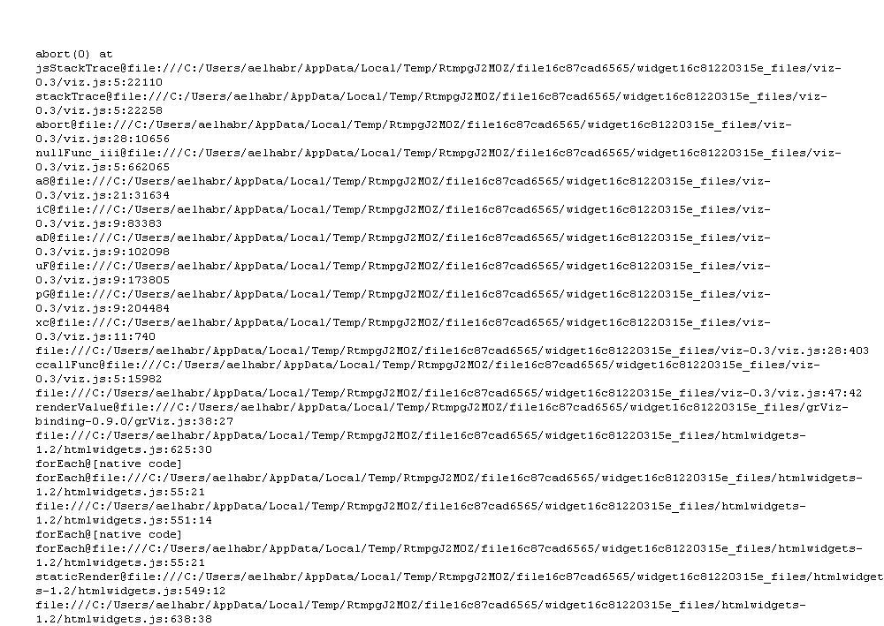

capton