**HW3 Calibrated Controlled Propeller**

Johns Hopkins University

Real Time Software for Embedded Systems

Fall 2014

Tony Florida

2014-10-07

**Requirements**

Hardware

* There shall be at least one IR led emitter and detector circuit
* There shall be two motor that are spun via electronic speed control (ESC)
* An Arduino board shall control the circuits
* External battery supply shall be used for the motors
* Blades shall be attached to at least one motor and pass through an emitter/detector pair

Software

* The software running on the Arduino shall use function queue scheduling design
* The software shall capture the rotations per minute (RPM) every second
* The software shall capture the command every second
* The software shall capture the time every second
* The software shall command the motors via the ESC from min rotation speed to max, then back down to min

Parts List

* (1) Arduino Uno
* (1) 10k resistor
* (1) 220 ohm resistor
* (1) spool of hobby wire
* (1) USB 2.0 A/B cable
* (1) breadboard
* (1) 12v battery preferable Zippy Compact 25c Series 4000 Li-Po Battery
* (1) XT60 Connector Pair
* (1) LED of any color
* (1) Infrared Emitter and Detector (Radio shack 276-142)
* (2) Turnigy Multistar 30 Amp Multi-rotor Brushless ESC 2-4S
* (1) Gemfan 9x4.7 Nylon Prop Set (1x CW & 1x CCW)
* (2) Turnigy Multistar ESC Programming Card
* Wood to hold motor and emitter/detector
* Nails
* Twist ties
* Black electrical tape

Required Software

* Arduino Sketch v1.0
* DuinOS v0.4
* AVRQueue
* Microsoft Excel 2010

**Architecture**

Hardware

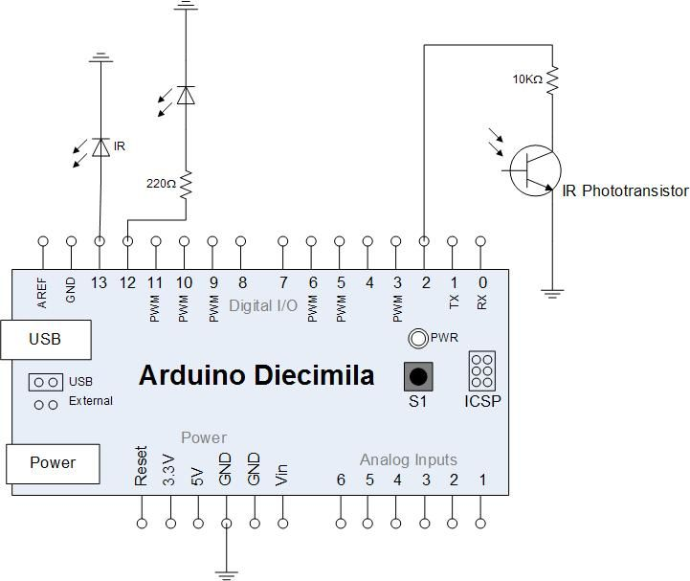

Figure - Circuit Schematic [1]

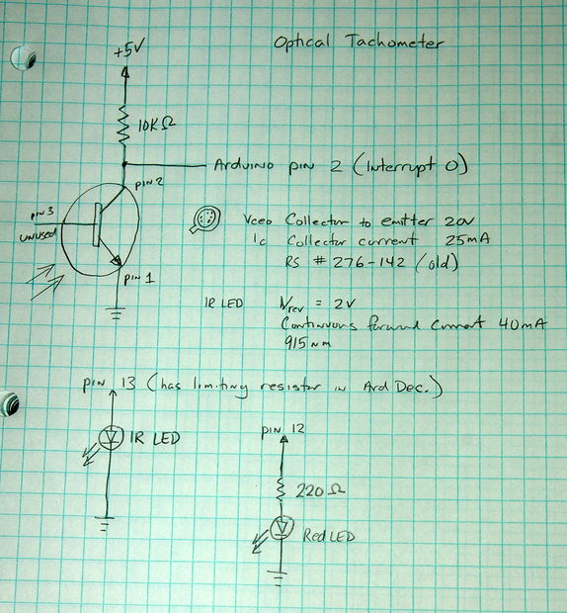

Figure – Schematic Notes[1]

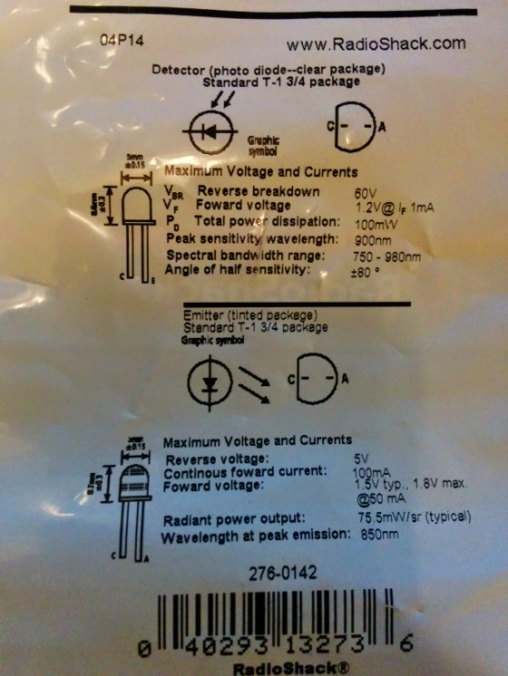

Figure – Emitter Detector Sensors

Software



Figure - Software Architecture Diagram

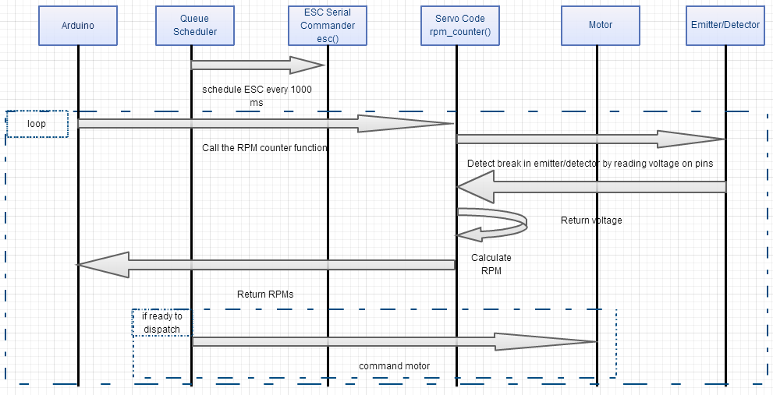

Figure - Hardware/Software Sequence Diagram

**Design**

Software



Photos of the Hardware

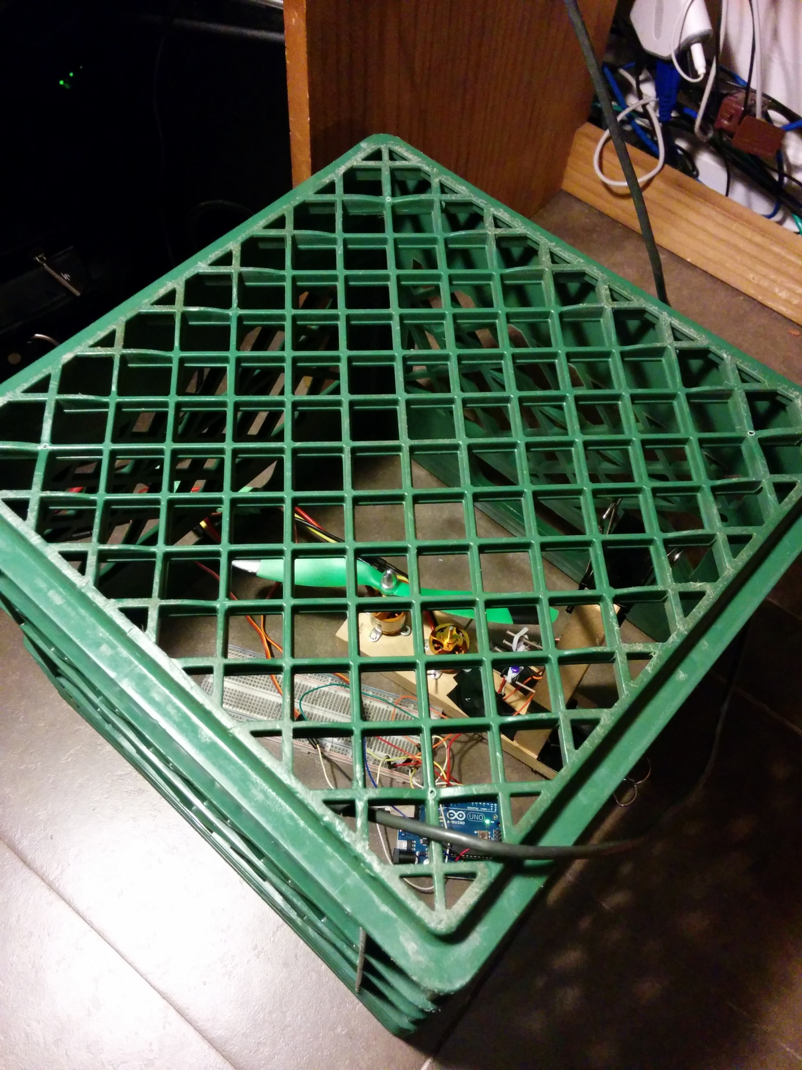

Figure – Tactical Test Setup

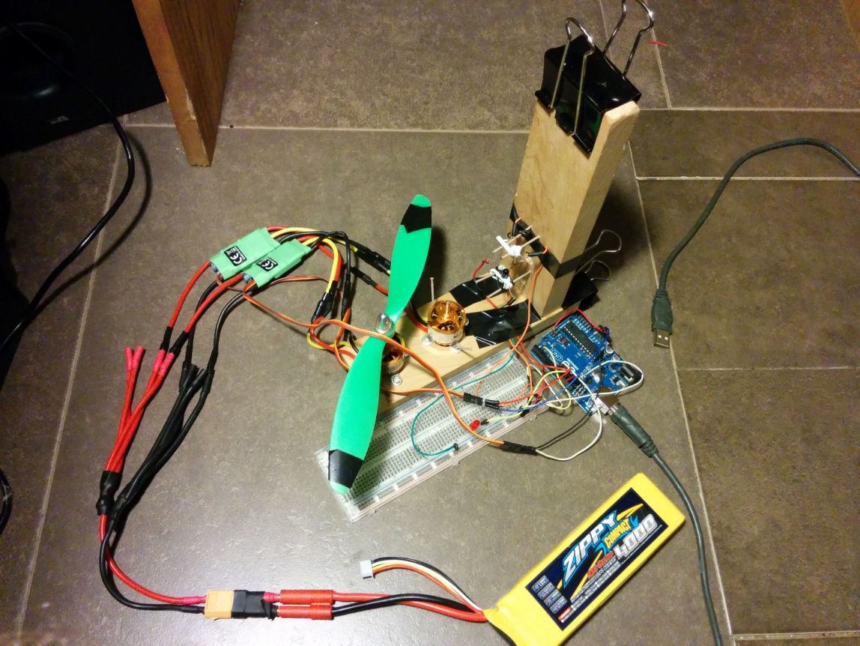

Figure - Top View of the Test Setup

**Implementation**

**#include <Queue.h>**

**#include <Servo.h>**

**//JHU RTSW HW 3 - HW3 - Calibrated Controlled Propeller**

**//Tony Florida**

**//2014-10-06**

**//References:**

**// http://www.instructables.com/id/Arduino-Based-Optical-Tachometer/**

**// http://techvalleyprojects.blogspot.com/2012/06/arduino-control-escmotor-tutorial.html**

**// https://github.com/Zuph/AVRQueue**

**//CMD variables (range of 15 to 150)**

**int serial_cmd = 5; //serial commands start at 10**

**int MAX_SERIAL_CMD = 100; //max serial command**

**int SERIAL_CMD_INCREMENT = 5; //increment serial commands by 20**

**//Queue variables**

**Queue myQueue;**

**//ESC variables**

**// This is our motor.**

**Servo myMotor;**

**Servo myMotor2;**

**// This is the final output**

**// written to the motor.**

**String incomingString;**

**//IR Emitter Detector variables**

**int ledPin = 13; // IR LED connected to digital pin 13**

**int statusPin = 12; // LED connected to digital pin 12**

**volatile byte rpmcount;**

**volatile int status;**

**unsigned int rpm;**

**unsigned long timeold;**

**//IR Emitter Detector function**

**void rpm_fun()**

**{**

**//Each rotation, this interrupt function is run twice, so take that into consideration for**

**//calculating RPM**

**//Update count**

**rpmcount++;**

**//Toggle status LED**

**if (status == LOW) {**

**status = HIGH;**

**} else {**

**status = LOW;**

**}**

**digitalWrite(statusPin, status);**

**}**

**int cmd()**

**{**

**serial_cmd+=SERIAL_CMD_INCREMENT; //increment the serial command**

**if(serial_cmd > MAX_SERIAL_CMD)**

**{**

**SERIAL_CMD_INCREMENT *= -1; //incrementally spin down the motors**

**}**

**if(serial_cmd <= 0)**

**{**

**// we are done!**

**myQueue.scheduleRemoveFunction("ESC");**

**}**

**return serial_cmd;**

**}**

**void setup() {**

**// Required for I/O from Serial monitor**

**Serial.begin(9600);**

**//ESC setup**

**Serial.println("Initializing ESC");**

**// Put the motors to Arduino pin 9 and 10**

**myMotor.attach(9);**

**myMotor2.attach(10);**

**//IR Emitter Detector setup**

**//Interrupt 0 is digital pin 2, so that is where the IR detector is connected**

**//Triggers on FALLING (change from HIGH to LOW)**

**attachInterrupt(0, rpm_fun, FALLING);**

**//Turn on IR LED**

**pinMode(ledPin, OUTPUT);**

**digitalWrite(ledPin, HIGH);**

**//Use statusPin to flash along with interrupts**

**pinMode(statusPin, OUTPUT);**

**rpmcount = 0;**

**rpm = 0;**

**timeold = 0;**

**status = LOW;**

**//Function queue scheduling setup**

**Serial.println("Initializing function queue scheduling");**

**myQueue.scheduleFunction(esc, "ESC", 0, 3000);**

**//Print table header**

**Serial.println("Time(ms),RPM,Command");**

**//Wait until start command i.e. any input serial comms**

**Serial.println("Plug battery into motors, then send any serial command");**

**while(!Serial.available()) {}**

**while(1) {**

**myQueue.Run(millis());**

**rpm_counter();**

**}**

**}**

**//Receive ESC commands via serial**

**int esc(unsigned long now)**

**{**

**int val = cmd(); //new rotation speed**

**/* We only want to write an integer between**

**\* 0 and 180 to the motor.**

**\*/**

**if (val > -1 && val < 181)**

**{**

**// Print confirmation that the**

**// value is between 0 and 180**

**// Write to Servo**

**myMotor.write(val);**

**myMotor2.write(val);**

**}**

**}**

**//Count RPMs**

**void rpm_counter()**

**{**

**//Update RPM every second**

**delay(1000);**

**//Don't process interrupts during calculations**

**detachInterrupt(0);**

**//Note that this would be 60*1000/(millis() - timeold)*rpmcount if the interrupt**

**//happened once per revolution instead of twice. Other multiples could be used**

**//for multi-bladed propellers or fans**

**rpm = 30*1000/(millis() - timeold)*rpmcount;**

**timeold = millis();**

**rpmcount = 0;**

**//Write it out to serial port**

**Serial.print(millis());**

**Serial.print(",");**

**Serial.print(rpm,DEC);**

**Serial.print(",");**

**Serial.println(serial_cmd);**

**//Restart the interrupt processing**

**attachInterrupt(0, rpm_fun, FALLING);**

**}**

**//not using the loop in this program**

**void loop() {**

**}**

**Results**

Blade 1

Time(ms) RPM Command

22408 0 25

23409 0 25

24410 0 25

25410 900 30

26411 638 30

27412 435 30

28412 1020 35

29414 1334 35

30414 1440 35

31415 2001 40

32416 2262 40

33417 2233 40

34418 2755 45

35419 2900 45

36419 3000 45

37421 3364 50

38421 3570 50

39422 3451 50

40423 3799 55

41424 3857 55

42425 3857 55

43425 4290 60

44427 4205 60

45427 4350 60

46429 4495 65

47429 4740 65

48430 4553 65

49431 4901 70

50432 5220 70

51433 4959 70

52433 5400 75

53435 5278 75

54435 5520 75

55436 5423 80

56437 5539 80

57438 5539 80

58439 5858 85

59440 5800 85

60440 5970 85

61442 6061 90

62442 6570 90

63443 1218 90

64444 6467 95

65445 6690 95

66446 6554 95

67446 690 100

68448 87 100

69448 7620 100

70450 7366 105

71450 7500 105

72451 7192 105

73452 7221 100

74452 7080 100

75454 232 100

76454 6720 95

77456 6438 95

78456 6660 95

79458 6119 90

80458 6270 90

81459 6061 90

82460 5800 85

83461 5771 85

84462 5742 85

85463 5510 80

86463 5640 80

87464 5481 80

88465 5394 75

89466 5249 75

90467 5278 75

91468 4988 70

92469 4959 70

93469 5100 70

94471 4640 65

95471 4740 65

96473 4582 65

97473 4410 60

98473 4380 60

99475 4234 60

100475 4050 55

101477 3828 55

102477 3990 55

103479 3538 50

104479 3570 50

105481 3451 50

106481 3150 45

107482 2900 45

108483 2871 45

109484 2465 40

110485 2291 40

111485 2370 40

112487 1711 35

113487 1470 35

114489 1363 35

115489 960 30

116491 522 30

117491 420 30

118492 116 25

119493 0 25

120494 0 25

Blade 2

Time(ms) RPM Command

17783 0 25

18784 0 25

19784 0 25

20786 928 30

21786 660 30

22787 464 30

23788 986 35

24788 1350 35

25789 1363 35

26790 2030 40

27791 2233 40

28792 2340 40

29793 2726 45

30793 3000 45

31795 2900 45

32795 3450 50

33797 3451 50

34797 3570 50

35799 3799 55

36799 3990 55

37799 4020 55

38801 4147 60

39801 4410 60

40803 4234 60

41803 4680 65

42804 4582 65

43805 4582 65

44806 4901 70

45807 4988 70

46808 4959 70

47808 5430 75

48809 5249 75

49810 5278 75

50811 5452 80

51812 5452 80

52812 5670 80

53814 5771 85

54814 6000 85

55816 5800 85

56816 6240 90

57818 6090 90

58818 6270 90

59819 6409 95

60820 6438 95

61820 6660 95

62822 6757 100

63822 7050 100

64824 6786 100

65824 7320 105

66826 7105 105

67826 7320 105

68828 6815 100

69828 7020 100

70829 6757 100

71830 6438 95

72830 6630 95

73832 6409 95

74832 6270 90

75834 6032 90

76834 6240 90

77835 5742 85

78836 5742 85

79837 5713 85

80838 5452 80

81839 5452 80

82839 5610 80

83841 5249 75

84841 5400 75

85842 5249 75

86843 4959 70

87843 5100 70

88845 4930 70

89845 4770 65

90847 4553 65

91847 4710 65

92849 4263 60

93849 4350 60

94850 4234 60

95851 3915 55

96851 3990 55

97853 3857 55

98853 3660 50

99854 3451 50

100855 3451 50

101856 3016 45

102857 2900 45

103858 2900 45

104859 2436 40

105860 2291 40

106861 2291 40

107862 1711 35

108863 1392 35

109863 1440 35

110865 928 30

111865 540 30

112866 435 30

113867 87 25

114868 0 25

115868 0 25

Plot

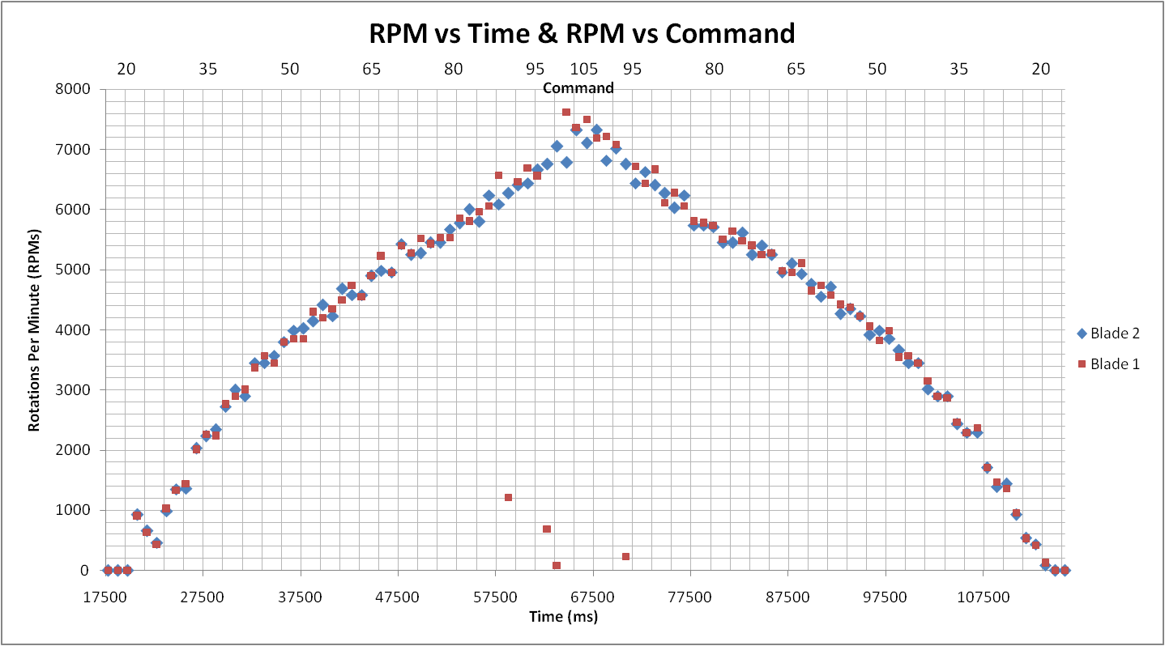

Video Presentation

<https://www.youtube.com/watch?v=vAZy4O3XNxI>

**References**

[1] <http://www.instructables.com/id/Arduino-Based-Optical-Tachometer/>

[2] <http://techvalleyprojects.blogspot.com/2012/06/arduino-control-escmotor-tutorial.html>

[3] <https://github.com/Zuph/AVRQueue>

[4] <https://github.com/DuinOS/DuinOS>