Supplementary material to the Corrigendum to “An accelerated Benders decomposition algorithm for the solution of the multi-trip time-dependent vehicle routing problem with time windows” [European Journal of Operational Research 317 (2024) 500–514]: corrected Tables 2–5 and Fig. 4(a)
Table 2 (corrected): Computational Results for Instances with 15 Customers, 5 Speed Intervals and 2 Vehicles (T15-5-2)
INSTANCES |  | CPU TIME (secs) |  |  |  |  |  | OBJECTIVE FUNCTION VALUE |  |  |  |  |  | OPTIMALITY GAP
A/A | CASE | MODEL-1 | MODEL-2 | MODEL-1-VI | MODEL-2-VI | BENDERS-DSEC-VI-SMS | BENDERS-DSEC-VI-SMS-MC | MODEL-1 | MODEL-2 | MODEL-1-VI | MODEL-2-VI | BENDERS-DSEC-VI-SMS | BENDERS-DSEC-VI-SMS-MC | MODEL-1 | MODEL-2 | MODEL-1-VI | MODEL-2-VI | BENDERS-DSEC-VI-SMS | BENDERS-DSEC-VI-SMS-MC | ALNS-VND [Pan et al. (2021)]
1 | c201 | 1.5 | 0.7 | 1.4 | 1.0 | 0.9 | 1.3 | 211.75 | 211.75 | 211.75 | 211.75 | 211.75 | 211.75 | 0% | 0% | 0% | 0% | 0% | 0% | 0%
2 | c202 | 3600 | 3600 | 341.3 | 92.7 | 1168 | 55.4 | 203.07 | 203.07 | 203.07 | 203.07 | 203.07 | 203.07 | 7% | 15% | 0% | 0% | 0% | 0% | 0%
3 | c203 | 3600 | 3600 | 2148 | 571.0 | 2150 | 85.4 | 203.07 | 214.19 | 203.07 | 203.07 | 203.07 | 203.07 | 17% | 25% | 0% | 0% | 0% | 0% | 0%
4 | c204 | 3600 | 3600 | 3546 | 813.9 | 2349 | 473.5 | 188.68 | 188.68 | 188.68 | 188.68 | 188.68 | 188.68 | 17% | 20% | 0% | 0% | 0% | 0% | 0%
5 | c205 | 14.5 | 11.6 | 8.2 | 3.6 | 3.7 | 1.7 | 208.79 | 208.79 | 208.79 | 208.79 | 208.79 | 208.79 | 0% | 0% | 0% | 0% | 0% | 0% | 0%
6 | c206 | 30.3 | 31.3 | 34.3 | 3.5 | 5.7 | 4.6 | 208.79 | 208.79 | 208.79 | 208.79 | 208.79 | 208.79 | 0% | 0% | 0% | 0% | 0% | 0% | 0%
7 | c207 | 839.8 | 1213 | 221.0 | 44.2 | 1007 | 30.0 | 204.85 | 204.85 | 204.85 | 204.85 | 204.85 | 204.85 | 0% | 0% | 0% | 0% | 0% | 0% | 0%
8 | c208 | 578.0 | 1783 | 373.4 | 82.0 | 238.4 | 15.9 | 203.07 | 203.07 | 203.07 | 203.07 | 203.07 | 203.07 | 0% | 0% | 0% | 0% | 0% | 0% | 0%
9 | r201 | 23.6 | 25.6 | 19.5 | 10.2 | 302.3 | 207.8 | 343.68 | 343.68 | 343.68 | 343.68 | 343.68 | 343.68 | 0% | 0% | 0% | 0% | 0% | 0% | 0%
10 | r202 | 3600 | 3600 | 3600 | 3526 | 3600 | 3600 | 304.67 | 297.80 | 297.80 | 297.80 | – | 324.13 | 11% | 12% | 7% | 0% | 100% | 9% | 0%
11 | r203 | 3600 | 3600 | 3600 | 3600 | 3600 | 3600 | 307.08 | 315.53 | 309.25 | 297.80 | – | – | 12% | 22% | 13% | 9% | 100% | 100% | 3%
12 | r204 | 3600 | 3600 | 3600 | 3600 | 3600 | 3600 | 284.92 | 283.61 | 289.22 | 277.22 | – | – | 14% | 20% | 18% | 14% | 100% | 100% | 3%
13 | r205 | 39.3 | 16.4 | 31.5 | 5.5 | 18.3 | 9.6 | 278.08 | 278.08 | 278.08 | 278.08 | 278.08 | 278.08 | 0% | 0% | 0% | 0% | 0% | 0% | 0%
14 | r206 | 225.5 | 340.7 | 261.1 | 82.9 | 87.2 | 31.2 | 248.91 | 248.91 | 248.91 | 248.91 | 248.91 | 248.91 | 0% | 0% | 0% | 0% | 0% | 0% | 0%
15 | r207 | 986.7 | 2053 | 950.1 | 298.5 | 111.9 | 62.1 | 248.91 | 248.91 | 248.91 | 248.91 | 248.91 | 248.91 | 0% | 0% | 0% | 0% | 0% | 0% | 0%
16 | r208 | 3600 | 3600 | 593.4 | 544.6 | 213.8 | 53.5 | 238.23 | 238.23 | 238.23 | 238.23 | 238.23 | 238.23 | 1% | 6% | 0% | 0% | 0% | 0% | 0%
17 | r209 | 90.4 | 40.2 | 94.8 | 27.8 | 15.1 | 5.3 | 263.48 | 263.48 | 263.48 | 263.48 | 263.48 | 263.48 | 0% | 0% | 0% | 0% | 0% | 0% | 0%
18 | r210 | 2724 | 3600 | 3600 | 3481 | 3389 | 1420 | 292.15 | 292.15 | 292.15 | 292.15 | 292.15 | 292.15 | 0% | 11% | 4% | 0% | 0% | 0% | 0%
19 | r211 | 962.4 | 316.9 | 898.7 | 241.7 | 554.7 | 232.1 | 247.23 | 247.23 | 247.23 | 247.23 | 247.23 | 247.23 | 0% | 0% | 0% | 0% | 0% | 1% | 0%
20 | rc201 | 48.8 | 45.2 | 29.8 | 17.2 | 529.1 | 341.6 | 313.08 | 313.08 | 313.08 | 313.08 | 313.08 | 313.08 | 0% | 0% | 0% | 0% | 0% | 0% | 0%
21 | rc202 | 3600 | 3600 | 3600 | 3600 | 3600 | 3600 | 235.37 | 235.37 | 235.37 | 235.37 | – | – | 26% | 29% | 12% | 14% | 100% | 100% | 2%
22 | rc203 | 3600 | 3600 | 3600 | 3600 | 3600 | 3600 | 198.64 | 198.64 | 198.64 | 198.64 | – | – | 28% | 32% | 28% | 29% | 100% | 100% | 13%
23 | rc204 | 3600 | 3600 | 3600 | 3600 | 3600 | 3600 | 192.18 | 231.33 | 192.18 | 192.18 | – | – | 32% | 45% | 30% | 32% | 100% | 100% | 14%
24 | rc205 | 1745 | 878.4 | 316.5 | 219.0 | 3600 | 3600 | 236.69 | 236.69 | 236.69 | 236.69 | – | – | 0% | 0% | 0% | 0% | 100% | 100% | 0%
25 | rc206 | 318.8 | 115.8 | 235.2 | 129.1 | 84.6 | 12.0 | 204.22 | 204.22 | 204.22 | 204.22 | 204.22 | 204.22 | 0% | 0% | 0% | 0% | 0% | 0% | 0%
26 | rc207 | 3600 | 3600 | 3600 | 3364 | 3600 | 3600 | 189.06 | 189.06 | 189.06 | 189.06 | – | – | 14% | 23% | 26% | 0% | 100% | 100% | 0%
27 | rc208 | 3600 | 3600 | 3600 | 3600 | 3600 | 757.0 | 157.01 | 157.01 | 157.01 | 157.01 | – | 157.01 | 15% | 18% | 16% | 17% | 100% | 0% | 0%
Bold: value different from the published table. Objective values are given with two decimals and compared with the published (integer) values after rounding. CPU times in seconds; 3600 = time limit of 1 hour reached; CPU times reached at the time limit are not marked bold. –: no feasible solution found within the time limit (optimality gap 100%). ALNS-VND: optimality gap of the best ALNS-VND solution (C_bst) reported by Pan, Zhang, & Lim (2021, Table 4), recomputed with the best lower bound obtained in this study. Computations: IBM ILOG CPLEX 22.1.1; Intel(R) Core(TM) i7-4790 CPU @ 3.6 GHz, 32 GB RAM.
Table 3 (corrected): Computational Results for Instances with 15 Customers, 11 Speed Intervals and 2 Vehicles (T15-11-2)
INSTANCES |  | CPU TIME (secs) |  |  |  |  |  | OBJECTIVE FUNCTION VALUE |  |  |  |  |  | OPTIMALITY GAP
A/A | CASE | MODEL-1 | MODEL-2 | MODEL-1-VI | MODEL-2-VI | BENDERS-DSEC-VI-SMS | BENDERS-DSEC-VI-SMS-MC | MODEL-1 | MODEL-2 | MODEL-1-VI | MODEL-2-VI | BENDERS-DSEC-VI-SMS | BENDERS-DSEC-VI-SMS-MC | MODEL-1 | MODEL-2 | MODEL-1-VI | MODEL-2-VI | BENDERS-DSEC-VI-SMS | BENDERS-DSEC-VI-SMS-MC | ALNS-VND [Pan et al. (2021)]
1 | c201 | 5.7 | 2.1 | 2.9 | 2.4 | 4.0 | 1.9 | 211.75 | 211.75 | 211.75 | 211.75 | 211.75 | 211.75 | 0% | 0% | 0% | 0% | 0% | 0% | 0%
2 | c202 | 3600 | 3600 | 3600 | 3600 | 3600 | 376.8 | 206.14 | 203.07 | 203.07 | 203.07 | – | 203.07 | 18% | 25% | 14% | 12% | 100% | 0% | 0%
3 | c203 | 3600 | 3600 | 3600 | 3600 | 3600 | 452.3 | 232.66 | 203.07 | 203.07 | 203.07 | – | 203.07 | 31% | 28% | 14% | 15% | 100% | 0% | 0%
4 | c204 | 3600 | 3600 | 3600 | 3600 | 3600 | 1203 | – | – | 188.68 | 188.68 | – | 188.68 | 100% | 100% | 11% | 11% | 100% | 0% | 0%
5 | c205 | 76.2 | 243.9 | 27.2 | 19.1 | 18.9 | 4.0 | 208.79 | 208.79 | 208.79 | 208.79 | 208.79 | 208.79 | 0% | 0% | 0% | 0% | 0% | 0% | 0%
6 | c206 | 817.9 | 2127 | 358.0 | 169.2 | 116.9 | 7.4 | 208.79 | 208.79 | 208.79 | 208.79 | 208.79 | 208.79 | 0% | 0% | 0% | 0% | 0% | 0% | 0%
7 | c207 | 3600 | 3600 | 536.1 | 335.6 | 1973 | 45.7 | 204.85 | 204.85 | 204.85 | 204.85 | 204.85 | 204.85 | 8% | 9% | 0% | 0% | 0% | 0% | 0%
8 | c208 | 3600 | 3600 | 3600 | 2447 | 978.0 | 44.5 | 203.07 | 203.07 | 203.07 | 203.07 | 203.07 | 203.07 | 21% | 23% | 10% | 0% | 0% | 0% | 0%
9 | r201 | 41.2 | 69.7 | 65.7 | 24.0 | 122.2 | 115.0 | 341.03 | 341.03 | 341.03 | 341.03 | 341.03 | 341.03 | 0% | 0% | 0% | 0% | 0% | 0% | 0%
10 | r202 | 3600 | 3600 | 3600 | 3600 | 3600 | 3447 | 316.27 | 297.80 | 311.66 | 297.80 | – | 297.52 | 19% | 24% | 18% | 13% | 100% | 0% | 0%
11 | r203 | 3600 | 3600 | 3600 | 3600 | 3600 | 3600 | 334.95 | – | 316.76 | 297.52 | – | 297.52 | 23% | 100% | 21% | 21% | 100% | 3% | 2%
12 | r204 | 3600 | 3600 | 3600 | 3600 | 3600 | 3600 | 406.74 | – | 416.17 | 276.34 | – | 266.59 | 44% | 100% | 47% | 19% | 100% | 6% | 6%
13 | r205 | 34.2 | 146.3 | 58.3 | 35.8 | 58.5 | 25.7 | 278.08 | 278.08 | 278.08 | 278.08 | 278.08 | 278.08 | 0% | 0% | 0% | 0% | 0% | 0% | 0%
14 | r206 | 3600 | 3600 | 3600 | 3600 | 3600 | 259.2 | 248.91 | – | 260.05 | 248.91 | – | 248.91 | 11% | 100% | 8% | 6% | 100% | 0% | 0%
15 | r207 | 3600 | 3600 | 3600 | 3600 | 3600 | 483.1 | – | – | 267.05 | 260.05 | – | 248.91 | 100% | 100% | 15% | 10% | 100% | 0% | 0%
16 | r208 | 3600 | 3600 | 3600 | 3600 | 3600 | 1086 | – | – | – | 255.59 | – | 238.23 | 100% | 100% | 100% | 16% | 100% | 0% | 0%
17 | r209 | 452.9 | 3600 | 370.7 | 83.8 | 340.5 | 12.0 | 263.48 | 263.48 | 263.48 | 263.48 | 263.48 | 263.48 | 0% | 5% | 0% | 0% | 0% | 0% | 0%
18 | r210 | 3600 | 3600 | 3600 | 3600 | 3600 | 3224 | 318.79 | 310.39 | 297.52 | 304.72 | – | 292.15 | 18% | 26% | 12% | 18% | 100% | 0% | 0%
19 | r211 | 3600 | 3600 | 3600 | 3600 | 3600 | 3600 | – | 273.69 | 275.75 | 262.14 | – | – | 100% | 21% | 19% | 15% | 100% | 100% | 6%
20 | rc201 | 107.3 | 124.2 | 28.8 | 20.6 | 18.1 | 9.9 | 288.84 | 288.84 | 288.84 | 288.84 | 288.84 | 288.84 | 0% | 0% | 0% | 0% | 0% | 0% | 0%
21 | rc202 | 3600 | 3600 | 3600 | 3600 | 3600 | 3600 | 258.80 | 258.80 | 235.37 | 235.37 | – | 235.37 | 45% | 48% | 18% | 17% | 100% | 15% | 15%
22 | rc203 | 3600 | 3600 | 3600 | 3600 | 3600 | 3600 | 198.64 | 198.64 | 200.70 | 198.64 | – | 198.64 | 32% | 34% | 31% | 30% | 100% | 27% | 27%
23 | rc204 | 3600 | 3600 | 3600 | 3600 | 3600 | 3600 | – | – | 192.93 | 192.18 | – | 192.93 | 100% | 100% | 33% | 32% | 100% | 29% | 29%
24 | rc205 | 639.3 | 3600 | 473.5 | 169.2 | 195.9 | 19.1 | 200.76 | 200.76 | 200.76 | 200.76 | 200.76 | 200.76 | 0% | 25% | 0% | 0% | 0% | 0% | 0%
25 | rc206 | 485.5 | 3600 | 2884 | 1064 | 555.7 | 36.6 | 204.22 | 204.22 | 204.22 | 204.22 | 204.22 | 204.22 | 0% | 2% | 0% | 0% | 0% | 0% | 0%
26 | rc207 | 3600 | 3600 | 3600 | 3600 | 3600 | 3600 | 189.06 | 189.06 | 189.06 | 189.06 | – | 189.06 | 32% | 33% | 29% | 28% | 100% | 25% | 25%
27 | rc208 | 3600 | 3600 | 3600 | 3600 | 3600 | 3600 | – | – | 161.51 | 158.53 | – | – | 100% | 100% | 25% | 25% | 100% | 100% | 3%
Bold: value different from the published table. Objective values are given with two decimals and compared with the published (integer) values after rounding. CPU times in seconds; 3600 = time limit of 1 hour reached; CPU times reached at the time limit are not marked bold. –: no feasible solution found within the time limit (optimality gap 100%). ALNS-VND: optimality gap of the best ALNS-VND solution (C_bst) reported by Pan, Zhang, & Lim (2021, Table 4), recomputed with the best lower bound obtained in this study. Computations: IBM ILOG CPLEX 22.1.1; Intel(R) Core(TM) i7-4790 CPU @ 3.6 GHz, 32 GB RAM.
Table 4 (corrected): Comparative Results of Instances Solved To Optimality And The Average CPU Time
INSTANCES |  |  | No OF INSTANCES SOLVED OPTIMALLY |  |  |  |  |  | AVERAGE CPU TIME (sec) FOR INSTANCES SOLVED OPTIMALLY |  |  |  |  |  | COMPARISON OF AVERAGE CPU TIME (sec) FOR INSTANCES SOLVED OPTIMALLY
A/A | CUSTOMERS - SPEED INTERVALS - VEHICLES | CASE - No OF INSTANCES | MODEL-1 | MODEL-2 | MODEL-1-VI | MODEL-2-VI | BENDERS-DSEC-VI-SMS | BENDERS-DSEC-VI-SMS-MC | MODEL-1 | MODEL-2 | MODEL-1-VI | MODEL-2-VI | BENDERS-DSEC-VI-SMS | BENDERS-DSEC-VI-SMS-MC | MODEL-2 vs MODEL-1 | MODEL-1-VI vs MODEL-1 | MODEL-2-VI vs MODEL-2 | BENDERS-DSEC-VI-SMS vs MODEL-1 | BENDERS-DSEC-VI-SMS-MC vs MODEL-1 | BENDERS-DSEC-VI-SMS-MC vs BENDERS-DSEC-VI-SMS
1 | 15-5-2 | C2 - 8 | 5 | 5 | 8 | 8 | 8 | 8 | 293 | 608 | 834 | 201 | 865 | 83 | 108% | 185% | -67% | 195% | -71% | -90%
2 | 15-5-2 | R2 -11 | 7 | 6 | 7 | 9 | 8 | 8 | 722 | 465 | 407 | 913 | 587 | 253 | -36% | -44% | 96% | -19% | -65% | -57%
3 | 15-5-2 | RC2 - 8 | 3 | 3 | 3 | 4 | 2 | 3 | 704 | 346 | 194 | 932 | 307 | 370 | -51% | -72% | 169% | -56% | -47% | 21%
4 | 15-11-2 | C2 - 8 | 3 | 3 | 4 | 5 | 5 | 8 | 300 | 791 | 231 | 595 | 618 | 267 | 164% | -23% | -25% | 106% | -11% | -57%
5 | 15-11-2 | R2 - 11 | 3 | 2 | 3 | 3 | 3 | 8 | 176 | 108 | 165 | 48 | 174 | 1082 | -39% | -6% | -56% | -1% | 514% | 523%
6 | 15-11-2 | RC2 - 8 | 3 | 1 | 3 | 3 | 3 | 3 | 411 | 124 | 1129 | 418 | 257 | 22 | -70% | 175% | 237% | -38% | -95% | -91%
TOTAL AVERAGE |  | 54 | 24 | 20 | 28 | 32 | 29 | 38 | 470 | 479 | 532 | 560 | 573 | 386 | 2% | 13% | 17% | 22% | -18% | -33%
Bold: value different from the published table. Solved optimally: proven optimal; Comparison columns: relative difference of the average CPU times.
Table 5 (corrected): Comparative Results of Average Optimality Gap
INSTANCES |  |  | AVERAGE OPTIMALITY GAP |  |  |  |  |  |  | COMPARISON OF AVERAGE OPTIMALITY GAP
A/A | CUSTOMERS - SPEED INTERVALS - VEHICLES | CASE - No OF INSTANCES | MODEL-1 | MODEL-2 | MODEL-1-VI | MODEL-2-VI | BENDERS-DSEC-VI-SMS | BENDERS-DSEC-VI-SMS-MC | ALNS-VND [ (Pan, Zhang, & Lim, 2021)] | MODEL-2 vs MODEL-1 | MODEL-1-VI vs MODEL-1 | MODEL-2-VI vs MODEL-2 | BENDERS-DSEC-VI-SMS vs MODEL-1 | BENDERS-DSEC-VI-SMS-MC vs MODEL-1 | BENDERS-DSEC-VI-SMS-MC vs BENDERS-DSEC-VI-SMS | ALNS-VND vs BENDERS-DSEC-VI-SMS-MC
1 | 15-5-2 | C2 - 8 | 5% | 7% | 0% | 0% | 0% | 0% | 0% | 2% | -5% | -7% | -5% | -5% | 0% | 0%
2 | 15-5-2 | R2 -11 | 3% | 6% | 4% | 2% | 27% | 19% | 1% | 3% | 0% | -4% | 24% | 16% | -8% | -19%
3 | 15-5-2 | RC2 - 8 | 14% | 18% | 14% | 11% | 75% | 62% | 4% | 4% | 0% | -7% | 61% | 48% | -12% | -59%
4 | 15-11-2 | C2 - 8 | 22% | 23% | 6% | 5% | 38% | 0% | 0% | 1% | -16% | -18% | 15% | -22% | -37% | 0%
5 | 15-11-2 | R2 - 11 | 38% | 52% | 22% | 11% | 73% | 10% | 1% | 15% | -16% | -42% | 35% | -28% | -63% | -9%
6 | 15-11-2 | RC2 - 8 | 39% | 43% | 17% | 17% | 62% | 25% | 12% | 4% | -22% | -26% | 24% | -14% | -38% | -12%
AVERAGE |  | 54 | 20.3% | 25.5% | 10.7% | 7.4% | 46.3% | 18.8% | 2.7% | 5.2% | -9.6% | -18.1% | 26.0% | -1.5% | -27.5% | -16.1%
Bold: value different from the published table. Solved optimally: proven optimal; Optimality gap of a run without a feasible solution = 100%. Comparison columns: difference of the average optimality gaps (percentage points). ALNS-VND: average of the recomputed ALNS-VND gaps of Tables 2 and 3.
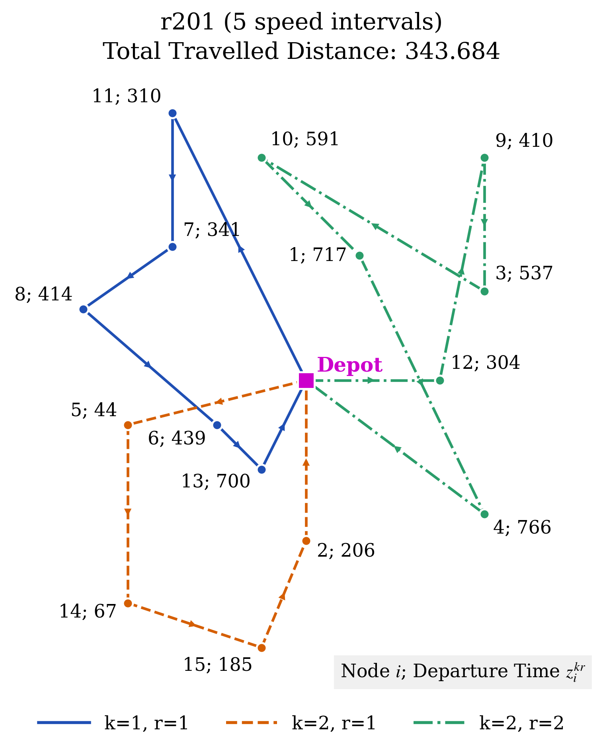
Fig. 4(a) (corrected). Optimal solution of the MTTDVRPTW for the instance r201 with 5 speed intervals (total travelled distance 343.684). Vehicle 1 performs one trip and vehicle 2 performs two trips. Fig. 4(b) (11 speed intervals) is unchanged.

