Project 2: A Secure Teller Terminal System

Anthony Tolbert

Class: COMP2710

Email: [azt0052@auburn.edu](mailto:azt0052@auburn.edu)

Description: A secure teller terminal system for the Auburn branch of Tiger Bank, which comprises multiple branches in the State of Alabama.

**System administrator**

Once the user successfully logs in as a system administrator, the user will be prompted to choose from the options of managing clients and accounts, adding a branch staff member, deleting a branch staff member, displaying the branch staff, changing the password, or exiting the program. If the user selects the valid choice of client and account management, the user will be directed to the client and account management menu. If the user chooses to change the password, the user will be prompted for a new password and the password will be changed if the password is valid. If the user chooses to add a branch staff member, the user is prompted to enter an user name, password, and specify the role of the staff member. If the user chooses to delete a branch staff member, the user will be prompted for the username of the user to be deleted and then whether to confirm or cancel the deletion. If the user chooses to confirm the deletion, the user is deleted. If the username entered is not found the user is given a warning and no user is deleted. If the user chooses to display the branch staff, the users within the system will be displayed along with their roles. If the new password matches the old password, then the user will be prompted to enter another password. If the user chooses to exit, the program is exits.

**Staff:**

Once the user successfully logs in as a branch staff, the user will be prompted to choose from the options of managing clients and accounts, changing the password, or exiting the program. If the user selects the valid choice of client and account management, the user will be directed to the client and account management menu. If the user chooses to change the password, the user will be prompted for a new password and the password will be changed. If the user chooses to exit, the program is exits.

**Quit:**

User selects “Quit” option and the program stops running.

**Design**

**Classes:**

Menu: Handles basic user screw-ups (choosing an option out of bounds).

Staff: Keeps track of all personnel.

Admin: Inherits from staff & handles information editing

File Tracker: Keeps track of the accounts and anything dealing with reading from or writing to files.

**Class Diagram**

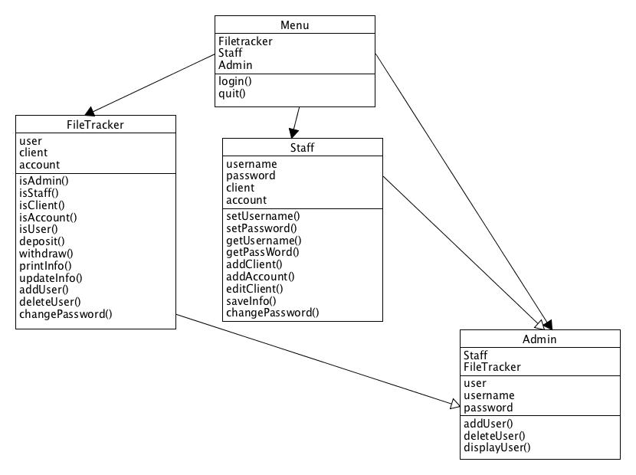

**Testing**

Test1: The first test will test the functionality of the login prompt that the user is given once the program starts. If the user enter a invalid option of 5 the user should be prompted to enter another choice until the user enters a valid of option of 1 or 2.

Test2: The second test will test the functionality of system administration management menu. If the user enters an invalid option of -1, the user will be prompted to enter a valid option until it is entered. Once a valid of 1 – 6 is entered, the user will be taken to the option.

Test3: The third test will test the functionality of logging in as staff. If the user enters an option of 5, the user will be given the option of entering another option until a correct one of the numbers 1 -3 is entered