|  |
| --- |
|  |
| Tic-tac-toe Game |
| Submitted for:   |  |  | | --- | --- | | Course# | CSC 432 | | Section: |  | | Instructor: | Dr. Hicham Hage | | Date: | 16 – 12 – 19 | |
| Submitted by:   |  |  |  | | --- | --- | --- | | Student ID | Name | Major | | 20122189 | Tony Habib | Computer Science | |

**Introduction:**

This Project is an AI project for a Tic Tac Toe game.

The user has 3 AI’s choice to play against: 1) Random Player, 2) Minimax Player, 3) AlphaBetta Player.

First of all, the program asks the user which player he wants to play against and waits for user for input.

Once the user choses his Opponent, then the game starts with the chosen AI. We will explain briefly the AIs how they work.

1. Random Player: As for random player, the opponent never thinks where to put his O. He puts it randomly as long as it is a legal move.
2. Minimax Player: This opponent uses the minimax algorithm to make the next move, It is impossible to be beaten as he searches the whole tree for the best move. In the worst case, the game will end up in a Draw.
3. AlphaBetta Player: This opponent uses the AlphaBetta Pruning algorithm to make the next move, It is similar to the minimax player, but it is faster processor wise, as it doesn’t go to the whole tree due to pruning.

**The Game:**

As we said in the Introduction, the first output is the user is asked which opponent he would like to play against:   
  
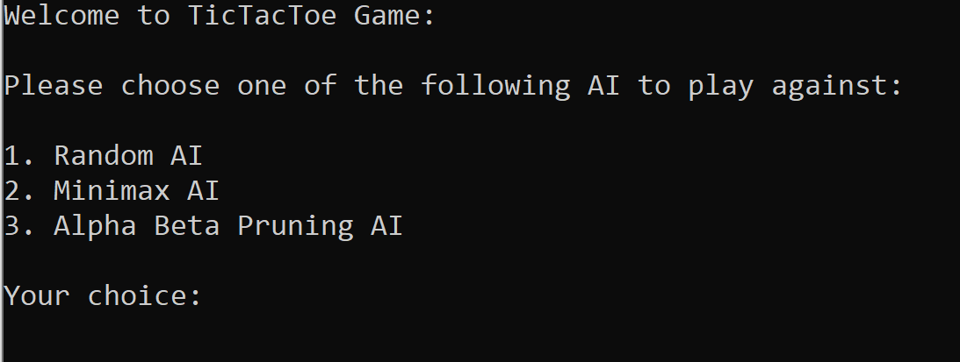  
  
The second step the user chooses from 1 to 3 as it shows, and we forced the user to enter a valid number once the user enters a valid choice the game starts, it draws the Game Board and it asks for the user move.

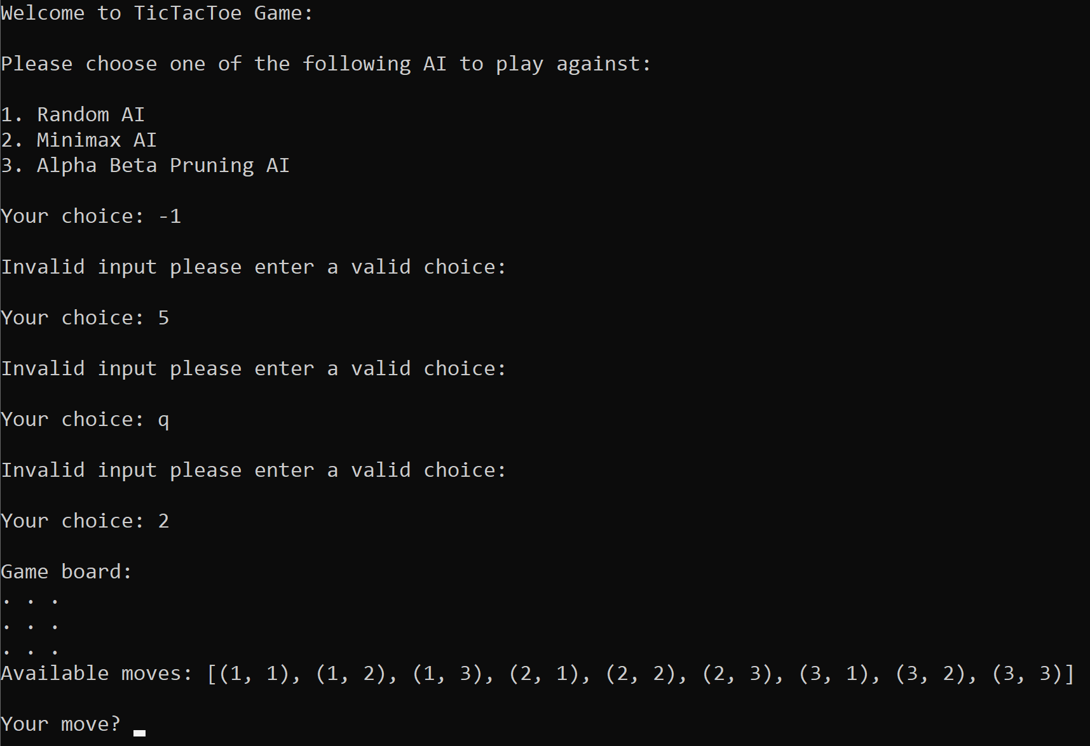

We’ve detected a minor bug where it might happens, where the user enters a character or an illegal move then the Player X/O switches between the human player and the AI.

To fix that bug we forced the user, to enter a valid move not a character , then we forced the user to enter a move that is available is the states then if he chooses an illegal move we force him to choose a legal one, once the user enters a legal move, It prints a new board with both, Human player and AI moves.

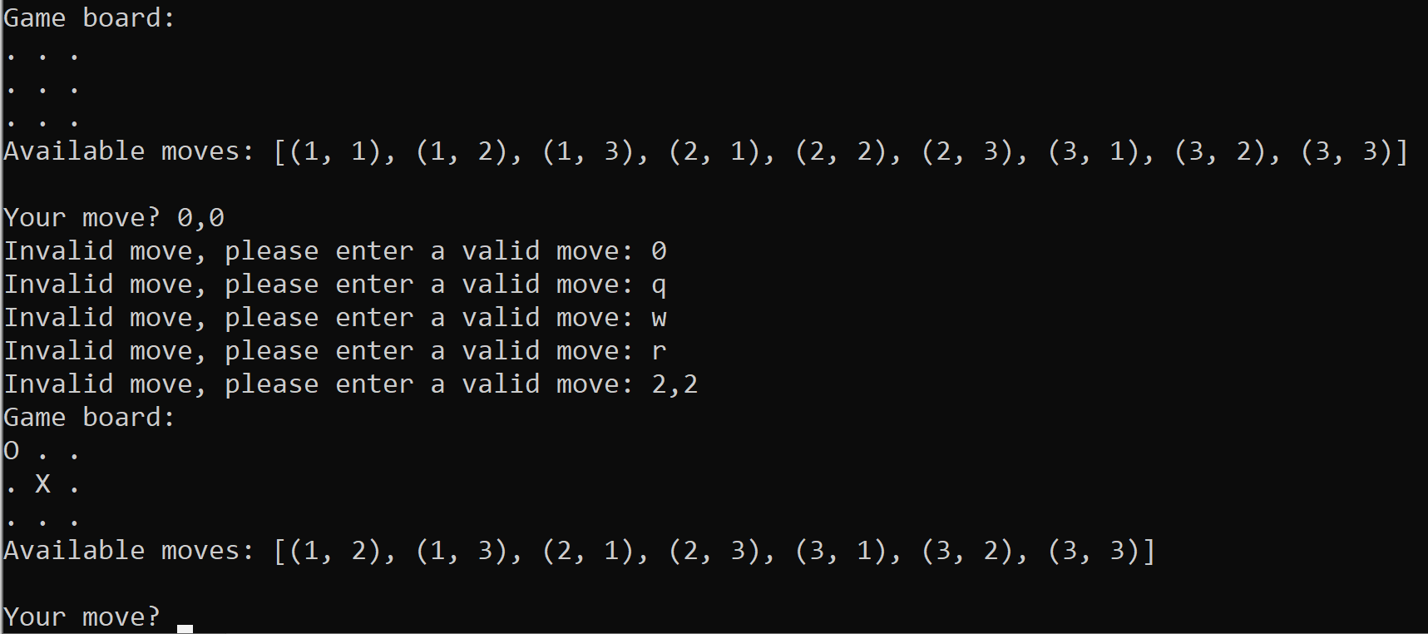

Now Once the game ends, the user has a choice to play again if he press 1, and if he does, the game starts all over by asking which AI he wants to play against.

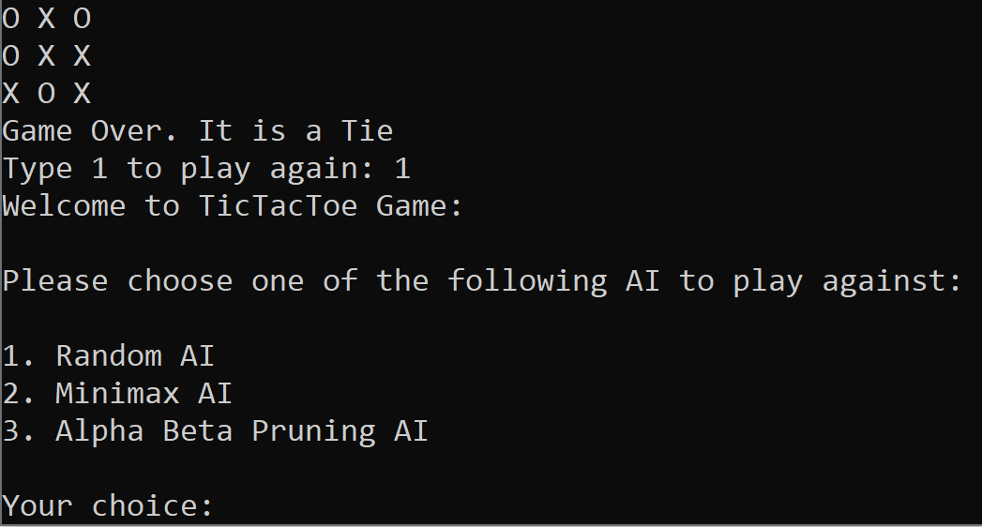

**Algorithms:**

In the Algorithms section we will show a sample game against of the each AI opponent to show how they behavior ingame.

**Random Player:**

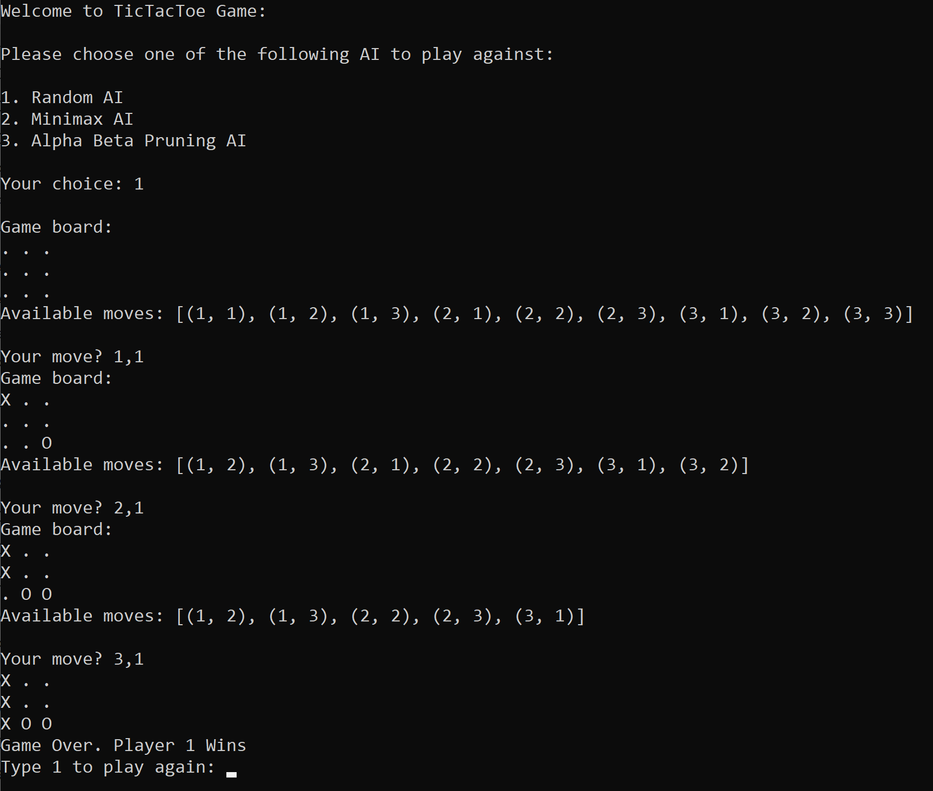

**Minimax Player:**

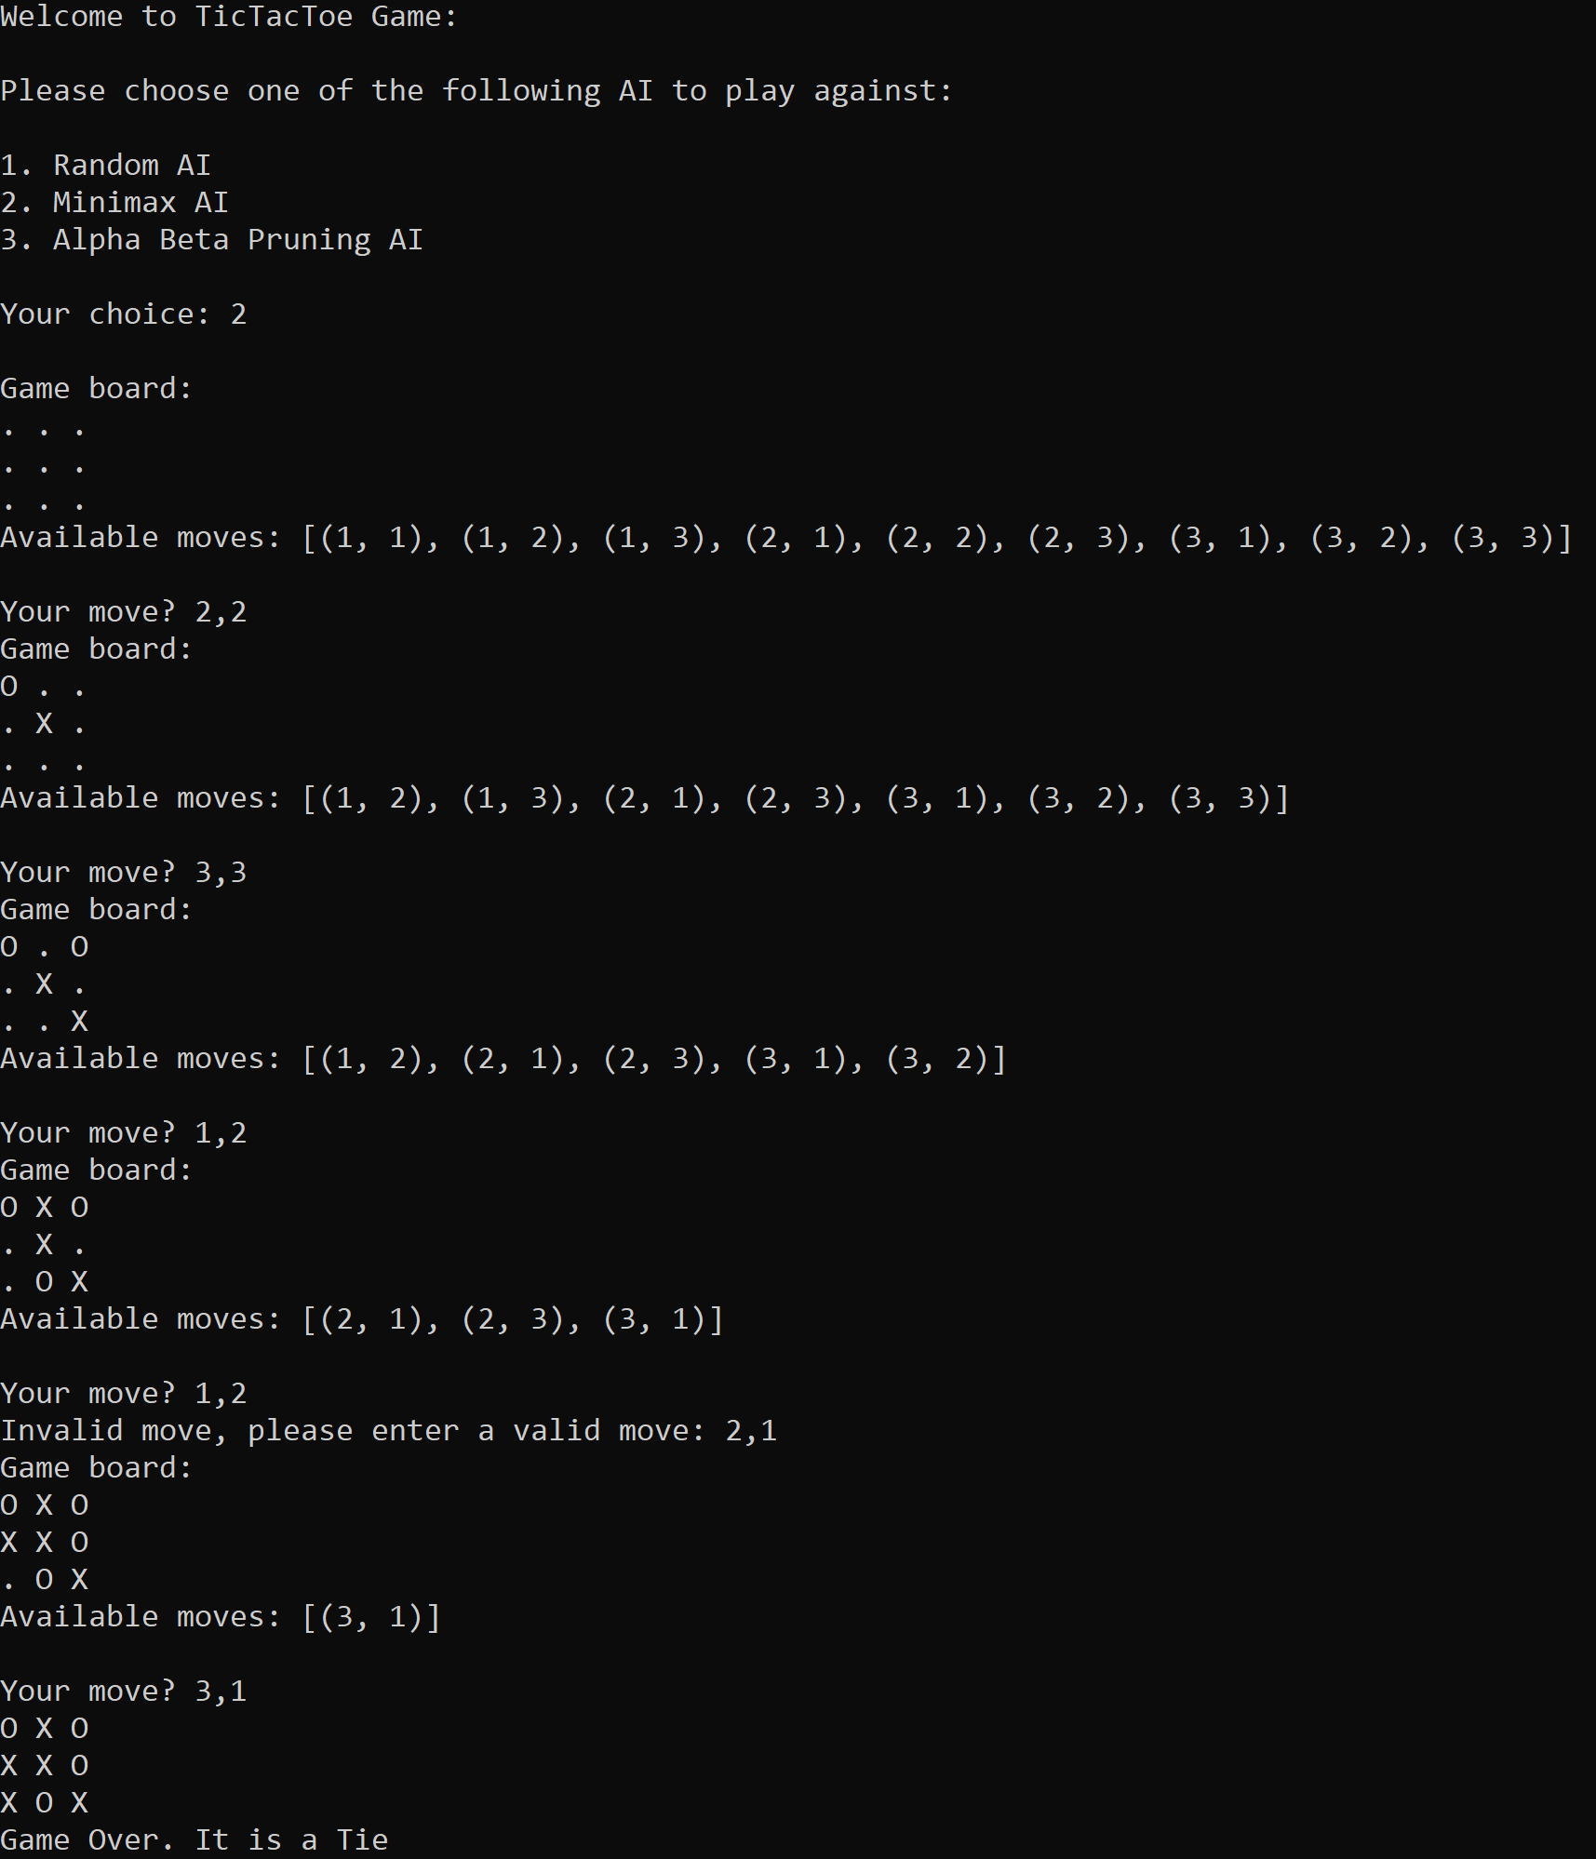

**AlphaBetta Player:**

