|  |
| --- |
|  |
| **Project Title** |
| Submitted for:   |  |  | | --- | --- | | Course: | CSC 426: Principles of Database Systems | | Section: | A | | Instructor: | Dr. Pierre Akiki | | Date: | 18/05/2019 | |
| Submitted by:   |  |  |  | | --- | --- | --- | | Student ID | Name | Major | | 20122189 | **Tony Habib** | **Computer Science** | |

**Project Description**

This is a Library Management Design where it contains :

Library Director that have an ID and Name and Working Hours , the Director supervises a Librarian that also have ID and Name and Working Hours.

There are two type of Librerian : Technical Librarian and General Librarian .

The Technical Librarian Manages the Library Collection that have : Barcode , Tile , can have multiple Author, ISBN , Publisher , can have multiple language, Form , PublishingDate, Location , can have multiple ShelfMark

The General Librarian Handles Loans , and the Loans have Loan ID , Date , Transaction , and Due Date.

There are 3 Types of Library Collection : General Reference that has Reference Type, Core Curriculum that has the Area, Academic Programs that requires the Course.

The Loans are loaned by the user that have UserID and Username. There are two types of User , The Library Member that requires a Type , and the Visitor that needs a Subscription .

The User can Search m the Library Collection , Reserve from the Library Collection on a specific Date , and can Borrow.

**Enhanced Entity Relationship (EER) Model**

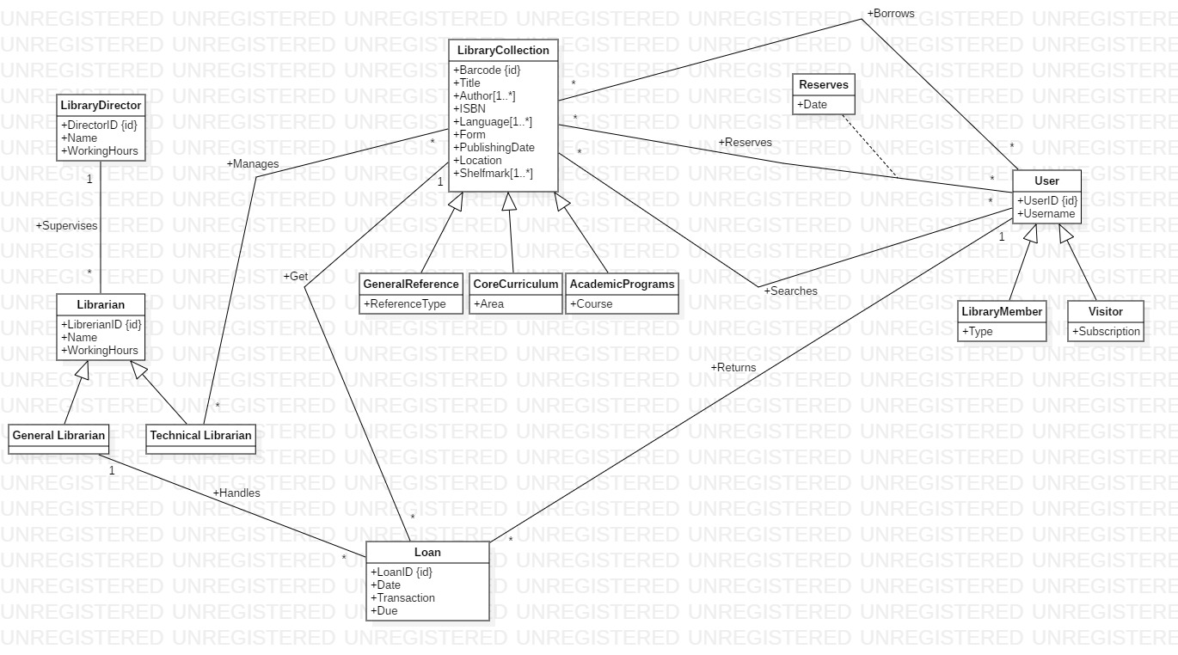

**Relational Model**



**Queries**

1. All information about users who borrowed books in April this year:

SELECT * FROM Users as U Inner Join Loan as L

ON U.UserID = L.UserID

WHERE L.Date Between ‘1/4/2019’ and ‘30/4/2019’ and L.Transactions = ‘Borrow’

1. Count the number of loans for each user:

SELECT UserID, COUNT(LoanID) as NumberOfLoans FROM Users Inner Join Loan on Users.UserID = Loan.UserID

Group by LoanID

1. Show all the Barcodes with their information:

SELECT L.* , A.Author, LA.Language, S.Shelfmark FROM LibraryCollection as L Inner Join CollectionAuthor as A on L.Barcode = B.Barcode

Inner Join CollectionLanguage as LA on A.Barcode = LA.Barcode

Inner Join CollectionShelfmark as S

ON LA.Barcode = S.Barcode

1. Library Collection which are on loan and show the loan due showing their UserID

SELECT L.Barcode, L.Title, LO.UserID, LO.Due

FROM LibraryCollections as L Inner Join Loan as LO

On L.Barcode = LO.Barcode

1. Show the number of different users served by each librarian:

SELECT LibrarianID, COUNT (distinct UserID) as NumberOfUsers

FROM Loan

GROUP BY LibrarianID

1. Show all visitors that took a loan in April:

SELECT U. UserID FROM UserID as U Inner Join Loan as L

on U.UserID = L.UserID

WHERE U.UserType = ‘Visitor’ and L.Date between ‘1/4/2019’ and ‘30/4/2019’

1. Show The UserID who Reserved The book with the Barcode = 123C4TT579

SELECT UserID, Barcode FROM Reserves

Where Barcode = ‘123C4TT579’

1. Show how many each Technical Librarian Manages LibraryCollection

SELECT L.LibID, M.Barcode, FROM Librarian Inner Join Manages

On L.LibID = M.LibID

WHERE LibType = ‘Technical’

1. Show the Reservation Date for each iten in the library collection , and the User who reserve it

SELECT * FROM Reserves

1. Show how many Loans Librarian Handled in year 2018

SELECT L.LibID, Count(LoanID) as NumberOfLoans FROM Librarian as L Inner Join Inner Join Loan as LO

On L.LibID = LO.LibID

Where LO.Date between 31/12/2017 and 1/1/2019

Group by L.LibID