# Exam – SoftUni Library

You need to create a **web application** where users **see and manage list of books**. Usually the users will visit the page, navigate either to **signing up or sign in**. When they are logged they will have the option to view **all books** listed. They can either **add** a new book, **view all their** booksor **edit** or **delete** existing, only if **they** added it.

# 1. Expected Result

General rules:

1. **No blank lines** should be left
2. Going **on new line** (click ENTER) in the same text should be done, **only after the sentence ends** (after full stop)
3. Each **title** is **Heading 1**
4. All **attribute values and tags** are **lowercase**
5. All name fields are lower_snake_case variant of the text/value
6. All **tables** have **head** and if they are filled with data, they have a **body**
7. Only **direct child tags** go on **new line** e.g. <tr> **is** on new line after <thead>, but <a> in <li> **is not** on new line.
8. All **success messages** are stored in the **session** under the “success” key and are **immediately deleted** from session after visualization. They are visualized on the **next line after the title** in a **paragraph** with style color:green.
9. All **error messages** are visualized on the **next line after the title** in a **paragraph** with style color=red.
10. All **relational dropdowns** follow the convention: name_snake_case_id

**index.php:**

* When user **is** **not** logged

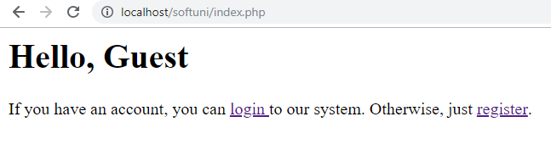

**register.php:**

* **Before** form is submitted

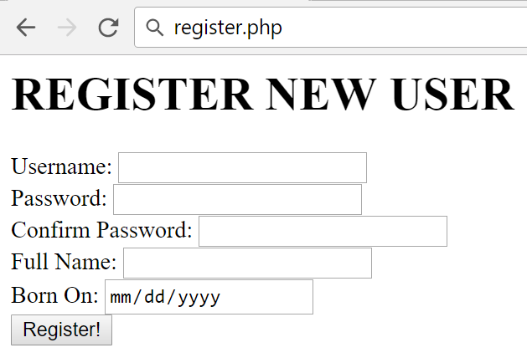

* Form **is submitted**, but there are **username** **duplicates**

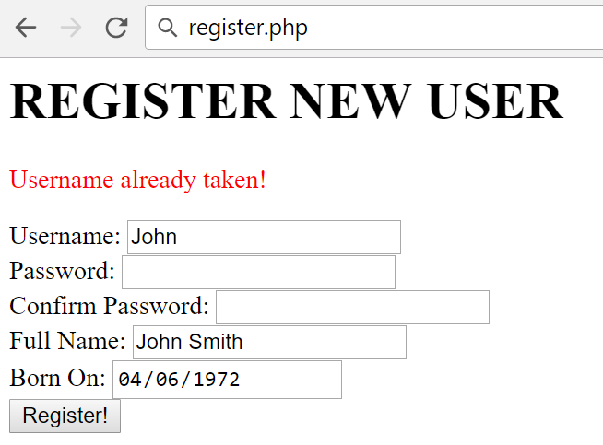

* Form **is submitted**, but the **password** and the **confirm password** field differs:

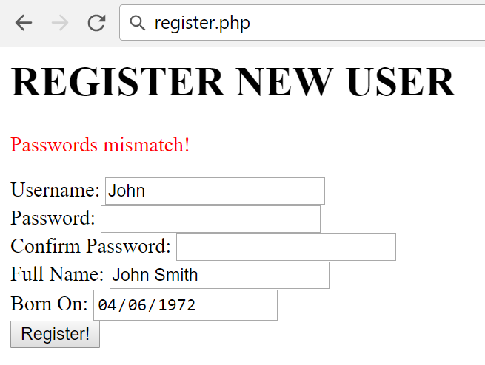

* Form **is submitted**, but **validation** did not pass:

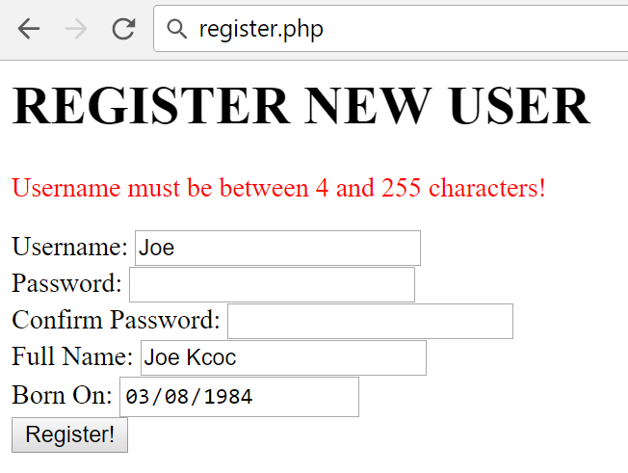

Show the **error only for the first field the validation did not pass** (they might all be out of range). The message is in the format:

* + For **text** fields: “{Field Name} must be between {MIN_LENGTH} and {MAX_LENGTH} characters!”.
  + For **number** fields: “{Field Name} must be between {MIN_VALUE} and {MAX_VALUE}!”
* **After** successful submission

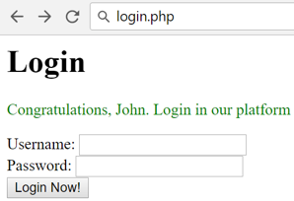

**login.php:**

* **Before** form is submitted

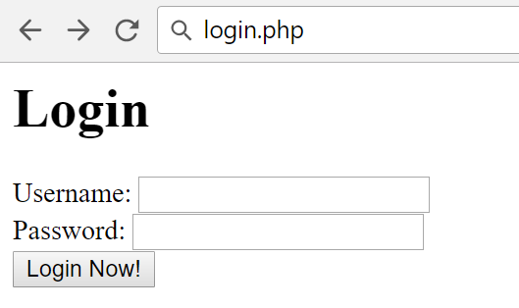

* Form **is submitted**, but **username** does not exist:

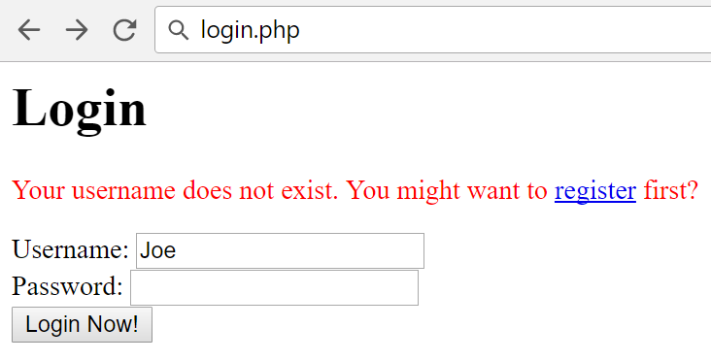

* Form **is submitted**, but the **password** is not the same:

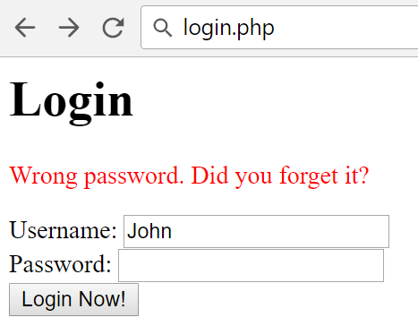

* **After** successful login:

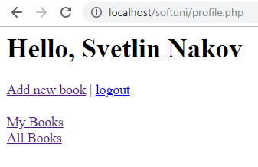

You should get a greeting message with your first and your last name. You must have 4 links for adding new book, for **logout** for viewing your books and for viewing all books

**add_book.php** should look like this:

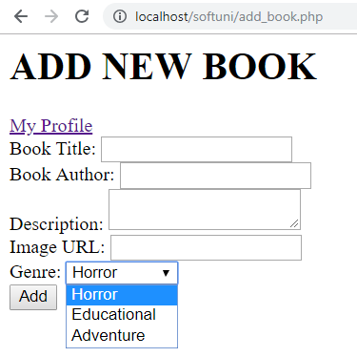

**my_books.php** :

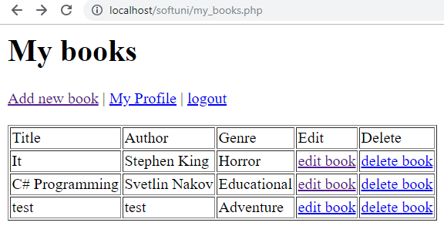

**all_books.php:**

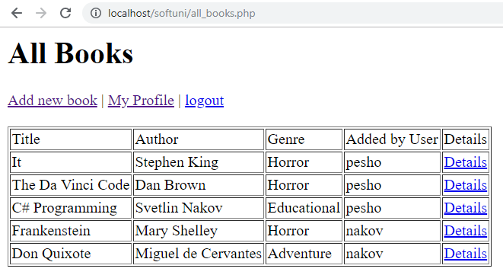

**edit.php?id={book id}** (Edit existing book):



* After **successful submission**, the operation is **edited**, **redirect** to the list of my books **my_books.php**

**delete.php?id={book_id}** (Delete existing operation):

* **Deletes** the operation and **redirects** to of my books **my_books.php**.

**view.php?id={book_id}** Whenyou click “details” from **all_books.php** you should be able to see the image and description about the books you selected. This option is available only for **logged in** users.

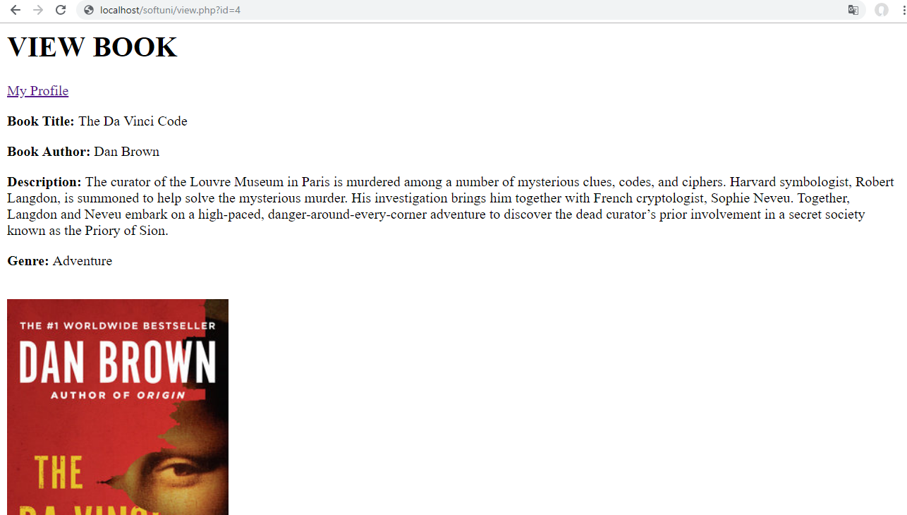

# Database

Create a database “softuni_library” and add the following tables:

# Data Definition

# DDL – Users

|  |  |  |
| --- | --- | --- |
| **users** | | |
| **Column Name** | **Type** | **Constraints** |
| username | String | 4…255. Unique. |
| password | String | 4…255 |
| full_name | String | 5…255 |
| born_on | date | not null |

# DDL – Genres

|  |  |  |
| --- | --- | --- |
| **genres** | | |
| **Column Name** | **Type** | **Constraints** |
| name | String | 3…50 |

# DDL – Books

|  |  |  |
| --- | --- | --- |
| **books** | | |
| **Column Name** | **Type** | **Constraints** |
| title | String | 3…50 |
| author | string | 3…50 |
| description | string | 10…10000 |
| image | string | 3…255 |
| genre_id | int | 1...4294967295 |
| user_id | int | 1...4294967295 |
| added_on | TimeStamp | Current timestamp |

# DML – Add Genres

**Adds** the following genres: Save the DDL in export.sql file in the top-level directory of your project.

|  |
| --- |
| **name** |
| Drama |
| Educational |
| Adventure |

# HTML

# Register Form

**Create register form**. Follow the constraints below:

1. Username with minimum length of **4** symbols
2. Password with minimum length of **4** symbols
3. Confirm password with minimum length of **4** symbols
4. Full Name with minimum length of **5** symbols
5. Born On with type date
6. Button, submitting the form with value “**Register**”

All fields are **required**. Use a convention for name attributes: **lower_snake_case**.

# Login Page

1. Username
2. Password
3. Button, submitting the form with text “**Login**”

All fields are **required**. Use a convention for name attributes: **lower_snake_case**.

# New Book Page

1. Title with minimum length of **3** symbols and max length – 50
2. Author with minimum length of **3** symbols and max length – 50
3. Description containing **10 to 10,000** symbols
4. Image string containing url
5. Genres which is **empty** **dropdown** (will be later populated with PHP)
6. Button, submitting the form with text “**Add**”

All fields are **required**. Use a convention for name attributes: **lower_snake_case**.

# Structure

You are required to have index.php in the project, even if it is initially empty. Consider all **object oriented best practices** you have been taught during the course.

# Initial File Structure

1. Create a file named “export.sql” holding CREATE DATABASE and all the CREATE TABLE statements. Put it in the top-level directory;
2. Create a directory named “Config” in the top-level directory. Put file named “db.ini” holding the database connection information under the following keys: dsn, user, pass;
3. Create endpoints (front layer) for all possible pages in the top-level directory: index, register, login, add_book, edit, all_books, my_books, view and logout;
4. Extract common operation such as autoloading classes in “common.php”.

# Database Abstraction Layer

Create an **abstraction layer over the database** operations in three stages – **prepare -> execute -> take result**. All objects should be in the \Database namespace.

# Repository Layer

Create repository layer in the namespace \App\Repository

# Service Layer

Create service layer in the namespace \App\Service

# Book Management Application

Make **all the layers to work**, according to the structure and the business requirement in **1.** and submit the **zip archive** in judge.