**Q1a.)**

**Training data:** tennis court data and it needs to know where it is, so it may needs some landmark too.

**Training data:** tennis ball data, such as color, size, etc...

2. Navigate itself to tennis ball location.

1. Detect tennis ball

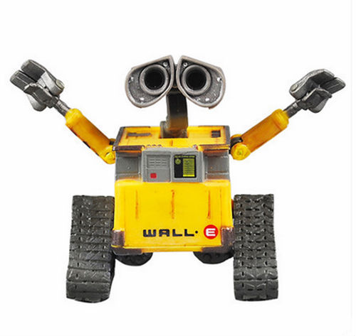

3. Player and obstacle detection and avoidance.

**Training data:** landmark, tennis court data, servers location data.

5. Delivery tennis balls back to servers.

**Training data:** landmark, tennis court data

4. Real time localization

**Training data:** player and obstacle’s data so that it can recognize this is obstacles.