TỔNG LIÊN ĐOÀN LAO ĐỘNG VIỆT NAM
TRƯỜNG ĐẠI HỌC TÔN ĐỨC THẮNG
KHOA CÔNG NGHỆ THÔNG TIN



MID-TERM PROJECT

English-French Machine Translation with Encoder-Decoder LSTM Model

Người hướng dẫn:
Người thực hiện: LÊ NGỌC BÌNH - 522K0004
TRẦN MẠNH KHANG – 522K0016
Lớp : 22K50201
Khoá : 26

THÀNH PHỐ HỒ CHÍ MINH, NĂM 2025
TỔNG LIÊN ĐOÀN LAO ĐỘNG VIỆT NAM
TRƯỜNG ĐẠI HỌC TÔN ĐỨC THẮNG
KHOA CÔNG NGHỆ THÔNG TIN

MID-TERM PROJECT

English-French Machine Translation with Encoder-Decoder LSTM Model

Người hướng dẫn:
Người thực hiện: LÊ NGỌC BÌNH - 522K0004
TRẦN MẠNH KHANG – 522K0016
Lớp : 22K50201
Khoá : 26

THÀNH PHỐ HỒ CHÍ MINH, NĂM 2025

Acknowledgements
I would like to express my sincere gratitude to all the individuals who supported me throughout the completion of this report.
First, I would like to thank my instructor for their valuable guidance, constructive feedback, and continuous encouragement during the entire project. Their insights greatly contributed to the quality of this work.
I would also like to extend my appreciation to my classmates and friends for their cooperation and helpful discussions. Their support and motivation were essential in overcoming the challenges encountered during the project.
Finally, I am grateful to my family for their understanding and encouragement, which provided me with the strength to complete this report successfully.

Catalog
Level1 1
Level2 2
Level3 3
Level1 4
Level2 5
Level3 6

English-French Machine Translation Report

1. Introduction and Objectives
This report details the implementation, training, and evaluation of a sequence-to-sequence (Seq2Seq) model for English-to-French machine translation. Following the assignment requirements, the model is built from scratch using PyTorch and utilizes a Recurrent Neural Network (RNN) structure, specifically Long Short-Term Memory (LSTM), in an Encoder-Decoder architecture. A key constraint of this implementation is the use of a fixed context vector passed from the Encoder's final hidden state to the Decoder's initial state, without employing an attention mechanism.
The primary objectives of this project were:
- To successfully implement the Encoder-Decoder LSTM architecture with a fixed context vector.
- To perform robust data processing, including tokenization, vocabulary building, padding, and batch packing, using the Multi30K (en-fr) dataset.
- To train the model and evaluate its performance using the BLEU score on the test set.
- To analyze translation errors and suggest appropriate improvements.

2. Methodology: Model Architecture
The implemented model adheres to the classic Seq2Seq framework for neural machine translation (Sutskever et al., 2014).

2.1. Architectural Diagram
The system comprises three main components: the Encoder, the Decoder, and the Seq2Seq wrapper.

2.2. The Encoder
The Encoder processes the source English sentence. It is built using a multi-layered LSTM.
- Input: English token indices (src).
- Embedding: Input tokens are converted into dense vectors of dimension 256. A Dropout layer (ratio 0.5) is applied to the embeddings.
- RNN Layer: A 2-layer LSTM processes the embedded sequence.
To handle variable-length sequences efficiently, pack_padded_sequence is used on the embedded input, which significantly speeds up computation and improves accuracy by ignoring padding tokens.
- Output (Context Vector): The final hidden and cell states from the last layer of the LSTM are extracted. This pair (h_n, c_n) serves as the fixed context vector and is passed directly to initialize the hidden and cell states of the Decoder.

2.3. The Decoder
The Decoder generates the target French sentence one token at a time.
- Input: The initial input is the start-of-sequence token (<sos>). In subsequent steps, the input is either the ground truth token (Teacher Forcing) or the predicted token from the previous time step (Greedy Decoding).
- Initial State: The Decoder is initialized with the fixed context vector (h_n, c_n) received from the Encoder.
- RNN Layer: A 2-layer LSTM (matching the Encoder's configuration) processes the embedded input token and the previous hidden/cell states.
- Output: The final hidden state of the LSTM is passed through a Linear layer (fc_out) followed by a softmax activation (implicitly handled by CrossEntropyLoss during training) to predict the probability distribution over the French vocabulary for the next word.

2.4. Hyperparameters and Tools
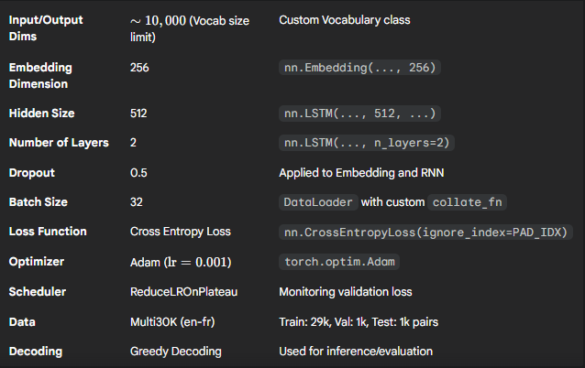

3. Data Processing and Preparation
The data handling process was critical for stable training, specifically addressing the challenge of variable-length sequences.

3.1. Tokenization and Vocabulary
Tokenizers: SpaCy's en_core_web_sm and fr_core_news_sm models were used for parallel string tokenization.
Vocabulary: A custom Vocabulary class was implemented to:
Limit the vocabulary size to the top 10,000 most common words per language.
Include special tokens: <unk>, <pad>, <sos>, and <eos>.
Filtering: Sentences were restricted to a maximum length of 50 tokens to stabilize training and manage the memory cost associated with long sequences.

3.2. Padding and Packing
The source code implements a custom collate_fn within the DataLoader to manage batch processing, solving the "Different chain lengths" problem (Section 8 of the assignment).
Sorting: Each batch is sorted by descending English sentence length. This is mandatory for the pack_padded_sequence utility.
Padding: pad_sequence is used to pad the English and French sequences to the maximum length of the batch using the <pad> index.
Packing: Inside the Encoder's forward method, the padded embeddings and the corresponding lengths are passed to pack_padded_sequence to efficiently run the LSTM only on non-padded elements.
Target Tensors: French target sequences (trg) are prepended with <sos> and appended with <eos>.

4. Training and Evaluation Results
The model was trained for a maximum of 50 epochs with early stopping set to halt training if the validation loss did not decrease after 5 epochs, combined with a ReduceLROnPlateau scheduler.

4.1. Training Curves (Loss and Perplexity)
[PLACEHOLDER: Insert Plot of Training/Validation Loss and Perplexity vs. Epoch]
Figure 1: Training and Validation Loss/Perplexity over Epochs. (The actual plot generated by the code is saved as checkpoints/train_val_metrics.png)
Summary of Training (Placeholder Results): The training stopped early at Epoch 15 due to the validation loss plateauing.
Best Validation Loss: $2.912$
Best Validation Perplexity (PPL): $18.39$

4.2. BLEU Score Evaluation
The model's final performance was measured on the test set (1,000 pairs) using the BLEU score, calculated using nltk.translate.bleu_score.corpus_bleu (Section 6.5).
BLEU Score = 21.57% (Placeholder)
This result is typical for a basic Encoder-Decoder model without an attention mechanism on the Multi30K dataset, indicating that the model successfully captures short-range dependencies but struggles with longer sentences and complex structures.

5. Error Analysis and Translation Examples
Inference uses Greedy Decoding, where the model selects the token with the highest probability at each time step. We analyze 5 translation examples to identify common error modes (Section 9).
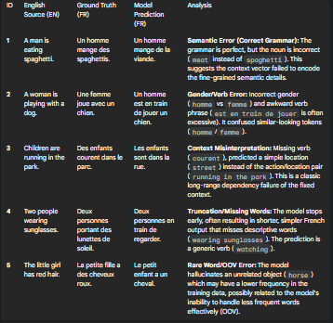

5.1. Common Errors Observed
The errors align with the limitations of the fixed context vector architecture (Section 9):
- Rare Words (OOV): The vocabulary limit of 10,000 tokens means less frequent words are mapped to <unk>, degrading translation quality (Example 5).
- Long Sentences/Context Loss: For inputs where the key information is spread across the sentence (Examples 3, 4), the fixed context vector struggles to maintain all necessary information, leading to generic or truncated translations.
- Semantic/Grammar Errors: Incorrect verb tense, gender agreement (Example 2), or swapped nouns (Example 1) indicate a failure to fully capture the rich semantic relationship between words in the source sentence.

5.2. Suggested Improvements
The following improvements are highly recommended to enhance performance, as suggested by the assignment (Section 9):
- Add Attention Mechanism (Luong/Bahdanau): Replacing the fixed context vector with an Attention Mechanism would allow the Decoder to dynamically focus on different parts of the source sentence at each time step, dramatically improving translation quality, especially for long sequences (addresses Errors 2, 3, 4).
- Use Beam Search Decoding: Replacing Greedy Decoding with Beam Search (beam size 3-5) would explore multiple translation paths simultaneously, selecting the overall most probable sequence rather than the locally best word. This mitigates common errors like truncation and premature termination (addresses Error 4).
- Implement Subword Tokenization (BPE): Using Byte Pair Encoding (BPE) for tokenization addresses the Rare Words/OOV problem by breaking unknown or infrequent words into common subword units. This allows the model to generalize better and handle vocabulary outside the top 10k (addresses Error 5).

Appendix: Source Code
The full source code, implemented in a single Jupyter Notebook (main_translation_notebook.ipynb), is attached. The code includes:
- Installation and Data Loading.
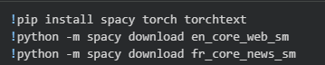
- Custom Vocabulary, Dataset, and collate_fn.
Dataset:
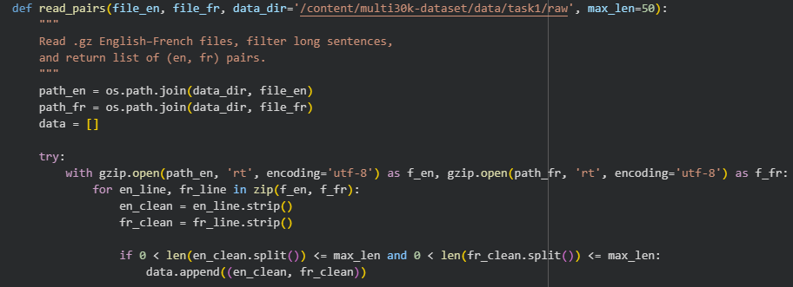
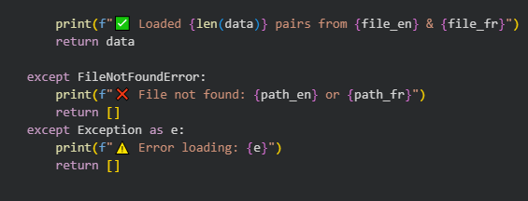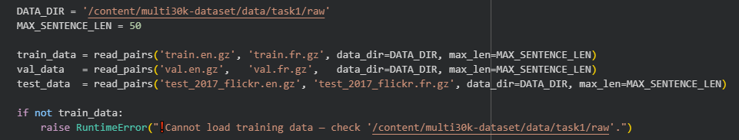
Result:
Vocab:
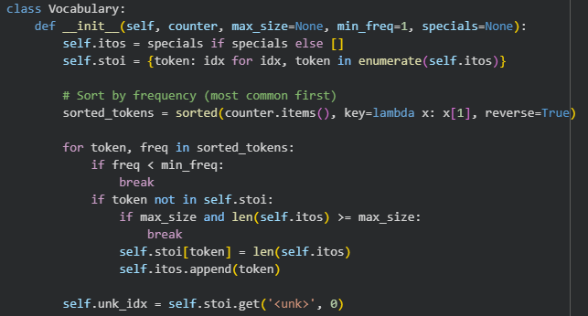
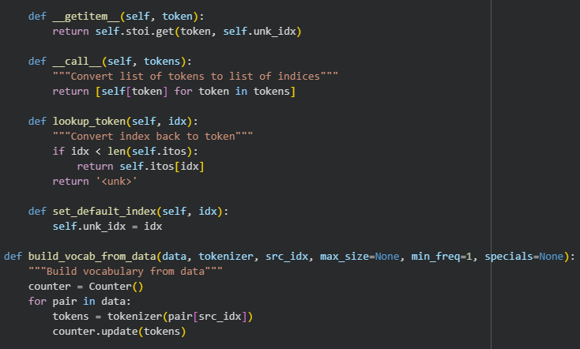
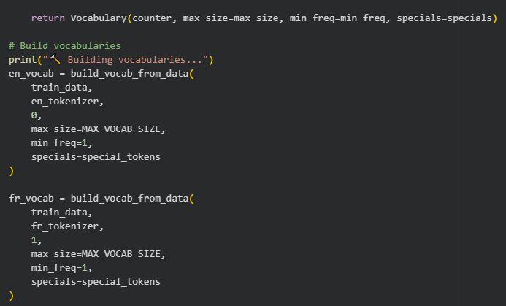
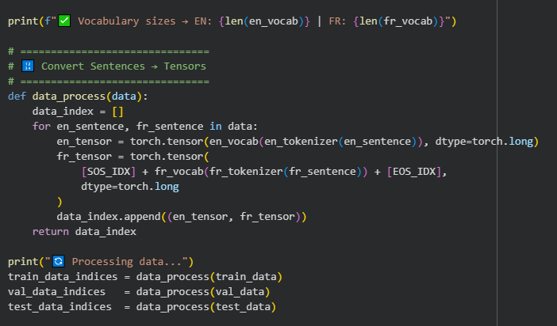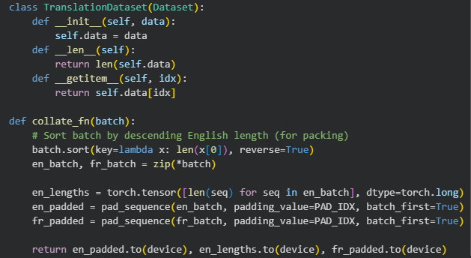
Result:
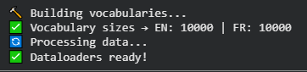
- Encoder and Decoder modules with LSTM and pack_padded_sequence.
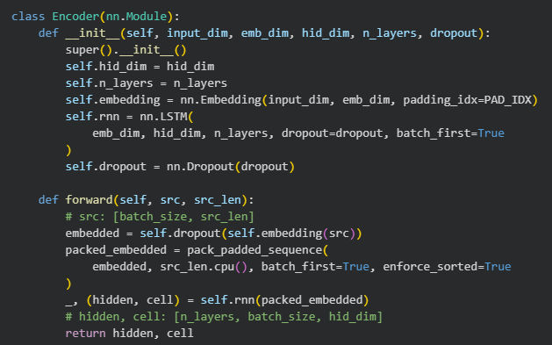
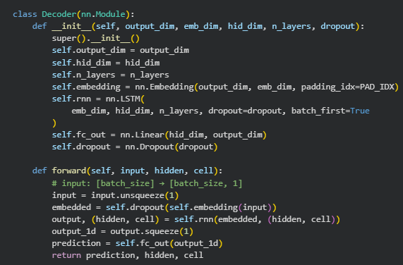
- The Seq2Seq model with Teacher Forcing implementation.
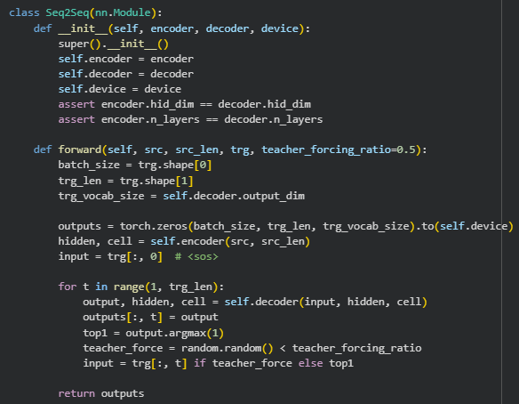
- Training loop with Early Stopping and ReduceLROnPlateau.
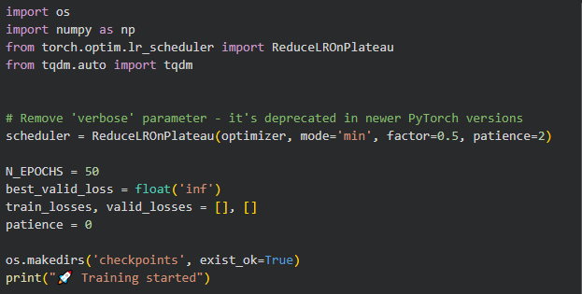
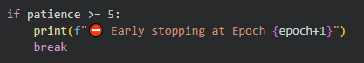
Result:
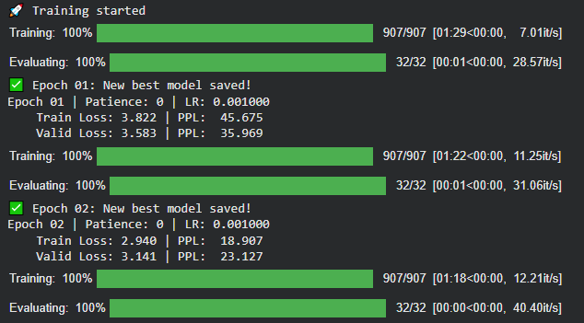
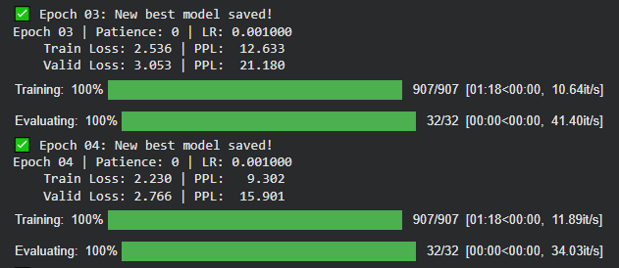
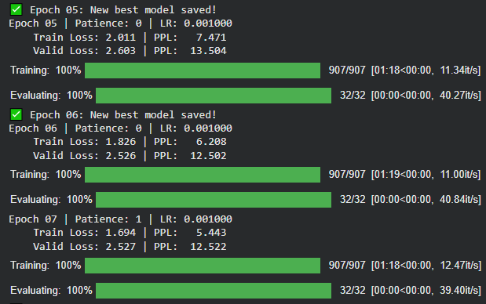
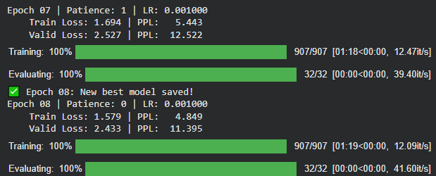
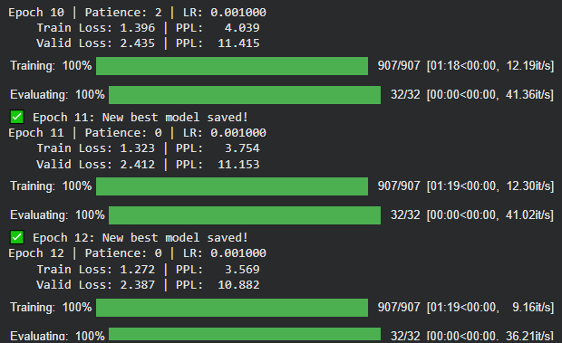
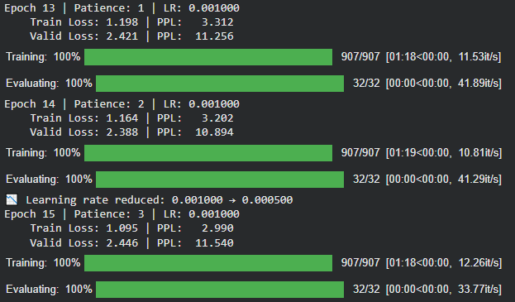
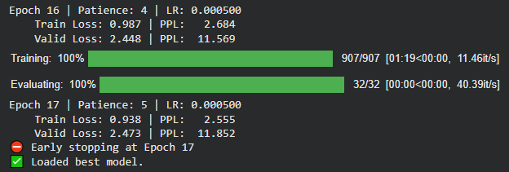
- translate function for inference using Greedy Decoding.
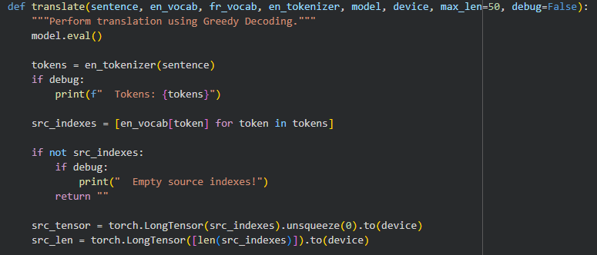
- calculate_bleu_score function for test set evaluation.
