R-Ggplot options

Cheatsheet: <http://zevross.com/blog/2014/08/04/beautiful-plotting-in-r-a-ggplot2-cheatsheet-3>

Reference: <http://ggplot2.tidyverse.org/reference/index.html#>

# plot Air Temperature Data across 2009-2011 using daily data AirTempDaily <- ggplot(harMetDaily.09.11, aes(date, airt)) + geom_point(na.rm=TRUE, color="purple", size=1) + ggtitle("Air Temperature\n 2009-2011\n NEON Harvard Forest") + xlab("Date") + ylab("Air Temperature (C)") # render the plot AirTempDaily

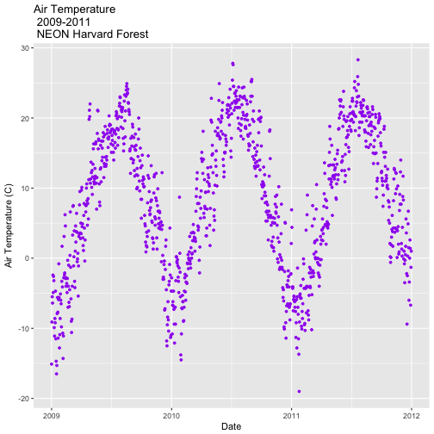

# format x-axis: dates AirTempDaily_1y <- AirTempDaily + (scale_x_date(breaks=date_breaks("1 year"), labels=date_format("%b %y")))

Subset by time

# Define Start and end times for the subset as R objects that are the time class startTime <- as.Date("2011-01-01") endTime <- as.Date("2012-01-01") # create a start and end time R object start.end <- c(startTime,endTime) start.end ## [1] "2011-01-01" "2012-01-01" # View data for 2011 only # We will replot the entire plot as the title has now changed. AirTempDaily_2011 <- ggplot(harMetDaily.09.11, aes(date, airt)) + geom_point(na.rm=TRUE, color="purple", size=1) + ggtitle("Air Temperature\n 2011\n NEON Harvard Forest") + xlab("Date") + ylab("Air Temperature (C)")+ (scale_x_date(limits=start.end, breaks=date_breaks("1 year"), labels=date_format("%b %y")))

Theme

Black and white grid

+ theme_bw()

+ theme_economist()

+ theme_stata()

Plot title

# theme(plot.title) allows to format the Title seperately from other text theme(plot.title = element_text(lineheight=.8, face="bold",size = 20))

## # Trend Lines

# adding on a trend lin using loess AirTempDaily_trend <- AirTempDaily + stat_smooth(colour="green") AirTempDaily_trend ## `geom_smooth()` using method = 'gam'

## 

# note - be sure library(gridExtra) is loaded! # stack plots in one column grid.arrange(AirTempDaily, AirTempMonthly, ncol=1)

