TaskBuddy
Technical Documentation
Prepared by Tony Joseph Sebastian
Architecture, folder structure, API purposes, orchestration, persistence, and testing details.
Document | Technical Documentation
Version | 1.0
Generated | 2026-03-15 22:47 Eastern Daylight Time

Overview
TaskBuddy is a deterministic task workspace built around:
- FastAPI for HTTP APIs and static frontend delivery
- a React client served from backend/static
- LangGraph for staged orchestration
- SQLite for local persistence
- documented, deterministic tool routing
- a generated documentation pack with screenshots, DOCX files, a PPTX deck, and a demo video
The design favors explainability, reproducibility, and a low-friction local setup. The app intentionally avoids external live data sources for the current toolset.

Runtime model
Area | Decision | Purpose
Web server | FastAPI | Single backend entrypoint for APIs and static UI delivery
Frontend delivery | Built React assets served from backend/static | No separate frontend runtime is required
Database | SQLite | Simple local persistence with no extra service
Orchestration | LangGraph around deterministic nodes | Explicit execution stages and traceability
Authentication | JWT cookie session | Lightweight local auth without token copy/paste
App runtime dependencies | requirements.txt in .venv | Keeps the normal runtime isolated
Documentation-pack dependencies | requirements-review-pack.txt in .review-pack-venv | Keeps DOCX, Playwright, and video tooling away from the app runtime

Architecture
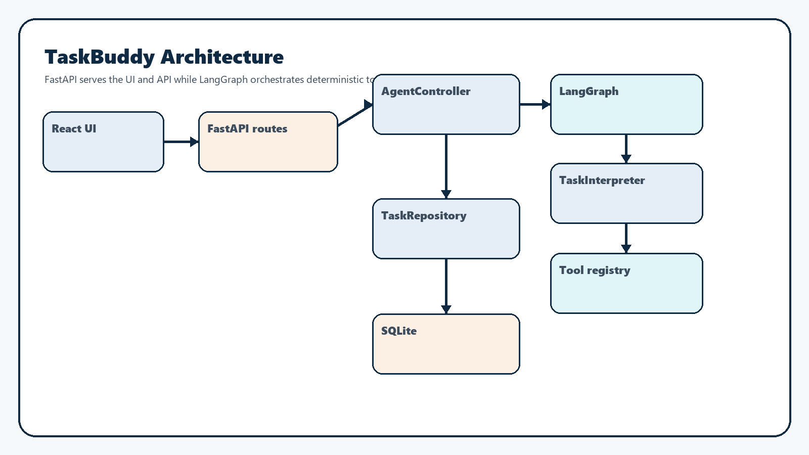
Architecture overview

Ownership model
Component | Responsibility
React UI | Sign-in flow, route changes, thread history, pending turn rendering, auto-scroll, and admin screen
FastAPI routes | Request validation, auth checks, thread CRUD, synchronous task execution, and SSE streaming
AgentController | Stable execution facade exposed to the API layer
LangGraph state graph | Validation, planning, tool execution, retry handling, and response assembly
TaskInterpreter | Deterministic prompt parsing, subtask splitting, and tool-step planning
Tool registry | Execution for the five supported tool families
TaskRepository | SQLite schema setup, seeding, persistence, limits, and lookups

Browser and API flow
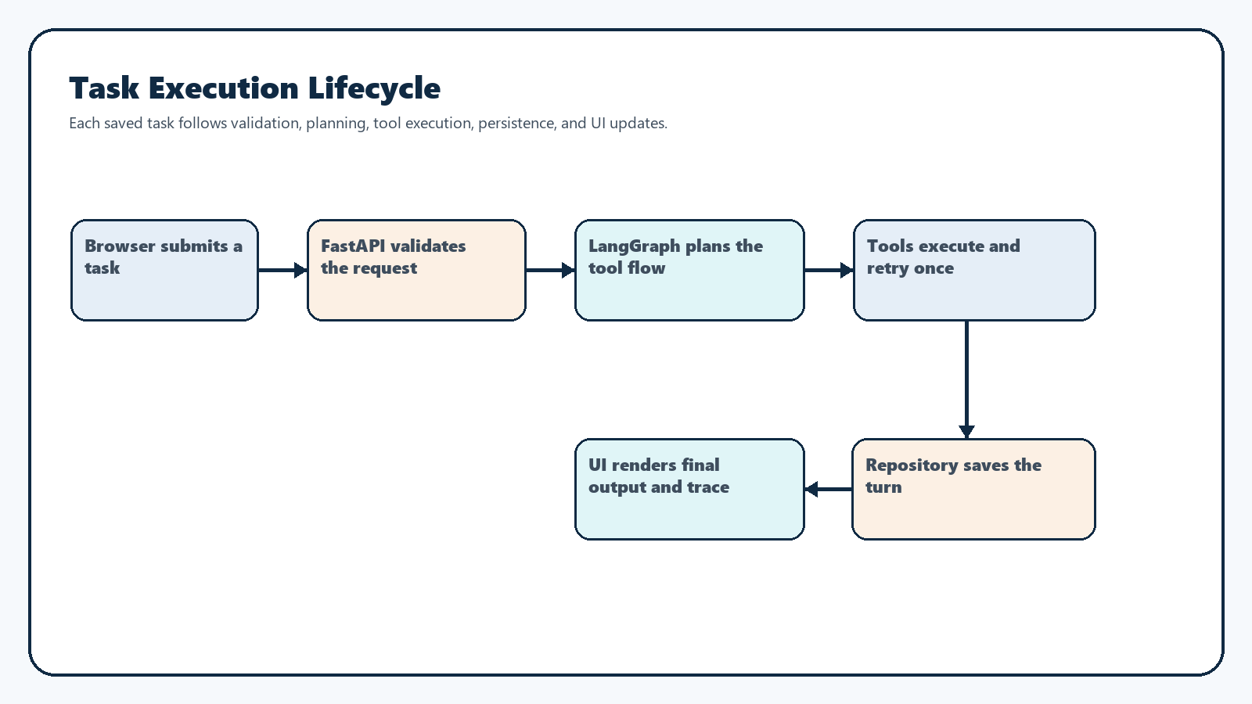
Request lifecycle

Browser routes
Route | Purpose | Access
/ | Workspace home with no thread preselected | Authenticated
/threads/:threadId | Selected chat thread | Authenticated
/admin | User-management page | Admin only

API endpoint catalog
Method | Path | Access | Purpose | Request summary | Response summary
POST | /api/v1/auth/login | Public | Validate credentials and create the session cookie | Username and password | user_id, username, role
POST | /api/v1/auth/logout | Public | Clear the session cookie | No body required | { "status": "ok" }
GET | /api/v1/auth/me | Authenticated | Return the signed-in account summary | Cookie session | user_id, username, role
GET | /api/v1/threads | Authenticated | List thread summaries and optional search results | Optional search query | Array of thread summaries
POST | /api/v1/threads | Authenticated | Create a new empty chat thread | No body required | Thread detail payload
GET | /api/v1/threads/{thread_id} | Authenticated | Return one thread and its saved turns | Thread id path parameter | Thread detail payload
DELETE | /api/v1/threads/{thread_id} | Authenticated | Delete a thread owned by the current user | Thread id path parameter | 204 No Content
POST | /api/v1/threads/{thread_id}/tasks | Authenticated | Run a task synchronously and persist the completed turn | task_text | Saved turn payload
POST | /api/v1/threads/{thread_id}/tasks/stream | Authenticated | Run a task through SSE and persist the completed turn | task_text | SSE run_started, trace_step, retry_scheduled, completed, failed
GET | /api/v1/admin/users | Admin only | List local users without passwords | Cookie session | Array of user summaries
POST | /api/v1/admin/users | Admin only | Create a local user | Username, password, role | User summary
DELETE | /api/v1/admin/users/{user_id} | Admin only | Delete a local user except the current admin session | User id path parameter | 204 No Content
GET | /health | Public | Return basic health status | No body required | { "status": "ok" }

Task-execution endpoints
Endpoint | Purpose | When to use it
POST /api/v1/threads/{thread_id}/tasks | Standard request/response task execution | Simple integrations, direct API testing, and non-streaming clients
POST /api/v1/threads/{thread_id}/tasks/stream | Streaming task execution with progressive trace events | Browser UX, live trace visibility, and SSE-oriented demos

LangGraph orchestration
Node | Responsibility | Output
validation | Normalize text, apply safety checks, and reject invalid requests early | Sanitized text and validation trace step
planning | Build the deterministic tool plan | One or two tool steps plus planning trace step
execute_tool | Run each tool in order, with retry metadata where applicable | Tool result data and execution trace step
issue_response | Build a handled failure or unsupported response | User-facing issue payload
response_assembly | Build final output, structured payload, tools-used list, and saved turn shape | Completed TurnExecution

State carried through the graph
- original task text
- sanitized task text
- parsed steps
- current tool index
- retry metadata
- prior summary context for chained text and result transforms
- collected result data
- ordered trace steps
- handled issue details
- final turn payload

Tool catalog
Tool | Purpose | Main routing cues | Dependencies | Known limits
TextProcessorTool | Case transforms and counts | convert, make, title case, count words, count characters | Internal string parsing only | Occurrence counting inside larger text is unsupported
CalculatorTool | Safe arithmetic evaluation | calculate, what is, add, minus, times, divide, quotient, product | Internal parser only | Arithmetic only; no variables or functions
WeatherMockTool | Deterministic weather summaries | weather, forecast, temperature, condition, humidity with a supported city | Mock city data from config | Supported cities only
CurrencyConverterTool | Fixed-rate currency conversion | convert, exchange, currency, rate, explicit amount/currency pairs | Mock exchange-rate table | Only USD, CAD, GBP, and AUD are supported
TransactionCategorizerTool | Keyword-based category mapping | categorize, classify, transaction, spend, merchant | Keyword mapping table | Unmatched descriptions fall back to other

Routing rules worth noting
- quoted text is protected from false multi-subtask splitting
- add 3+2 and what is 8 minus 3 both route to the calculator
- count the word "test" is treated as a word-count request over the provided text
- Categorize Starbucks transaction 45 CAD stays on the categorizer
- Categorize Starbucks transaction 45 CAD and convert to USD creates a two-tool finance flow
- Convert 67 CAD to INR routes to the converter and returns a handled CURRENCY_NOT_SUPPORTED response

Persistence design
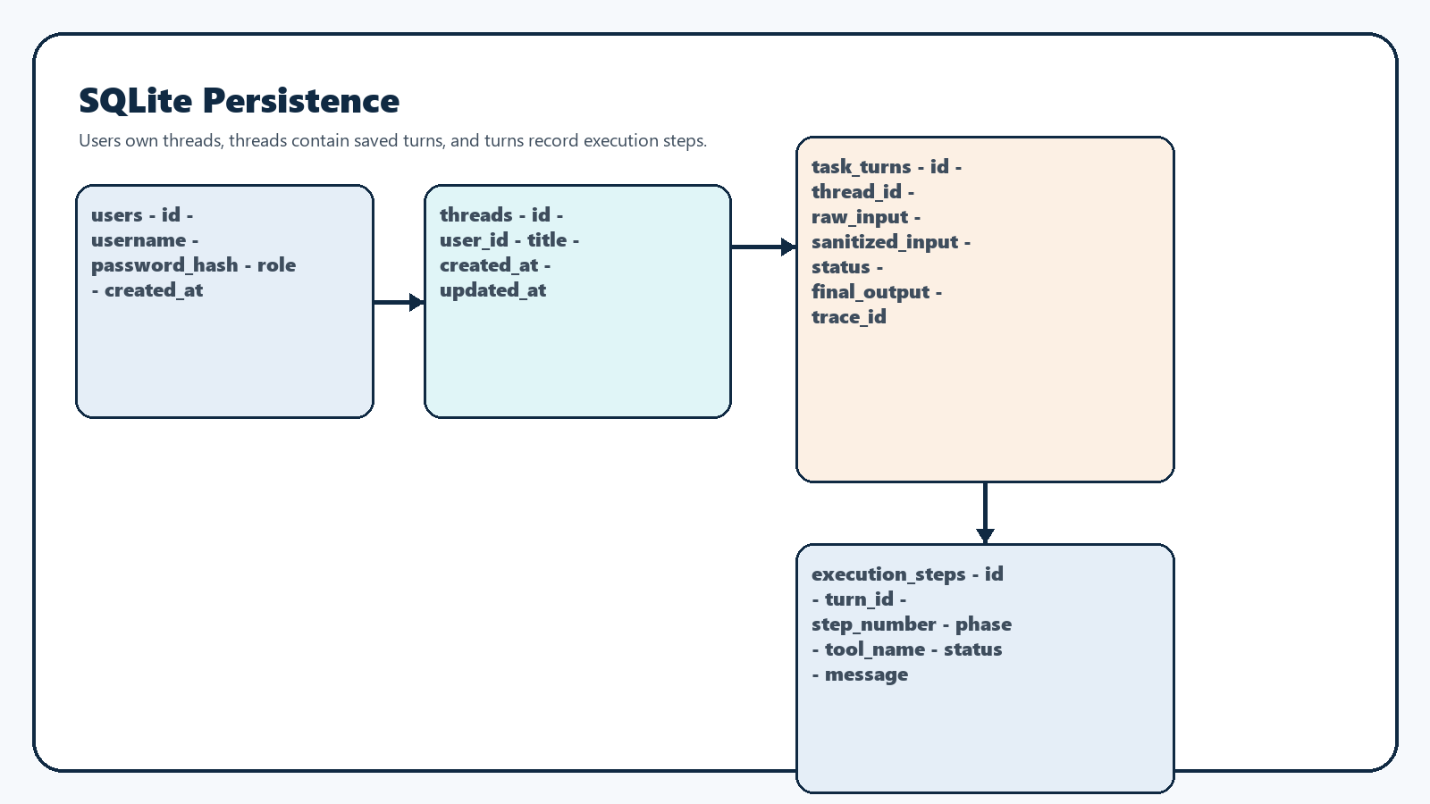
Database schema

Persistence behavior
Area | Behavior
User bootstrap | Fresh initialization seeds only admin / admin123
Thread titles | The first saved task becomes the thread title, trimmed to the configured limit
Turn history | Each saved turn includes task text, final output, output payload, tools used, trace steps, timestamp, and trace ID
Limits | The repository enforces max threads per user, max saved flows per thread, and role capacity
Sensitive handling | Sanitized text is stored when the safety layer changes the original input

Authentication and session model
Decision | Why it was chosen
JWT cookie session | Works well for a single FastAPI-served UI without manual token handling
PBKDF2 + salt | Keeps local passwords hashed and non-recoverable
Admin-only user APIs | Protects user creation and deletion behind role checks
Session-only password reveal | Allows visibility for newly created users without persisting recoverable passwords

Validation and limits
Limit | Value | Enforcement point
Request length | 250 characters | Safety guard and UI validation
Subtasks per request | 2 | Interpreter and composer validation
Threads per user | 5 | Repository and UI blocking
Saved task flows per thread | 3 | Repository and composer blocking
Admin accounts | 1 | Repository
Standard user accounts | 2 | Repository

Folder structure
Path | Purpose
backend/ | FastAPI app, orchestration, persistence, tools, and schemas
frontend/ | React source, tests, and Vite config
docs/ | User guide, technical content, manual test plan, demo script, and generated pack output
scripts/ | Runtime helpers, report export, and documentation-pack generation
tests/ | Backend unit and integration coverage plus metadata for export reports
reports/ | Generated JUnit XML, Excel summaries, and HTML dashboards

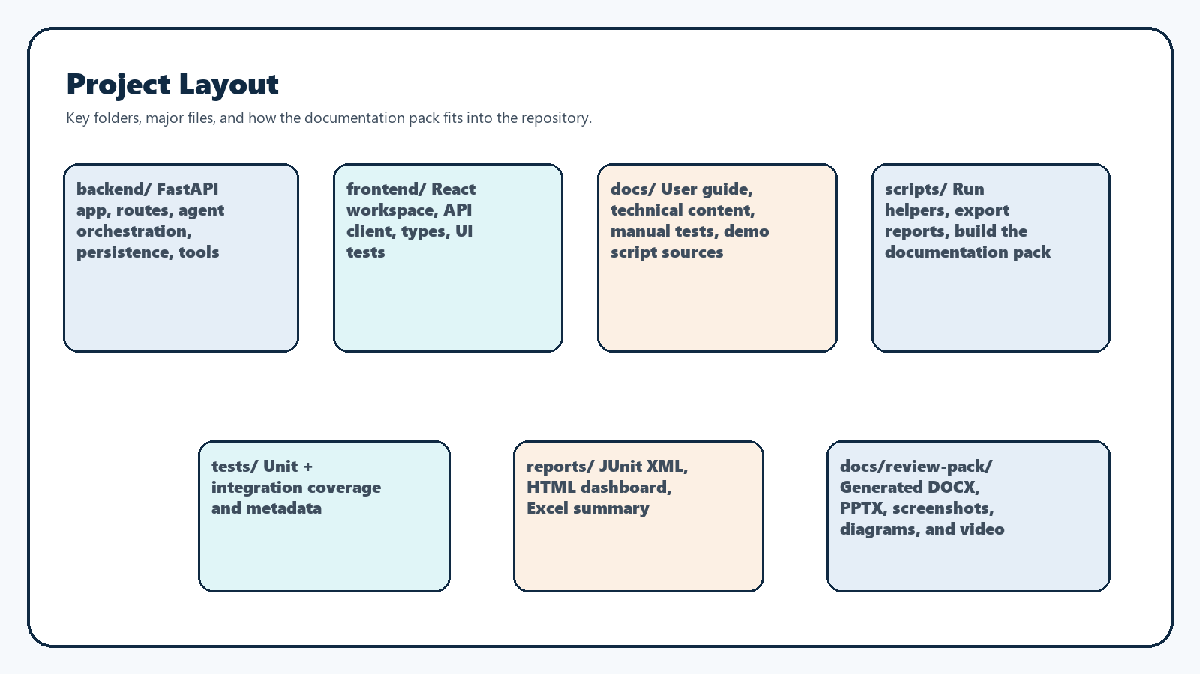
Project layout

Source-focused file inventory

Backend Python files
File | Purpose
backend/app.py | Creates the FastAPI app, registers exception handlers, mounts static assets, and exposes the health route
backend/config.py | Central constants, limits, demo data, and paths
backend/errors.py | App-specific error classes used for handled API and tool failures
backend/models.py | Dataclasses for parsed tasks, tool results, turns, threads, and users
backend/security.py | Password hashing, verification, and JWT helpers
backend/api/routes.py | REST and SSE endpoints plus auth dependencies
backend/agent/controller.py | API-facing execution facade around LangGraph orchestration
backend/agent/interpreter.py | Deterministic prompt parsing, subtask splitting, and tool planning
backend/agent/state_graph.py | LangGraph state definition and node wiring
backend/persistence/repository.py | SQLite schema setup, CRUD, seeding, and limit enforcement
backend/safety/guard.py | Input-length checks and sanitization helpers
backend/schemas/api.py | Pydantic request and response models
backend/tools/base.py | Shared tool contract
backend/tools/text_processor.py | Text tool implementation
backend/tools/calculator.py | Calculator implementation
backend/tools/weather_mock.py | Mock weather implementation
backend/tools/currency_converter.py | Currency conversion implementation
backend/tools/transaction_categorizer.py | Transaction categorization implementation

Frontend TypeScript files
File | Purpose
frontend/src/main.tsx | React entrypoint
frontend/src/App.tsx | Main application shell, route handling, workspace flow, admin page, and composer behavior
frontend/src/App.test.tsx | Frontend interaction, routing, and regression tests
frontend/src/api.ts | Browser API helpers for auth, threads, tasks, and admin routes
frontend/src/types.ts | Shared frontend response and event types
frontend/src/setupTests.ts | Vitest and DOM test setup
frontend/src/components/BrandMark.tsx | Reusable TaskBuddy mark component

Scripts, docs, and tests
File | Purpose
app.py | Root run entrypoint that delegates to backend.app.run()
scripts/run-taskbuddy.ps1 | Windows one-command launcher for the app runtime
scripts/run-taskbuddy.sh | Linux, macOS, WSL, or Git Bash launcher for the app runtime
scripts/build-review-pack.ps1 | Windows builder for the documentation pack with separate environments
scripts/build-review-pack.sh | POSIX shell builder for the documentation pack with separate environments
scripts/generate_review_pack.py | Screenshot capture, DOCX generation, PPTX generation, and video assembly
scripts/export_test_results.py | JUnit-to-Excel and HTML report export
README.md | Project overview and runtime instructions
docs/user-guide.md | Source content for the user guide DOCX
docs/manual-test-plan.md | Source content for the manual test plan DOCX
docs/demo-script.md | Source narration for the deck and demo video
tests/integration/test_api.py | Backend API integration coverage
tests/unit/test_agent.py | Interpreter, controller, and repository coverage
tests/unit/test_tools.py | Tool execution unit coverage
tests/unit/test_safety.py | Safety-guard coverage
tests/unit/test_reports.py | Report-export validation

Documentation-pack generation
Area | Behavior
Runtime isolation | .venv uses requirements.txt only
Documentation isolation | .review-pack-venv uses requirements-review-pack.txt only
Screenshot capture | Playwright drives the running app and stores PNGs under docs/review-pack/screenshots/
DOCX generation | python-docx renders the markdown sources into branded documents
PPTX generation | python-pptx builds the widescreen demo deck and speaker notes
Narration | pyttsx3 runs first, gTTS is the fallback, and silent video is the last fallback
Video output | moviepy assembles slide images and narration into TaskBuddy-Demo.mp4

Testing and reporting
Area | Coverage
Backend unit tests | Interpreter routing, controller behavior, retry handling, repository limits, and tool behavior
Backend integration tests | Auth, thread CRUD, sync tasks, streaming tasks, and handled failures
Frontend tests | Login flow, route changes, thread limits, task-flow limits, auto-scroll, and admin interactions
Reports | Backend JUnit XML, frontend JUnit XML, Excel summary, HTML dashboard, and the generated documentation pack

Design tradeoffs
- FastAPI serves the built frontend to keep local runtime simple.
- Deterministic tool routing is favored over opaque model reasoning so behavior stays testable and explainable.
- Mock weather and currency data keep the challenge self-contained and reproducible.
- SQLite is sufficient for a local workflow and easy artifact sharing.
- The current React app still concentrates a large amount of UI logic in App.tsx; that is a maintainability tradeoff, not a functional blocker.
- The documentation pack uses a separate environment because presentation tooling should never interfere with the app runtime.

