TaskBuddy
User Guide
Prepared by Tony Joseph Sebastian
Setup instructions, core workflows, response interpretation, and troubleshooting guidance.
Document | User Guide
Version | 1.0
Generated | 2026-03-15 22:47 Eastern Daylight Time

Purpose
This guide explains how to access TaskBuddy, sign in, create and manage chats, understand response cards, and use the admin page.

What TaskBuddy does
TaskBuddy is a chat-style workspace for deterministic tool execution. A signed-in user can submit a supported prompt, see which tool ran, inspect the final output, and review the saved execution trace later.

Roles
Role | Access
admin | Can sign in, create threads, run tasks, inspect saved history, open the admin page, and create or delete local users.
user | Can sign in, create threads, run tasks, and inspect saved task history.

How to access the app

Local: one command
Windows PowerShell:
powershell -ExecutionPolicy Bypass -File .\scripts\run-taskbuddy.ps1
Linux, macOS, WSL, or Git Bash:
./scripts/run-taskbuddy.sh
Open http://localhost:8000.

Docker Compose
docker compose up --build
Open http://localhost:8000.

Default sign-in
Username | Password | Role
admin | admin123 | admin

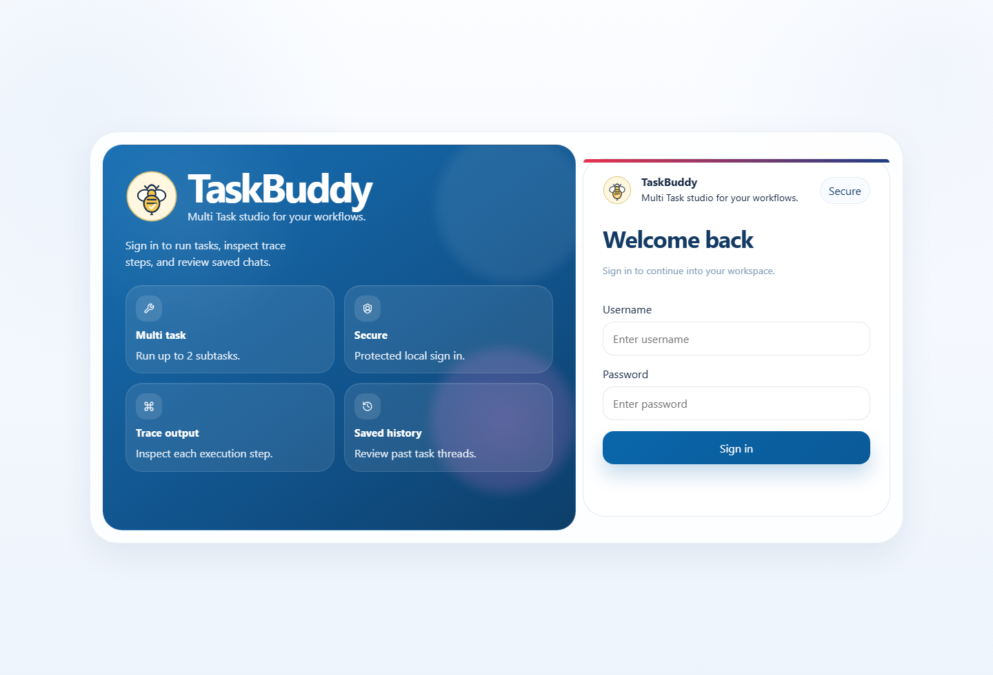
Login page

Workspace overview
After sign-in, TaskBuddy opens the main workspace. The workspace includes:
- a thread history sidebar
- a workspace home state or selected chat thread
- a composer for supported tasks
- response cards that show final output, tools used, structured output, and trace steps
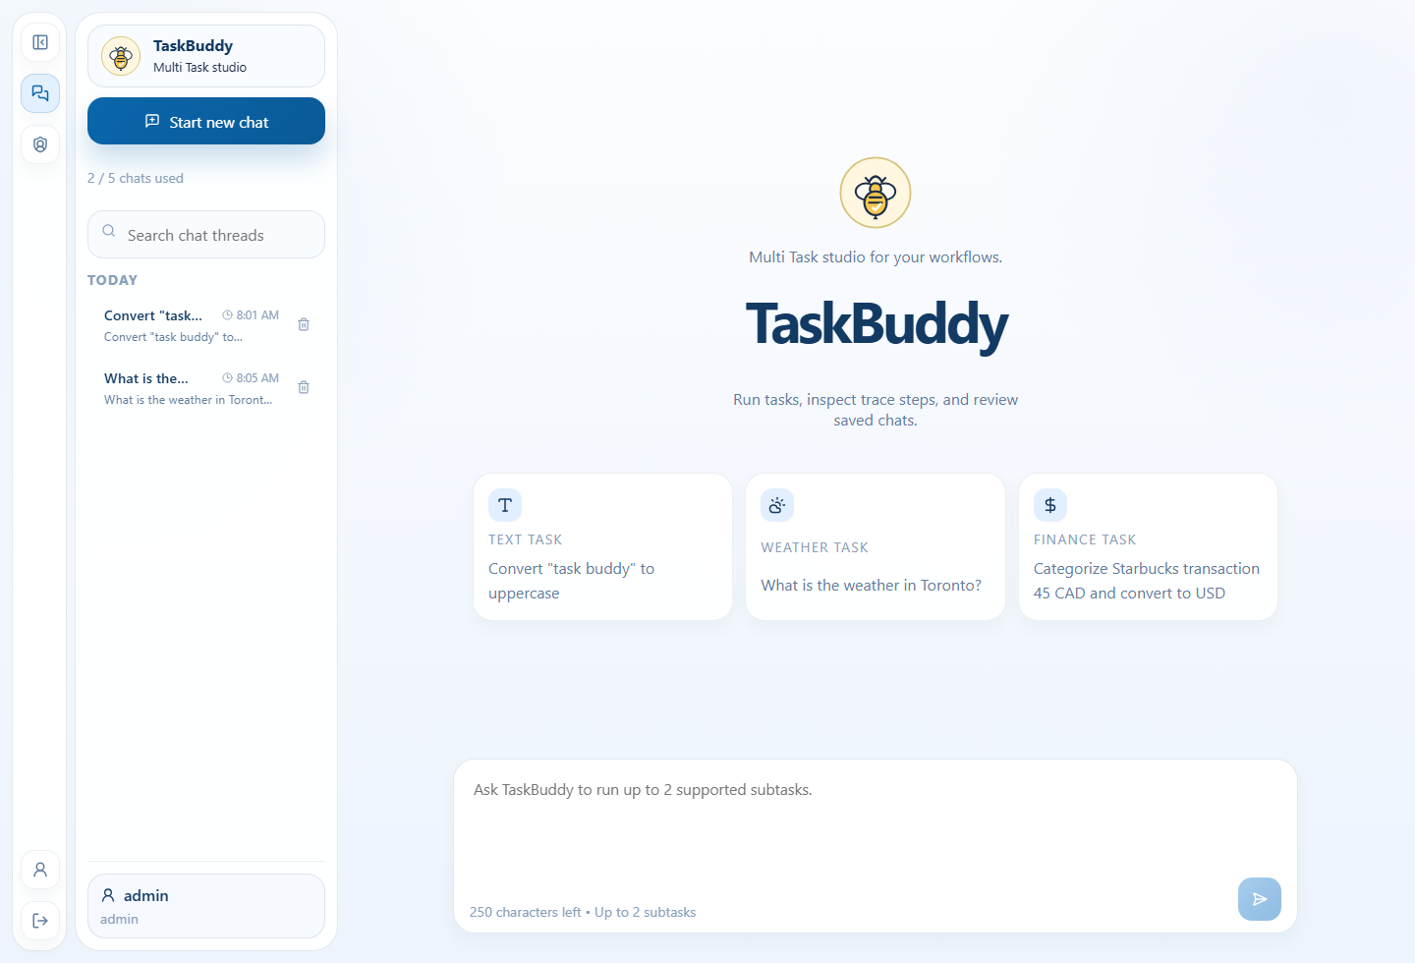
Workspace home

Creating and managing chats
- Select Start new chat.
- Enter a supported prompt in the composer.
- Submit with Run task.
- Review the completed result inside the active thread.
- Reopen or delete older chats from the sidebar when needed.

Chat and flow limits
- each user can keep up to 5 chat threads
- each chat can keep up to 3 saved task flows
- each request can include up to 2 subtasks

Running supported tasks
TaskBuddy supports five tool families.
Tool | What it does | Example prompt
TextProcessorTool | Converts case or counts words and characters. | Convert "task buddy" to uppercase
CalculatorTool | Solves arithmetic expressions without eval. | Add 3+2
WeatherMockTool | Returns deterministic weather data for supported cities. | Forecast for London
CurrencyConverterTool | Converts supported currencies using fixed mock rates. | Exchange 15 USD to CAD
TransactionCategorizerTool | Categorizes merchant and spend descriptions. | Categorize Starbucks transaction 45 CAD

Reading the response card
Each completed turn shows the information in this order:
- final output
- tools used
- structured output data
- execution trace
- timestamp and trace ID
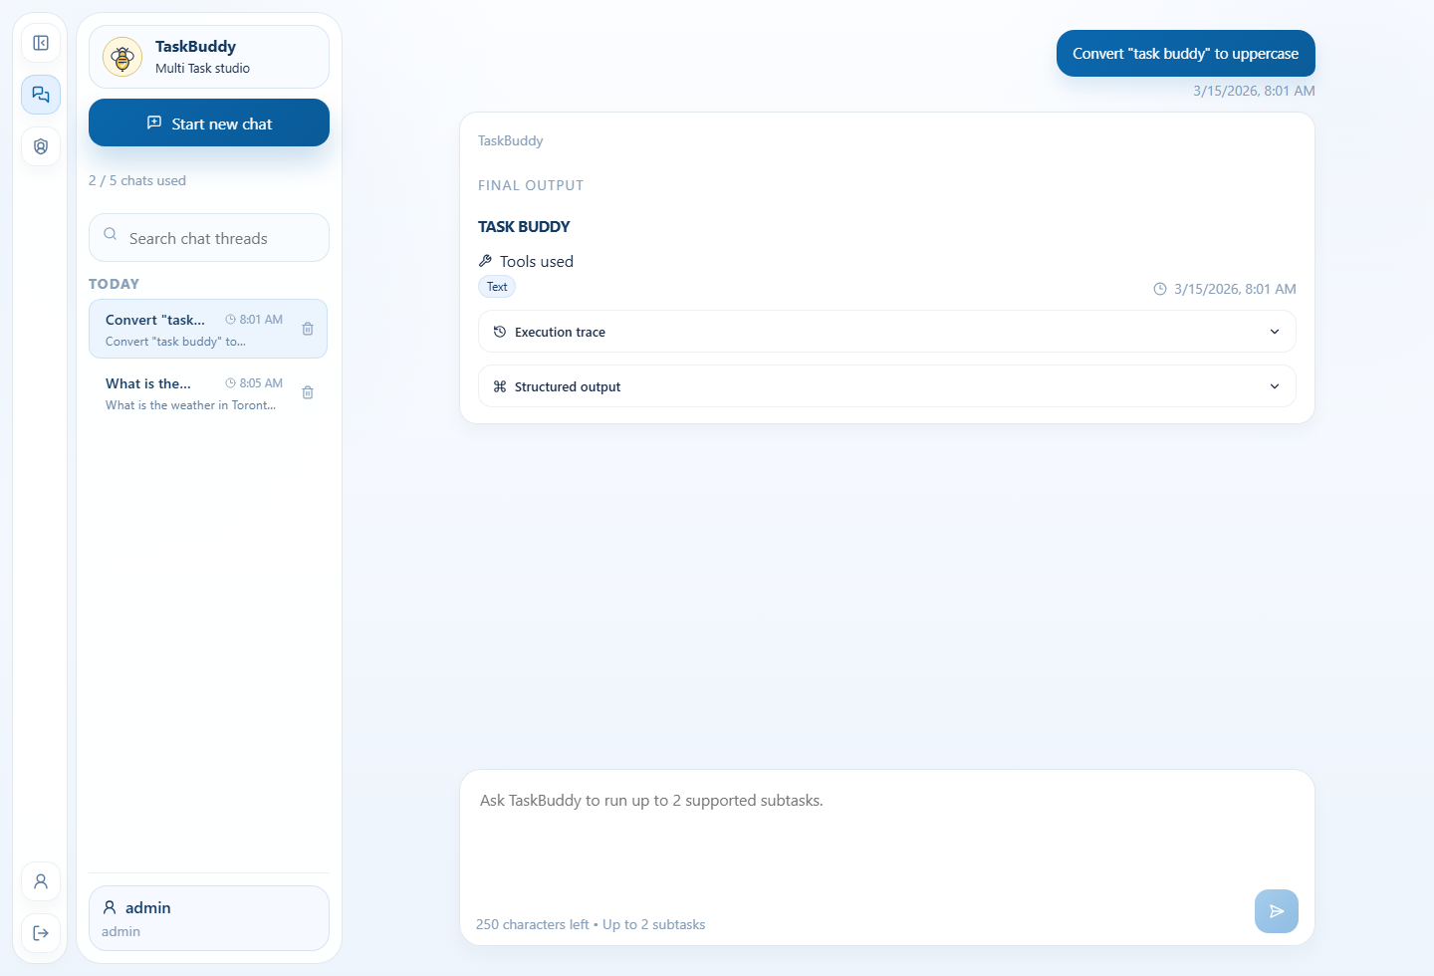
Completed text task

Multi-tool responses
If a request triggers two supported tools, TaskBuddy returns both results in numbered order and records both steps in the trace.
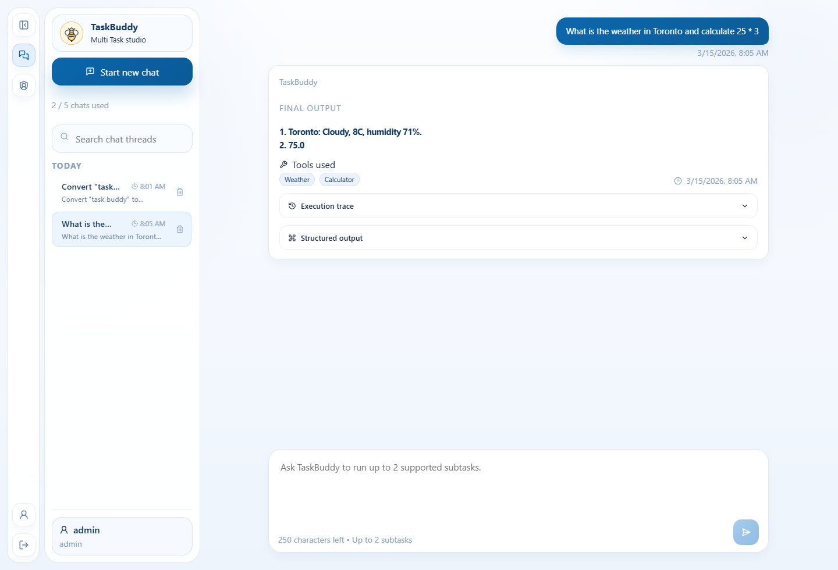
Multi-tool trace

Admin page
The admin page is available only to the admin role.
From the admin page you can:
- create local users
- delete local users
- review usernames, roles, and created timestamps
- reveal the password only for users created during the current admin session
Rules:
- only 1 admin account is allowed
- only 2 standard users are allowed
- passwords remain hashed in the database
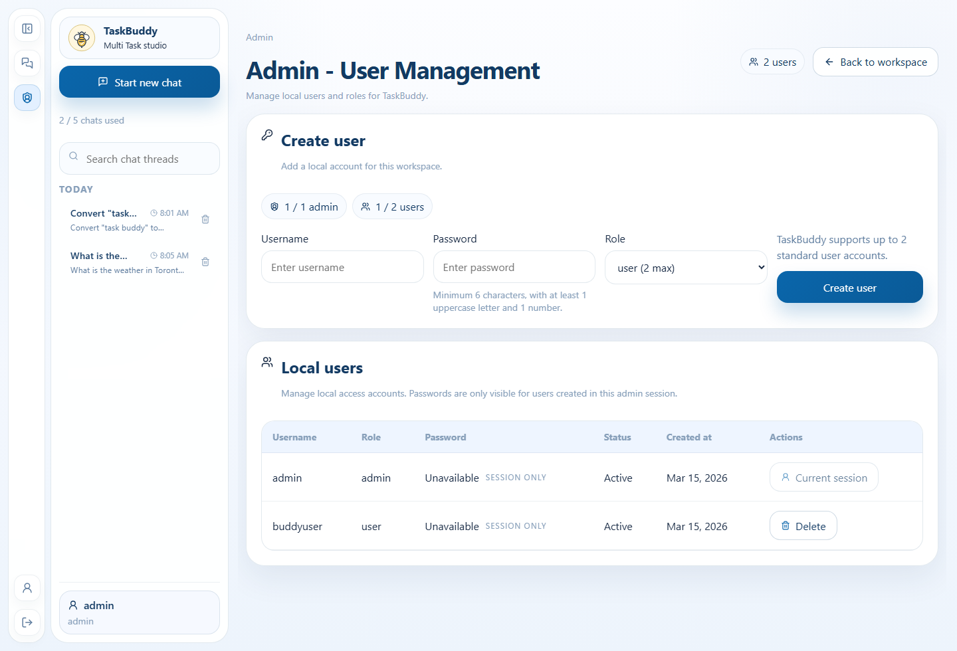
Admin page

Validation and troubleshooting
TaskBuddy shows inline validation when the browser can detect the issue before sending the request.
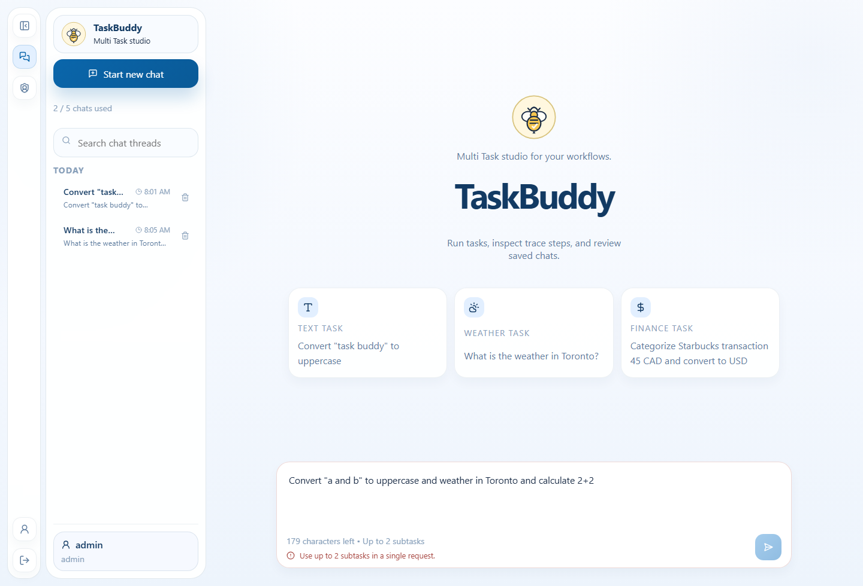
Validation example
Symptom | Likely cause | What to do
Login fails | Wrong username or password | Use admin / admin123 on a fresh database or create a user from the admin page.
A request is rejected as too complex | The prompt has more than 2 subtasks | Split the work into multiple requests.
A chat cannot accept a new task | The thread already has 3 saved task flows | Create a new chat or delete an older one.
Currency conversion fails | Unsupported target currency such as INR | Use USD, CAD, GBP, or AUD.
Weather prompt fails | Unsupported city | Use Toronto, Vancouver, New York, Chicago, London, or Sydney.
The password eye icon is unavailable for a row | The user was not created in the current admin session | Passwords are intentionally not recoverable from storage.

Quick verification checklist
- Sign in with the admin account.
- Create one text-processing chat and one multi-tool chat.
- Confirm that the response card shows final output first and trace details afterward.
- Open the admin page and review user-management controls.
- Confirm that thread and task-flow limits are enforced with clear messages.

