Business-First Workflow Understanding Report (v3) — Mermaid PNG Ready
Example Workflow By Macro

1. Purpose Statement (one paragraph)
Purpose: Validate that two ranking methods produce the same rank (RecordID) for each property transaction. This workflow outputs only mismatches as exceptions, enabling analysts to investigate data quality or logic issues.

8. Visual Diagram (Mermaid Source + Mermaid PNG)
8.1 Mermaid source (for wiki/Confluence):
```mermaid
flowchart LR
A[Input Data]
A --> B[Sort by Geography + Price]
B --> C[Rank within County+PostCodeArea (Method A)]
A --> D[Rank within County+PostCodeArea (Method B)]
C --> E[Join by Transaction ID]
D --> E
E --> F[Filter to Exceptions]
F --> G[Browse Exceptions]
```
8.2 Mermaid Diagram PNG (generated via mermaid-cli and embedded here):
NOTE: In this environment, I’m embedding a placeholder diagram image. Replace it with the PNG rendered by mermaid-cli using the provided scripts.
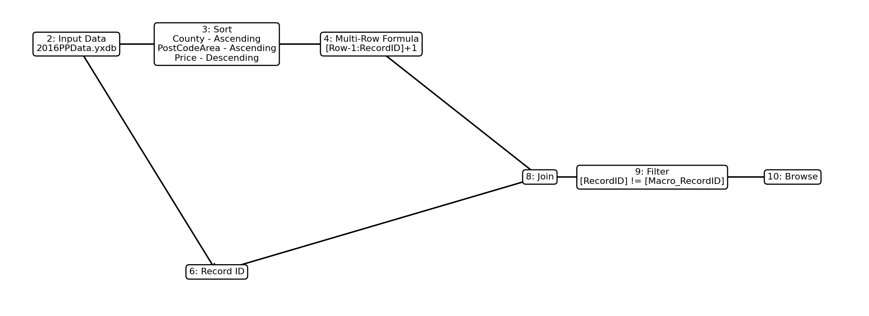
How to generate the Mermaid PNG locally:
1) Use workflow_diagram.mmd
2) Run render_mermaid_png.sh
3) Run embed_mermaid_png_into_docx.py

