which anaconda

/anaconda/bin/anaconda --version # anaconda Command line client (version 1.5.1)

which python

/anaconda/bin/python --version # Python 2.7.12 :: Anaconda 4.2.0 (x86_64)

sudo find / -name jupyter

which jupyter

/anaconda/bin/jupyter --version # 4.2.0

Jupyter notebook（又称IPython notebook）是一个交互式的笔记本，支持运行超过40种编程语言。它可用来创造优美的可交互式文档和教育资源。

# 如何启动jupyter

# 在Linux终端(或Mac OS terminal)运行命令

localhost:~ tonykidkid$ jupyter notebook

[I 23:22:39.702 NotebookApp] [nb_conda_kernels] enabled, 2 kernels found

[I 23:22:41.807 NotebookApp] ✓ nbpresent HTML export ENABLED

[W 23:22:41.807 NotebookApp] ✗ nbpresent PDF export DISABLED: No module named nbbrowserpdf.exporters.pdf

[I 23:22:41.833 NotebookApp] [nb_conda] enabled

[I 23:22:42.101 NotebookApp] [nb_anacondacloud] enabled

[I 23:22:42.116 NotebookApp] Serving notebooks from local directory: /Users/tonykidkid

[I 23:22:42.117 NotebookApp] 0 active kernels

[I 23:22:42.117 NotebookApp] The Jupyter Notebook is running at: http://localhost:8888/

[I 23:22:42.117 NotebookApp] Use Control-C to stop this server and shut down all kernels (twice to skip confirmation).

(按照上面命令行提示，访问本机的URL链接即可 <http://localhost:8888/tree>)

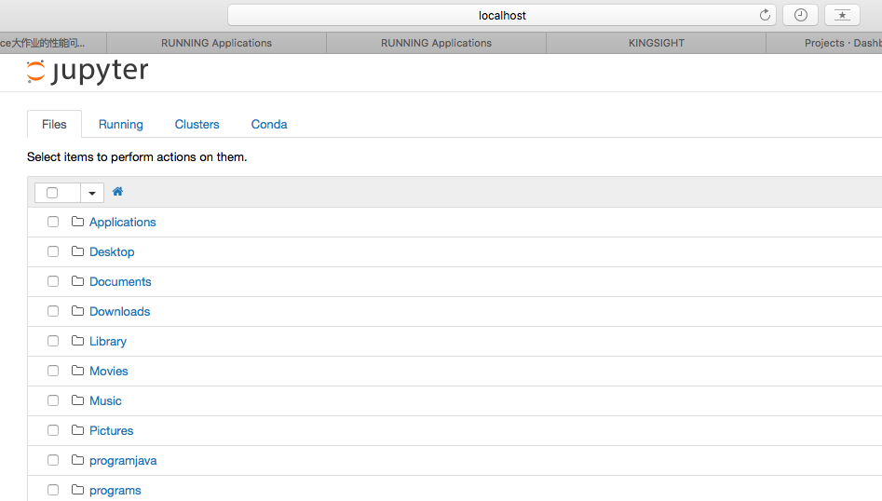

Jupyter notebook（又称IPython notebook）是一个交互式的笔记本。推荐使用Anaconda，因为Anaconda自带了Numpy、Scipy、Matplotlib等多种python开发包和Jupyter notebook。

[开始] 在所有cell之前添加标题、run all运行所有代码

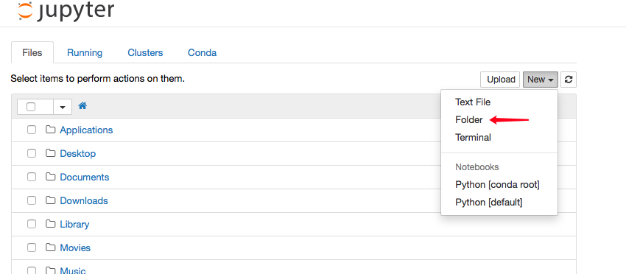

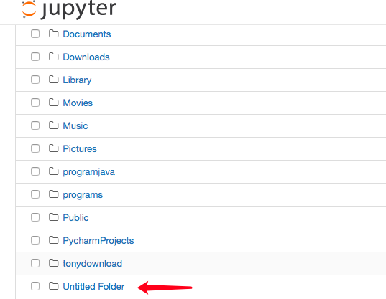

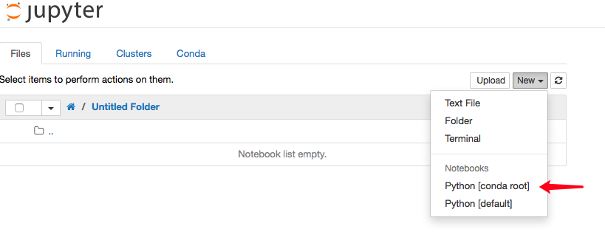

之后开始使用conda环境的命令行

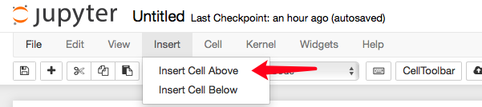

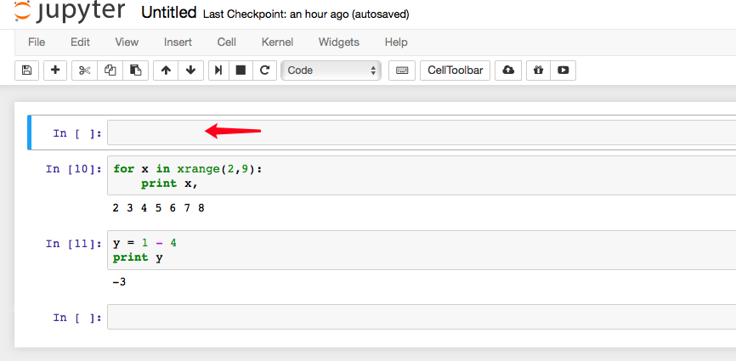

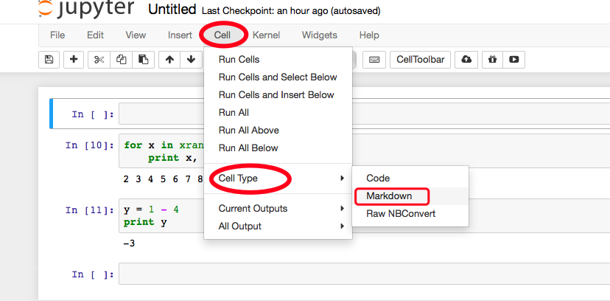

[已选中MarkDown]

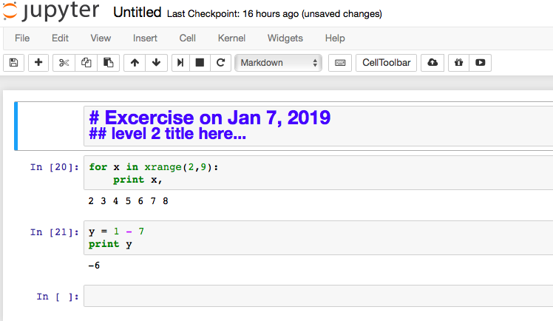

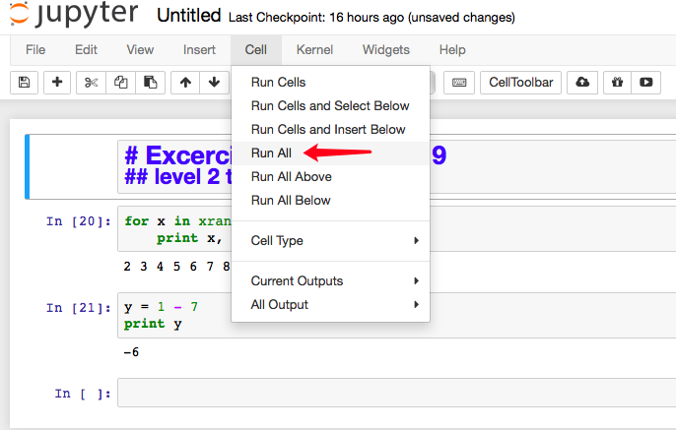

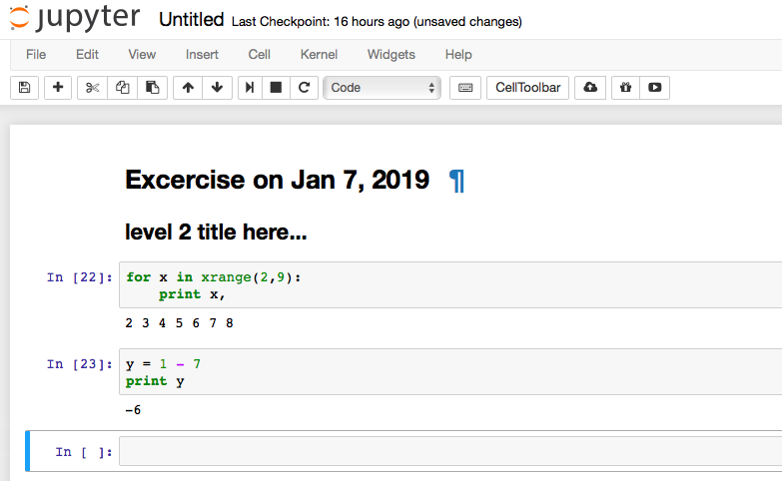

[完成] 添加一级标题后run all运行所有cell中的代码

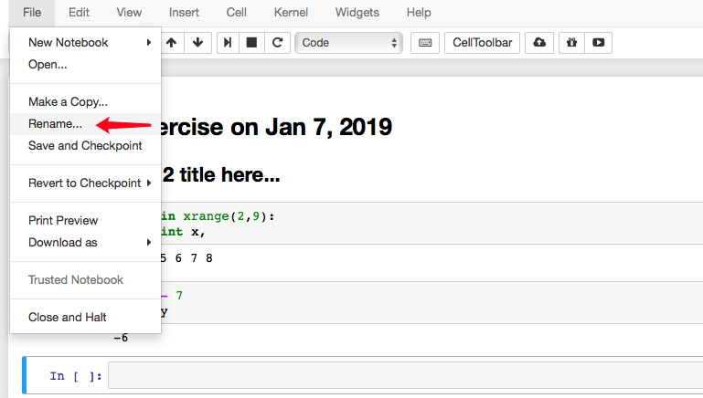

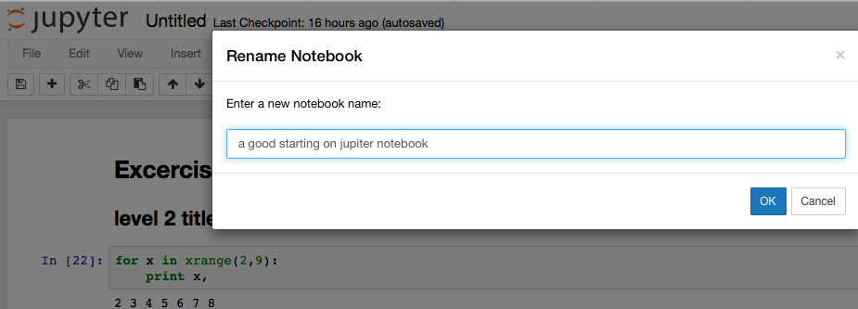

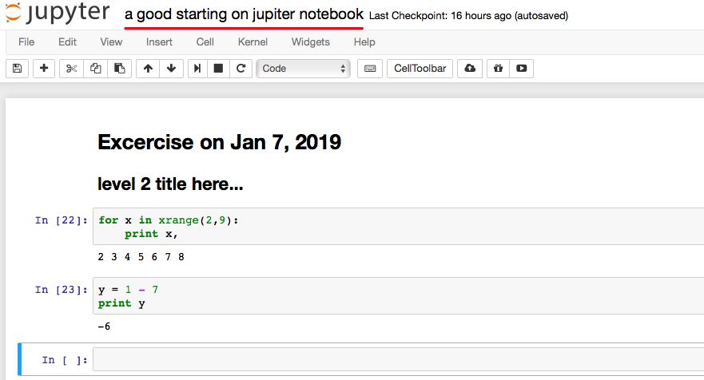

------------more usage at Jupyter----------

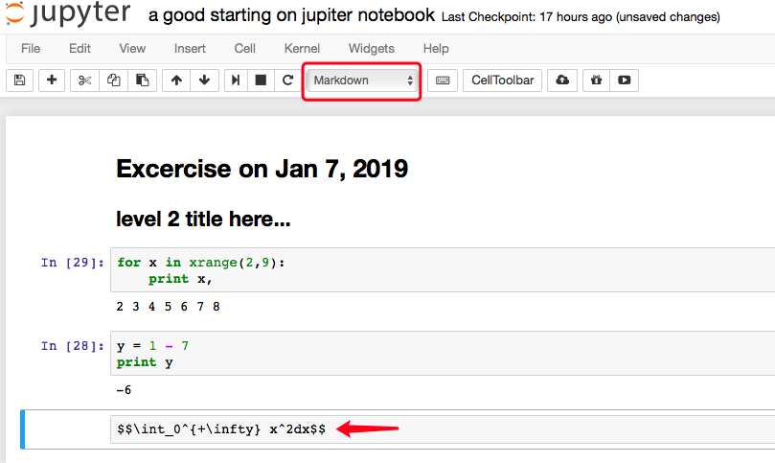

after running as “shift + return”:

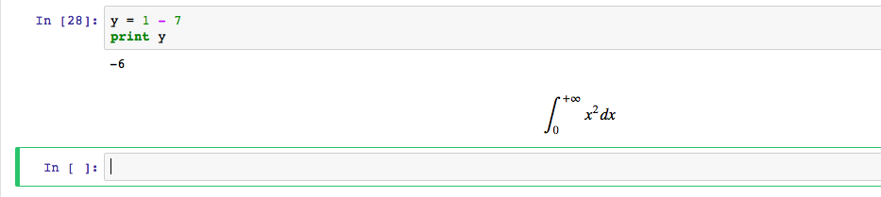

[画图]

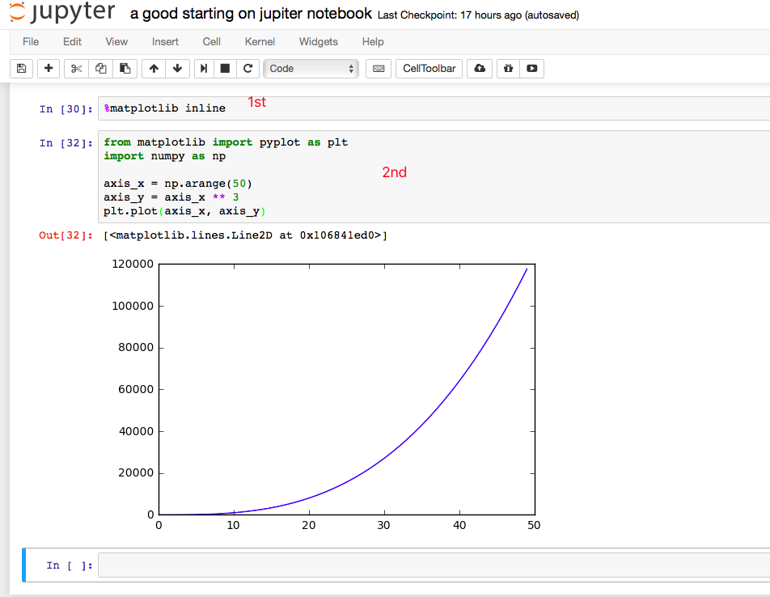

导出刚才的整个notebook

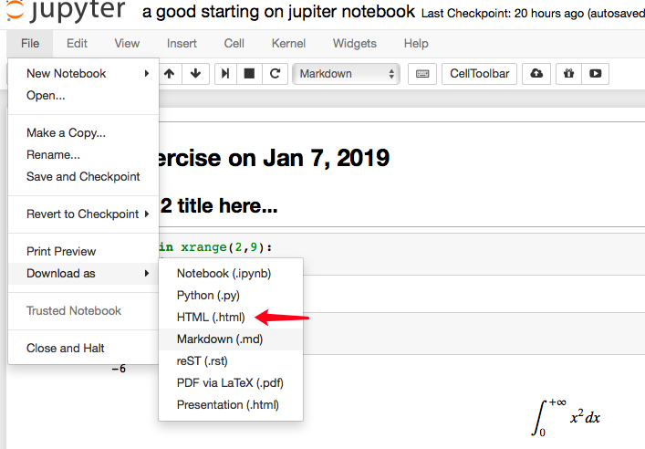

会被保存成a+good+starting+on+jupiter+notebook.html

在浏览器中打开那个html文件即可，打开后的效果如下：

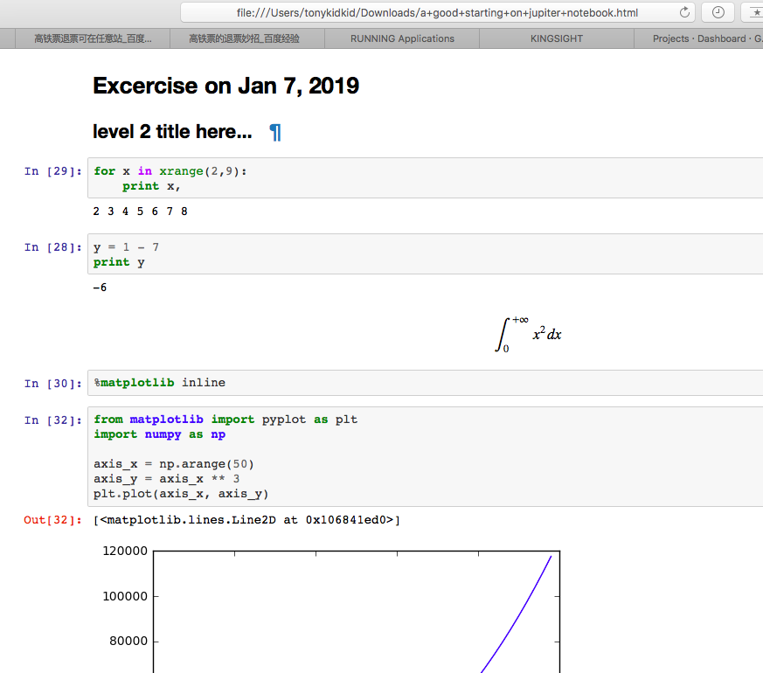

========================

Pycharm已配置成功

